DATA SCIENCE TOOLBOX: PYTHON PROGRAMMING

PROJECT REPORT
(Project Semester January-April 2026)

SOCIAL MEDIA IMPACT ANALYSIS ON STUDENTS

Submitted by

Vinay Jaiswal

Registration No :- 12411819

Programme and Section :- Btech CSE and 3M031
Course Code :- INT375

Under the Guidance of

Dr. Mrinalini Rana 22138

Discipline of CSE/IT

Lovely School of Computer Science and Engineering

Lovely Professional University, Phagwara

CERTIFICATE

This is to certify that Vinay Jaiswal bearing Registration no. 12411819 has completed INT375 project titled,“
Social Media Impact Analysis On Students ” under my guidance and supervision. To the best of my knowledge, the present work is the result of his/her original development, effort and study.

Signature and Name of the Supervisor
Designation of the Supervisor
School of Computer Science and Engineering
Lovely Professional University
Phagwara, Punjab.

Date: 15-04-2026

DECLARATION

I, Vinay Jaiswal , student of Btech Cse under CSE/IT Discipline at, Lovely Professional University, Punjab, hereby declare that all the information furnished in this project report is based on my own intensive work and is genuine.

Date:15-04-2026 Signature:- vinay
Registration No. 12411819 Name of the student Vinay Jaiswal

Acknowledgement

I would like to express my sincere gratitude to my faculty mentor for their constant guidance, valuable suggestions, and encouragement throughout the development of this project. Their support played a crucial role in helping me understand the practical aspects of data science and apply theoretical concepts effectively. Their timely feedback and motivation enabled me to complete this work successfully.

I am also thankful to Lovely Professional University for providing a supportive academic environment and necessary resources that facilitated the completion of this project. The infrastructure, learning facilities, and academic exposure provided by the university helped me enhance my knowledge and skills in the field of data science.

I would like to acknowledge the creators and contributors of the dataset used in this project, as their efforts made it possible to perform meaningful analysis and derive valuable insights.

I extend my heartfelt thanks to my family for their continuous support, patience, and encouragement during the course of this project. Their belief in me helped me stay focused and motivated.

Finally, I would like to thank my friends and peers for their support, discussions, and assistance whenever needed, which contributed significantly to the successful completion of this project.

Contents
1. INTRODUCTION 8
2. SOURCE OF DATASET 9
3.EXPLORATORY DATA ANALYSIS (EDA) 10
4. ANALYSIS ON DATASET 11
4.1 OBJECTIVE 1 11
Analysis Results 11
4.2 OBJECTIVE 2 14
Analysis Results 14
4.3 OBJECTIVE 3 16
Analysis Results 16
4.4 OBJECTIVE 4 19
Analysis Results 19
4.5 OBJECTIVE 5 21
Analysis Results 21
5. Conclusion 23
6. Future Scope 24
7. REFERENCES (IEEE FORMAT) 25

INTRODUCTION
In recent years, the rapid growth of social media platforms has significantly influenced the daily lives of individuals, especially students. Social media has become an integral part of modern communication, providing users with opportunities to connect, share information, and engage in various forms of digital interaction. However, along with its benefits, excessive use of social media has raised concerns regarding its impact on academic performance, mental health, and overall lifestyle.
Students are among the most active users of social media platforms such as Instagram, Facebook, and Twitter. While these platforms provide educational resources and social connectivity, prolonged usage can lead to negative consequences such as reduced sleep duration, decreased academic performance, and increased levels of stress and anxiety. Therefore, it becomes essential to analyze and understand the effects of social media usage on different aspects of students' lives.
Data science provides powerful tools and techniques to analyze such real-world problems. By using methods such as Exploratory Data Analysis (EDA), data visualization, regression analysis, and hypothesis testing, meaningful insights can be extracted from datasets. These techniques help in identifying patterns, relationships, and trends within the data, enabling better understanding and decision-making.
The primary objective of this project is to analyze the impact of social media usage on students using a structured data science approach. The dataset used in this project contains information related to students’ social media usage, sleep patterns, academic performance, and mental health scores. By applying various analytical techniques, this project aims to explore how these variables are interconnected.
This project begins with data preprocessing and cleaning to ensure the quality and consistency of the dataset. Following this, Exploratory Data Analysis is performed to understand the structure and characteristics of the data. Various visualization techniques are then used to identify patterns and relationships among variables. Furthermore, statistical methods such as Simple Linear Regression and hypothesis testing are applied to validate the findings and draw meaningful conclusions.
The analysis focuses on key aspects such as the relationship between social media usage and sleep duration, its impact on academic performance, and its influence on mental health. Additionally, comparisons are made across different social media platforms to understand their varying effects on users.
The findings of this project are expected to provide valuable insights into how social media usage affects students and highlight the importance of maintaining a balanced digital lifestyle. This study also demonstrates the practical application of data science techniques in solving real-world problems.

2. SOURCE OF DATASET
The dataset used in this project is titled “Social Media Impact on Students” and was obtained from an online data repository. The dataset contains structured information related to students’ social media usage and its impact on various aspects of their lives.
The dataset includes a total of 1705 records with 11 attributes. These attributes provide information about demographic details, social media usage patterns, and their effects on academic performance, sleep, and mental health. The key features of the dataset include:
- Student_ID: Unique identifier for each student
- Age: Age of the student
- Gender: Gender of the student
- Academic_Level: Educational level of the student
- Country: Country of the student
- Avg_Daily_Usage_Hours: Average number of hours spent on social media per day
- Most_Used_Platform: The social media platform most frequently used by the student
- Affects_Academic_Performance: Indicates whether social media usage affects academic performance
- Sleep_Hours_Per_Night: Average number of hours of sleep per night
- Mental_Health_Score: Numerical score representing mental well-being
- Overall_Impact: Overall impact of social media usage
The dataset is well-structured and contains both categorical and numerical variables, making it suitable for applying various data science techniques such as data visualization, correlation analysis, regression, and hypothesis testing.
This dataset was chosen because it provides relevant and meaningful information to analyze the impact of social media on students. It enables the study of relationships between different variables such as usage time, sleep patterns, academic performance, and mental health, which are critical factors in understanding student behavior in the digital age.
The dataset was sourced from an online platform such as Kaggle.
Link:- https://www.kaggle.com/datasets/abrerjawod/student-mental-health-and-burnout-dataset

3. EXPLORATORY DATA ANALYSIS (EDA)
Exploratory Data Analysis (EDA) is a crucial step in the data science process that involves examining and understanding the dataset before applying any advanced analytical techniques. The main objective of EDA is to identify patterns, detect anomalies, handle missing values, and gain insights into the structure of the data.
In this project, EDA was performed systematically to ensure that the dataset is clean, consistent, and suitable for further analysis.
Initially, the dataset was loaded into the Python environment using the pandas library. The first few rows of the dataset were displayed to understand the structure and format of the data. This helped in identifying the different attributes and their corresponding values.
The shape of the dataset was examined to determine the number of rows and columns. The dataset consists of 1705 rows and 11 columns, indicating a moderately sized dataset suitable for analysis. The data types of each column were also inspected to differentiate between numerical and categorical variables.
Descriptive statistics were computed for numerical features such as age, average daily usage hours, sleep hours, and mental health score. These statistics provided information about the mean, minimum, maximum, and standard deviation of the data, helping in understanding its distribution.
Missing values were checked using appropriate functions. It was observed that the dataset did not contain significant missing values, which ensured data reliability. Therefore, no major imputation was required during the preprocessing stage.
Data cleaning was performed to ensure consistency and accuracy. The dataset was checked for duplicate entries, and no duplicates were found. Data types were verified and maintained appropriately for further analysis.
Outlier detection was carried out using the Interquartile Range (IQR) method and box plot visualizations. The analysis indicated that there were no significant extreme outliers in the dataset. However, minor variations were observed within certain groups, which represent natural differences in user behavior and were retained for analysis.
Feature engineering techniques were applied where necessary. For example, numerical extraction and transformation methods were used to prepare the data for analysis and visualization. These steps ensured that the dataset was in a suitable format for applying statistical and machine learning techniques.
Visualization techniques such as count plots, box plots, scatter plots, and histograms were used to explore the data. These visualizations helped in identifying relationships between variables, such as the impact of social media usage on sleep duration and mental health.
Overall, the EDA process provided a clear understanding of the dataset and prepared it for further analysis. It ensured that the data was clean, structured, and ready for applying advanced techniques such as regression and hypothesis testing.

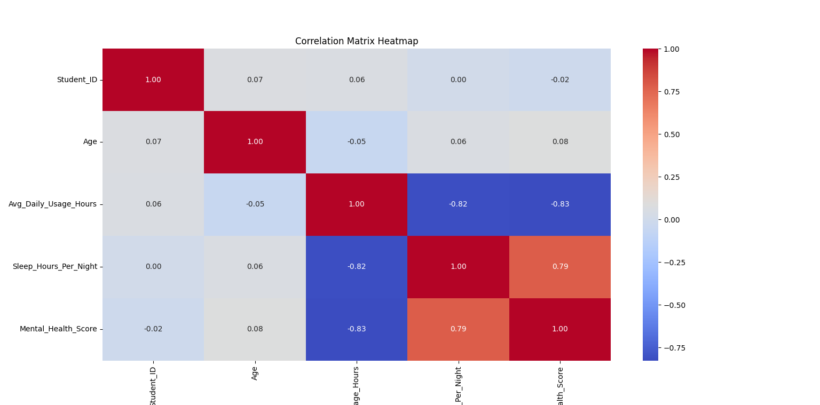
Figure 1: Correlation Heatmap of Numerical Variables

A correlation heatmap was used prior to regression analysis to identify the strength and direction of relationships between variables. Based on this analysis, Average Daily Usage Hours and Mental Health Score were selected as the independent and dependent variables for regression.

4. ANALYSIS ON DATASET

4.1 OBJECTIVE 1
To analyze the relationship between average daily social media usage and sleep duration using data visualization techniques.

Introduction
This analysis focuses on examining the relationship between the amount of time students spend on social media and their sleep duration. With the increasing usage of digital platforms, it is important to understand how social media consumption affects daily habits such as sleep. Visualization techniques are used to identify patterns and trends between these variables.

General Description
The variables considered for this analysis are Average Daily Usage Hours and Sleep Hours Per Night. Both variables are numerical in nature, making them suitable for identifying relationships using scatter plots and regression visualization. The goal is to determine whether increased social media usage leads to reduced sleep duration.

Specific Requirements, Functions and Formulas
The analysis was performed using Python libraries such as pandas, matplotlib, and seaborn. A scatter plot was used to visualize the relationship between the variables, while a regression line was added to observe the trend.
The scatter plot represents individual data points, and the regression line indicates the direction of the relationship between the variables.

Analysis Results
The analysis shows a negative relationship between average daily social media usage and sleep duration. As the number of hours spent on social media increases, the number of sleep hours tends to decrease. This suggests that excessive use of social media may interfere with proper sleep patterns.

Visualization

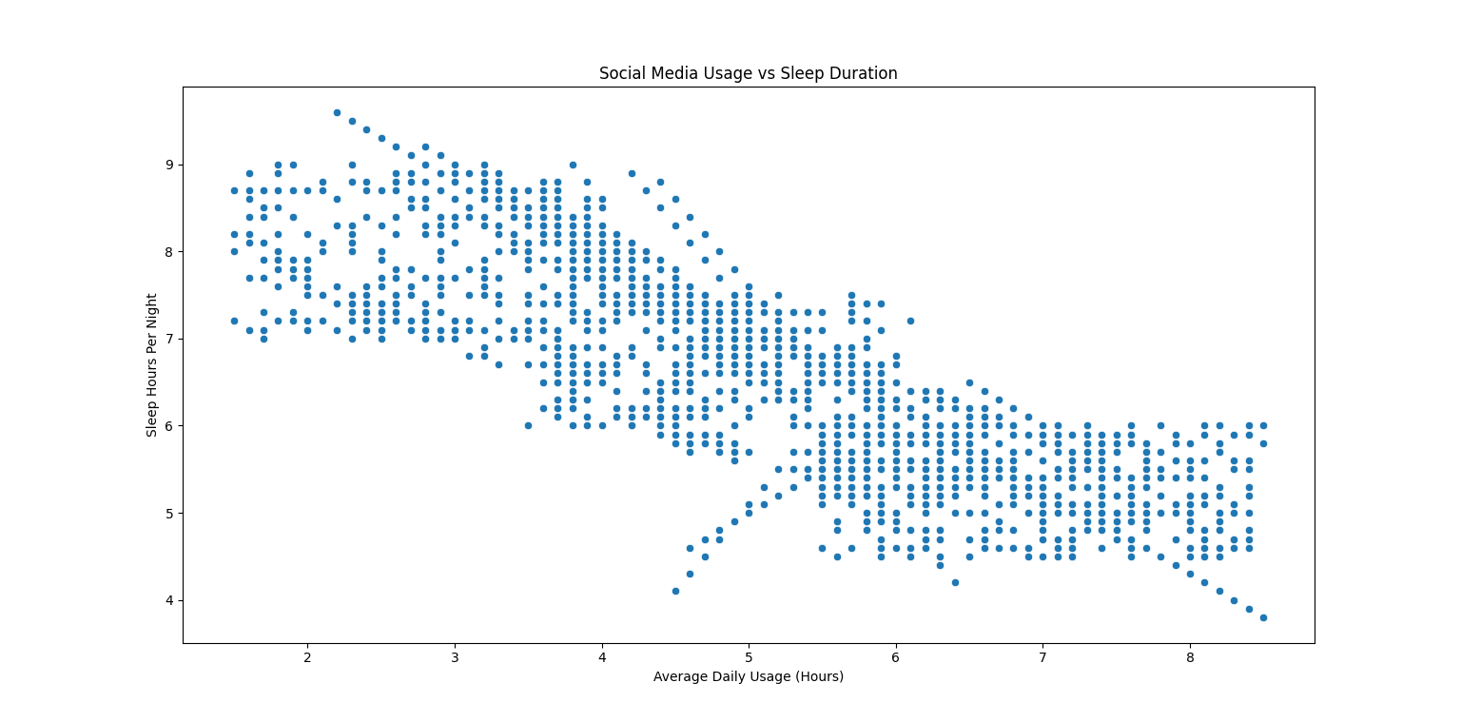
Figure 2: Social Media Usage vs Sleep Duration

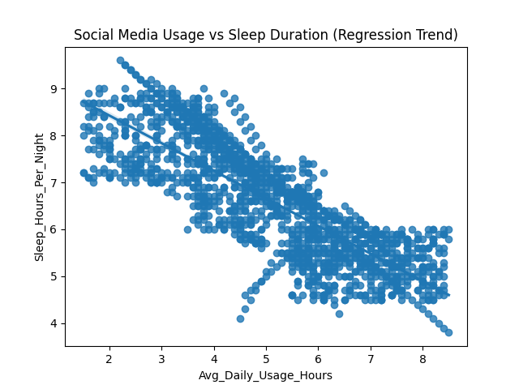
Figure 3: Regression plot showing trend between social media usage and sleep duration

4.2 OBJECTIVE 2
To analyze the impact of social media usage on academic performance using data visualization techniques.
Introduction
This analysis aims to examine how social media usage affects students’ academic performance. With increasing time spent on digital platforms, it becomes important to understand whether excessive usage has any influence on academic outcomes. Visualization techniques are used to compare social media usage across different groups of students.
General Description
The variables considered for this analysis are Average Daily Usage Hours and Affects Academic Performance. The variable Affects Academic Performance is categorical in nature, indicating whether social media usage impacts academic performance. The Average Daily Usage Hours is a numerical variable. A box plot is used to compare the distribution of usage across different categories.

Specific Requirements, Functions and Formulas
The analysis was performed using Python libraries such as pandas, seaborn, and matplotlib. A box plot was used to visualize the distribution of average daily usage hours across different categories of academic performance impact.
The box plot displays the median, quartiles, and possible outliers, helping in understanding the variation in usage between groups.

Analysis Results
The analysis indicates that students who reported that social media affects their academic performance tend to have higher average daily usage compared to those who reported no impact. The distribution of usage hours is higher in the affected group, suggesting that excessive social media usage may negatively influence academic performance.

Visualization

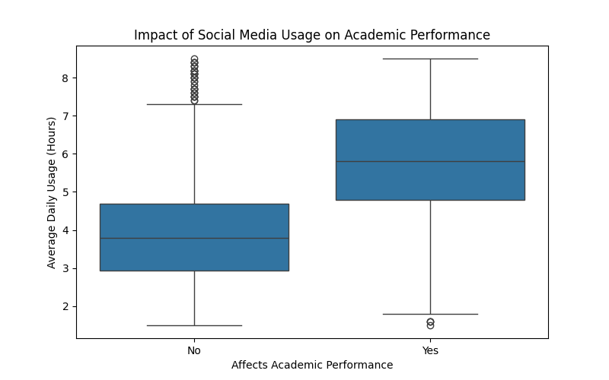
Figure 4: Impact of Social Media Usage on Academic Performance)

4.3 OBJECTIVE 3
To analyze the relationship between average daily social media usage and mental health score using Simple Linear Regression.
Introduction
This analysis applies Simple Linear Regression to examine the relationship between social media usage and mental health score. With the increasing dependence on digital platforms, it is important to understand how usage patterns influence mental well-being. Regression analysis helps in identifying trends and predicting the dependent variable based on the independent variable.

General Description
The variables used in this analysis are Average Daily Usage Hours as the independent variable and Mental Health Score as the dependent variable. Both variables are numerical in nature, making them suitable for regression analysis. The objective is to determine how changes in social media usage affect mental health.

Specific Requirements, Functions and Formulas
The analysis was performed using the Linear Regression model from the scikit-learn library. The model establishes a linear relationship between the independent variable (X) and the dependent variable (Y).
The general form of the regression equation is:
Y = a + bX
where:
Y = Mental Health Score
X = Average Daily Usage Hours
a = Intercept
b = Slope (coefficient)
The slope indicates the change in mental health score for each unit increase in social media usage.

Analysis Results
The regression analysis shows a strong negative relationship between average daily social media usage and mental health score. The negative slope of the regression line indicates that as social media usage increases, the mental health score decreases. This suggests that excessive use of social media may have an adverse impact on mental well-being.

Visualization
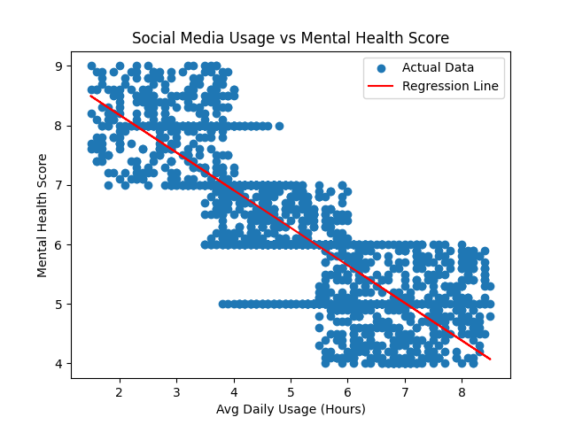
Figure 5: Regression Analysis of Social Media Usage vs Mental Health Score

4.4 OBJECTIVE 4
To test whether there is a significant difference in average daily social media usage between students whose academic performance is affected and those whose performance is not affected.
Introduction
This analysis aims to statistically examine whether social media usage has a significant impact on students’ academic performance. Hypothesis testing is used to compare the average daily usage of students who report that social media affects their academic performance with those who report no impact.
General Description
The analysis involves two groups of students based on the variable Affects Academic Performance. The first group includes students whose academic performance is affected, while the second group includes students whose performance is not affected. The average daily usage hours are compared between these two groups to identify any significant difference.

Specific Requirements, Functions and Formulas
The independent t-test was used to compare the means of two independent groups. The test was performed using the ttest_ind function from the scipy.stats library.
The hypotheses for the test are defined as follows:
H0 (Null Hypothesis): There is no significant difference in average daily social media usage between the two groups.
H1 (Alternative Hypothesis): There is a significant difference in average daily social media usage between the two groups.
The decision is based on the p-value obtained from the test. If the p-value is less than 0.05, the null hypothesis is rejected.

Analysis Results
The results of the t-test show a t-statistic value of approximately 24.51 and a p-value significantly less than 0.05. This indicates a statistically significant difference between the two groups. Therefore, the null hypothesis is rejected.
This result suggests that students whose academic performance is affected by social media tend to have higher average daily usage compared to those whose performance is not affected.

Visualization
Figure 6: Comparison of Social Media Usage across Academic Performance Groups)

4.5 OBJECTIVE 5
To analyze the impact of different social media platforms on mental health score using data visualization techniques.
Introduction
This analysis aims to examine how different social media platforms influence the mental health of students. Since students use various platforms for communication and entertainment, it is important to understand whether the type of platform used has any association with mental well-being. Visualization techniques are used to compare mental health scores across different platforms.

General Description
The variables considered in this analysis are Most Used Platform and Mental Health Score. The Most Used Platform is a categorical variable representing different social media platforms, while Mental Health Score is a numerical variable indicating the mental well-being of students. A box plot is used to compare the distribution of mental health scores across different platforms.

Specific Requirements, Functions and Formulas
The analysis was performed using Python libraries such as pandas, seaborn, and matplotlib. A box plot was used to visualize the distribution of mental health scores for each social media platform.
The box plot displays important statistical measures such as median, quartiles, and potential outliers, allowing for an effective comparison between different platforms.

Analysis Results
The analysis shows that mental health scores vary across different social media platforms. Some platforms exhibit lower median mental health scores, indicating a potentially negative impact, while others show relatively higher scores. This suggests that the type of social media platform used may influence mental well-being. However, the differences observed may also depend on individual usage patterns and other external factors.

Visualization
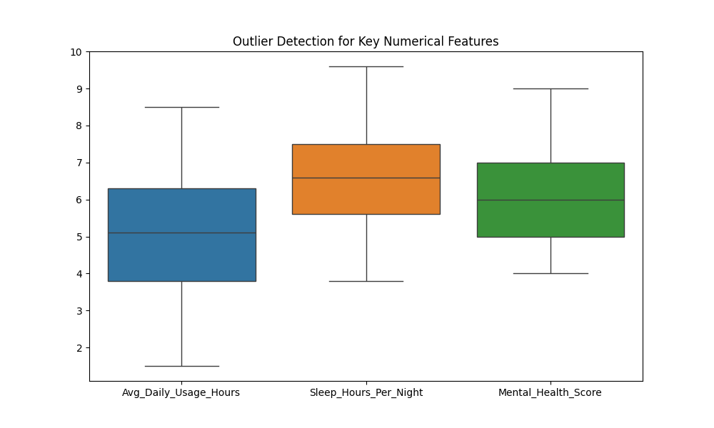
Figure 7: Mental Health Score across Different Social Media Platforms

5. Conclusion
This project focused on analyzing the impact of social media usage on various aspects of students’ lives using data science techniques. Through systematic data analysis, meaningful insights were derived regarding the relationship between social media usage, sleep patterns, academic performance, and mental health.
The Exploratory Data Analysis (EDA) provided a clear understanding of the dataset and revealed important patterns and relationships among variables. It helped in identifying key trends such as the influence of social media usage on sleep duration and mental well-being.
The analysis showed that increased social media usage is associated with reduced sleep hours, indicating that excessive usage may negatively affect daily routines. Furthermore, students who reported that social media affects their academic performance were found to have higher average usage compared to those who reported no impact.
The regression analysis demonstrated a strong negative relationship between average daily usage and mental health score, suggesting that increased usage may lead to a decline in mental well-being. This finding was further supported by correlation analysis, which confirmed strong relationships among usage, sleep, and mental health variables.
Additionally, hypothesis testing confirmed that there is a statistically significant difference in social media usage between students whose academic performance is affected and those whose performance is not affected. This validates the impact of social media usage on academic outcomes.
The platform-based analysis indicated that mental health scores vary across different social media platforms, suggesting that the type of platform used may also influence user well-being.
Overall, the results of this project highlight the importance of balanced social media usage. While social media offers various benefits, excessive usage can have negative consequences on sleep, academic performance, and mental health. The study emphasizes the need for awareness and responsible usage among students.

6. Future Scope
The present study provides valuable insights into the impact of social media usage on students; however, there are several areas where the analysis can be extended further.
In future work, a larger and more diverse dataset can be used to improve the generalizability of the results. Including data from different age groups, educational backgrounds, and geographic regions would provide a more comprehensive understanding of social media behavior and its effects.
Advanced machine learning techniques such as multiple linear regression, decision trees, or classification models can be applied to predict outcomes such as mental health status or academic performance based on multiple factors. This would enhance the predictive capability of the analysis.
Time-series analysis can also be incorporated to study changes in social media usage patterns over time and their long-term impact on users. This would help in understanding trends and behavioral shifts.
Further analysis can include additional variables such as physical activity, screen time from other devices, and social interactions to provide a more holistic view of lifestyle factors affecting mental health.
The development of interactive dashboards using tools such as Power BI, Tableau, or web-based frameworks can make the analysis more user-friendly and accessible. This would allow stakeholders to explore the data dynamically.
Additionally, sentiment analysis on user-generated content from social media platforms can provide deeper insights into emotional and psychological states.
Overall, future enhancements can focus on improving data quality, expanding analytical techniques, and developing practical applications to support better decision-making and awareness regarding social media usage.

7. REFERENCES (IEEE FORMAT)

[1] Social Media Impact on Students Dataset, Kaggle. [Online]. Available: https://www.kaggle.com
[2] Pandas Documentation, “pandas: Python Data Analysis Library,” [Online]. Available: https://pandas.pydata.org/
[3] Seaborn Documentation, “Statistical Data Visualization,” [Online]. Available: https://seaborn.pydata.org/
[4] Matplotlib Documentation, “Visualization with Python,” [Online]. Available: https://matplotlib.org/
[5] Scikit-learn Documentation, “Machine Learning in Python,” [Online]. Available: https://scikit-learn.org/
[6] SciPy Documentation, “Scientific Computing Tools for Python,” [Online]. Available: https://scipy.org/
[7] J. Han, M. Kamber, and J. Pei, “Data Mining: Concepts and Techniques,” 3rd ed., Morgan Kaufmann, 2011.
[8] I. Goodfellow, Y. Bengio, and A. Courville, “Deep Learning,” MIT Press, 2016.

