

## A

**Report on**

“Bike Buddy”

Submitted To

Shivaji University, Kolhapur

## In Partial Fulfillment of the

## Requirement

## For the Degree Of

## Final Year of B.Tech

## (COMPUTER SCIENCE AND ENGINEERING)

Submitted by

## PRN Name of Student 2021000145 Vinay Karande

2021000022 Saira Sanadi

## 2021000111 Omkar Birajdar

2021000061 Sayali Gurav

2021000299 Krutik Ukunde

Under the guidance of

**Mrs. Y. S. Narule**

Submitted at

**Kolhapur Institute of Technology’s College of Engineering (Autonomous), Kolhapur**

Year 2023-24



# CERTIFICATE

This is to certify that **Vinay Karande(2021000145), Saira Sanadi(2021000022), Omkar Birajdar(2021000111), Sayali Gurav(2021000061), Krutik Ukunde(2021000299)** have completed the Project Part-I on subject entitled **“Bike Buddy”**, in the fulfilment of the requirement for the award of Final Year (Computer Science and Engineering) of KIT’s College of Engineering, Kolhapur in the academic year 2023-24.

**Date:**

**Place:** Kolhapur

Mrs. Y. S. Narule External Examiner Dr. L.A. Hadimani **Project Guide** **Head CSE**

Dr. M. B. Vanarotti **Director**

# ACKNOWLEDGMENT

We would like to express our deep gratitude towards Mrs. Y. S. Narule and Dr. L. A. Hadimani Head of Department for their constant en- couragement and guidance. Their support and cooperation throughout the project work has been of immerse help to us.

We express our sincere thanks to all the teaching and non-teaching staff and all those who have directly or indirectly helped in making project a success.

### PRN No Name of Student

### 2021000145 Vinay Karande

### 2021000022 Saira Sanadi

### 2021000111 Omkar Birajdar

### 2021000061 Sayali Gurav

### 2021000299 Krutik Ukunde

# Contents

1. ABSTRACT 5
2. INTRODUCTION 6
3. REVIEW OF LITERATURE 7
4. SYSTEM ANALYSIS 8
   1. Existing System 8
   2. Requirements 9
      1. Functional Requirements 9
      2. Non-Functional Requirements 11
      3. Usability Requirements 11
      4. Implementation Requirements 11
   3. Problem Definition 12
   4. Analysis Diagrams 13
      1. Flow chart 13
      2. Entity-Relationship diagram 14
5. PROPOSED SYSTEM 15
   1. Purpose 15
   2. Scope 16
   3. System Design 16
   4. Modules Involved 17
6. REQUIREMENTS 18
   1. Hardware and Software Interface 18
7. IMPLEMENTATION 19
   1. Module Implementation 19
      1. Login / Signup Module. 19
      2. Offer/Book Ride Module 19
      3. Location Module 21
      4. Review Module 21
   2. Product Functions 22
   3. Screenshots 23
   4. Constraints 29
   5. Assumptions and Dependencies 29
   6. External Interface Requirements 30
8. PROJECT MANAGEMENT 31
   1. Process model 31
   2. Project Timeline 34
   3. Feasibility Study 35
9. TESTING 37
   1. Module Name: Registration and Login 37
   2. Module Name: Path Matching 42
10. CONCLUSION 43
11. REFERENCES 44

# 1 ABSTRACT

This report presents the development and implementation of "Bike Buddy," a student-centric transportation solution aimed at addressing the transportation challenges faced by college students, with a focus on enhancing educational accessibility and outcomes. The problem statement identifies the inadequacy and unreliability of existing transportation systems as a barrier to education, particularly in colleges like KIT. Through market research, it is evident that students seek affordable, reliable, and safe transportation options tailored to their unique needs. Unlike profit-driven alternatives, Bike Buddy operates as a non-profit platform, prioritizing the educational well-being of students over financial gain. The solution facilitates connections between riders and students sharing similar commute routes, offering a cost-effective and dependable mode of transportation. Innovations such as security features, rider/passenger feedback systems, and gender-based prioritization enhance safety and user experience. However, limitations include the solution's exclusivity to college students, temporal and spatial constraints, and route specificity. Despite these challenges, Bike Buddy represents a pioneering effort in fostering a more inclusive and equitable educational environment by empowering students to overcome transportation barriers and achieve their academic potential.

# 2 INTRODUCTION

In today's urban environments, plagued by traffic congestion and environmental concerns, bike pooling has emerged as a promising solution. This concept involves shared bicycle use for transportation, offering a sustainable and efficient means of city travel. While its roots date back to the late 20th century, recent advancements in technology and urban planning have propelled its popularity.

This report focuses on "Bike Buddy," a student-centric transportation solution addressing the challenges faced by college students. Designed to enhance educational accessibility, Bike Buddy provides affordable, reliable, and safe transportation options tailored to students' needs. Unlike profit-driven alternatives, Bike Buddy prioritizes student welfare over financial gain.

By connecting student riders and student passengers along similar commute routes, Bike Buddy offers a cost-effective and dependable mode of transportation. Innovative features such as enhanced security and user feedback systems further enhance its appeal. Though limited to certain routes and students, Bike Buddy promotes inclusivity and empowers students to overcome transportation challenges.

# 3 REVIEW OF LITERATURE

Existing literature on transportation solutions, including bike pooling, sheds light on its potential benefits and challenges. Studies highlight the positive impacts of bike pooling on urban mobility, such as reduced congestion, lower emissions, and improved accessibility, aligning closely with the goals of Bike Buddy.

However, hurdles to adoption include safety concerns, inadequate infrastructure, cultural preferences for car ownership, and regulatory complexities. Overcoming these challenges requires collaborative efforts involving government agencies, planners, community groups, and bike sharing operators.

By drawing insights from this literature, Bike Buddy can refine its approach to address these challenges effectively, maximizing its contribution to enhancing transportation accessibility and sustainability in urban environments.

# 4 SYSTEM ANALYSIS

## Existing System

In the existing system, urban commuters typically rely on traditional modes of transportation such as cars, buses, or trains for their daily travel needs. However, these modes often contribute to traffic congestion, air pollution, and carbon emissions, highlighting the need for more sustainable alternatives. While biking offers a greener option, concerns about safety, convenience, and accessibility hinder its widespread adoption. Moreover, existing bike-sharing systems may lack the flexibility and reliability desired by users, leading to underutilization and inefficiencies in urban transportation networks.,

## Requirements

The functional and non-functional requirements are as follows

### Functional Requirements

The bike Buddy system, facilitate the following functionalities:

* User Registration and Authentication: Users are be able to create accounts on Bike Buddy by providing necessary information such as name, email address, and contact details. The system authenticate users securely to ensure the integrity and confidentiality of user accounts.
* Bike Availability Tracking and Reservation: Bike Buddy display real-time information about available bikes at various locations within the service area. Users are be able to search for nearby bikes, view their current status (e.g., available, reserved), and reserve a bike for a specified duration.
* Route Planning and Navigation Assistance: The system provides users with route planning tools to help them identify optimal biking routes based on their destination and preferences. Integration with mapping services offer turn-by-turn navigation guidance to users during their bike rides.
* Feedback and Rating System: Users have the ability to provide feedback and ratings for bikes and other users within the Bike Buddy community. The system aggregate user feedback and ratings to help improve the overall quality of bike sharing services and user experiences.
* Integration with Urban Transportation Infrastructure: Bike Buddy integrates seamlessly with existing urban transportation infrastructure, such as bike lanes, parking facilities, and public transit networks.
* Administrative Tools: Administrative functionalities are available to system administrators to manage user accounts, bikes, and other system resources. Tools for monitoring system performance, generating reports, and addressing user inquiries or issues are provided.

### Non-Functional Requirements

Non-functional requirements for Bike Buddy include:

* + - * Reliability: The system should operate consistently without disruptions.
      * Performance: Response times for user requests and system operations should be fast and efficient.
      * Security: User data should be protected through encryption and secure authentication mechanisms.
      * Scalability: The system should be able to accommodate a growing user base and increasing demand over time.
      * Compatibility: Bike Buddy should be compatible with a variety of devices and operating systems.

### Usability Requirements

Usability requirements focus on ensuring a seamless and intuitive user experience, including:

* User-friendly interface design
* Clear and concise instructions for using the system

### Implementation Requirements

Implementation requirements involve technical specifications and considerations for developing the Bike Buddy system, such as:

* + - * Choice of programming languages and development frameworks
      * Database management system for storing user and bike data
      * Integration with third-party services (e.g., mapping APIs)
      * Hardware requirements for hosting the system (e.g., servers, network infrastructure) FileZilla: It is a tool for accessing the files on ftp. We use FileZilla to upload and download files from hosting.

## Problem Definition

The primary problem addressed by Bike Buddy is the lack of a convenient and reliable bike pooling solution for urban commuters. By providing a user-friendly platform for sharing bikes, Bike Buddy aims to promote sustainable transportation options, reduce traffic congestion, and improve overall mobility in urban areas.

## Analysis Diagrams

### Flow chart

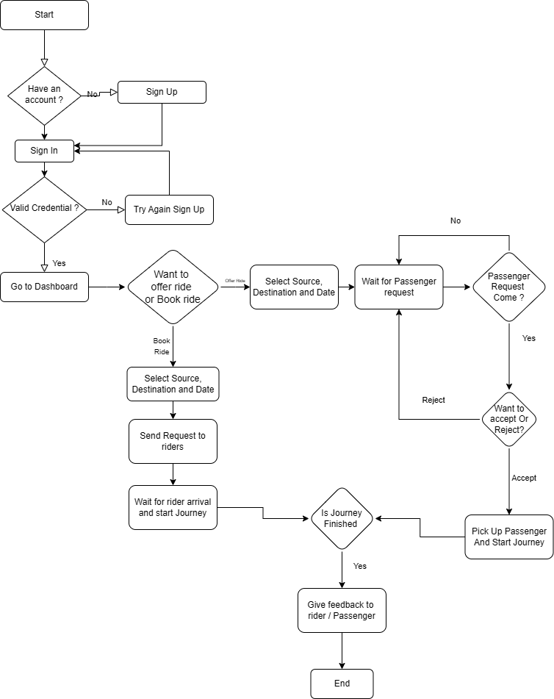

Fig 4.1 Flow Chart

### Entity-Relationship diagram

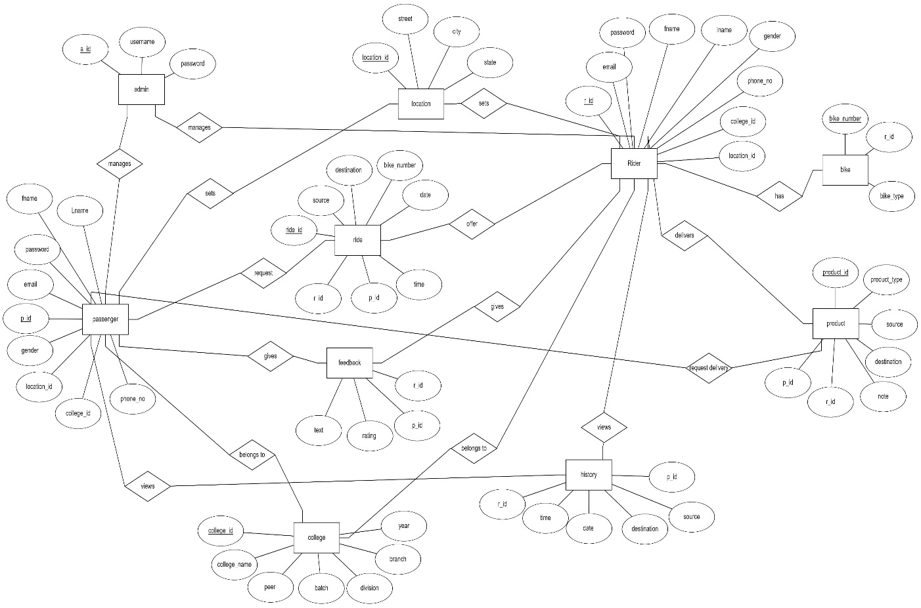

Fig 4.2 E-R diagram of database

# 5 PROPOSED SYSTEM

The Bike Buddy project introduces a transformative approach to student transportation, emphasizing sustainability, affordability, and user-centricity. Utilizing bike pooling as its core mechanism, Bike Buddy offers a mobile application with a user-friendly interface, enabling students to effortlessly input their pickup and drop-off locations, explore ride options, and connect with fellow riders and passengers. Sophisticated algorithms drive route matching, ensuring optimized efficiency and reduced travel expenses for students. Safety and security are paramount, with features like rider/passenger suggestions according to their batch-division-branch, feedback systems, and gender-based prioritization fostering trust and accountability within the college community. By promoting a non-profit model, Bike Buddy prioritizes the educational well-being of students, while innovative security measures and route optimization algorithms enhance the overall user experience. Ultimately, Bike Buddy not only provides a cost-effective alternative to traditional transportation but also fosters environmental sustainability and community building, shaping a more inclusive and environmentally conscious campus environment.

## Purpose

The purpose of the proposed system, "Bike Buddy," is to address the transportation challenges faced by college students, particularly at institutions like KIT. The aim is to provide an efficient, cost-effective, and reliable transportation solution that enhances students' access to education by connecting them with riders traveling along similar routes. By facilitating ridesharing among students within the college community, the system aims to alleviate the burden of expensive and irregular public transportation, ultimately contributing to a more inclusive and equitable educational experience.

## Scope

Bike Buddy goes beyond simply offering another ride-sharing option. It specifically addresses the transportation challenges faced by college students, creating a system designed to meet their unique needs.

Here's a closer look at the scope of Bike Buddy:

* Developing a platform that enables students to input their pick-up and drop-off locations.
* Connecting passenger’s students with rider’s students who are willing to offer rides along their regular commute routes.
* Prioritizing affordability, reliability, and safety in transportation solutions tailored specifically to students' needs.
* Implementing security features to foster trust and accountability within the college community.
* Enhancing the overall educational experience by ensuring reliable transportation options that support students' academic pursuits.

## System Design

The system design of Bike Buddy revolves around creating a user-friendly platform that facilitates ridesharing among college students.

Key components of the system design include:

* User Interface: A simple and intuitive interface for students to input their pick-up and drop-off locations and connect with students riders.
* Matching Algorithm: A sophisticated algorithm to match students passenger with students riders traveling along similar routes, optimizing travel time and expenses.
* Security Features: Implementing measures such as rider/passenger feedback and rating, recommendations based on college community relationships, and optional gender-based prioritization for enhanced security and peace of mind.
* Integration: Seamless integration of the system with existing college infrastructure and transportation networks.

## Modules Involved

## The proposed system comprises several interconnected modules:

* User Registration and Authentication: Allows students to create accounts and authenticate their identities.
* Ride Request Management: Enables students to input their pick-up and drop-off locations and request or offer rides.
* Matching and Scheduling: Utilizes algorithms to match students passenger with suitable students riders and schedule rides efficiently.
* Feedback and Rating: Facilitates the exchange of feedback and ratings between riders and passengers to maintain accountability and trust.
* Security and Privacy: The Bike Buddy system prioritizes passenger safety through recommendation systems based on college relationships and gender-based prioritization. By matching passengers with familiar individuals from their academic batch, division, and branch, it fosters trust during ridesharing. Additionally, gender-based prioritization enhances safety by allowing passengers to choose rides with individuals of the same gender, respecting their comfort levels. These features ensure a safer and more inclusive transportation environment for college students.

# 6 REQUIREMENTS

## Hardware and Software Interface

Hardware Requirements:

* + - Android Version: Android 9 and above
    - RAM : 2GB and above
    - Disk Space : Minimum 1GB required.

Software Requirements:

* + - Apk file with following app permission:
    - Storage Permission.
    - Location Permission.
    - Contact Permission

# 7 IMPLEMENTATION

## Module Implementation

### Login / Signup Module

Description: This module serves as the gateway for users to access the bike buddy application. It facilitates two primary functions: user registration (signing up) for new users and user authentication (login) for existing users.

Functionality:

* Signup: Allows new users to create an account by providing necessary information such as name, email address, phone number, password, department, division, batch and gender.
* Login: Provides existing users with a secure login page where they can enter their credentials (email/username and password) to access the application.

Purpose: By enabling users to sign up and log in, this module ensures secure access to the bike buddy application, personalizing the user experience and allowing access to other functionalities.

### Offer/Book Ride Module

Description: This module presents users with the option to either offer a ride (for those willing to share their ride with others) or book a ride (for those seeking transportation).

Functionality:

* Offer Ride: Enables users to offer available seatx in their vehicle for other users to book.
* Book Ride: Allows users to search for available rides based on their desired route and schedule, and book a seat in a vehicle offered by another user.

Purpose: By providing these options, the module facilitates efficient transportation arrangements among students, promoting bike pooling and reducing individual commuting costs.

### Location Module

Description: This module facilitates the input of pickup and drop-off locations for users participating in ride-sharing arrangements.

Functionality:

* Enter Locations: Allows users to input their current pickup location and desired drop-off location.
* Journey Tracking: Provides users with real-time tracking of their journey, enabling them to monitor their progress from pickup to drop-off.

Purpose: By capturing and tracking location data, this module enhances the user experience by ensuring accurate route planning and facilitating seamless navigation during the ride-sharing process.

### Review Module

Description: This module enables users (both riders and passengers) to provide feedback on their ride-sharing experiences by rating and reviewing each other.

Functionality:

* Rating System: Allows users to assign a numerical rating (e.g., stars) to their ride-sharing partner based on their experience.
* Review Submission: Provides users with the option to submit written reviews, sharing their thoughts and suggestions regarding the ride.

Purpose: By incorporating a review system, the module promotes accountability and transparency within the bike buddy community, helping users make informed decisions when choosing ride-sharing partners.

## Product Functions

User Registration and Authentication: This function ensures that users can create accounts securely and access the bike buddy application. It involves user registration, where individuals provide necessary personal information to establish their identity, and authentication mechanisms to verify user credentials during login, safeguarding user data and ensuring a personalized experience.

Ride Offering and Booking: This function empowers users to either offer rides or book available rides, catering to their commuting needs. It involves creating ride offers with details like pickup and drop-off locations, departure times, as well as searching for and booking rides based on preferred routes and schedules, promoting efficient transportation arrangements and cost-effective commuting solutions.

Location Input and Tracking: This function enables users to input pickup and drop-off locations and tracks their journey in real-time. It involves facilitating the input of precise location details through intuitive interfaces and utilizing GPS technology to track users' movements, providing accurate route guidance and enhancing the overall ride-sharing experience with seamless navigation and progress monitoring.

Rating and Reviewing: This function allows users to rate and review their ride-sharing experiences, fostering a community of accountability and trust. It involves assigning ratings based on various aspects of the ride, such as punctuality, cleanliness, and safety, and submitting detailed reviews sharing insights, suggestions, and feedback, promoting transparency, encouraging positive behavior, and assisting users in making informed decisions when choosing ride-sharing partners.

## Screenshots

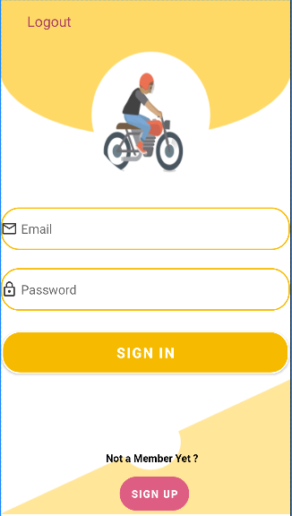

Fig 7.3.1 Login Page

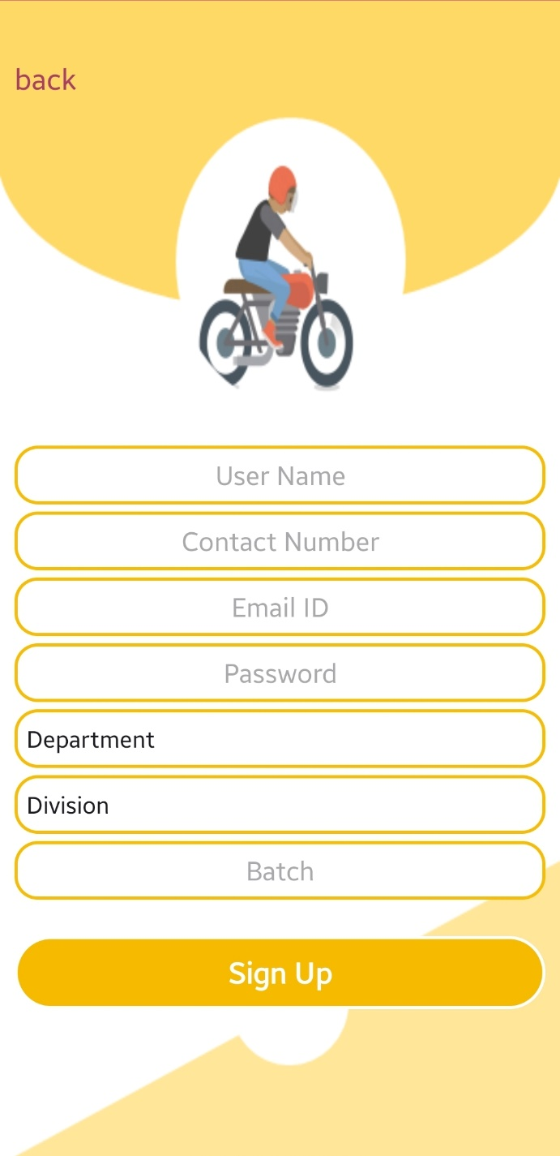

Fig 7.3.2 Sign Up Page

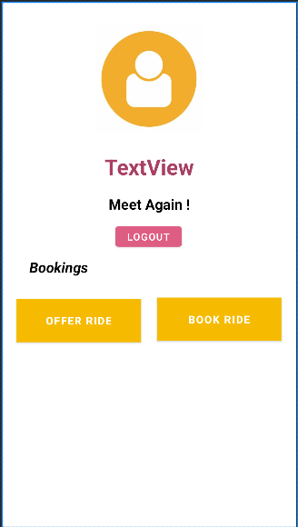

Fig 7.3.3 Dashboard Page

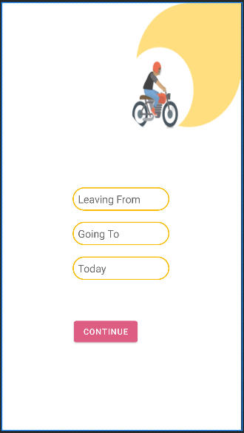

Fig 7.3.4 Selecting Source and destination

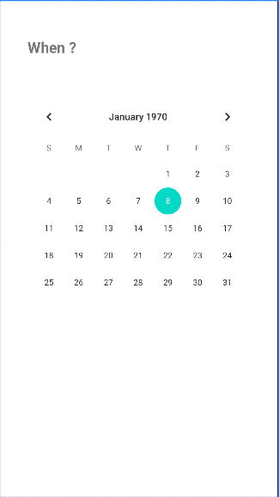

Fig 7.3.5 Date selection

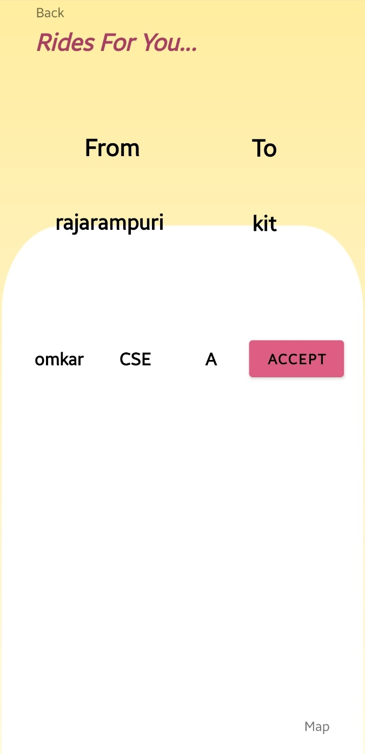

Fig 7.3.6 Ride details

## Constraints

Time Specific Solution: The bike buddy application is designed to address transportation needs within a specific time frame, catering primarily to the daily commuting routines of KIT's college students.

Route Specific Solution: It focuses on providing transportation solutions for predefined routes typically followed by students commuting to and from KIT's college.

Limited User Base: The application is exclusively available for use by KIT's college students, restricting its accessibility to a specific user demographic.

## Assumptions and Dependencies

Assumptions

* Fixed Pickup and Drop Points: It assumes that students have consistent pickup and drop-off locations for their daily commute.
* Fixed Route Patterns: It assumes that riders follow the same route daily when offering rides to passengers.

Dependencies

* Smartphone with Android OS: The application requires users to have smartphones running on the Android operating system to access its features and functionalities.
* Google Maps APIs: Integration with Google Maps APIs is essential for implementing the main functionality of the application, including location tracking and navigation services.
  + Place AIP:

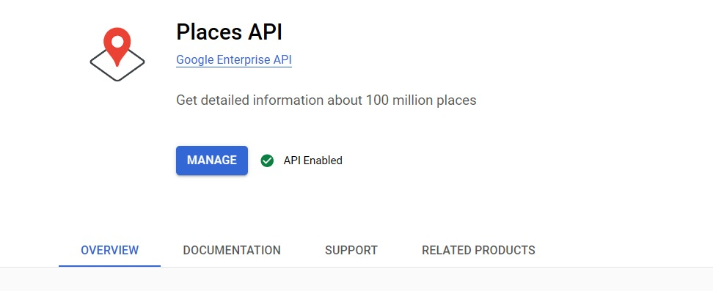

* + GeoCoding API:

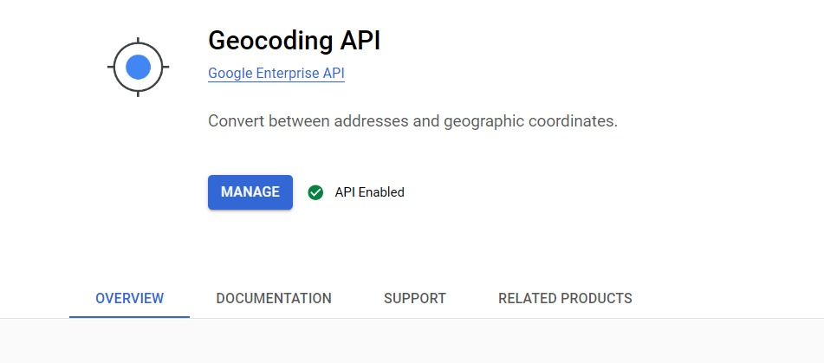

* + Geo-Location API:

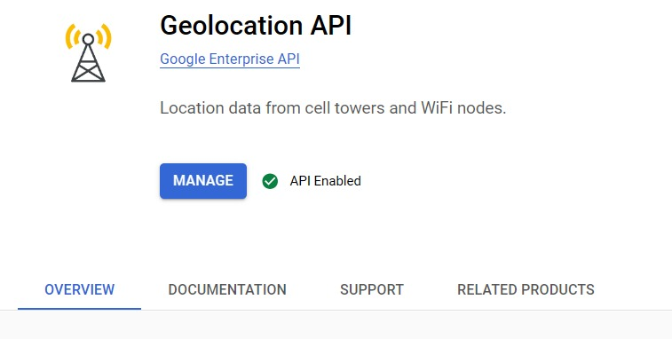

* + Direction API:

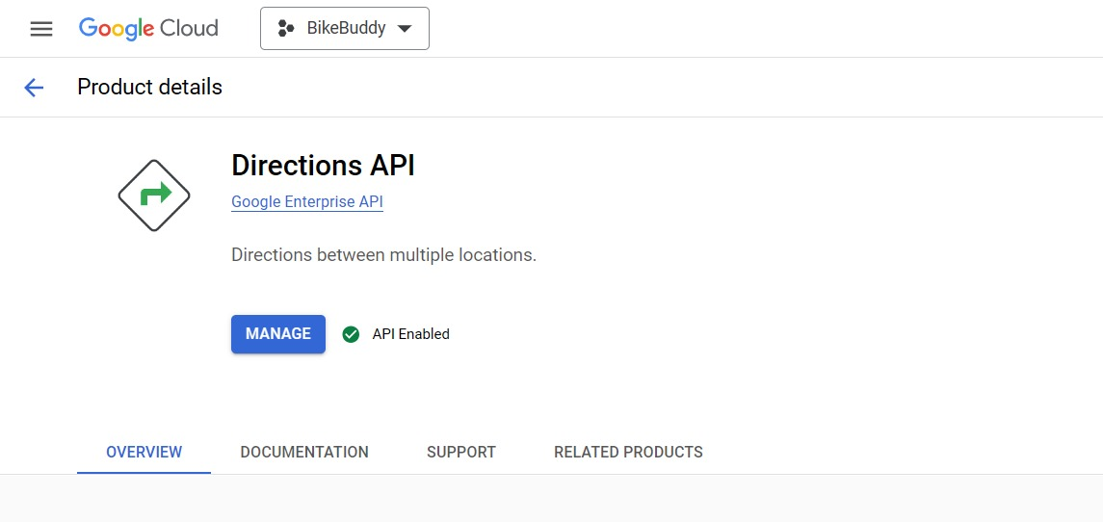

## External Interface Requirements

Compatibility: The system must be compatible with all existing versions of the Android operating system to ensure broad accessibility among users.

Google Maps APIs: The application relies on Google Maps APIs for essential functionalities such as location tracking, route planning, and navigation services. Integration with these APIs is necessary for the proper functioning of the app

# 8 PROJECT MANAGEMENT

## Process model

* Requirements Gathering: Begin by gathering and analysing the requirements for the bike pooling system. Identify the specific needs, constraints, and functionalities expected from the system, such as user registration, bike availability tracking, route planning, and payment processing.
* Design: Design the overall architecture of the system, including backend servers, databases, mobile applications, and web interfaces. Create a high-level design that outlines the system's structure and interactions, including how users will request rides, how bikes will be allocated, and how payments will be processed.
* Implementation: Develop the system incrementally, starting with core functionalities such as user registration, bike tracking, and basic ride scheduling. Utilize appropriate technologies and frameworks for backend development, mobile app development, and web development. Implement features such as GPS tracking for bikes, real-time ride status updates, and secure payment processing.
* Testing: Conduct thorough testing at multiple levels to ensure the correctness and reliability of the system. Perform unit testing to verify individual components, integration testing to test interactions between different modules, and end-to-end testing to validate the entire system's functionality. Test the system with simulated ride requests, user interactions, and various edge cases.
* Evaluation and Feedback: Evaluate the system's performance and gather feedback from users or stakeholders. Assess the user experience, reliability of ride allocation, and efficiency of payment processing. Identify any issues or areas for improvement and incorporate feedback into the development process.
* Iterative Refinement: Based on evaluation and feedback, iterate on the development process to address any identified issues or enhancements. This may involve improving algorithms for ride allocation, optimizing user interfaces for better usability, or enhancing security features. Repeat steps 3 to 5 as necessary to incrementally improve the system.
* Deployment: Prepare the system for deployment in the intended environment, whether it's a mobile app store, web hosting platform, or on-premises server. Ensure proper installation, configuration, and compatibility with target devices and platforms. Perform any necessary system integration and data migration tasks.
* Maintenance and Updates: Provide ongoing maintenance and support for the deployed system. Address any issues or bugs that arise and release updates or patches as needed. Monitor the system's performance and implement enhancements or new features based on user feedback or changing requirements.

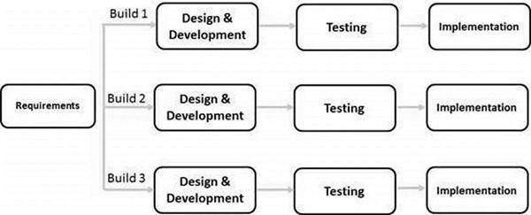

Fig 8.1.1 Iterative model

## Project Timeline

|  |  |  |
| --- | --- | --- |
| Week 1 | Requirement analysis | 34 hrs |
| Week 2 | Project Presentation | 2 |
| Week 3 | Technical requirements | 5 |
| Week 4 | Analyzing existing bike pooling platforms and market trends | 23 |
| Week 5 | Code Analysis | 20 |
| Week 6 | Referring Git hub repos | 3 |
| Week 7 | Study For Existing projects | 4 |
| Week 8 | Progress Of presentation | 8 |
| Week 9 | Literature Survey | 9 |
| Week 10 | Investigating optimal database structure and Android architecture | 10 |
| Week 11 | Developing UI design and layout for the app | 23 |
| Week 12 | Setting up environment for server-side scripting | 3 |
| Week 13 | Setup Requirements | 4 |
| Week 14 | Study of algorithm | 2 |
| Week 15 | Study for Required Libraries | 34 |
| Week 16 | Checking For fixes | 23 |
| Week 17 | Applying Fixes | 4 |
| Week 18 | Progress Presentation | 23 |
| Week 19 | Final Code check | 32 |

## Feasibility Study

1.Technical Feasibility:

* Android Development: Android provides robust development frameworks and tools for building mobile applications, making the technical feasibility of the project high.
* Database Management Systems: Utilizing database management systems like Firebase enables efficient data storage and retrieval for user profiles, ride history, and transaction records.
* Google Maps API: Integration with Google Maps API facilitates route planning, location tracking, and navigation functionalities, enhancing the user experience.
* Backend Development: Implementing a scalable backend system using technologies such as Java in Android development ensures seamless communication between the mobile app and server.

2.Economic Feasibility:

* Cost Implications: Evaluate the cost of hardware requirements (e.g., server hosting, GPS tracking services for users), software licenses (e.g., Google Maps API usage fees), development tools, and infrastructure.
* Open-source Tools: Leveraging open-source tools and frameworks like Android Studio, Firebase, and Google Maps API significantly reduces the economic burden, as they are often free to use or offer affordable pricing plans.
* Return on Investment (ROI): Estimate the ROI by considering potential benefits such as increased user engagement, reduced traffic congestion, environmental impact, and revenue generation through advertisements or premium features.

3.Operational Feasibility:

* User Experience: Evaluate the usability and intuitiveness of the bike pooling app's interface to ensure ease of use for riders and bike owners.
* User Training: Assess the training requirements for users to effectively utilize the app, including registration, ride booking, payment processing, and bike unlocking procedures.
* Integration with Existing Systems: Determine the compatibility and integration requirements with existing transportation systems, payment gateways, and government regulations.
* Resource Availability: Consider the availability of skilled personnel for app development, maintenance, customer support, and administrative tasks. Evaluate the need for additional training or outsourcing for specialized tasks. language.py.

# 9 TESTING

## Module Name: Registration and login

Test Title: Register Page

Test summary/Description:

|  |  |  |  |  |
| --- | --- | --- | --- | --- |
| Test Condition | Test Data | Expected result | Actual Result | Status of  Test Case |
| Loading page | Register page | Should open quickly | Opened quickly as expected | Passed |
| User input field | User input | Should allow all users to enter their details. | Allows all users to enter details | Passed |
| User Data Stored to database | Inputted data by user | Able to store a user inputted data into database | Stored user Inputted data in database in proper format. | Passed |

Test Title: Login

Test summary/Description:

|  |  |  |  |  |
| --- | --- | --- | --- | --- |
| Test Condition | Test Data | Expected result | Actual Result | Status of  Test Case |
| Loading page | Login page | Should open quickly | Opened quickly as expected | Passed |
| Enter valid data | Login details | Validate the data entered by user | Validates the data entered by user with database data. | Passed |
| Navigate to next page | User input | Should navigate user to next page if login details are correct | It Navigates properly to next page upon entering correct login data | Passed |

Test Title: Dashboard Test summary/Description:

|  |  |  |  |  |
| --- | --- | --- | --- | --- |
| Test Condition | Test Data | Expected result | Actual Result | Status of  Test Case |
| Fetch data from database | Stored data | Should be able to fetch data from database | Fetch data from database properly | Passed |
| Display user data | Stored data | Should be able to display user data as per user login | Displays correct data in dashboard as per user login | Passed |
| Navigate Buttons | User Input | It should navigate to next page as per user click either book ride or offer ride button | Navigates to next page properly according to user button click. | Passed |

Test Title: Book Ride

Test summary/Description:

|  |  |  |  |  |
| --- | --- | --- | --- | --- |
| Test Condition | Test Data | Expected result | Actual Result | Status of  Test Case |
| Navigate to Book ride | User click | It should navigate to Book ride page if user click on book ride button | It navigates to book ride when user click book ride button. | Passed |
| Enter Source | User Input | Able to get source location enter by user | It gets the user source location entered by user | Passed |
| Enter Destination | User Input | Should be able to get user entered destination location | It gets the user destination location | Passed |
| Map Suggestions | Map | Should Suggest source and destination to user using google map suggestion | Suggest user while entering source and destination by using google map | Passed |

Test Title: Offer Ride summary/Description:

|  |  |  |  |  |
| --- | --- | --- | --- | --- |
| Test Condition | Test Data | Expected result | Actual Result | Status of  Test Case |
| Navigate to Offer ride | User click | It should navigate to Offer ride page if user click on Offer ride button | It navigates to Offer ride when user click Offer ride button. | Passed |
| Enter Source | User Input | Able to get source location enter by user | It gets the user source location entered by user | Passed |
| Enter Destination | User Input | Should be able to get user entered destination location | It gets the user destination location | Passed |
| Map Suggestions | Map | Should Suggest source and destination to user using google map suggestion | Suggest user while entering source and destination by using google map | Passed |

## 9.2 Module Name: Path Matching

Test Title: Path matching

Test summary/Description:

|  |  |  |  |  |
| --- | --- | --- | --- | --- |
| Test Condition | Test Data | Expected result | Actual Result | Status of  Test Case |
| Get Rider’s Path | From rider input | Should fetch riders’ source and destination from database | Fetch riders’ source and destination from database | Passed |
| Get passenger’s Path | From  passenger  input | Should fetch passengers’ source and destination from database | Fetch passengers’ source and destination from database | Passed |
| Match both paths | Rider’s and  passenger’s  path | Should match the paths of both passenger and rider | Matches the rider’s and passenger’s path | Passed |

Test Title: Display passengers and riders

Test summary/Description:

|  |  |  |  |  |
| --- | --- | --- | --- | --- |
| Test Condition | Test Data | Expected result | Actual Result | Status of  Test Case |
| Display riders and Passengers to each others | Matched paths data | Should able to display all available riders and passengers to each other | Display’s all riders and passengers to each other and can send request to riders and receive request from passengers | Passed |

# CONCLUSION

The Bike Buddy project represents a groundbreaking endeavor in addressing the transportation challenges faced by college students, with a focus on enhancing educational accessibility and outcomes. By leveraging the concept of bike pooling and implementing a user-centric approach, Bike Buddy offers a transformative solution that prioritizes affordability, reliability, and safety.

Through comprehensive market research and a thorough review of existing literature on transportation solutions, Bike Buddy has identified the inadequacies of traditional transportation systems and the potential benefits of bike pooling. By connecting student riders and passengers along similar commute routes, Bike Buddy provides a cost-effective and dependable mode of transportation tailored specifically to the needs of college students.

The project's system analysis highlights the functional, non-functional, and usability requirements essential for the successful implementation of Bike Buddy. These requirements ensure that the system operates reliably, efficiently, and securely, while also offering a seamless and intuitive user experience.

With a clear understanding of its purpose and scope, Bike Buddy aims to alleviate the burden of expensive and irregular public transportation, ultimately contributing to a more inclusive and equitable educational experience for college students. By fostering trust and accountability within the college community through innovative security features and route optimization algorithms, Bike Buddy not only provides a practical transportation solution but also promotes environmental sustainability and community building.

In conclusion, the Bike Buddy project represents a pioneering effort in fostering a more inclusive and environmentally conscious campus environment by empowering students to overcome transportation barriers and achieve their academic potential. Through its innovative approach and commitment to student welfare, Bike Buddy stands as a testament to the power of technology to address real-world challenges and create positive social impact.

# REFERENCES

* + 1. Fishman, E., Washington, S., & Haworth, N. (2012). Bike share: A synthesis of the literature. Transport Reviews, 32(3), 335-352. DOI: 10.1080/01441647.2012.675657
    2. Pucher, J., & Buehler, R. (2008). Making cycling irresistible: Lessons from the Netherlands, Denmark and Germany. Transport Reviews, 28(4), 495-528. DOI: 10.1080/01441640701806612
    3. Shaheen, S. A., & Cohen, A. P. (2013). Understanding the diffusion of public bikesharing systems: Evidence from Europe and North America. Journal of Transport Geography, 31, 94-103. DOI: 10.1016/j.jtrangeo.2013.06.010
    4. Macmillan, A., Connor, J., Witten, K., Kearns, R., & Rees, D. (2014). The societal costs and benefits of commuter bicycling: Simulating the effects of specific policies using system dynamics modeling. Environmental Health Perspectives, 122(4), 335-344. DOI: 10.1289/ehp.1307250
    5. de Luca, G., & Nijkamp, P. (2007). Bike-and-ride: Building an innovative mobility network in urban areas. Transport Reviews, 27(5), 547-558. DOI: 10.1080/01441640701345038
    6. Shaheen, S. A., & Martin, E. W. (2019). Innovation diffusion of shared mobility: A synthesis of recent literature. Transport Reviews, 39(1), 22-43. DOI: 10.1080/01441647.2018.1433205i