**ANALYSIS**

**___________________________________________**

**CIS 4008 – N:** Big Data and Business Intelligence



**Title:**

**Optimising Manufacturing Operations: A Deep Dive Analysis into Defects, Downtime, and Quality Metrics**

**PROJECT DETAILS**

**NAME:** [Your Name]

**UNIVERSITY ROLL:** [Your University Roll]

**COURSE NAME:** [Your Student Course]

**MODULE LEADER:** [Module Leader's Name]

**Table of Content**

**BUSINESS REPORT 1**

**1. Executive Summary 1**

1.1. Key Findings 2

1.2. Conclusions & Recommendations 4

**2. Report Body 5**

2.1. Introduction 5

2.2. Data Source 6

**3. Power BI Requirements 6**

**4. BI Design 7**

4.1. Data preparation using M Query 7

4.2. Data preparation using DAX 10

**5. Findings 11**

5.1. Monthly Defect Quantity Overview 11

5.2. Monthly Total Downtime Hours Analysis 12

5.3. Downtime Analysis by Category: Impact of Defects on Operations 13

5.4. Monthly Distribution of Defect Types 14

5.5. Distribution of Components Across Vendors, Plants, and Materials 15

5.6. Total Defect Quantity by Material Type 16

5.7. Total Defect Quantities by Vendor 17

5.8. Total Defect Quantities Across Different Plants 18

5.9. Defect Distribution by Category and Type 19

5.10. Distribution of Items Across Different Categories 21

5.11. Downtime Hours by Material Type and Defect 21

5.12. Total Downtime Hours by Defect 23

5.13. Total Downtime Hours by Vendor 23

5.14. Downtime Hours Distribution by Defect Type 24

5.15. Total Downtime Hours by Category 25

5.16. Total Downtime Hours for Various Plants 26

**6. Conclusions and Recommendations 28**

7. Design of the Dashboard 29

**Self-Assessment Table 32**

# 

# **BUSINESS REPORT**

# **Executive Summary**

This supplier analysis study provides a thorough examination of manufacturing processes and supplies of the goods, with specific goals on defects, downtime, and quality measures to understand the patterns in the data and in the production so that they can take necessary measures. This research extracted practical insights from the dataset which contained almost every data related to the supply of the product like vendor, plant, material etc.

The key findings reveal notable disparities in the prevalence of defects among different plant locations, months, and vendor performances. The analysis of monthly defect amounts and downtime hours uncovered clear patterns, underscoring the necessity for focused quality control procedures during specified time frames.

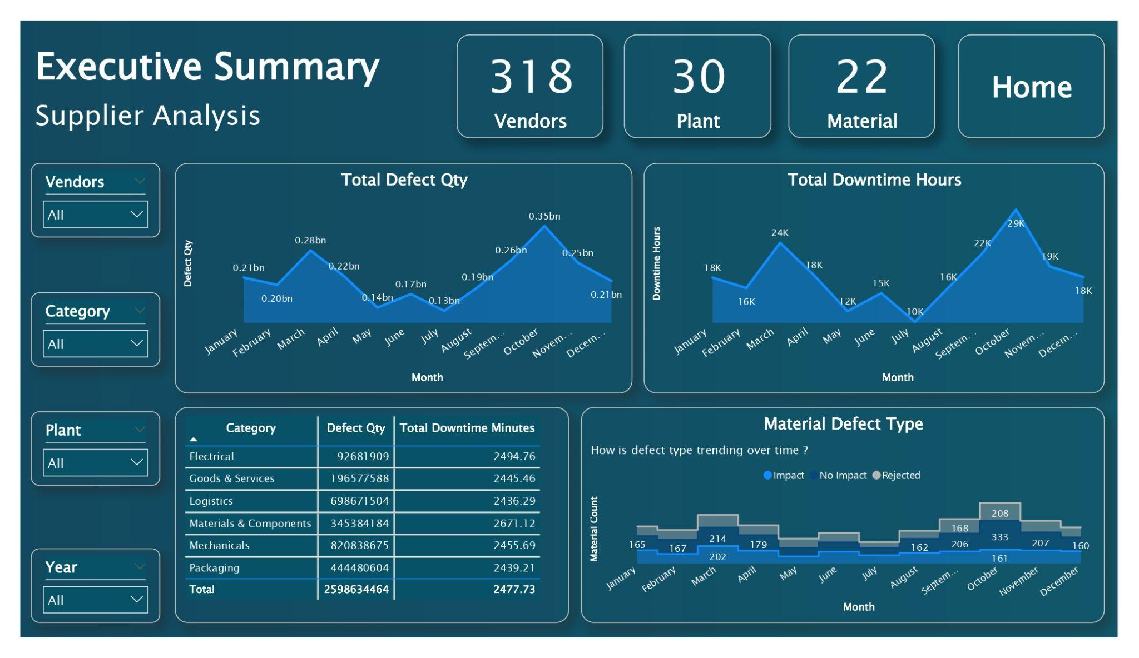

Figure 1.1.: Executive Summary of Suppliers

This report also addressed some of the questions like:

* What is the distribution pattern of defects across different plant locations?
* How do defect quantities vary on a monthly basis, and are there discernible trends?
* Which vendors demonstrate consistent high performance or exhibit deficiencies in defect management?
* What impact do different defect categories have on overall downtime hours?
* Are there specific material types significantly contributing to defect occurrences?
* How does the distribution of defect types impact operational downtime?
* What is the relationship between defects, material types, and their respective downtime hours?
* Which categories or types of defects exhibit a more profound impact on product quality?
* How does defect occurrence vary across different categories and plants?
* Are there specific periods or months exhibiting significant fluctuations in defect quantities or downtime hours?
* What are the key factors influencing defects and downtime within the manufacturing process?
* How can targeted improvements in quality control and vendor relations optimise operational efficiency and reduce defects?

These insights serve as a basis for making well-informed decisions, allowing stakeholders to implement specific enhancements, strengthen quality standards, and reduce operational interruptions in the industrial sector.

## Key Findings

One of the key findings are mentioned below:

The number of categories are varying significantly across different plant locations, ranging from 62 to 92. On an average the number is 78 that means there are 78 categories. This indicates a diverse distribution in the occurrences of these categories across various locations. Locations such as Bloomingdale, Charles City, Chesaning, Clarksville, Climax, Henning, Hingham, Riverside, Twin Rocks, and Weaverville have relatively higher counts, all ranging between 84 and 92. Barling, Bruce Crossing, Charlevoix, De Ruyter, Frazer, Garwood, Jordan Valley, New Britain, Prescott, Ripton, Savannah, and Waldoboro locations have a number of categories ranging from 72 to 83. And finally the lower number of categories are 62 to 68 and their locations are Clay, Cottonwood, Florence, Middletown, Reading, and Westside.

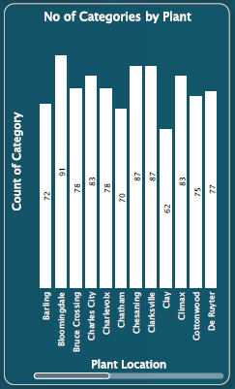

Figure 1.2.: Number of categories by plant

## Conclusions & Recommendations

Some of the conclusions are:

* The performance of vendors has a substantial influence on the frequency of defects. Vendors with higher defect rates have a significant impact, highlighting the need to develop better alliances, establish strict quality standards, and promote ongoing improvement efforts.
* The study unveiled diverse patterns of downtime over different months, emphasising periods of heavy activity and periods of consistent operational performance. These observations highlight the necessity of flexible operating tactics to adjust to changing demands and reduce extended periods of inactivity.
* Materials such as 'Corrugate' and 'Raw Materials' are notable for their significant numbers of defects. Implementing stringent quality control measures and optimising the supply chain for these materials may effectively minimise flaws and improve the reliability of the product.

Some of the recommendations are:

* Utilise a methodical approach when dealing with high-defect materials such as 'Corrugate' and 'Raw Materials.' To decrease the occurrence of faults related to these materials, it is advisable to establish strong inspection standards, conduct vendor audits, and implement supplier diversification methods.
* Analyse the operational trends seen during months of reduced defects, such as May and July, and replicate those techniques consistently throughout the year. Examine the methods, quality control measures, and manufacturing techniques employed during these time periods in order to improve overall efficiency.
* Implement focused quality control initiatives, specifically targeting categories such as 'Mechanicals' and 'Materials & Components,' which are prone to frequent faults and prolonged periods of inactivity. Enforce rigorous inspection methods and implement process improvements to reduce flaws in crucial areas.

# **Report Body**

## Introduction

In an era of data, the ability to extract insightful information from huge datasets has become a big task for operational excellence and product quality assurance mainly in the businesses who were supplying the products. This study presents a thorough analysis performed on a large dataset using Business Intelligence tools and methods to understand the complex patterns of defects, trends in downtime, and their effects on operational efficiency at various plant sites.

***Contextualising the Analysis:***

The dataset being examined reveals a complex network of information that showcases the complicated relationship between the frequency of defects, the locations of plants, the performance of vendors, and the types of materials. Upon further examination of this repository, the analysis reveals interesting patterns and trends that emphasise the complex nature of processes inside the context being studied.

***Navigating the Report:***

This paper explores a comprehensive examination of data, utilising powerful technologies including Power BI, M Query transforms, and DAX language measurements. The objective is to extract practical observations from unprocessed data, revealing areas that require improvements in quality control, operational efficiency, and strategic allocation of resources.

## Data Source

The dataset consists of interrelated features which are sourced from Kaggle named [Supplier dataset](https://www.kaggle.com/datasets/bhavyapriyan/supplierchallenge) that are essential for a full study in the manufacturing field. The Supplier Quality data includes important elements such as Date, Vendor, Plant Location, and categorical parameters like Category, Material Type, Defect Type, and Defect. The information accurately correlates the Total Defect Quantity and Total Downtime Minutes, providing a comprehensive perspective on operational difficulties.

The collection is interconnected using distinct IDs, allowing for a comprehensive analysis of defect incidents, including their categories, kinds, materials, and locations. This linked dataset provides a thorough basis for analysing the complexities of errors, their many forms, and the effects they have on operational downtime in different plants and categories. It is crucial for making informed decisions and optimising processes in manufacturing operations.

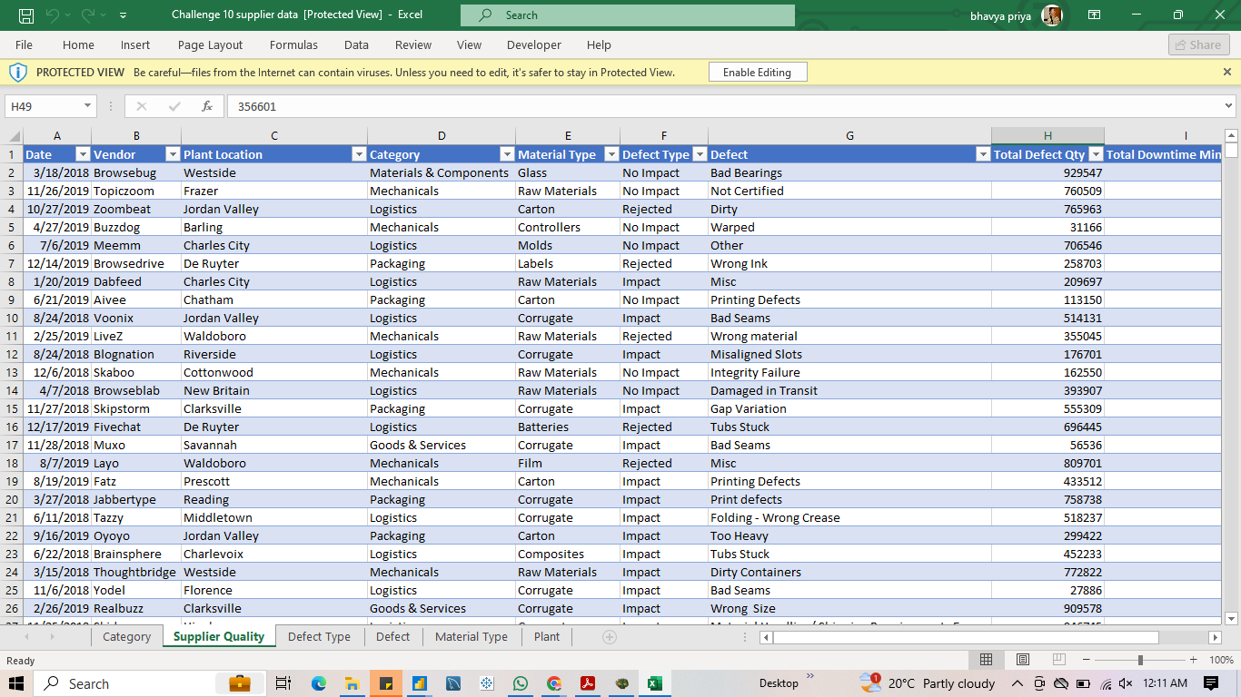

Figure 2.1.: This is master table supplier quality

# **Power BI Requirements**

Should acquire a profound comprehension of the dataset's organisation, connections between entities, and the significance of each characteristic. Should understand the data before proceeding into any analysis. This entails examining the data dictionary or schema in order to properly grasp the context of the data. Proficiency in utilising technology Power BI for data cleansing, transforming for visualisation and analysis is advantageous.

# **BI Design**

## Data preparation using M Query

Every data is not clean for analysis so it is mandatory to preprocess and clean the data for the analysis, the data preparation includes clearing null values, imputing null values, renaming the columns to understand it better etc.

The below are the M Queries which involves in the preprocessing of the data:

= Table.SelectColumns(#"Changed Type",{"Vendor"})

* This step selects the vendor column alone, it means remove all columns except vendor to create a dim table.

= Table.Distinct(#"Removed Other Columns")

* This step will remove all the duplicate rows in the columns to keep them as a primary key.

= Table.AddIndexColumn(#"Removed Duplicates", "Index", 1, 1, Int64.Type)

* This step adds an index column to the table that’s how the primary key has been generated.

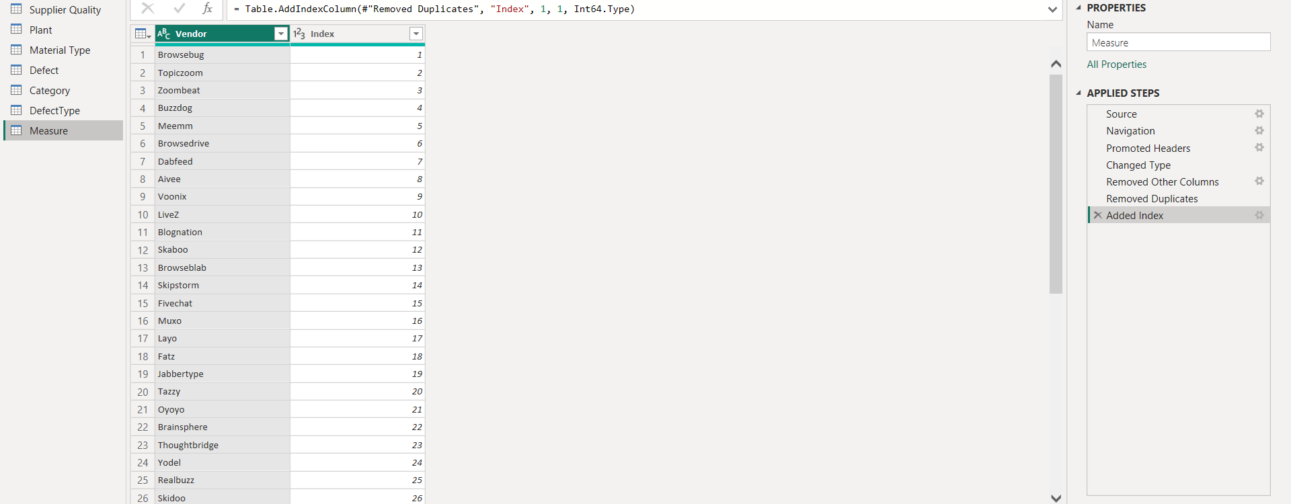

Figure 4.1.: Creation of vendor dimension table.

From the below steps using this dim table the supplier quality will merge the primary key and foreign key where it has a connection.

**= Table.NestedJoin(#"Changed Type", {"Vendor"}, Measure, {"Vendor"}, "Measure", JoinKind.LeftOuter)**

* This step performs a join operation between the two tables fact table supplier quality and measure
* It joins these tables based on the vendor column from the supplier quality and vendor table.
* The resulting column from the measure table is renamed as measure.

**= Table.ExpandTableColumn(#"Merged Queries", "Measure", {"Index"}, {"Measure.Index"})**

* This step expands the measure column that was created above, which contains a nested table.
* It especially expands the index column from the nested table to create the foreign key.

**= Table.RemoveColumns(#"Expanded Measure",{"Vendor"})**

* This final step removes the vendor column from the table obtained after expanding the measure column.

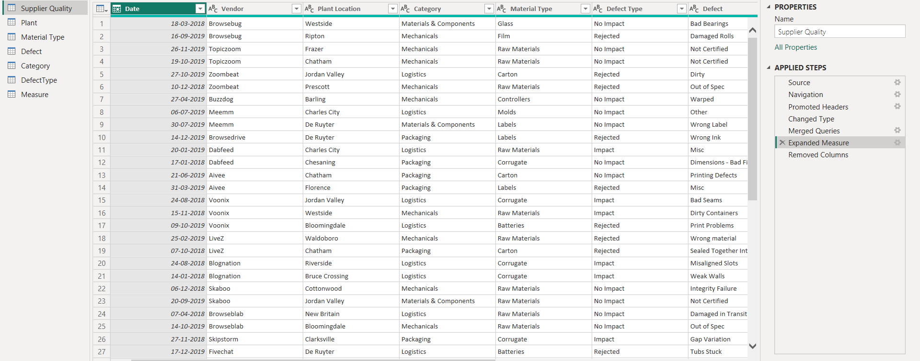

Figure 4.2.: Merging the columns to create a connection

This is the final star schema where the fact table is connected with all the dimension tables like defect, category, measure, plant, material type, defect type. All the dimension tables have the ID column which is connected to the supplier quality table.

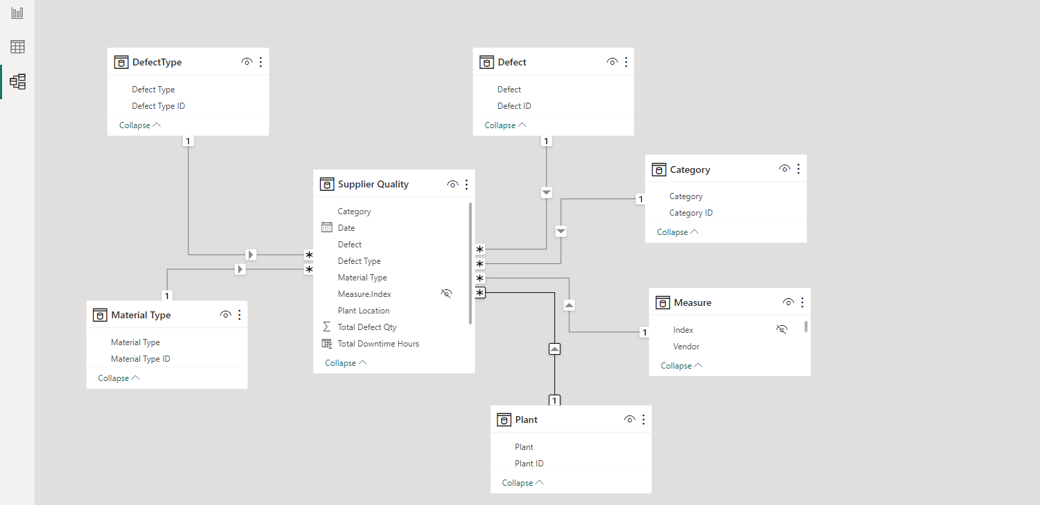

Figure 4.3.: Star Schema of the final data

## Data preparation using DAX

**Total Downtime Hours = ROUND(('Supplier Quality'[Total Downtime Minutes]/60),1)**

This measure will create total downtime hours using the downtime minutes, by dividing it by 60, which will give how many hours have been taken for the downtime.

**material = DISTINCTCOUNT('Material Type'[Material Type])**

This measure will give the number of materials in the data which is used to know the count of materials there.

**plant_cnt = DISTINCTCOUNT(Plant[Plant])**

This measure gives the number of plants the supplier has. This will give some overview of the capacity of the supplier.

**total_defect_qty = SUM('Supplier Quality'[Total Defect Qty])**

This measure gives the total sum of the defect quantity where it will give some understanding about the number of products which are getting defected and further categorical analysis can be made using this measure to know the patterns and where they are getting defected, it can be used for taking any necessary decisions based on the categories.

**vendor_cnt = DISTINCTCOUNT('Measure'[Vendor])**

This measure will give the count of vendors in the

**year = YEAR('Supplier Quality'[Date])**

This DAX function will extract the year from the date column, which is used to do the analysis based on year more easily than going with date hierarchical mode to fetch the year.

# **Findings**

## Monthly Defect Quantity Overview

The chart displays the total defect quantity by month. The y-axis represents the sum of defect quantity, while the x-axis shows the months of the year. After analysing the data, a distinct pattern shows that there is an apparent increase in defect numbers in the later months of the year. With 346,062,418 being the largest total defect quantity, October is clearly the peak month. The rise in defects observed in the latter half of the year may be an indication of higher production needs, pressures associated with the end of the year, and the other external variables impacting the manufacturing process.

The mid-year months, especially May and July, on the other hand, show a decrease in defect amounts. Defects are recorded at 137,022,239 in May and 128,701,309 in July. This could indicate that during these months, there was an improvement in quality control, production procedures were improved, and a combination of these factors contributed to a drop in defects. Gaining insight from an understanding of these times of reduced defect amounts can be beneficial.The data also shows that defect quantities were stable in the first few months of the year, with values that were mostly unchanged from January to March. The number of defects in March is slightly higher than in the previous months 283,354,436, indicating the need for more research into potential causes of this increase.

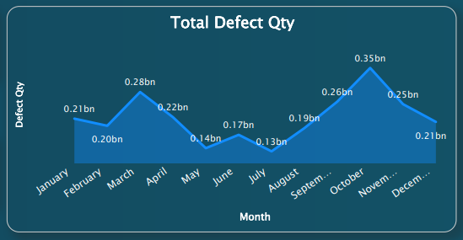Figure 5.1.:Monthly Defect Quantity Overview

## Monthly Total Downtime Hours Analysis

This chart, "Monthly Total Downtime Hours Analysis," analyses the total number of downtime hours in each month to provide a thorough over the course of the year.When the data is examined, a clear pattern emerges, with October having the most total downtime hours at 29,209.2. It indicates a major annual impact or increased operational demands during that particular month. Understanding the times of high demand is critical for organisations to correctly allocate resources and implement methods that reduce disturbances during high months.

May and July, on the other hand, have significantly a smaller amount of total downtime hour 11,860.2 and 10,039.8 hours, respectively. This decrease in downtime in the middle of the year points to a possible time of increased efficiency or operational stability. The elements that contribute to reduced downtime in these months may reveal the best practices that could be applied more regularly all year long.

With a total of 17,690.6 hours, December's total downtime hours are significantly lower than those of the previous months. This decrease raises the possibility of putting more of a focus on year end maintenance and planning, which would increase operational effectiveness as the year comes to an end.

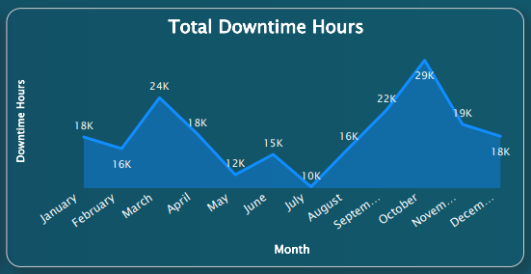Figure 5.2.:Monthly Total Downtime Hours Analysis

## Downtime Analysis by Category: Impact of Defects on Operations

This chart shows the total number of downtime minutes and the defect quantity for each category .In the Mechanicals category, which has a defect quantity of 820,838,675 and indicates a high frequency of mechanical problems in the system. Likewise, the Materials & Components category has the longest total downtime minutes 2,671.12 despite having a lower defect quantity 345,384,184. It is possible that these kinds of defects could result in longer durations of system outages or lower productivity.

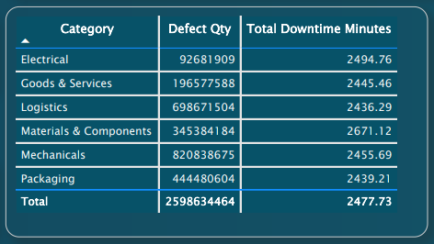

Figure 5.3.:Downtime Analysis by Category: Impact of Defects on Operations

Comparatively, the total downtime minutes for Logistics is 6986,671,504 and for Goods & Services is 196,577,588, with defect quantities of 698,671,504 and 196,577,588, respectively. Even though the numbers of defects are different, these two categories' effects on system downtime are essentially similar.92,681,909 defects and 2,494.76 minutes of total downtime are displayed in the Electrical, indicating a moderate impact. Similarly, the Packaging endures 2,439.21 total downtime minutes, indicating a moderate effect on system performance, with a defect quantity of 444,480,604.

## Monthly Distribution of Defect Types

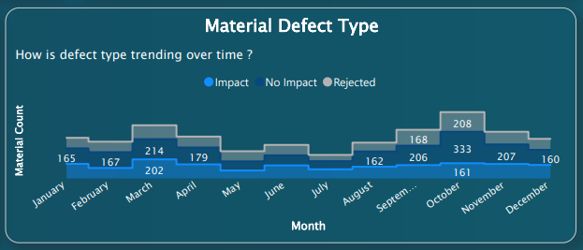

Figure 5.4.:Monthly Distribution of Defect Types

This chart shows the monthly distribution of defect types with each category as Impact, No Impact, and Rejected, and their corresponding material counts.Impact total defects was 154, No Impact total defects was 165, and Rejected total defects was 111 in January totally, this is a fairly balanced total for defect types. October is notably having a higher number of No Impact defects 333 .This may indicate that the manufacturing procedures were improved and altered during that particular month.

The Impact defect counts were differ at reaching their highest point with 202 in March and then again with 161 in October. Such highs could indicate specific difficulties during those months. It shows the need for a more thorough analysis and focused quality-improvement efforts Like the Rejected defects, these also show changes, with a notable high of 208 in October. This increase could be a sign of a commitment to maintaining product standards, indicating a tougher rejection criteria during quality control procedures.

## Distribution of Components Across Vendors, Plants, and Materials

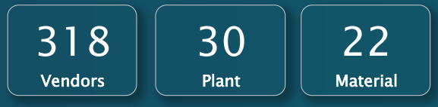

Figure 5.5.: Distribution of Components Across Vendors, Plants, and Materials

This KPIs shows the distribution of component resources in Vendors,Plants and Materials. The Vendors have the count of 318 after that Plant have the count of 30 and Material have the count of 22.

## Total Defect Quantity by Material Type

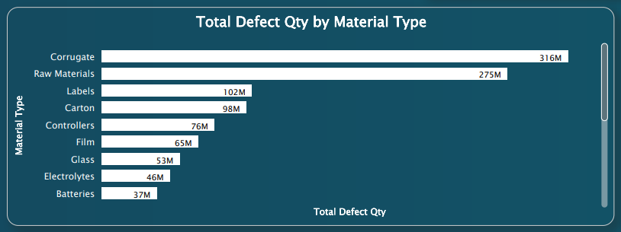

Figure 5.6.: Total Defect Quantity by Material Type

This chart shows an analysis of the total quantity of defects in each of the different material types.

Corrugate and Raw Materials Defect Quantity: The two materials with the largest total defect quantity are corrugate and raw materials corrugate with 315,722,484 and raw materials with 274,714,661 . It also indicates that problems with these kinds of materials account for a large portion of the total defects, highlighting the importance of serious inspection and quality control and use of these materials.

Significant Defects in Labels and Carton Materials: The total defect quantity for labels and carton materials are also high, at 101,559,984 and 97,782,281. These components, which can be related to packaging and product information, require special consideration to ensure the end product's quality and dependability.

Critical Components with High Defects:Glass, Film, and Controllers are components with considerable defect quantities such as 76,356,134, 65,320,899, and 52,784,694. Correcting flaws in these materials is critical to maintain the usability and quality of the product because these elements are essential to many different industries.

Various Defects in Mechanical and Technical Components:A variety of defect quantity is displayed by mechanical parts like pumps, drives, motors, moulds, hardware, and valves. Some have a relatively lower quantity of defects than others, such as motors and valves, and others, such as moulds and hardware, have moderate amounts of defects. The requirement for focused quality control procedures targeted to particular material kinds and component types can be seen by this variation.

Low Defects in Tape and Packaging Materials:The total number of defects in tape and packaging materials is comparatively low. Tapes have 1,600,926 numbers and packaging materials have 10,196,664 numbers. Although these quantities are smaller, it is still important to remain aware in order to avoid any possible effects on the total quality of the end result.

## Total Defect Quantities by Vendor

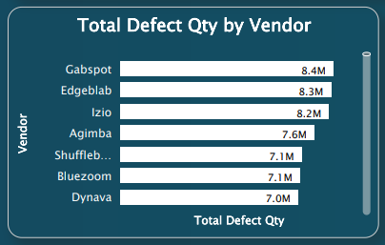

Figure 5.7.: Total Defect Quantities by Vendor

This chart shows the total defect quantity by vendor and each vendor is listed alongside with its corresponding sum of total defect quantity into their respective performance in terms of product quality.

Hubspot has reported 8,400,116 defects, so it is the vendor with the highest total defect quantity. This implies that in order to address and correct existing defects, products received from Hubspot might need to be analysed more closely and given quality control processes. Edgeblab and Izio come in second and third place with 8,299,429 and 8,214,940 defects. Those vendors also show a major impact on the total number of defects, which shows that their supply chains require comprehensive quality assurance ways.Vendor defect quantity is gradually decreasing, with the lower-ranking vendors showing slowly fewer defects. Even vendors with comparatively low defect counts in Zoomdog. It has 202,273 defects that show the value of constant quality control preserving product integrity.

## Total Defect Quantities Across Different Plants

This chart shows the total defect quantity with across different plants ,with various plants analysis,

Hingham has the highest defect quantity at 50,883,947, followed by Henning has the second highest at 48,137,061, and Clarksville at 44,245,731. These numbers show a critical need to focus on improving the processes and correct actions in these high defect plants.

Chesaning and Frazer, with defect quantities of 43,528,419 and 43,507,819, come into the mid range. Analysing the specific defect types and their patterns over time can help the targeted analysis to enhance quality and reduce defects in these plants.

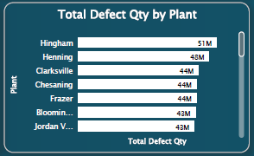

Figure 5.8.: Total Defect Quantities Across Different Plants

Plants like Bloomingdale (43,118,199), Jordan Valley (42,692,602), and Charles City (42,248,392) also had similarly significant defect quantities, with a detailed analysis of manufacturing to identify areas for improvement.

Weaverville (42,151,083), Riverside (41,578,795), and De Ruyter (40,463,481) maintain moderate defect quantities, showing a need for notable improvement efforts to ensure consistent product quality.

On the lower end, plants such as Florence (31,268,565), Middletown (31,253,093), and Reading (30,481,440) demonstrate relatively lower defect quantities, suggesting effective quality control measures or successful process optimization.

## Defect Distribution by Category and Type

The chart shows how defects are distributed among various categories and types, with areas in need of extra care in terms of quality control. With the total defects of 156,246,335 in Logistics and also with the highest total defect quantity. No Impact defects exceed Rejected and Impact types in the Mechanicals section, with 149,935,039 as their total. This indicates that mechanical defects might not have a visible impact on the end result, they still cause an important portion of all defects, leading to the need for a closer inspection of mechanical parts and their production processes.

Materials and Components show 132,396,020 "No Impact" defects in total, which indicates there is possibly room for change in the sources and production of those components. In this category, there are a lot of Rejected defects with 15,200,669, which indicates that more effective quality control procedures are needed to decrease defects to product combinations.

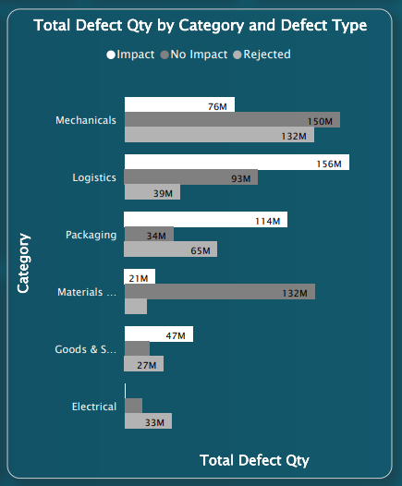

Figure 5.9.:Defect Distribution by Category and Type

There are a large number of Impact defects in the Packaging category with 113,530,422 which highlights the need to deal with problems in packaging supplies and procedures. Also, the fact that packaging contains 64,671,635 Rejected defects shows how important it is to improve packaging standards in order to prevent faults and warranty product quality.

The Goods and Services category, Impact defects are prevented at 47,374,983, indicating that the issues related to the goods and services which have a direct impact on the product quality. The chart shows that improvement in this category may influence the overall product quality.

## Distribution of Items Across Different Categories

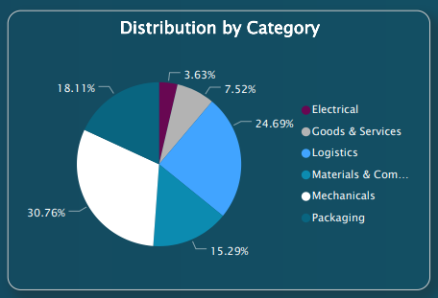

Figure 5.10.:Distribution of Items Across Different Categories

This chart shows an overview of the items across different categories, which shows how items are distributed among various categories . such as Mechanicals has the highest count of 720 and it indicates an important amount of mechanical products and components. Logistics has the second highest count of 578 a lot of logistical components and goods. The chart variety is enhanced by the 176 and 424 items found in the products and Services and Packaging categories. The Materials & Components category has 358 products, showing the variety and value of materials and components. Likewise, the Electrical category has the lowest count of 85 representing a comparatively smaller representation of electrical components and products .

## Downtime Hours by Material Type and Defect

The chart of downtime for various material types and defect categories provides important information for improving work. Corrugate defects, especially those with an indication of Impact add an important amount of downtime of 13,916.9 hours. The large downtime for raw materials is 14,039.3 hours and for No Impact defects as well as 6,530 hours for Rejected defects. It highlights the importance of careful quality control in their use.

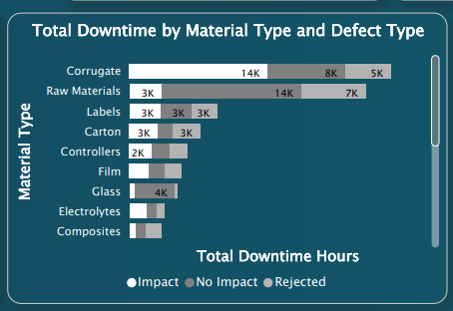

Figure 5.11.:Downtime Hours by Material Type and Defect

Carton defects mainly in the Impact types and labels cause major downtime hours of 3,217.4 and 2,848, respectively with the need for dealing with issues with these components. Targeted quality control measures are required at 2,243.5 and 2,017.4, as significant downtime hours are caused by controllers and film defects, especially Impact types. A lot of defect types are seen in composites and moulds, which increases downtime. calling for concentrated effort in quality assurance.

Defects in electrolytes, including Impact and No Impact types, cause major downtime at 1,790.5 and 1,011.8 hours, showing the necessity for improved quality control procedures. This wide variation in downtime hours within material types highlights the significance of customised quality management strategies for every category, directing successful tactics to decrease delays while improving overall efficiency.

## Total Downtime Hours by Defect

Ths chart provides a sum of Total Downtime Hours by Defect with various production defects,"Bad Seams," responsible for 9955.4 hours of downtime, is the greatest cause. It means that there's a sudden requirement to look into and Bad Seams quality issues. Focusing on the value of resolving in complete in the manufacturing process, "incomplete" products follow closely behind with 4459.7 hours of downtime. The 3941.5 hours of downtime caused by "Out of Spec",the need to follow product specifications in order to maximise efficiency.

"Foreign Material" at 3592.7 hours shows the value of better quality controls and the impact that material quality has on production delays. The "Warped" and "Warping" defects are considered at 2983.2 and 2415 hours, showing issues that need to be addressed in the manufacturing or storage processes. "Gap Variation" at 2307.8 hours indicates how crucial it is to minimise variances in order to improve product consistency.

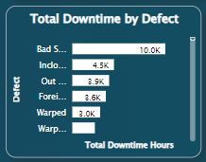

Figure 5.12.:Total Downtime Hours by Defect

## Total Downtime Hours by Vendor

This chart shows the information regarding the total number of hours of downtime given to various vendors and gives light on the various kinds of downtime connected to each vendor With 752.2 hours of recorded downtime, Izio has the greatest amount of downtime that could have an effect on a stable operation. Just remaining Edgeblab and Agimba has a record of 750.5 and 674.8 hours of downtime indicating lengthy periods of non-operation.

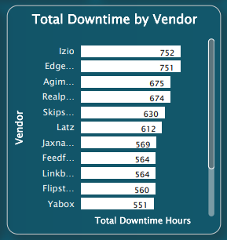

Figure 5.13.: Total Downtime Hours by Vendor

The importance of handling issues with these vendors is seen by the 674 and 629.6 downtime hours that Realpoint and Skipstorm both have, respectively. The downtime hours of Latz, Jaxnation, Feedfire, Linkbridge, and Flipstorm are between 611.5 and 560.3, which indicates moderate effects to their services.Yabox, Bluezoom, Topic Lounge, Blognation, and Browse Drive show a downtime hours between the 550.6 and 537.3,and showing a bit smaller but still significant effect on operational effectiveness. With significant downtime, organisations should assess and improve their relationships with vendors in order to improve overall operational efficiency. This chart emphasises the significance of vendor performance and reliability.

## Downtime Hours Distribution by Defect Type

This chart shows an extensive overview of the effects of defects on vendors given by the data on downtime hours distributed by defect types. Defects classified as No Impact caused the largest total of downtime hours with 38,554.7 hours. These defects greatly increase downtime while they have no direct impact on the final product, which highlights the importance of giving focus on non-impactful problems for overall efficiency.

Impact defects come in second highest, resulting in 33,245.1 hours of downtime, showing that defects that directly affect the end product have an important effect on the continuity of operation. Defects that are rejected have a 24,800.6 hours of downtime, which highlights how critical it is to fix and reduce defects before they get to the end of production.

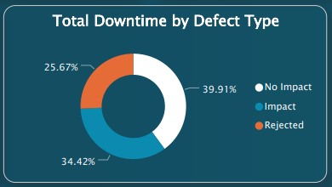

Figure 5.14.: Downtime Hours Distribution by Defect Type

The division of downtime hours by defect type shows a variety of operational difficulties, which calls for a comprehensive approach to defect management and quality control across a range of defect categories in order to reduce downtime and increase overall productivity.

## Total Downtime Hours by Category

This chart shows the important insights into the production areas that are most affected by disruptions from the total downtime hours data that is separated by various operational aspects. The category Mechanicals has the highest total downtime hours of 29,375.2, showing that difficulties with mechanical parts and procedures are a major cause of operational delays.

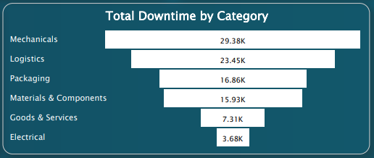

Figure 5.15.:Total Downtime Hours by Category

The Logistics category comes in second highest with 23,449 downtime hours, showing the effect of logistical issues on general production stability.It is valuable to look into issues in the Packaging and Materials & Components categories to reduce delays, and they indicate a 16,858.5 and 15,927.1 of downtime hours, In order to improve productivity, particular attention must be given to the Goods & Services and Electrical categories, which have relatively lower downtime hours of 7,312.4 and 3,678.2 hours.

## Total Downtime Hours for Various Plants

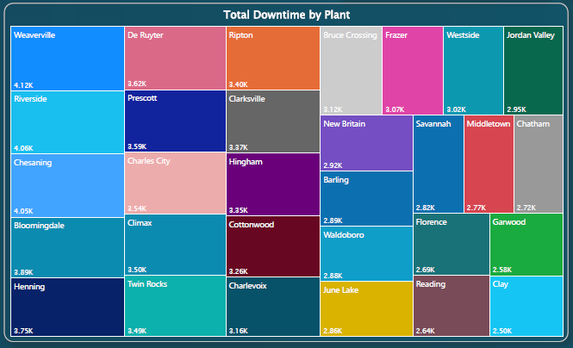

Figure 5.16.:Total Downtime Hours for Various Plants

The below are the Top 20 plants which has more total downtime hours:

* Weaverville (4116.7 hours): Has the highest total downtime hours among the listed plants, shows possible operational difficulties and problems that require fixing.
* Riverside (4064.9 hours): It was close to Weaverville in downtime hours, showing another plant with notable impacts to operations.
* Chesaning (4052.9 hours): Similar to Riverside and Weaverville, this plant also experiences a substantial amount of downtime.
* Bloomingdale (3893.1hours): Bloomingdale has less downtime than the top three, but it's still considerable, so the reasons should be looked at more.
* Henning (3749.5 hours): Has a Fall in the mid-range for downtime hours, showing a moderate degree of impact with operations.
* De Ruyter (3621.1 hours): Similar to Henning, it also experiences a moderate amount of downtime.
* Prescott (3592.9 hours): Comes within the category of plants that have a moderate amount of downtime and need maintenance to increase efficiency.
* Charles City (3535.9 hours): Another plant with a moderate level of downtime, indicating potential areas for operational improvement.
* Climax (3500.3 hours): Similar to Charles City, comes in the mid-range for downtime.
* Twin Rocks (3493.1 hours): Continues the trend of plants with moderate downtime.
* Ripton (3401.9 hours):Even though it's lower than some, it still indicates a notable amount of downtime that requires attention.
* Clarksville (3367.8 hours): Comes within the mid-range for downtime hours.
* Hingham (3347.2 hours): Another plant with a moderate level of downtime, indicating potential areas for improvement.
* Cottonwood (3257.1 hours): Below the mid-range but still substantial, shows potential operational challenges.
* Charlevoix (3164.6 hours): Experiences a notable amount of downtime, requiring attention to improve operational efficiency.

This pattern continues with other plants experiencing various degrees of downtime.

# **Conclusions and Recommendations**

Analysis of defect quantity trends reveals that the highest incidence of defects are observed in the latter months, indicating probable operational strain or heightened production demands. The months in the middle of the year show a decrease in faults, suggesting that there have been improvements in quality control procedures.

An analysis of the impact of categories reveals that the Mechanical and Materials & Components categories have longer periods of downtime, although having lower counts of defects. This highlights the need for more extensive quality control procedures.

**Operational Improvement:**

* By giving priority to implement the quality control upgrades in categories that have a high number of defects may increase a chance of reducing the defects in future.
* By enforcing uniform protocols during periods of high failure rates to ensure constant maintenance of quality.

**Resource Allocation:**

* By optimising operational efficiency by allocating resources for repair and analysis in facilities with significant downtime.
* By enhancing the connections with vendors by ensuring their constant delivery of high-quality performance.

**Continuous Improvement:**

* By implementing ongoing surveillance methods to detect patterns of defects and adapt quality control measures accordingly.
* By allocating resources towards the enhancement of personnel training and skill development in order to improve the quality assurance processes.

If the businesses implement these recommendations there are more chances to increase their profit in a short time.

# **Design of the Dashboard**

The below are the full snapshots of the dashboards which have navigation buttons from home to other pages and other pages to home to make it user friendly.

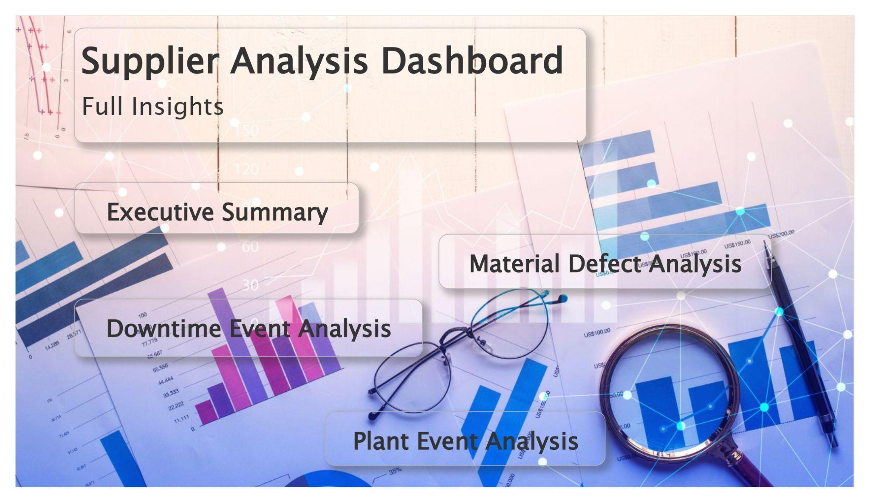Figure 7.1.: Home Page of Dashboard

****Figure 7.2.: Executive Summary

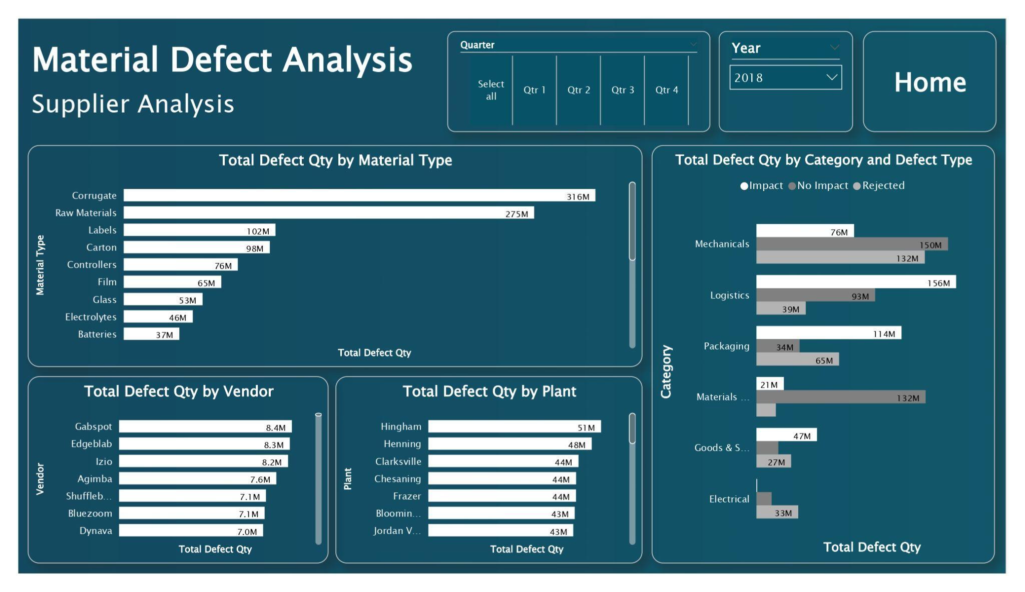Figure 7.3.: Material Defect Analysis

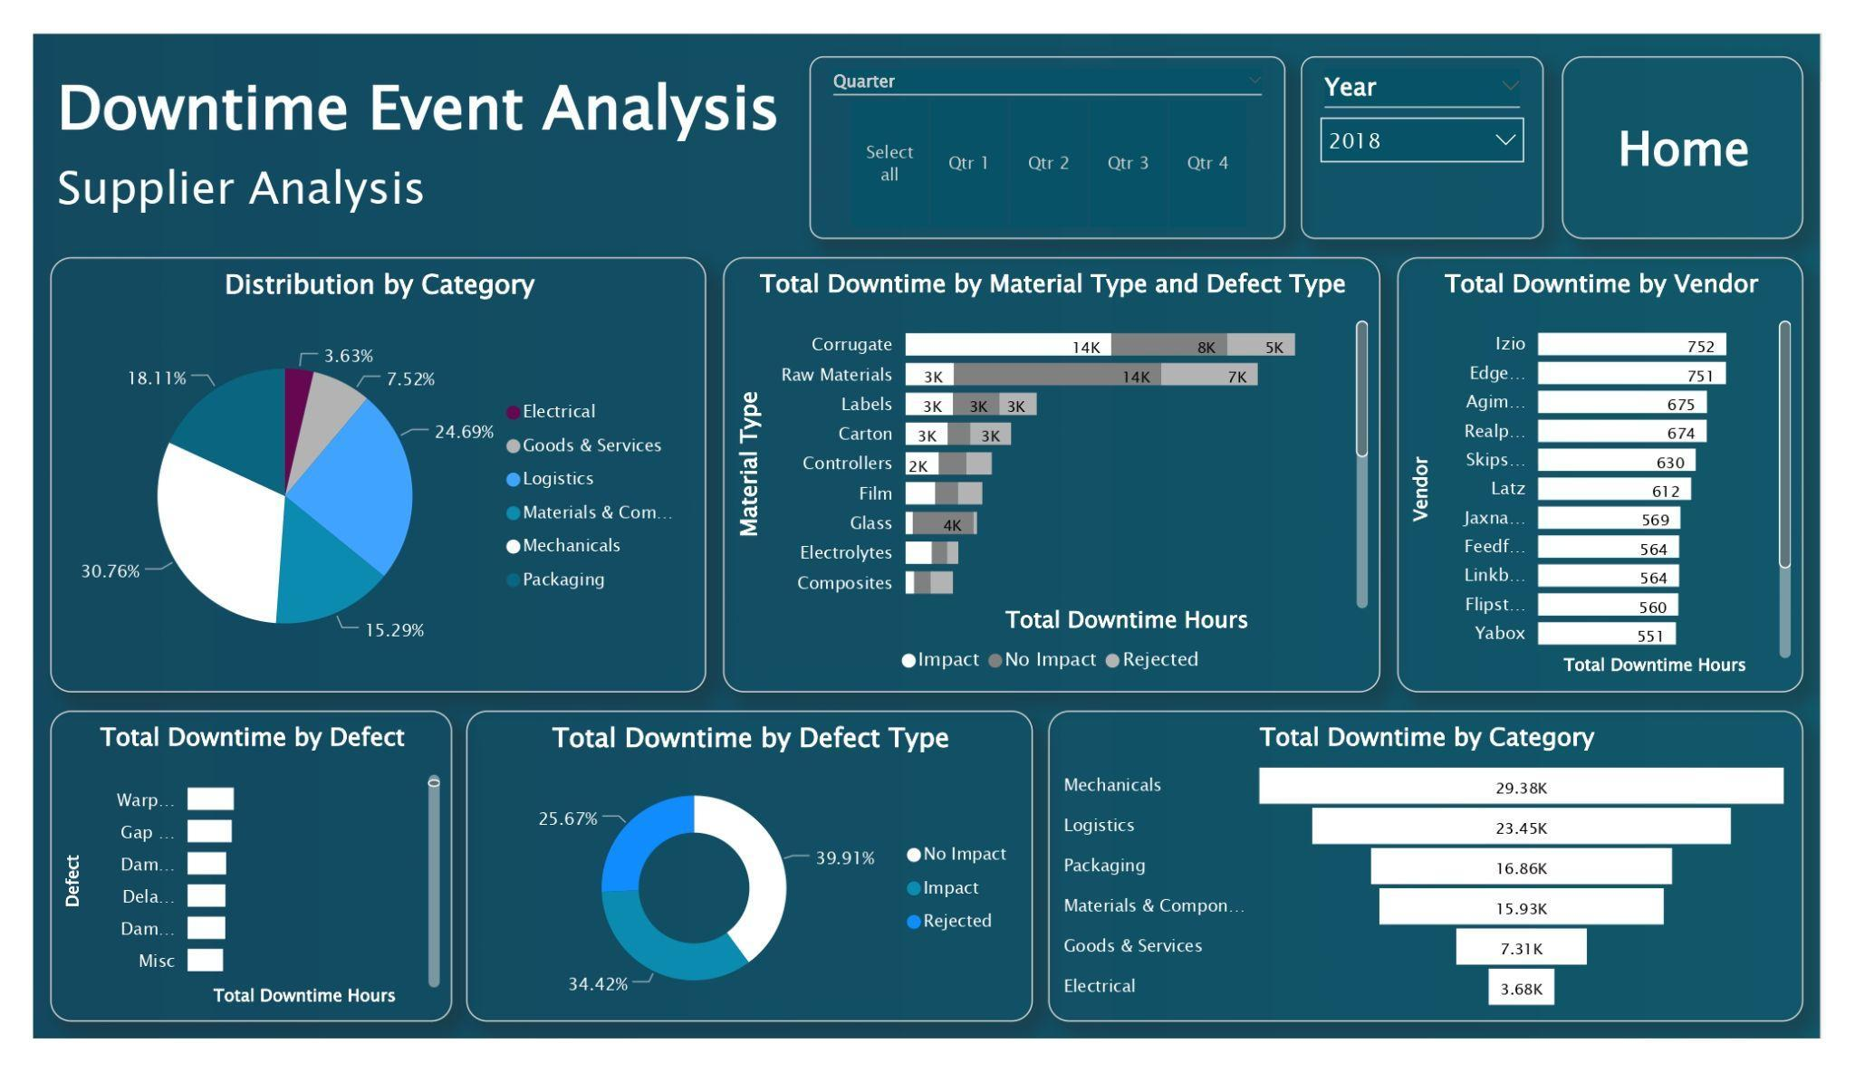Figure 7.4.: Downtime Event Analysis

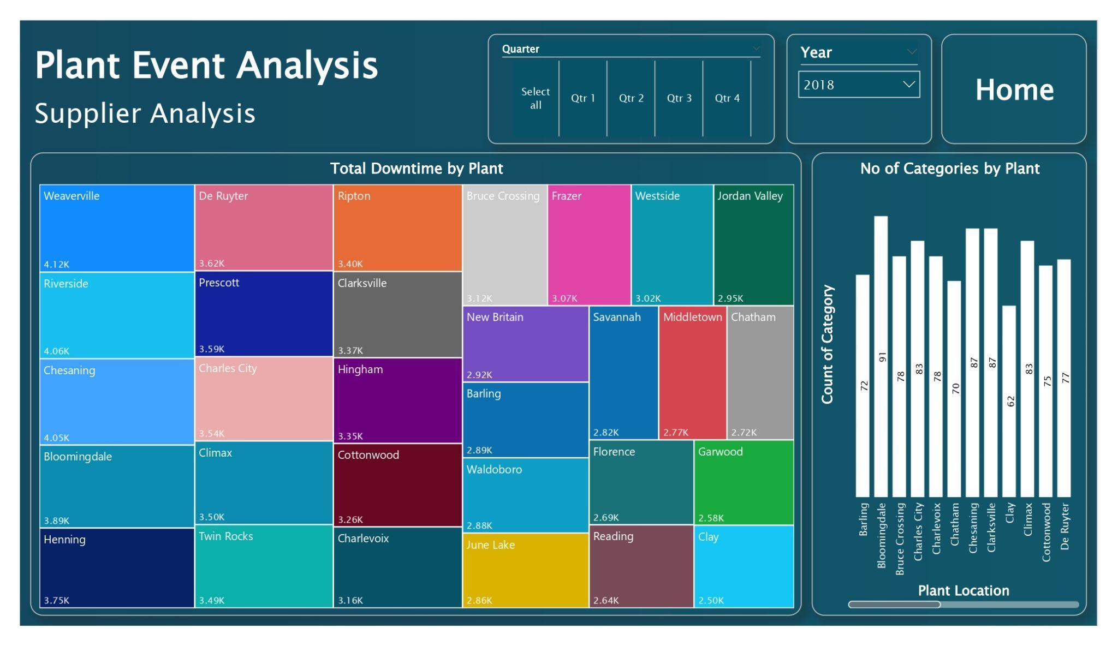Figure 7.5.: Plant Event Analysis

# **Self-Assessment Table**

| **Report Section** | **Description** | **Grade your work from 0 to 100** |
| --- | --- | --- |
| Report Structure | The document encompasses all essential divisions, with each component properly designated by pertinent titles and subheadings. | 94 |
| Data Pre-processing and Data Modelling | Data preparation is conducted to purify the data and remove any interference. The star schema is designed by integrating sub-tables produced from the core dataset. | 95 |
| Dax and M language | DAX computations are employed to deduce statistical estimations from the data. The M language is employed for converting measurements during the data processing. | 83 |
| Dashboard Design | A multi-page interactive dashboard is designed to display the user-friendly view of the dashboard. | 92 |
| **Average** |  | **Add below the average of the four cells above:**  **91** |