Maharashtra State Board of Technical Education, Mumbai

Micro-Project Report
On
“Online Shopping”
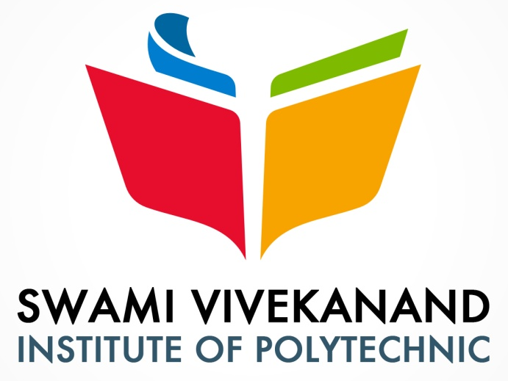
Submitted By
Miss. Muktai Vishwambhar Kodre

Subject Teacher
Miss. Kachare S.M.

In Fulfillment of
Diploma In Computer Engineering

2021-2022
Maharashtra State Board of Technical Education, Mumbai

J.S.P.M. Group of Institute’s
Swami Vivekanand Institute of Polytechnic


Computer Engineering Department

Certificate

This is to certify that, Miss. Muktai Vishwambher Kodre of Third Year Computer Engineering has completed the micro-project on “Online Shopping” for the fulfillment of the course work in Diploma in Computer Engineering. In this volume, they have submitted a satisfactory report in the academic year 2020-2021

Miss. Kchare S.M Mr. Patil S.
Subject teacher H.O.D.

Prof. Sakhare R. S.
Principal

ACKNOWLEDGEMENT

We offer our sincere and hearty thanks with a deep sense of gratitude to our subject teacher Miss. Kachare S.M. and HOD of Computer Department Mr. Patil S. S. for their valuable direction and guidance to our micro project, their meticulous attention towards our project without taking care of their voluminous work.
We are thankful to our Principal Prof. Sakhare R.S. for his encouragement towards our project. We are also thankful to our families and all friends for their support and encouragement towards our project.

Miss. Muktai Vishwambher Kodre

