**TASK**

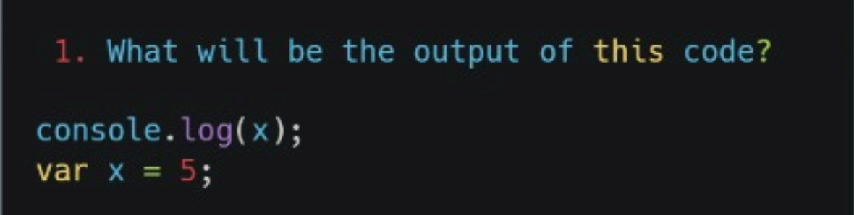

OUTPUT :

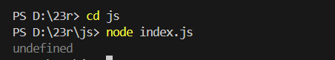

**Explanation :**

The code tries to print the value of **x** to the console. However, **x** is declared after the **console.log(x)** line. Because of this, JavaScript hoists the variable **x** but doesn't assign it a value yet, so **undefined** gets printed instead of **5**.

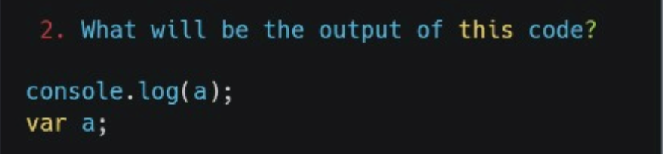

OUTPUT :



**Explanation :**

The code tries to print the value of **a** to the console. The variable **a** is declared but not given a value. In JavaScript, the variable is hoisted, so it exists but without a value, so **undefined** gets printed.

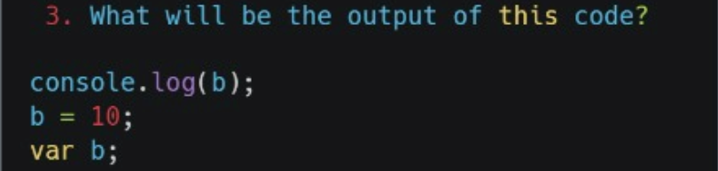

OUTPUT :



**Explanation :**

The code tries to print **b** to the console before assigning it a value. Since **b** is declared after the **console.log(b)** line but hoisted by JavaScript, it exists but without a value, so **undefined** is printed. After that, **b** is assigned the value **10**.

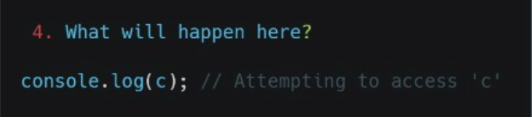

OUTPUT :

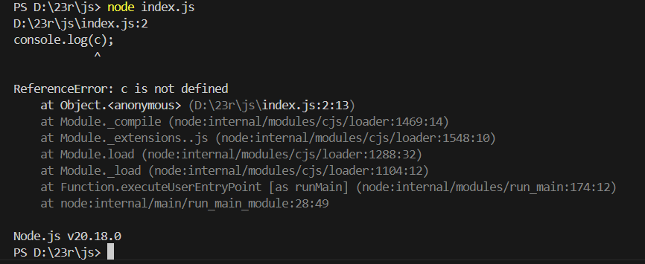

**Explanation :**

The code tries to print the value of **c** to the console. However, since **c** is not declared anywhere in the code, it will cause a "ReferenceError" because JavaScript doesn't know what **c** is. This means the code will stop with an error.

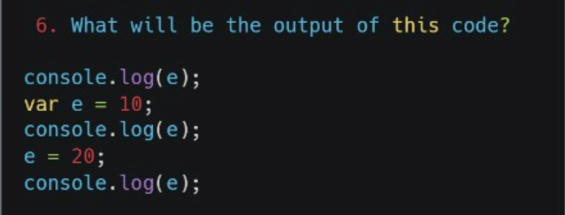

OUTPUT :

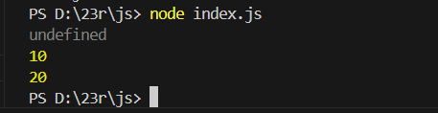

**Explanation :**

The code first tries to print **e** before assigning it a value, so it prints **undefined.** Then, **e** is assigned **10,** and the next **console.log(e)** prints **10.** Finally, **e** is changed to **20**, and the last **console.log(e)** prints **20.**

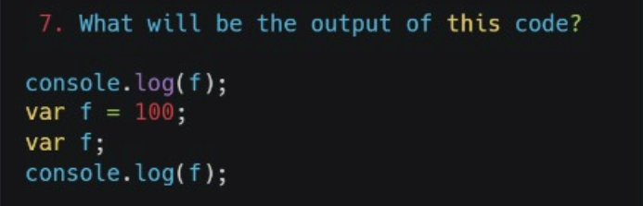

OUTPUT :

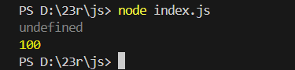

**Explanation :**

The code first tries to print **f** before assigning it a value, so it prints **undefined**. Then**, f** is assigned **100.** The second **Var f**; has no effect because **f** is already declared, so the second **console.log(f)** prints **100.**

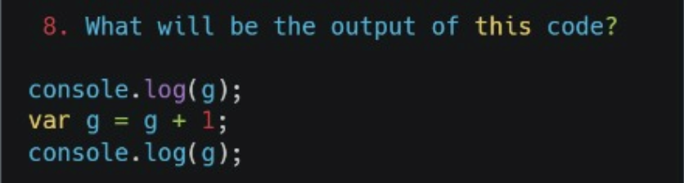

OUTPUT :

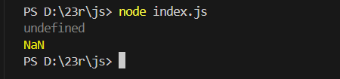

**Explanation :**

In the first line, you are trying to log **g** before it is defined, which causes an error.

In the second line, **var g** declares the variable, but you're trying to add 1 to g, which hasn't been set yet, so it's **undefined.**

To fix this, you should initialize **g** with a value before using it, like **var g = 0.**

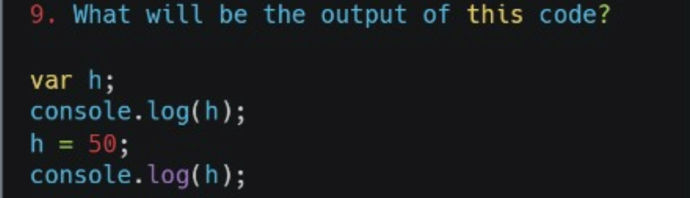

OUTPUT :

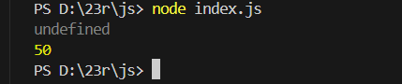

**Explanation :**

First, **var h;** declares a variable **h** without giving it a value, so it is **undefined.**

The first **console.log(h)** prints **undefined** because **h** has no value yet.

Then, **h = 50**; sets **h** to 50, and the second **console.log(h**) prints 50.

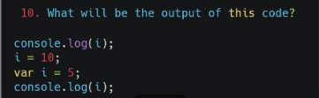

OUTPUT :

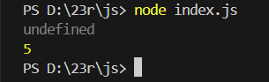

**Explanation :**

The code has some errors because of incorrect capitalization and declaration. The first **console.log(i);** prints **undefined** because **i** is not yet defined. After setting **i** to 10 and then declaring **var i = 5**;, the second **console.log(i);** prints **5**, which is the final value of **i.**