**TASK-3(Java Script)**

**1.**



**Code:**

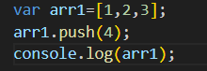

**Output:**



**Explanation:**

In this JavaScript code, an array arr1 is initialized with the values [1, 2, 3].

- The push(4) method adds the value 4 to the end of the array.

- console.log(arr1) outputs the updated array: [1, 2, 3, 4].

**2.**



**Code:**

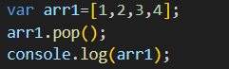

**Output:**



**Explanation:**

In this JavaScript code, an array arr1 is initialized with the values [1, 2, 3, 4].

- The pop() method removes the last element from the array, which is 4.

- console.log(arr1) outputs the updated array: [1, 2, 3].

**3.**



**Code:**

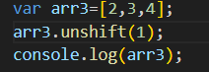

**Output:**



**Explanation:**

In this JavaScript code, an array arr3 is initialized with the values [2, 3, 4].

- The unshift(1) method adds the value 1 to the beginning of the array.

- console.log(arr3) outputs the updated array: [1, 2, 3, 4].

**4.**



**Code:**

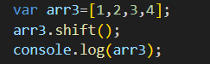

**Output:**



**Explanation:**

In this JavaScript code, an array arr3 is initialized with the values [1, 2, 3, 4].

- The shift() method removes the first element of the array, which is 1.

- console.log(arr3) outputs the updated array: [2, 3, 4].

**5.**



**Code:**



**Output:**



**Explanation:**

The join("") method in JavaScript concatenates all elements of the array into a single string without any separator. For arr5 = [1, 2, 3], it joins the numbers to form the string "123". The console.log() statement outputs "123" to the console.

**TASK-3.1(Java Script)**

**1.**

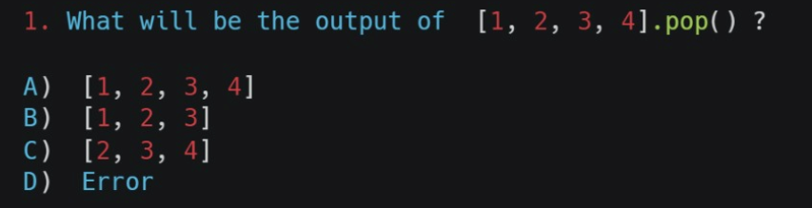

**Output:**

B.[1,2,3]

**Explanation:**

The .pop() method without any argument removes and returns the last element of the list. In this case, it removes 4, leaving the list as [1, 2, 3].

**2.**

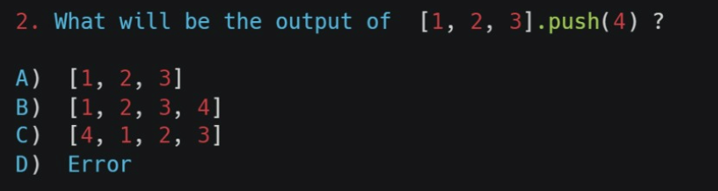

**Output:**

B.[1,2,3,4]

**Explanation:**

The push() method in JavaScript adds one or more elements to the end of an array and returns the new length of the array. Here, the array [1,2,3] gets updated to [1,2,3,4].

**3.**

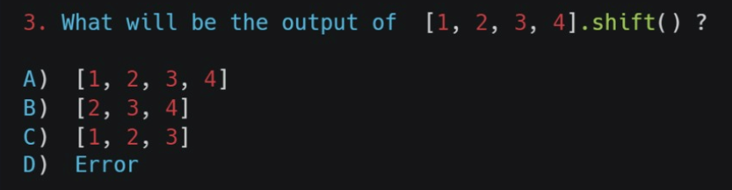

**Output:**

B.[2,3,4]

**Explanation:**

The shift() method in JavaScript removes the first element from an array and returns it. After applying shift() to [1,2,3,4], the array becomes [2,3,4].

**4.**

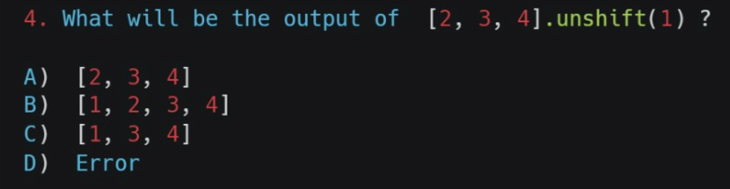

**Output:**

B.[1,2,3,4]

**Explanation:**

The unshift() method adds one or more elements to the beginning of an array. In this case, it adds 1 to the start of [2, 3, 4], resulting in [1, 2, 3, 4].

**5.**

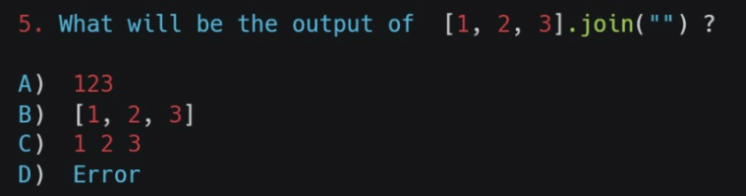

**Output:**

A.123

**Explanation:**

The join() method in Python concatenates elements of the list into a single string, using the specified separator. Here, the separator is an empty string "", so the list [1, 2, 3] will be converted to the string "123".