**TASK-5**

**1.**

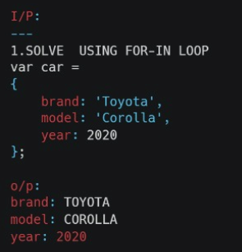

**Code:**

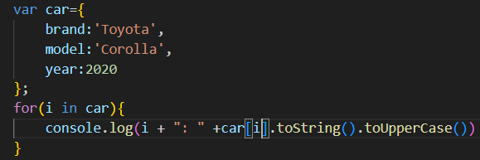

**Output:**

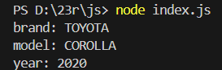

**Explanation:**

1. The for-in loop iterates over the properties (brand, model, year) of the car object.

2. Each property key and its corresponding value are printed, with the values converted to uppercase where applicable.

**2.**

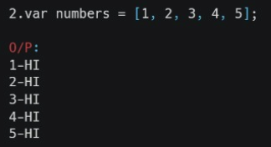

**Code:**

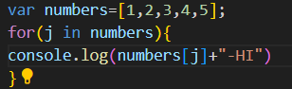

**Output:**

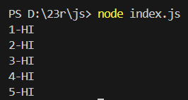

**Explanation:**

1. The loop goes through each element in the numbers array.

2. It prints the number followed by -HI for each element.

**3.**

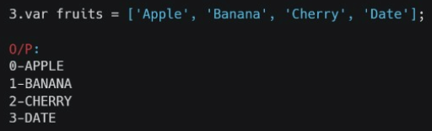

**Code:**

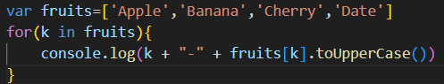

**Output:**

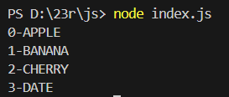

**Explanation:**

1. The for-in loop goes through each index of the fruits array.

2. It prints the index followed by the fruit name in uppercase.

**4.**

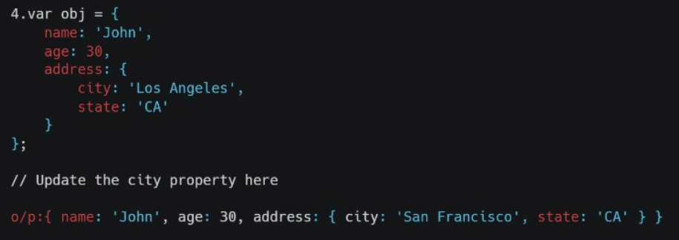

**Code:**

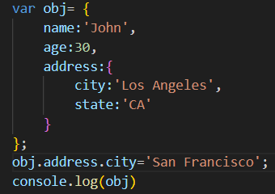

**Output:**

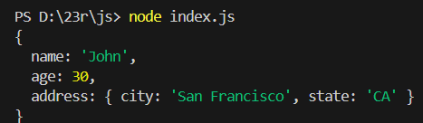

**Explanation:**

1. The object obj initially has the city property set to 'Los Angeles' within the address key.

2. The line obj.address.city = 'San Francisco'; updates the city value to 'San Francisco'.

3. The final object reflects the updated city while keeping the rest of the properties unchanged.

**5.**

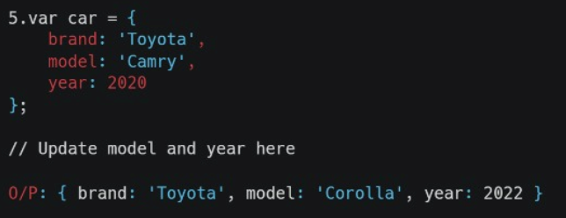

**Code:**

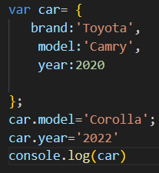

**Output:**



**Explanation:**

1. The object car is initially defined with brand: 'Toyota', model: 'Camry', and year: 2020.

2. The model property is updated to 'Corolla' and the year is updated to '2022'.

3. The final output reflects these changes, showing { brand: 'Toyota', model: 'Corolla', year: '2022' }.

**6.**

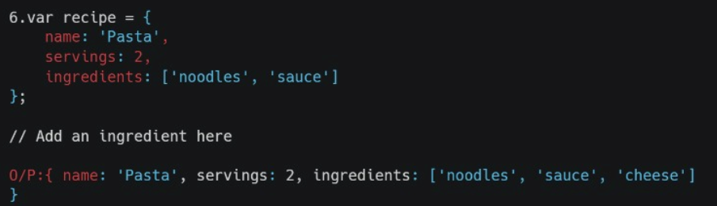

**Code:**

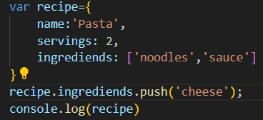

**Output:**

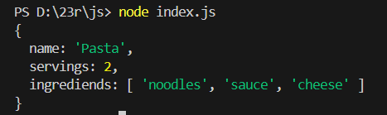

**Explanation:**

1. The provided JavaScript code defines an object recipe with properties for the name, servings, and ingredients of a pasta dish.
2. It then adds "cheese" to the ingrediends array using the push method. Finally, it logs the updated recipe object to the console, which now includes "cheese" in the ingredients list.