**TASK-7**

**1.**

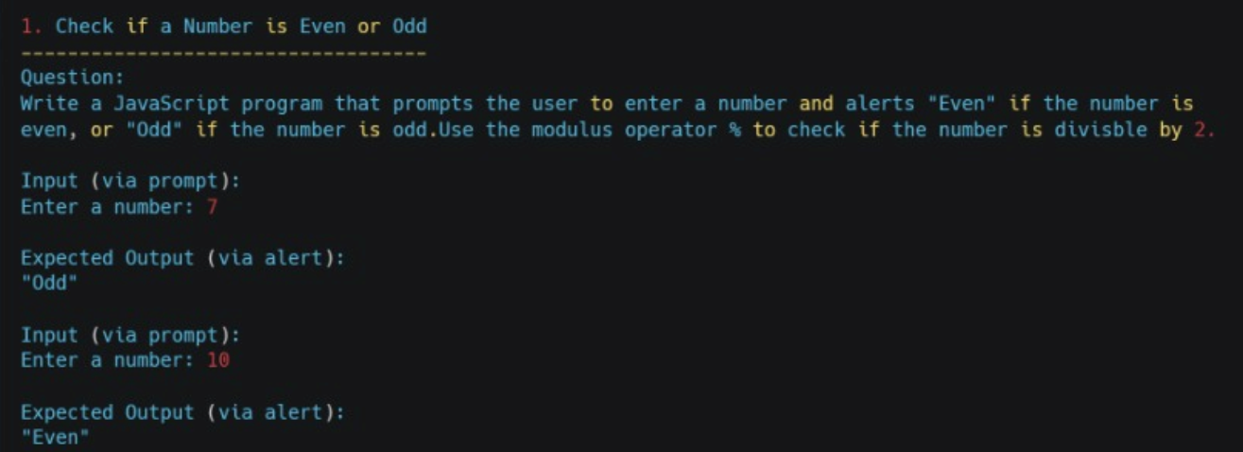

**Code:**

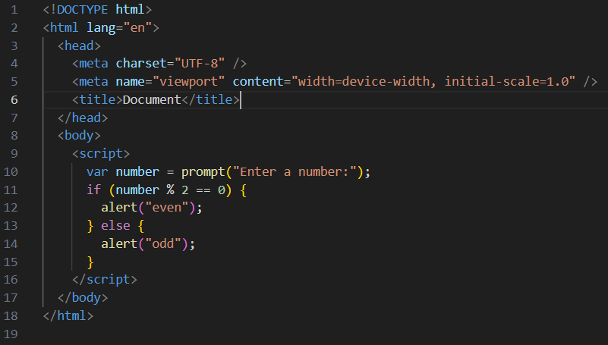

**Outputs:**

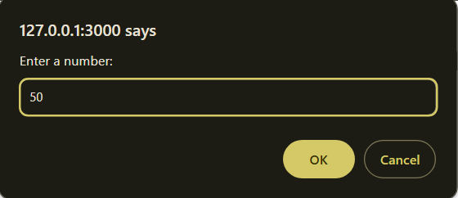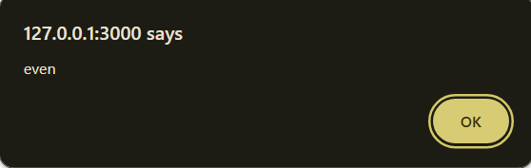

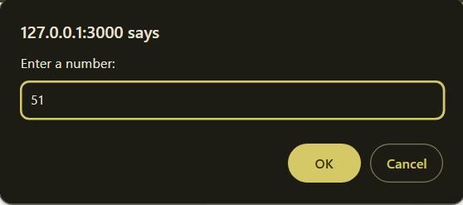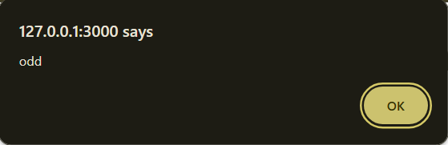

**Explanation:**

1. The code prompts the user to enter a number.

2. It checks if the entered number is divisible by 2 without a remainder.

3. If true, it displays "even"; otherwise, it displays "odd.

**2.**

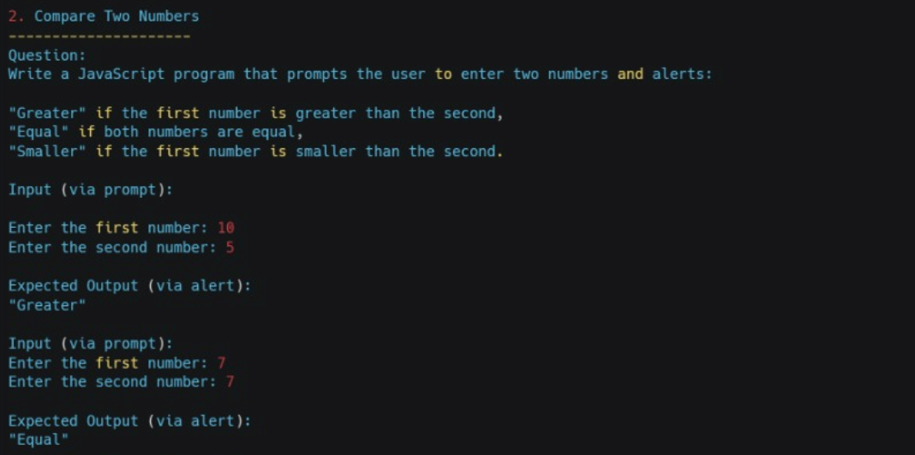

**Code:**

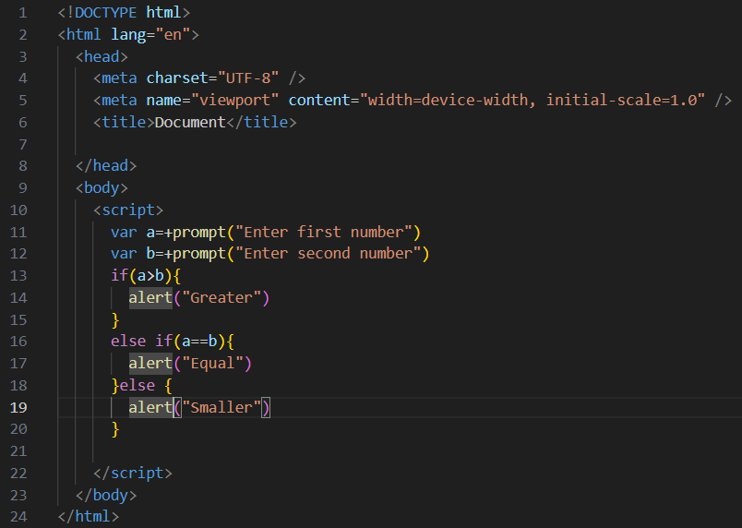

**Outputs:**

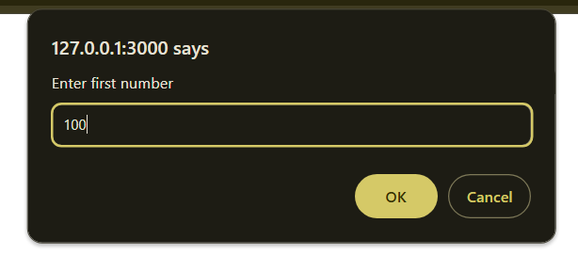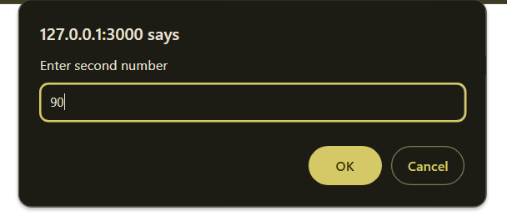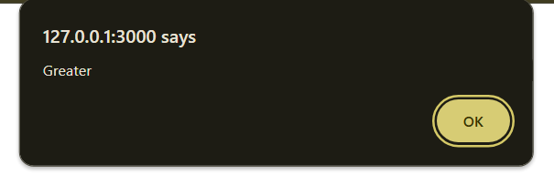

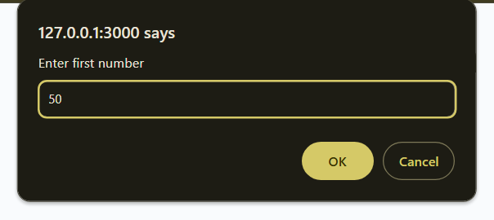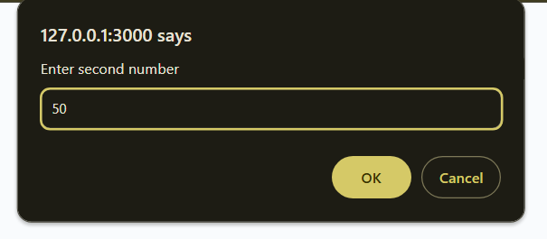

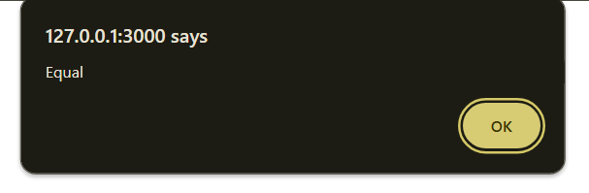

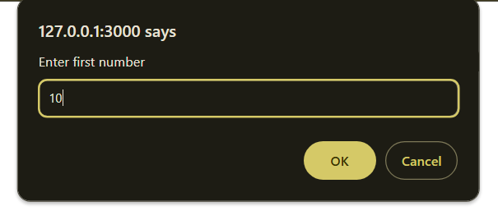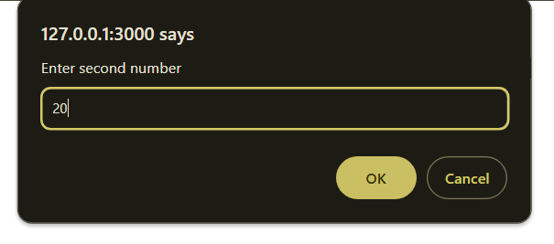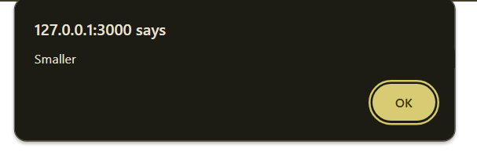

**Explanation:**

1. **var a = +prompt("Enter first number");**

Prompts the user to enter a number, and stores it in variable a as a number (using the + sign to convert the input to a numeric type).

2. **var b = +prompt("Enter second number");**

Prompts the user to enter another number, and stores it in variable b as a number.

3. **if (a > b) {**

Checks if a is greater than b.

4. **alert("Greater");**

If the condition above is true, it displays an alert saying "Greater".

5. **else if (a == b) {**

Checks if a is equal to b.

6. **alert("Equal");**

If the condition above is true, it displays an alert saying "Equal".

7. **else {**

Executes this block if neither of the above conditions is true, meaning a is less than b.

8. **alert("Smaller");**

Displays an alert saying "Smaller".

**3.**

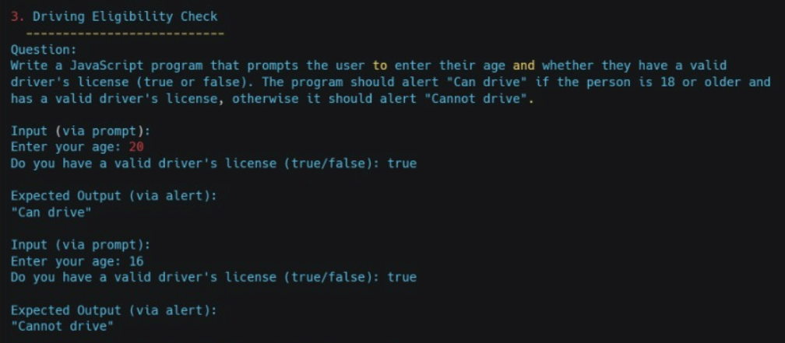

**Code:**

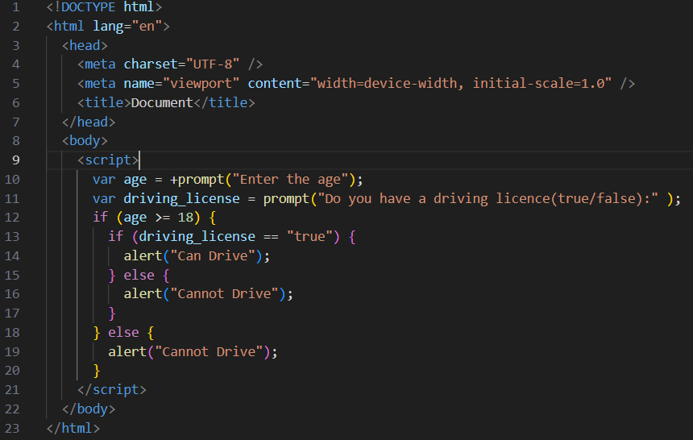

**Outputs:**

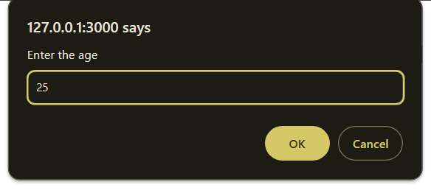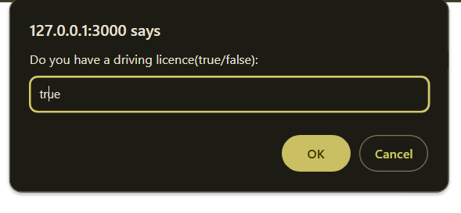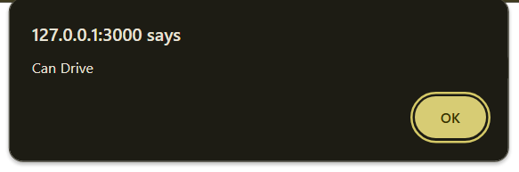

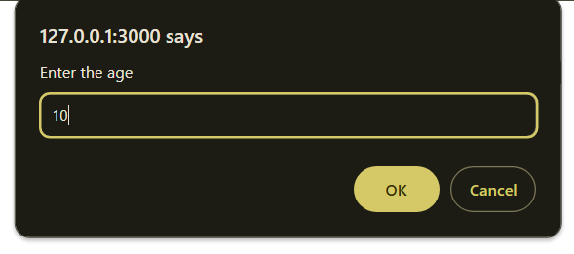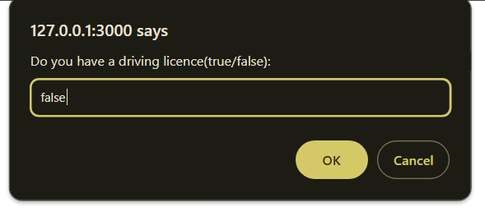

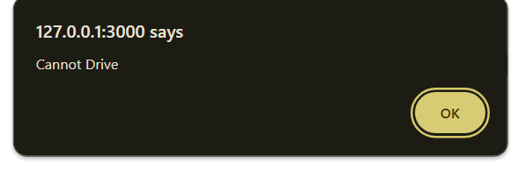

**Explanation:**

1. **var age = +prompt("Enter the age");**

Prompts the user to enter their age. The + converts the input from a string to a number and assigns it to the variable age.

2. **var driving_license = prompt("Do you have a driving licence(true/false):");**

Asks the user if they have a driving license, expecting them to enter "true" or "false" as a response. This value is stored in the driving_license variable.

3**. if (age >= 18) {**

Checks if the entered age is 18 or older.

4. **if (driving_license == "true") {**

If the age is 18 or older, it further checks if driving_license is "true" (indicating the user has a driving license).

5. **alert("Can Drive");**

If both conditions are true (age is 18 or older and the user has a license), it displays "Can Drive" in an alert box.

6**. } else { alert("Cannot Drive"); }**

If the age is 18 or older, but driving_license is not "true" (the user does not have a license), it displays "Cannot Drive" in an alert box.

7. **} else { alert("Cannot Drive"); }**

If the age is below 18, regardless of the driving license status, it displays "Cannot Drive" in an alert box.

**Summary:**

Age ≥ 18 and driving_license is "true" ➔ "Can Drive".

Age ≥ 18 but driving_license is not "true" ➔ "Cannot Drive".

Age < 18 ➔ "Cannot Drive".

**4.**

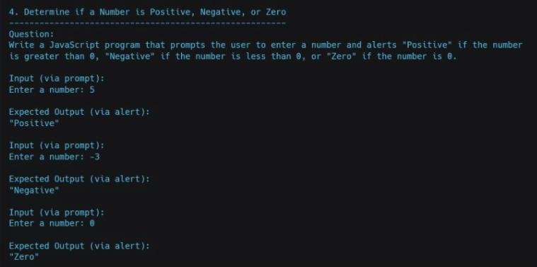

**Code:**

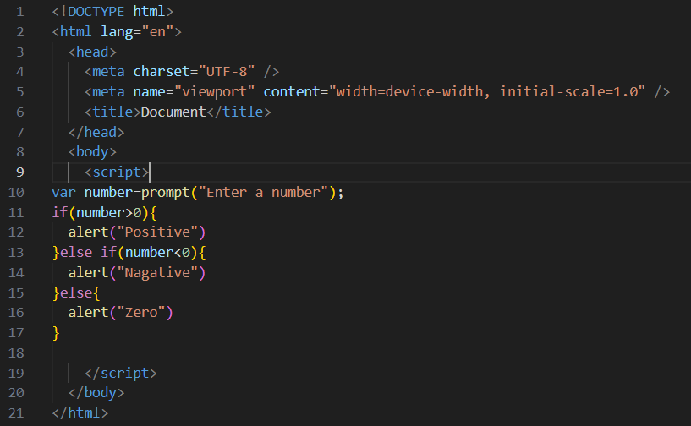

**Outputs:**

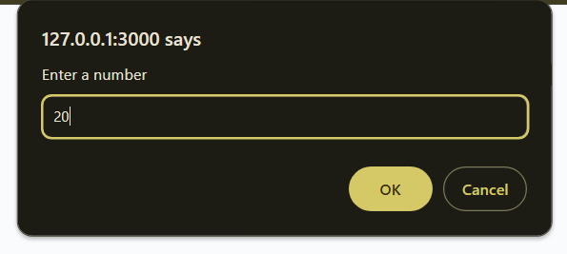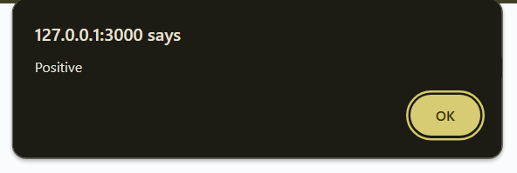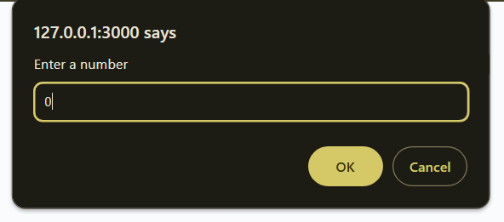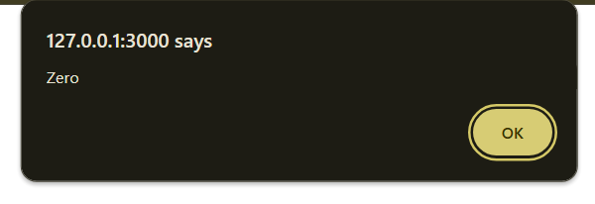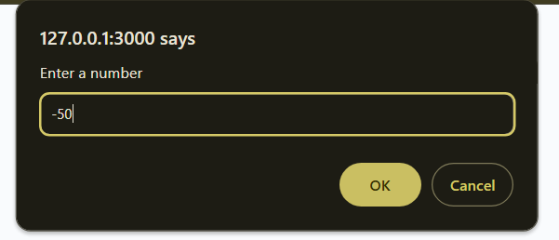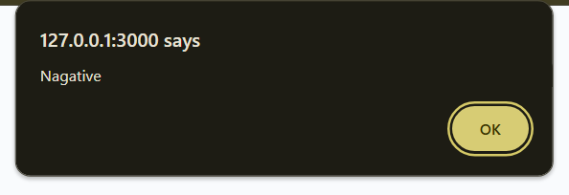

**Explanation:**

1. **var number = prompt("Enter a number");**

Asks the user to enter a number and stores the input as a string in the variable number.

2. **if (number > 0) {**

Checks if the entered number is greater than 0.

3. **alert("Positive");**

If the number is greater than 0, it displays "Positive" in an alert box.

4. **} else if (number < 0) {**

If the number is not greater than 0, this line checks if it is less than 0.

5. **alert("Negative");**

If the number is less than 0, it displays "Negative" in an alert box.

6. **} else {**

If the number is neither greater than 0 nor less than 0, it means it is 0.

7. **alert("Zero");**

Displays "Zero" in an alert box if the number is exactly 0.

This code checks if a number is positive, negative, or zero and then displays the appropriate message.