EISystems Internship

**Important sections in project report**  
Makesure to keep these sections in your project report Page

1. Cover page of report ..2
2. Student declaration ..3
3. Content Table (With Serial Number, Title, Page Number) ..4
4. List of Figures (With Caption & Figure Number) ..5
5. List of Tables (With Caption & Table Number) ..6
6. Nomenclature / Notations if any. ..7
7. Executive Summary ..8
8. Overview of Organization ..9
9. Project Summary (Preamble, Introduction, Motivation, Plan of Research) ..10
10. Data Flow Diagram / Processflow ..11
11. Code / Program with Supported Screenshots ..12
12. Input / Output Datasets with Screenshots. ..13
13. Images / Video links ..14
14. References. ..15
15. Student Self Evaluation ..16
16. Annexure 1 (Daily Activity Report) ..17
17. Annexure 2 (Weekly Activity Report) ..18

[EISystems Logo]

# Internship Report

**On**

# Tic Tac Toe game with python

# Submitted by Submitted to [Avula Vinay Kumar] Mallika Srivastava [U21CS055] Head, Training Delivery [Bharath Institute of Higher Education and Research] EISystems Services

# & Mayur Dev Sewak

# Head, Internships & Trainings

# EISystems Services

**Student’s Declaration**

I,Avula Vinay Kumar,a student of Btech program, Roll No U21CS055 of the Department ofCSE,Bharath Institue of Higher Education and Research College do hereby declare that I have completed the mandatory internship in Eisystems Technologies under the faculty guideship of mentor

**Table of Content**

Tac Toe game with python

**Executive Summary**

. **Tic Tac Toe Game with AI Integrated and Front End Framework**

GUI based 5x5 tic tac toe game with 2 modes 1.player vs AI 2.player vs player. We have given certain conditions for the ai to perform its operations and the AI performs quite well and is difficult to beat. Player vs Player allows us to play it with 2 users.

### Dataset Description:

No dataset used. It is all done on the basis of probability and permutation and combinations.

**Methodology:**

To build this game, I first created the board. This is a 5x5 game and hence a board with 25 boxes for entries.

Next, I created the winning conditions i.e. when the game should end, when either vertically or horizontally 5 elements of same character are repeated.

I wrote a function to get the input from user based on a mouse click, the entry is done only when that particular area/board location does not have any previous value on it.

For the AI to decide which moves to make next, I used basic if else conditions. The AI first covers the corners to make sure the probability of AI winning is high and the other moves are based on how the user gives his/her input. The program is designed in a very basic way but the AI is difficult to beat. It is easy to play a tie game though. We have used MinMax algorithm to build similar TicTacToe game

To make the game more interesting, I added a timeout condition wherein if the player does not make his/her move in 5 seconds (you can change this in code), the player loses the match.

**How to Execute?**

So, before execution we have some pre-requisites that we need to download or install i.e., anaconda environment, python and a code editor. **Anaconda**: Anaconda is like a package of libraries and offers a great deal of information which allows a data engineer to create multiple environments and install required libraries easy and neat.

To check on how to install anaconda environment, set up jupyter notebook refer to this article. You can skip the article if you have knowledge of installing anaconda, setting up environment and installing requirements.txt

To run the code, open anaconda prompt. Go to virtual environment if created or operate from the base itself and go to your file location and type python gui.py to run the code

**Data Flow Diagram / Process Flow**

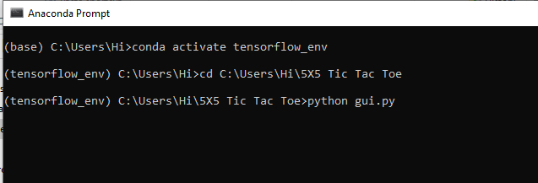

**Code / Program with Supported Screenshots**

**Results:**

You can select any option based on your choice.

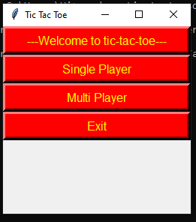

Demo game of user vs computer.

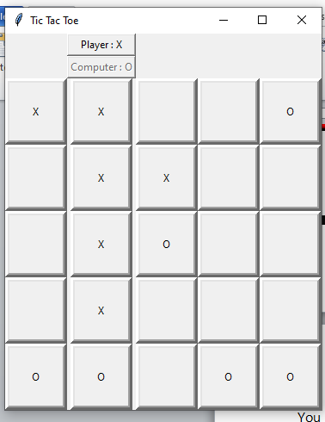

Result when I did not enter my move within the given time

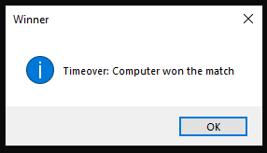

**Issues faced/ Points to note:**

1. Ensure you have all libraries installed.
2. Give correct paths wherever necessary