Assignment-5: SYNOPSIS

PROJECT MEMBERS:-
NAME- VINAYSINGH PATIL MIS- 111903124
NAME- VEDASHREE SATPUTE MIS- 111903122

BATCH- T3
COURSE TEACHER – V. M . KHADSE

Problem statement

BLOOD BANK MANAGEMENT SYSTEM

Objectives

A system which manage person blood group details

Functional requirements
1) View Details of all person and their blood group
2) Adding new patient information into databse
3)Modify patient’s information into database
4)Delete patient’s information from database
5)View blood group wise patients
6) Total Registered patients
7) Exit

ER diagram
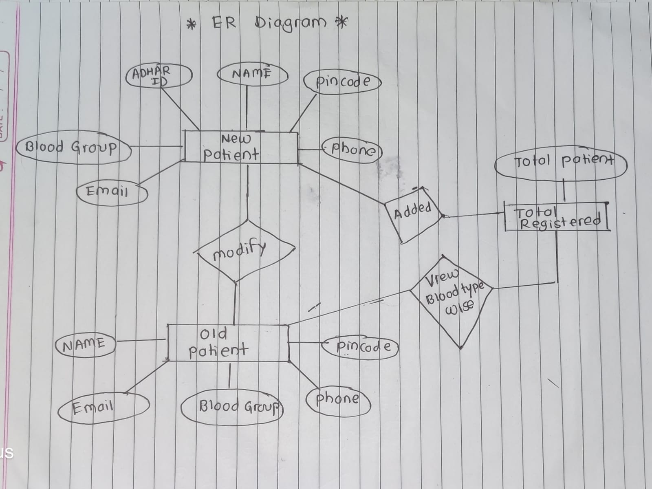

Relational schemas obtained from ER.

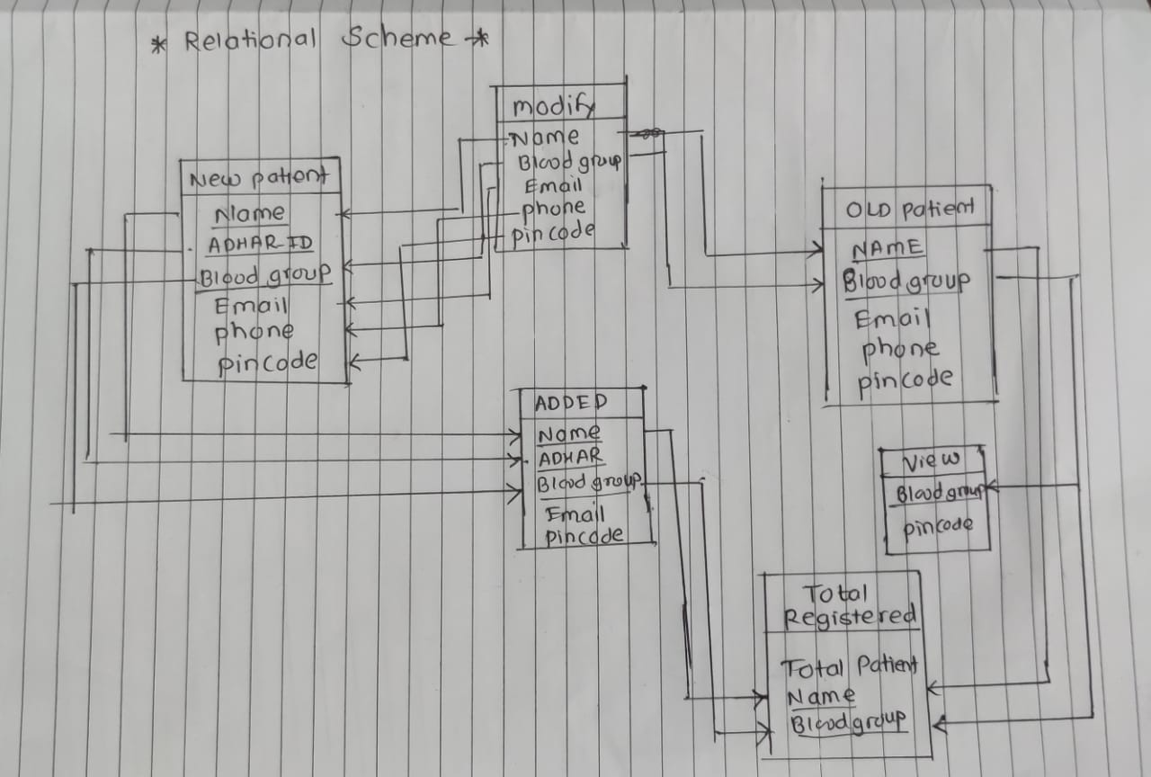

Set of Functional dependencies that must hold on each table.

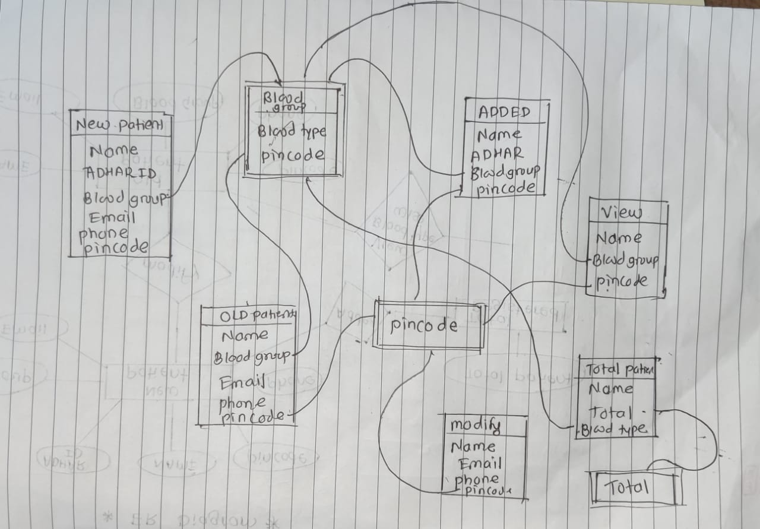

Each table has to be normalized upto 3NF.
