ST. PAUL’S UNIVERSITY

DEPARTMENT OF COMPUTER SCIENCE

PROJECT PROPOSAL

TITLE OF PROJECT

SMART TRAFFIC SYSTEM

BY

VINCENT OTIENO ANYIM

REGISTRATION NUMBER

BSCLMR153522

SUPERVISOR: Lucy

Submitted in partial fulfillment of the requirements for the award of the *Degree in Computer science*

OCTOBER 2024

# DECLARATION

I hereby declare that the project titled **AI-Powered Smart Traffic System Prototype** is my original work except for citations and quotations which have been duly acknowledged. This project has not been submitted previously, in part or whole, for the award of any degree or diploma in any other institution.

**Name:** [Vincent Otieno Anyim]  
**Registration Number:** [BSCLMR153522]

Signature: .................................................... Date: ...........................................................…

I the undersigned do hereby certify that this is a true proposal for the project undertaken by the above-named student under my supervision and that it has been submitted to St Pauls University with my approval

Supervisor Name:

Signature: .....................................................Date: ...................................................

SUPERVISOR: Lucy

Submitted in partial fulfillment of the requirements for the award of the *Degree in Computer science*

DECEMBER 2024

# DEDICATION

I would like to dedicate my project work to God for having guided me all the way and whose strength, wisdom, and knowledge have made sure that I give it all it takes to finish that which I have started and not quit in the middle of this journey. My sincere gratitude goes to my fellow colleagues for supporting me.

I also dedicate this project to my family for their love, support, motivation, patience; encouragement, and understanding that gave me the will and determination to study hard and rise above all the setbacks.

# ACKNOWLEDGMENT

I would like to express my deepest appreciation to all those who provided me with the possibility to complete this report. A special gratitude I give to St Paul’s University School of Communication and Computer Science for offering this Bachelor’s degree program to individuals like myself who seeking knowledge in the IT industry, and also to all the staff members who guide students from the beginning of the program.

Furthermore, I would also like to express my gratitude to Mrs Lucy Ndungu my supervisor for the invaluable guidance, encouragement, and precious support given throughout the journey. More importantly, the valuable advice and criticisms drive the project more successful.

I also take this opportunity to express a deep sense of gratitude to my closest friends who supported me to evaluate this project by giving their genuine and valuable feedback.

Finally, I express my heartfelt gratitude to my parents, my colleagues, and friend who were with me during the project period by providing advice, guidance, and valuable support to make this if successful.

## Abstract

The rapid growth in urban populations and the increasing number of vehicles on the road have led to congestion and inefficiencies in traffic management systems. Traditional traffic control methods, which rely heavily on fixed signals and manual interventions, struggle to adapt to the dynamic and complex nature of modern traffic patterns. This paper proposes an Artificial Intelligence (AI)-based traffic management system designed to optimize traffic flow and improve road safety. By leveraging machine learning algorithms, computer vision, and real-time data analysis, the system can predict traffic congestion, dynamically adjust signal timings, and provide adaptive route suggestions to minimize delays. The AI system incorporates data from various sensors, including cameras and GPS devices, to monitor traffic conditions, detect accidents, and facilitate communication between vehicles and infrastructure. The proposed solution not only enhances efficiency and reduces traffic-related emissions but also promotes a safer and more sustainable urban environment. The effectiveness of the system is demonstrated through simulations and real-world case studies, which show significant improvements in traffic throughput, reduced wait times, and better overall management of traffic resources. This research highlights the potential of AI to revolutionize traffic management systems, offering scalable, adaptable, and future-proof solutions to meet the growing demands of modern cities.

Table of Contents

DECLARATION 2

DEDICATION 3

ACKNOWLEDGMENT 4

Abstract 5

Chapter 1 - Introduction 9

1.1 Background 9

1.2 Problem Statement 10

1.3 OBJECTIVES 11

1.3.1 General objectives: 11

1.3.2 Specific Objectives : 11

1.4 Current Challenges 11

1.5 Proposed AI-Based Solution 13

1.6 Expected Outcomes 14

1.7 Significance of the study 15

1.8 Scope of the study 15

1.9 Assumptions 17

1.10 Limitations and Delimitations 19

1.10.1 Limitations 19

1.10.2 Delimitations 20

Chapter 2 - Literature Review 22

2.1 Introduction 22

2.2 Limitations of Existing Traffic Management Systems 22

2.3 Addressing The limitation With The Proposed System 23

2.4 Related Systems in AI-based Traffic Management 24

2.5 Research Gaps and Alignment with Objectives 26

2.6 Conceptual framework 26

Chapter 3 - Methodology and System Design 27

3.1 Agile Methodology 27

3.2 Justification for using Agile methodology 28

3.3 Project Design 29

3.4 Design Procedures 29

3.4.1. Planning and requirements phase 29

3.4.2. Design phase 29

3.4.3. Development phase 29

3.4.4 Testing phase 30

3.4.5 Model process 30

3.4.6 System Architecture 31

3.5 System Requirements 32

3.5.1 Hardware Requirements 32

3.5.2 Software Requirements 32

3.5.3 Communication Network 32

3.6 Analysis Techniques 32

Chapter 4 - MODEL ANALYSIS AND REQUIREMENT SPECIFICATION 34

4.1 Introduction 34

4.2 Detailed Analysis of the Existing System 34

4.2.1 Flowchart of Existing System 34

4.3 Proposed model 35

4.5 Class Diagram: 36

4.3 Context Diagram 36

36

4.4Limitations of the Current System 37

4.4 Requirements Definitions and Specifications of the Project 37

4.4.1 User Requirements 37

4.4.2 Functional Requirements for the New System 37

4.4.3 Non-Functional Requirements 38

Chapter 5-MODEL DESIGN 39

5.1 Introduction 39

5.2 System Architecture 39

5.3 System Components 41

5.3.1 ERD (Entity-Relationship Diagram): 41

5.5 Data Flow and Interactions 42

Appendices and References 45

Appendices 45

Project budget 45

References 46

Table of Figures

Figure I: conceptual framework 26

Figure II: agile methodology to guide in the project 28

Figure III: System Architecture 31

Figure IV: Flowchart of Existing System 34

Figure V: flowchart for the proposed model 35

Figure VI: Class Diagram 36

Figure VII: Context Diagram 36

Figure VIII: multi-layer system architecture 40

Figure IX: ERD diagram 41

Figure X:Sequence Diagram. 42

Figure XI: DFD Diagram 43

Figure XII: UML Diagram 44

## Chapter 1 - Introduction

### 1.1 Background

Smart traffic systems **will become** essential in modern urban planning, offering transformative solutions to enhance transportation efficiency, improve safety, and reduce congestion in cities like Nairobi and globally (Karanja & Mwangi, 2020). Historically, traffic management systems **relied** on manual methods such as traffic lights, traffic police, and street signs, which were foundational but limited in their ability to address the growing complexity of urban traffic. These early methods **will lay** the groundwork for the development of more advanced, technology-driven solutions. In the late 20th century, the development of Intelligent Transportation Systems (ITS) **marked** a significant shift. ITS solutions **will incorporate** sensors, cameras, and other technologies to monitor and manage traffic in real time, providing greater control and visibility (Jones, 2022). The integration of real-time data collection **will allow** for more responsive and dynamic traffic management, but challenges related to data processing and prediction **will remain**.

Looking ahead, smart traffic systems **will increasingly rely** on cutting-edge technologies like Artificial Intelligence (AI) and machine learning to predict congestion patterns, optimize traffic flow, and enhance the management of urban mobility (Tan, Wong, & Lim, 2021). For instance, AI-driven systems **will analyze** real-time data from traffic sensors, cameras, and connected vehicles to make instant adjustments to traffic signals, effectively managing congestion and improving traffic flow (Smith & Chang, 2020). Additionally, the integration of connected and autonomous vehicles **will enable** seamless communication between vehicles and traffic management systems, creating safer, more coordinated transportation networks (Lee, 2021). As emerging technologies continue to evolve, the capacity for proactive traffic management **will increase**, allowing cities to prevent traffic bottlenecks before they form and respond to accidents or emergencies in real time (Odhiambo, 2023).

Furthermore, the inclusion of the Internet of Things (IoT) in these systems **will enable** continuous monitoring, data collection, and communication between devices embedded throughout the urban environment (Mungai & Kamau, 2022). IoT technology **will allow** for the constant flow of traffic data, which **can be used** to optimize routes for individual vehicles or public transportation systems, reduce idle times, and cut down on fuel consumption and emissions (Karanja & Mwangi, 2020). This **will play** a critical role in supporting sustainability efforts, as smart traffic systems **will help** reduce carbon footprints by promoting more efficient traffic flow and encouraging the use of public transportation or eco-friendly vehicles.

For cities like Nairobi, the adoption of smart traffic systems **will not only alleviate** current traffic-related problems but also **pave** the way for a more resilient and sustainable urban environment. AI models that dynamically adjust traffic signals based on real-time data **will significantly reduce** delays and enhance the overall efficiency of the city’s transport system, directly impacting the quality of life for residents (Odhiambo, 2023). Additionally, by integrating smart technologies with urban planning efforts, these systems **will contribute** to a more sustainable and equitable transportation network, which **will be** crucial as Nairobi’s population continues to grow (Mungai & Kamau, 2022).

The long-term goal of these innovations **will be** to create a smart city ecosystem where mobility is seamlessly integrated into daily life, with intelligent traffic systems **serving** as a backbone for safer, more efficient, and environmentally conscious urban living. By adopting AI and IoT-based solutions, Nairobi and other cities worldwide **will be** well-positioned to address the challenges of urbanization while fostering a higher quality of life and more resilient infrastructure for future generations (Smith & Chang, 2020).

### 1.2 Problem Statement

As urban areas like Nairobi continue to face challenges of traffic congestion, inefficient traffic management, and increasing road safety concerns due to population growth and rising vehicle numbers, the need for advanced solutions becomes more urgent. Traditional traffic systems, including manual traffic signals and basic signage, are unable to adapt in real-time to changing conditions, leading to longer travel times, higher fuel consumption, increased pollution, and more accidents (Karanja & Mwangi, 2020; Jones, 2022; Mungai & Kamau, 2022). The growing population and urbanization in Nairobi, expected to exceed 6 million by 2030, will further exacerbate the situation, making the lack of real-time data collection and analysis in the current public transport system a significant issue (UN Habitat, 2020; Odhiambo, 2023).

The future of Nairobi’s transportation system depends on the integration of advanced technologies like Artificial Intelligence (AI) and the Internet of Things (IoT) to address these challenges. Traditional systems will not suffice to handle the dynamic needs of a growing city. AI can optimize traffic flow by analyzing real-time data from traffic sensors, cameras, and connected vehicles, while IoT devices will enable continuous monitoring and data collection, allowing for proactive traffic management (Tan, Wong, & Lim, 2021; Lee, 2021). Despite the benefits, implementing these systems will face challenges such as infrastructure limitations, privacy concerns, and the complexity of integrating AI-driven solutions with existing urban infrastructure (Odhiambo, 2023; Smith & Chang, 2020).

This project aims to design and implement a Smart AI Traffic System that uses AI, machine learning, and IoT to monitor and optimize traffic flow, reduce congestion, and improve road safety. By providing real-time adaptability and integrating with citywide infrastructure, the system will contribute to Nairobi's goal of becoming a smart, sustainable city capable of managing future growth and improving the quality of life for its residents (UN Habitat, 2020). Implementing AI and IoT-based solutions will be critical to overcoming congestion, pollution, and safety challenges in Nairobi’s transportation system.

### 1.3 OBJECTIVES

#### **1.3.1 General objectives:**

1. Design and implement a functional prototype that integrates **Machine Learning** technologies to manage and optimize traffic flow in a selected area of Nairobi, aiming to improve traffic management and reduce congestion.

#### **1.3.2 Specific Objectives :**

1. **To assess the current state of traffic management in Nairobi**,
2. **To identify a scalable framework for integrating the AI-based traffic management system**
3. To develop an AI-driven traffic monitoring system

### 1.4 Current Challenges

One of the most significant challenges facing the implementation of smart traffic systems in Nairobi is severe traffic congestion, driven by rapid urbanization and an increasing number of vehicles on the roads. Current manual and semi-automated traffic management systems are insufficient to handle the fluctuating traffic patterns, especially during peak hours. This leads to inefficiencies, long delays, and heightened commuter frustration (Karanja & Mwangi, 2020).

Nairobi's infrastructure also presents limitations for adopting advanced smart traffic technologies. Many existing traffic control systems are outdated and lack the capability to integrate modern IoT devices and AI solutions. Major infrastructure upgrades would be required to accommodate these technologies, posing logistical and financial challenges (Odhiambo, 2023). Compounding this issue is the high cost of implementing smart traffic systems, which require substantial investment in hardware such as sensors, cameras, and communication networks, alongside the development of sophisticated AI algorithms. Budget constraints in developing countries like Kenya make it difficult to prioritize such projects in urban planning (Odhiambo, 2023).

Another critical concern is data privacy and security. Smart traffic systems depend on real-time data collection, including vehicle counts, location tracking, and congestion analysis, which raises privacy concerns. Without robust legal frameworks to regulate data collection and use, there is a significant risk of data misuse or breaches (Lee, 2021). Additionally, interconnected IoT devices used in smart systems are vulnerable to cyberattacks, potentially leading to system disruptions or the compromise of sensitive information. Strengthening cybersecurity measures will be vital for the system's success (Jones, 2022).

The lack of technical expertise and skilled personnel further complicates implementation. Smart traffic systems require AI developers, IoT technicians, and maintenance teams to ensure effective deployment and long-term operation. However, Nairobi faces a shortage of professionals in these fields, potentially causing delays and operational inefficiencies (Karanja & Mwangi, 2020). Moreover, integrating these advanced systems with Nairobi’s legacy traffic infrastructure is another hurdle. Existing systems were not designed to accommodate real-time, adaptive technologies, and retrofitting them for smart traffic solutions will require complex modifications (Mungai & Kamau, 2022).

Public awareness and acceptance also remain low. Many Nairobi residents are unfamiliar with the benefits of smart traffic systems and may resist adopting new technologies, particularly if their advantages are not immediately apparent. Effective communication strategies and stakeholder engagement will be essential to encourage public cooperation and foster trust in the system (Odhiambo, 2023).

Environmental challenges further complicate the system’s deployment. While the optimization of traffic flow aims to reduce emissions, Nairobi’s congested road networks and existing pollution levels may hinder achieving immediate environmental benefits. Proper calibration and extensive testing will be necessary to ensure meaningful reductions in fuel consumption and emissions (Tan, Wong, & Lim, 2021). Finally, the absence of clear policies and regulatory frameworks for AI and IoT in traffic management hinders progress. Policymakers must address legal, ethical, and operational concerns to enable the successful integration of these advanced technologies into urban systems (UN Habitat, 2020).

### 1.5 Proposed AI-Based Solution

The proposed solution is an AI-based Smart Traffic System Prototype designed to address traffic congestion and inefficiencies in Nairobi. The system will utilize Artificial Intelligence (AI) to optimize traffic flow, reduce delays, enhance road safety, and contribute to environmental sustainability. By analyzing real-time traffic data, the AI will dynamically adjust traffic signal timings to prioritize lanes with higher traffic volumes and manage congestion more effectively. The system will also employ predictive analytics to anticipate traffic surges, enabling proactive traffic management (Karanja & Mwangi, 2020).

The AI system will include an incident detection module that identifies irregular traffic patterns, such as accidents or road obstructions. In these cases, the system will prioritize emergency response vehicles and suggest alternative routes for other road users, improving safety and reducing incident response times (Tan, Wong, & Lim, 2021). Additionally, by optimizing traffic flow, the system will help reduce fuel consumption and carbon emissions, contributing to a cleaner and more sustainable urban environment (Mungai & Kamau, 2022).

Implemented as a prototype in a selected area of Nairobi, the system’s impact on traffic congestion, travel times, and road safety will be evaluated. Challenges such as system reliability, data security, and public acceptance will also be addressed to provide insights for scaling the system across the city (Lee, 2021; Odhiambo, 2023). This AI-driven solution will offer a forward-looking approach to traffic management and has the potential to be expanded to other urban areas, transforming transportation systems and supporting the development of smarter, more sustainable cities globally.

In addition to its primary objectives, the AI-based Smart Traffic System Prototype will serve as a crucial step toward the development of a more resilient and adaptive transportation infrastructure in Nairobi. By leveraging AI technology, the system will not only improve the day-to-day management of traffic but also provide valuable data insights for urban planners and transportation authorities. This data can be used to identify long-term patterns and trends in traffic behavior, which will be essential for future city planning, infrastructure development, and policy-making. As Nairobi continues to grow, the insights gained from this prototype can guide the scaling of smart traffic solutions to other parts of the city and beyond, ensuring that the transportation system keeps pace with the city's evolving needs and contributes to overall urban sustainability (Karanja & Mwangi, 2020; Tan, Wong, & Lim, 2021).

### 1.6 Expected Outcomes

The AI-based Smart Traffic System will improve traffic flow by dynamically adjusting signal timings based on real-time data, reducing congestion, and shortening travel times, leading to increased commuter satisfaction and productivity (Karanja & Mwangi, 2020).

The system will enhance road safety through real-time incident detection and prioritizing emergency response vehicles, reducing accident-related delays and saving lives by enabling quicker interventions (Lee, 2021).

Environmental benefits include reduced fuel consumption and greenhouse gas emissions by optimizing traffic flow, contributing to cleaner air and promoting a more inclusive transportation environment for all users (Tan, Wong, & Lim, 2021).

Continuous monitoring through IoT devices will allow proactive traffic management and reduce operational costs by automating processes and minimizing the need for manual intervention (Mungai & Kamau, 2022).

As a prototype, the system will provide valuable data for expanding AI-based traffic solutions citywide and integrating other smart city initiatives, fostering a more connected, sustainable urban environment (Odhiambo, 2023).

Public awareness and acceptance will increase through visible benefits, encouraging the adoption of smart technologies and supporting the long-term success of future urban innovations (Jones, 2022).

The success of the prototype will lay the foundation for Nairobi’s smart city ambitions, supporting complementary technologies and establishing the city as a leader in sustainable urban development (Tan, Wong, & Lim, 2021).

### 1.7 Significance of the study

The proposed AI-based Smart Traffic System study will provide critical solutions for traffic management, reducing congestion, and improving transportation in Nairobi. It will set a precedent for other East African cities, showcasing how technology can effectively address urban mobility challenges.

This study will provide valuable data for policymakers and urban planners, helping them integrate AI-based solutions into urban infrastructure. The success of the system will serve as a model for scalable traffic management solutions in Nairobi and other similar urban environments (Karanja & Mwangi, 2020).

The study will contribute to the body of knowledge on AI in transportation, especially in developing countries. It will offer a framework for integrating AI with IoT, providing valuable insights for researchers and cities looking to improve traffic management (Mungai & Kamau, 2022).

By improving traffic flow, the AI-based system will help reduce air pollution and carbon emissions, aligning with global goals for environmental conservation and climate change mitigation (Tan, Wong, & Lim, 2021).

The study will emphasize technology’s role in enhancing public safety and quality of life by reducing accidents and response times. It will also contribute to more inclusive transportation for all users, including cyclists and those with disabilities (Lee, 2021).

This study will position Nairobi as a leader in smart city development, demonstrating how AI can address urban challenges and contribute to a more connected, efficient, and sustainable future (Odhiambo, 2023).

### **1.8 Scope of the study**

This system will integrate **Artificial Intelligence (AI)** technologies to optimize traffic flow, reduce congestion, and enhance road safety. The study will primarily examine the application of these technologies in a selected urban area in Nairobi, aiming to test their feasibility, effectiveness, and potential for scalability to other areas of the city. By focusing on a pilot project, the study will provide critical insights into the potential benefits and challenges of AI-driven traffic management solutions in an African urban context, a region that has yet to fully embrace smart city innovations (Karanja & Mwangi, 2020).

Geographically, the study will focus on specific high-traffic zones within Nairobi, particularly areas known for their congestion during peak hours. These zones will be selected based on traffic density, strategic importance, and their potential to benefit from improved traffic management. By testing the system in these areas, the study will aim to understand how real-time traffic data can inform signal adjustments and manage congestion effectively. The choice of Nairobi as the study site will also serve as a model for other East African cities facing similar urban mobility challenges (Odhiambo, 2023).

In terms of technology, the AI-based system will utilize sensors, cameras, and GPS trackers to collect real-time data, which will then be analyzed by AI algorithms. These algorithms will dynamically adjust traffic signal timings to improve traffic flow and reduce delays. IoT devices will monitor vehicle counts, traffic speeds, and road conditions, providing a comprehensive picture of traffic behavior throughout the day. The study will focus on understanding how these technologies can be integrated seamlessly to create an efficient and adaptive traffic management system (Lee, 2021).

The timeframe for the study will span several months, beginning with the design and installation of the prototype system, followed by its operation and monitoring over a predetermined period. During this period, the system will be tested in different traffic conditions, such as peak and off-peak hours, to evaluate its performance under various scenarios. The study will assess the system’s ability to adapt to real-time traffic changes, the efficiency of traffic signal adjustments, and the overall reduction in congestion (Tan, Wong, & Lim, 2021).

Data collected for the study will include vehicle counts, speeds, traffic flow rates, and incidents. The study will also gather environmental data, such as fuel consumption and emissions, to measure the system's potential impact on air quality. This comprehensive data collection will allow the study to evaluate the effectiveness of the AI-based system in reducing congestion, improving traffic safety, and decreasing environmental pollution. Additionally, public feedback will be obtained to assess user satisfaction with the changes in traffic flow and the perceived safety benefits (Mungai & Kamau, 2022).

The evaluation scope will focus on several key performance indicators (KPIs), such as the reduction in traffic delays, improved road safety (measured by accident reduction), and environmental benefits (fuel savings and emissions reductions). The study will also assess the system's scalability and its potential for integration with other smart city technologies. This includes exploring the possibility of integrating the traffic management system with autonomous vehicles, public transport systems, and broader smart city initiatives in Nairobi (Karanja & Mwangi, 2020).

Although the study will provide valuable insights into the potential of AI-based traffic systems, it will be limited to a prototype phase in a specific area of Nairobi. As such, the findings may not be directly applicable to all regions of Nairobi or to cities with different traffic dynamics. The study will not focus on the full integration of autonomous vehicles or complete smart city infrastructure but will lay the groundwork for future developments in these areas (Odhiambo, 2023).

Finally, the social and economic impact of the AI-based traffic system will be another important aspect of the study. By reducing traffic congestion and improving traffic safety, the system is expected to enhance commuter experience, shorten travel times, and reduce fuel costs. These improvements will have a direct positive effect on the economy by increasing productivity and reducing the economic burden caused by traffic-related delays and accidents. Furthermore, by demonstrating the benefits of smart traffic technologies, the study will encourage public acceptance and support for future smart city projects in Nairobi (Jones, 2022).

The environmental benefits of the AI-based traffic system will be significant as well. By optimizing traffic flow and reducing idle times, the system will contribute to reduced vehicle emissions and air pollution. This aligns with Nairobi's efforts to address environmental challenges and contribute to global sustainability goals (Tan, Wong, & Lim, 2021). The study will provide valuable insights into how smart traffic systems can support cleaner, more sustainable urban environments, which is essential as cities worldwide work toward reducing their carbon footprint.

In conclusion, the scope of the study will focus on testing and evaluating a prototype AI-based Smart Traffic System in Nairobi, with the potential to scale to other regions of the city in the future. The research will provide important insights into the effectiveness of AI and IoT technologies in solving urban mobility challenges, and will serve as a model for other cities facing similar issues. Through this study, Nairobi will position itself as a leader in the adoption of smart city technologies, paving the way for a more efficient, safe, and sustainable urban future (Mungai & Kamau, 2022).

### **1.9 Assumptions**

Several key assumptions will guide the implementation and evaluation of the Smart Traffic System. First and foremost, The project assumes that the IoT devices (e.g., cameras, sensors) used for gathering traffic data will provide accurate and consistent real-time information with minimal downtime (Lee, 2021). This data is critical for training and testing AI models and ensuring reliable optimization results.Additionally, **PyTorch** will be used for deployment on IoT devices due to its efficient integration with edge computing, while **PyTorch** will be used for model prototyping and experimentation.

In addition, the study assumes that the selected pilot areas in Nairobi will experience a sufficient volume of traffic during peak and off-peak hours to effectively evaluate the system. These areas must be representative of typical urban traffic conditions to assess the real-world effectiveness of the AI-based system in reducing congestion and improving traffic flow. Without a high enough traffic volume, the study may not accurately gauge the system's potential in managing congestion or providing effective signal adjustments (Tan, Wong, & Lim, 2021).

The study further assumes that local authorities and stakeholders in Nairobi will provide the necessary support for the deployment and monitoring of the AI-based traffic system. This includes cooperation from government agencies and traffic authorities, as well as facilitating access to critical infrastructure such as roads, communication networks, and traffic control centers. The success of the system’s implementation relies heavily on these stakeholders’ engagement and their ability to integrate the system into the existing traffic management framework (Odhiambo, 2023).

Additionally, it is assumed that the AI algorithms designed to optimize traffic flow will be effective in adjusting traffic signal timings and improving overall traffic management. The study assumes that these algorithms will be able to accurately analyze real-time data and make appropriate adjustments to traffic signal timings in a manner that reduces congestion, enhances safety, and optimizes traffic flow throughout the day (Lee, 2021). This assumption is fundamental to the success of the study, as the effectiveness of the AI system hinges on the precision of its algorithms.

The study assumes that the AI-based system will have a positive environmental impact by reducing fuel consumption and emissions. With improved traffic flow and reduced congestion, the system is expected to minimize idle time, leading to lower vehicle emissions and better air quality. This assumption aligns with Nairobi's sustainability goals and broader global initiatives aimed at reducing urban pollution (Tan, Wong, & Lim, 2021).

Moreover, the study assumes that the AI-based system will be scalable. If the system proves effective in the pilot areas, it is assumed that it can be expanded to other parts of Nairobi and potentially to other cities facing similar challenges. The scalability of the system will be a key factor in determining its long-term viability and potential impact on urban traffic management (Karanja & Mwangi, 2020).

### **1.10 Limitations and Delimitations**

#### **1.10.1 Limitations**

The limitations of this study will define the constraints within which the research will operate and the factors that could impact the study's findings. One significant limitation will be the geographic scope of the AI-based smart traffic system. The system will be tested in selected high-traffic areas of Nairobi, which, although representative of typical urban congestion, may not fully capture the diversity of traffic patterns across the entire city. Nairobi is a large and complex urban area with varying traffic behaviors in different regions, and thus, the findings may not be directly applicable to other parts of the city or other cities with distinct infrastructural and traffic characteristics (Karanja & Mwangi, 2020). Therefore, the outcomes of this study should be interpreted with consideration of its limited geographic focus.

The timeframe for the study will also present a limitation. As the research is primarily focused on a pilot phase, the testing of the AI-based system will be conducted over a relatively short period. While the study aims to assess the system’s effectiveness in managing traffic congestion, this short duration may not allow for a comprehensive evaluation of the system's long-term impact on traffic patterns or its sustainability in diverse seasonal conditions (Jones, 2022). The system’s ability to adapt to long-term changes, such as shifts in traffic behavior or growth in urban development, cannot be fully assessed within the study’s timeframe.

Technological challenges are anticipated as a limitation in the execution of this study. The AI system will rely on data collected through sensors, cameras, and IoT devices, which are integral to the system’s ability to optimize traffic flow. However, technical malfunctions, sensor inaccuracies, or issues with data transmission could result in incomplete or faulty data collection, which may hinder the accuracy of the system’s predictions and real-time adjustments (Smith & Chang, 2020). Additionally, connectivity problems or hardware failures could disrupt the functionality of the system, limiting its ability to effectively manage traffic during the test phase.

External factors, such as roadworks, major events, or temporary changes in traffic laws, could also affect the study's results. These unforeseen changes in the urban landscape can temporarily alter traffic patterns and influence the performance of the AI-based system. Events like road closures or special public gatherings could lead to abnormal traffic flows that the system might not handle as efficiently, affecting the evaluation of the system’s real-world effectiveness (Mungai & Kamau, 2022). These unpredictable elements will be acknowledged as potential limitations when interpreting the study’s outcomes.

Finally, privacy and security concerns related to data collection will also pose a limitation. Given that the AI-based traffic management system will gather real-time data through cameras and IoT devices, it could raise concerns regarding the protection of personal data. Even with measures in place to anonymize and secure the data, the public's trust in the system may be challenged. Privacy issues surrounding the collection and use of such data may influence the acceptance and adoption of the technology, which could limit its overall impact (Lee, 2021).

#### ****1.10.2 Delimitations****

The delimitations of the study will establish the boundaries of the research and define its specific focus.

One major delimitation is that the study will only assess the effectiveness of the AI-based system in a pilot phase rather than attempting a city-wide implementation. The research will concentrate on high-traffic areas that are representative of typical congestion zones, which will allow for a controlled evaluation of the system’s impact. However, this approach limits the study's findings to a specific subset of urban traffic conditions. A city-wide deployment would involve more complex logistics and require a broader scope of analysis, which will be beyond the reach of this study (Tan, Wong, & Lim, 2021).

Another delimitation is that the research will not focus on the integration of autonomous vehicles into the traffic management system. While autonomous vehicles are anticipated to play a role in the future of smart city transportation, this study will concentrate solely on human-driven vehicles. This decision is made to ensure a manageable scope and clear objectives, as the introduction of autonomous vehicles would require a different set of technologies, regulatory considerations, and traffic management strategies (Odhiambo, 2023). Future studies may explore the integration of such vehicles into smart traffic systems.

The environmental impacts of the AI-based traffic management system will be acknowledged, but a detailed environmental assessment will not be conducted within the scope of this study. While the expectation is that the system will lead to reduced fuel consumption and lower emissions, the study will focus primarily on evaluating traffic flow, road safety, and congestion reduction. A comprehensive environmental impact study would require additional data and time, and thus, it will not be included in the present research (Karanja & Mwangi, 2020).

Furthermore, the study will not explore the full integration of the AI system into a broader smart city infrastructure. Although the system will utilize IoT devices to monitor traffic, it will not be integrated with other smart city technologies, such as energy management or waste management systems, during the study period. The research will remain focused on the specific challenge of optimizing traffic flow and managing congestion, which is one of the most pressing issues in urban mobility (Smith & Chang, 2020).

Finally, the study will not conduct an in-depth sociological analysis of how the AI-based traffic system affects public behavior or attitudes. While public feedback will be gathered to understand initial reactions, the study’s primary focus will remain on technical evaluations of the system's performance. Future studies could expand on this by investigating how the introduction of such technologies might influence commuter behavior, public perceptions of urban mobility, or societal trends in transportation (Mungai & Kamau, 2022).

## Chapter 2 - Literature Review

### ****2.1 Introduction****

The increasing challenges of traffic congestion and inefficiency in urban areas, particularly in cities like Nairobi, necessitate innovative solutions to enhance traffic management. Artificial Intelligence (AI) technologies have emerged as a viable solution for addressing these challenges. This chapter reviews relevant literature, contextualizing the objectives of this study within existing knowledge and research gaps.

### 2.2 Limitations of Existing Traffic Management Systems

Many cities, including Nairobi, rely on traditional traffic management infrastructure, such as manual traffic lights and basic sensors, which are not designed to handle the demands of modern, rapidly growing urban environments. The lack of advanced technologies such as real-time monitoring systems and automated signal control means that traffic management decisions are often based on outdated information or human intervention. This results in delays, inefficiencies, and poor coordination, especially during peak traffic hours. Additionally, many roads and intersections lack the necessary infrastructure, such as cameras and sensors, to support more sophisticated data-driven systems (Karanja & Mwangi, 2020).

Traditional traffic management systems often operate on fixed signal cycles or simple timing adjustments. This static approach is ill-suited for responding to the dynamic and unpredictable nature of modern traffic, especially in busy urban areas. Without the ability to adapt in real-time to changing traffic conditions, these systems can cause unnecessary congestion, longer commute times, and inefficient use of road space. For example, when traffic surges unexpectedly due to accidents or events, existing systems cannot quickly adjust to manage the flow, leading to gridlock and safety risks (Mungai & Kamau, 2022).

Existing traffic management systems often rely on isolated data sources, such as manual traffic counts or individual cameras and sensors. This fragmented approach means that there is no unified system for collecting and analyzing data, limiting the ability to make comprehensive decisions. Without integrated, real-time data on traffic conditions, incidents, and congestion patterns, city authorities cannot respond effectively to emerging issues or optimize traffic flow across the entire city. As a result, cities are unable to leverage the full potential of data analytics and predictive modeling to improve traffic management and safety (Lee, 2021).

### 2.3 Addressing The limitation With The Proposed System

Existing traffic systems in Nairobi and similar cities often rely on outdated infrastructure, including manual traffic signals and basic sensors, which are ill-equipped to handle growing urban traffic demands. The AI-based Smart Traffic System addresses this limitation by introducing a more advanced infrastructure that incorporates real-time data collection through sensors, cameras, and IoT devices. This system dynamically adjusts traffic light timings based on current traffic conditions, which optimizes the flow of vehicles and reduces congestion. As AI continuously processes and analyzes data, it ensures that the traffic management system adapts to fluctuations in traffic patterns, thereby enhancing traffic efficiency even in the face of infrastructure constraints (Odhiambo, 2023).

One of the main drawbacks of traditional systems is their reliance on fixed signal timings, which fail to respond to real-time traffic fluctuations. The proposed AI-based Smart Traffic System solves this problem by utilizing machine learning algorithms that predict traffic patterns and make dynamic adjustments to signal timings. By continuously analyzing data from traffic sensors, the AI system can identify congestion hotspots, predict peak traffic times, and prioritize signal changes accordingly. This dynamic adaptability reduces congestion, shortens travel times, and optimizes the use of existing road infrastructure, providing a more efficient solution to urban traffic management (Tan, Wong, & Lim, 2021).

Existing systems are often slow to react to incidents such as accidents, roadblocks, or emergencies. This delay can exacerbate congestion and pose safety risks. The AI-based Smart Traffic System addresses this by incorporating real-time incident detection algorithms that can identify unusual traffic patterns or accidents quickly. By analyzing data from cameras and sensors, AI can instantly detect disruptions and alert authorities. Furthermore, the system can dynamically adjust traffic signals to prioritize emergency response vehicles, ensuring quicker response times and minimizing the impact of incidents on overall traffic flow (Lee, 2021). This system enhances road safety by reducing accident-related delays and ensuring that emergency services can reach their destinations faster.

Traditional traffic systems typically do not account for environmental concerns, leading to higher fuel consumption and increased carbon emissions, especially during periods of congestion. In contrast, the AI-based Smart Traffic System is designed to reduce environmental impact by optimizing traffic flow and reducing vehicle idle times. By ensuring smoother traffic movement and dynamically adjusting traffic signals to avoid unnecessary stops, the system helps decrease fuel consumption, lower emissions, and improve air quality in urban areas. According to Mungai and Kamau (2022), such systems not only contribute to reducing greenhouse gases but also align with global sustainability efforts, making them an essential component of smart city initiatives aimed at tackling climate change.

### ****2.4 Related Systems in AI-based Traffic Management****

Several cities have successfully implemented AI-based traffic management systems to tackle congestion, improve safety, and enhance sustainability, offering valuable insights for Nairobi's proposed system.

1. **Singapore’s Smart Traffic Management System**: Singapore is a global leader in using AI to manage urban traffic. The city-state uses an extensive network of sensors and cameras integrated with AI to monitor traffic flow in real-time. The system dynamically adjusts traffic signal timings based on real-time traffic data, improving traffic flow and reducing congestion. Singapore also employs predictive analytics to anticipate traffic surges and reroute vehicles accordingly, which not only improves efficiency but also reduces environmental impact by minimizing fuel consumption and emissions.
2. **Barcelona’s Integrated Traffic Control System**: Barcelona has developed an AI-driven traffic management system that combines real-time data from traffic cameras, sensors, and GPS to optimize traffic flow. The system uses AI to control traffic lights, adjust traffic flow, and even monitor and manage incidents such as accidents or road obstructions. By prioritizing emergency vehicles and ensuring smooth traffic patterns, the system improves road safety. Moreover, the system reduces overall congestion and helps in the city’s environmental goals by minimizing idle time and reducing carbon emissions.
3. **Los Angeles Smart City Traffic System**: Los Angeles has implemented an AI-based traffic management system known as "LA Traffic". The system uses machine learning to optimize the flow of traffic based on real-time data and adjusts signal timings based on traffic patterns. The city's system focuses heavily on reducing delays and improving air quality by reducing congestion. It also includes predictive analytics that anticipates traffic patterns and events, allowing the city to take proactive measures to prevent traffic jams and accidents.
4. **London’s Congestion Charge and AI Integration**: While London has a long-standing congestion charge system, it has integrated AI to enhance traffic management. The city uses AI to analyze traffic conditions, optimize the operation of traffic signals, and predict congestion patterns. The system also focuses on reducing emissions by encouraging the use of alternative transport modes and reducing the number of vehicles entering congested areas, which aligns with environmental sustainability goals.
5. **Hangzhou’s AI-based Traffic Management System**: In China, Hangzhou has deployed one of the most advanced AI-powered traffic systems. The system uses AI to analyze real-time data from traffic cameras and sensors installed across the city. It adjusts traffic lights dynamically based on the traffic flow and can predict traffic congestion. The system has helped reduce congestion and improve traffic flow significantly, proving effective in managing large-scale urban environments.

### ****2.5 Research Gaps and Alignment with Objectives****

Despite notable advancements in AI-based traffic management systems globally, significant research gaps persist in adapting these technologies, where infrastructure constraints and inconsistent data pose unique challenges. Specifically, there is limited exploration of how AI can be implemented effectively in developing urban environments. This study aims to address these gaps by:

1. Conducting a detailed assessment of Nairobi's current traffic management system to identify its specific challenges and limitations.
2. Proposing a localized and scalable framework for integrating AI into Nairobi's traffic systems, tailored to the city's unique infrastructure and traffic patterns.
3. Developing a functional AI-driven traffic monitoring system that leverages real-time data to predict congestion and optimize traffic flow efficiently.

### 2.6 Conceptual framework

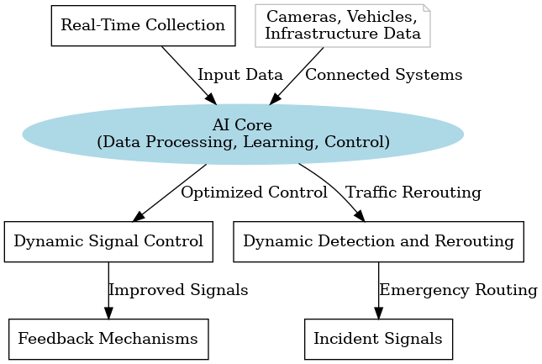Figure I: conceptual framework

## Chapter 3 - Methodology and System Design

This project will seek to incorporate the machine learning model development process into agile methodology as discussed below.

### 3.1 Agile Methodology

Agile methodology is a project management approach that emphasizes flexibility, collaboration, and continuous improvement. It originated in software development, but it has since been applied to many other fields, including project management, marketing, and education. The agile approach emphasizes iterative development, where projects are divided into small, manageable chunks that are completed in short cycles. This allows teams to quickly respond to changes in requirements, feedback from stakeholders, or new information that emerges during the project. Finally, agile methodology encourages continuous improvement, where teams reflect on their progress and identify ways to improve their processes and outcomes. Overall, agile methodology is well-suited to projects where requirements are likely to change, where there is a need for flexibility and collaboration, and where rapid feedback and iteration are essential for success.

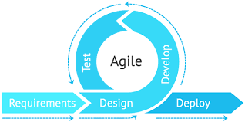Figure II: agile methodology to guide in the project

### 3.2 Justification for using Agile methodology

**Agile methodology is well-suited for this project of building a predictive model for smart traffic system. The project involves working with large amounts of data that may require constant updates and modifications, and the iterative approach of agile allows for flexibility in adapting to changes in the data or requirements. Agile methodology is conducive to this type of experimentation and iteration, as it allows for continuous feedback and improvement throughout the development process. In addition, since the project will involve constant communication between lecturer in charge and the student who is carrying out the project this methodology will be suitable. Agile methodology emphasizes communication and collaboration between members involved, ensuring that everyone is working towards the same goal and can adapt to changes in the project as needed.**

### 3.3 Project Design

The **project design** follows an **iterative approach** to ensure continuous adaptation to changing urban traffic conditions. This approach will allow for the incorporation of real-time feedback and ensure that the system evolves with the city's growth and evolving transportation needs

### 3.4 Design Procedures

#### 3.4.1. Planning and requirements phase

This is the first phase of this methodology. In the context of smart traffic system, the requirements and planning phase of agile methodology involves several key steps. First, the scope and objectives of the project will be defined, as well as identify any constraints or limitations that may impact the project's success. This includes understanding the specific data available, as well as the intended use cases for the model. Next step will involve creating a prioritized list of features or requirements for the model.

#### 3.4.2. Design phase

In the design phase of the project, the focus will be on defining the system architecture and data models to be used for the predictive model. This phase will involve designing the data processing pipeline to clean, transform and preprocess the data. Also, the design of the model architecture will be carried out, including the selection of appropriate machine learning algorithms and techniques for the prediction of product demand. Furthermore, the design phase will also involve developing the necessary software tools and infrastructure to support the model development and evaluation process. This will include setting up the necessary hardware and software environments for model development, testing, and deployment. Finally, the design phase will involve the creation of the project plan, including setting milestones and defining the criteria for the completion of each phase of the project.

#### 3.4.3. Development phase

During the development phase of the project using agile methodology, the focus is on the implementation of the design and the creation of the model. This phase involves a lot of collaboration and communication between the student and lecturer, as they work together to develop the models and ensure that they meet the requirements of the project. In the context of the project on smart traffic system, the development phase would involve implementing the ensemble model. The research will work to ensure that the models are properly integrated and that the data is being processed correctly.

#### 3.4.4 Testing phase

The testing phase of an Agile project is an evaluation phase where the project's success is assessed based on the criteria set in the planning phase. It is essential to test the system's functionality and performance before releasing it into production. Testing helps to ensure that the system meets the client's requirements, is user-friendly, and operates reliably. In the context of the project on smart traffic system, the testing phase would involve testing the accuracy and effectiveness of the model. This would be done by comparing the smart traffic system against actual traffic system to determine the accuracy of the model.

The testing phase would also involve testing the system's performance by assessing its ability to handle large amounts of data and processing requests quickly. Additionally, the system's reliability would be tested to ensure that it can function without errors and provide accurate solutions consistently. During the testing phase, any defects or issues identified would be reported, tracked, and fixed in subsequent iterations. This would ensure that the system is continually improved, and the quality of the model is enhanced.

#### 3.4.5 Model process

**Data Collection Layer (Sensors)**: IoT-enabled devices (such as cameras, sensors, and inductive loops) are deployed along roads and intersections to capture real-time data on vehicle count, speed, and traffic congestion.

Data is sent to the **Processing Layer** for analysis.

**Processing Layer (AI)**: **AI Models**: Machine learning algorithms analyze real-time data to predict traffic patterns, detect congestion, and optimize traffic signals.

**It i**mplements traffic flow algorithms that control traffic lights in real-time based on input from the AI model. It also stores historical traffic data for trend analysis.

**Control Layer (Traffic Signals)**:Traffic signal controllers adjust light timings dynamically based on AI recommendations.

Communication with traffic lights is established using protocols.

#### 3.4.6 System Architecture

The system architecture defines the structural framework of the traffic simulation, highlighting the interaction between its key components. At its core, the architecture revolves around four main elements: vehicles, sensors, traffic lights, and the central control system. Vehicles are represented as moving entities within the simulation, responding to signals and other traffic conditions. Sensors are deployed to detect the presence of vehicles at intersections and relay this information to the control system. The central control system acts as the decision-making hub, processing inputs from the sensors and generating outputs to control the traffic lights. Traffic lights manage the flow of vehicles by alternating between predefined states (red, yellow, and green) based on the control system's decisions. Data flows seamlessly between these components, ensuring that the system functions dynamically and adapts to real-time conditions.

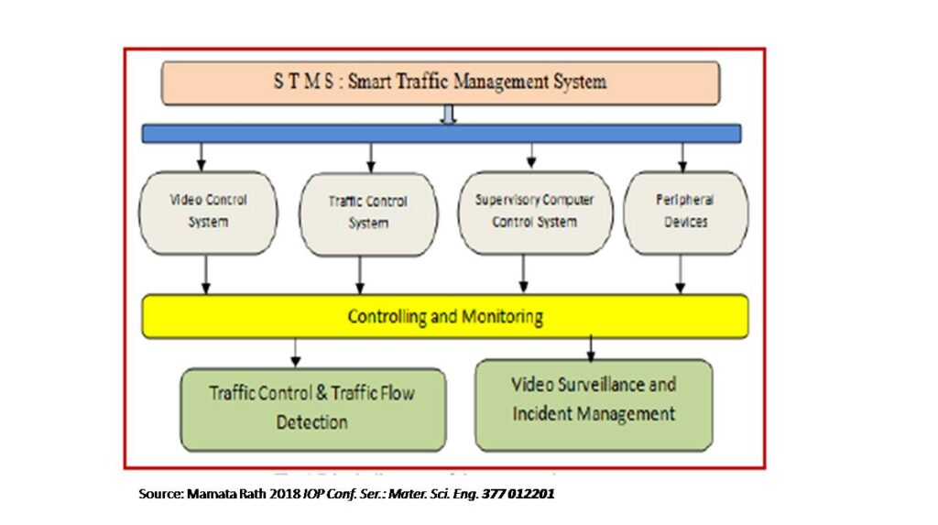Figure III: System Architecture

### 3.5 System Requirements

#### 3.5.1 Hardware Requirements

8 GB Ram for the device computer

Core i5 processor

A computer speed of 2.5 GHz

A hard disk with at least 50 GB

#### 3.5.2 Software Requirements

The prototype will leverage AI and machine learning tools, with Python as the primary programming language for developing predictive algorithms and models. These tools will analyze traffic data and enable accurate forecasting, paving the way for smarter traffic management solutions.

PostgreSQL will serve as the database management system, providing a reliable platform for storing and analyzing large volumes of traffic data. Its advanced querying capabilities will ensure efficient data handling, essential for real-time and historical traffic analysis.

For traffic modeling and visualization, SUMO will be utilized as a simulation tool. It will enable detailed traffic modeling and testing of various scenarios, offering a controlled environment to evaluate the performance of algorithms before deployment in real-world settings.

#### **3.5.3 Communication Network**

**The prototype will rely on using TraCI (Traffic Control Interface), SUMO’s API, which allows real-time communication between the simulation environment and external programs.**

### 3.6 Analysis Techniques

The analysis phase of the project will incorporate a range of techniques to derive meaningful insights from traffic data.

Descriptive analysis will use statistical methods to examine current traffic patterns and conditions. This will provide a clear understanding of existing trends and serve as a foundation for further analysis.

Predictive analytics will involve the development of machine learning models to forecast traffic congestion. By leveraging historical and real-time data, these models will predict future traffic scenarios, enabling proactive traffic management strategies.

Visualization techniques will play a key role in presenting data through graphical representations. These visual tools will enhance decision-making and facilitate effective communication by making complex data easier to interpret and understand.

## Chapter 4 - MODEL ANALYSIS AND REQUIREMENT SPECIFICATION

### 4.1 Introduction

In this chapter, we will focus on model analysis for the predictive modeling for smart traffic system. The goal of model analysis is to identify the problem, define the requirements, and design a solution that meets the needs of the stakeholders. The proposed model will provide quick and efficient prediction for traffic systems.

### 4.2 Detailed Analysis of the Existing System

The current traffic management system in Nairobi primarily relies on manually controlled traffic lights and basic static timers at major intersections. This system does not adapt dynamically to fluctuating traffic patterns, resulting in inefficiencies such as extended congestion during peak hours and underutilized roads during off-peak hours. Below is a detailed analysis using various modeling techniques

#### 4.2.1 **Flowchart of Existing System**

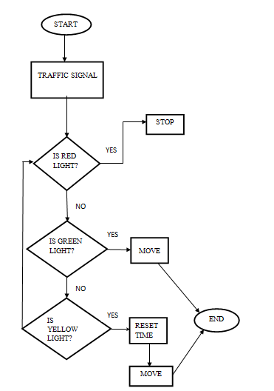Figure IV: Flowchart of Existing System

## 4.3 Proposed model

This model will be a functional prototype that integrates **Machine Learning** technologies to manage and optimize traffic flow aiming to improve traffic management and reduce congestion.

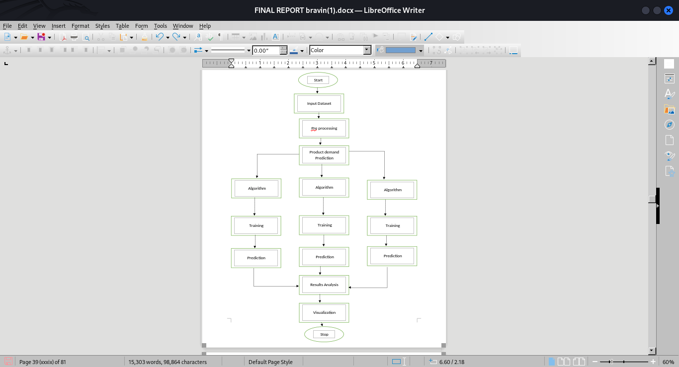Figure V: flowchart for the proposed model

### ****4.5 Class Diagram****:

### ****4.3 Context Diagram****

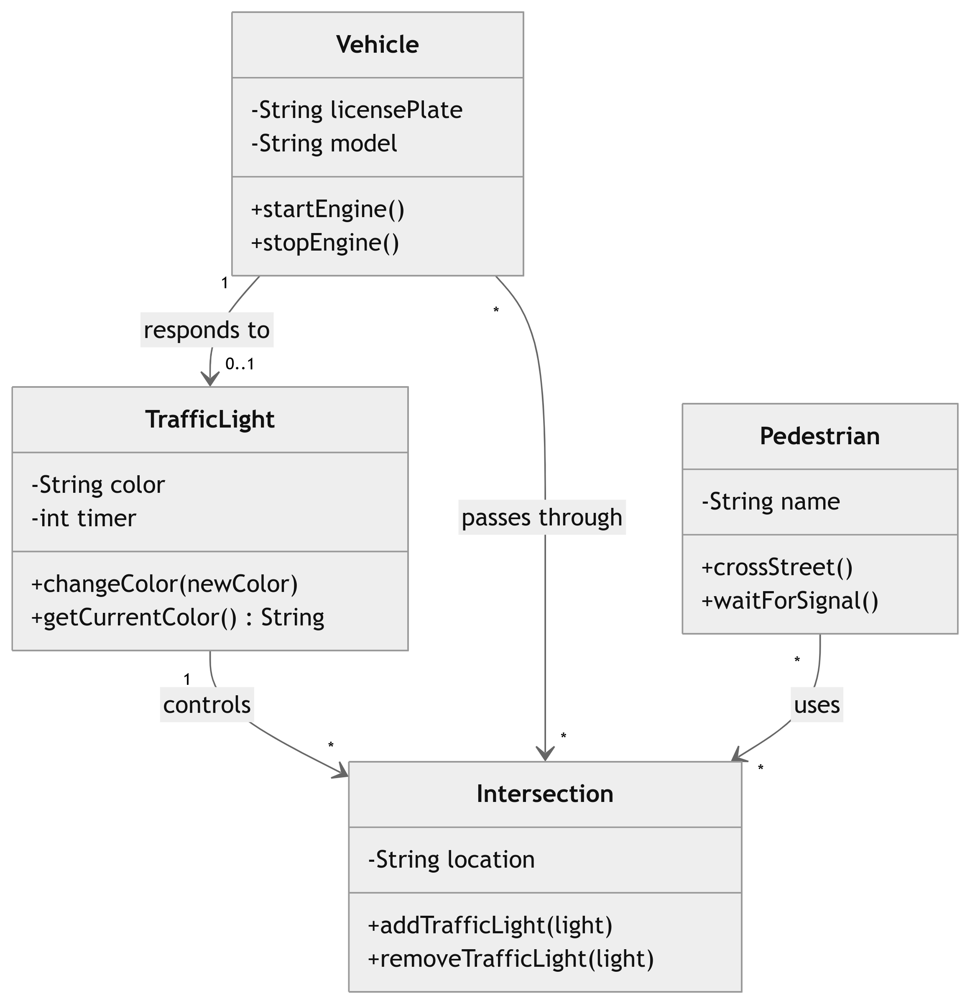Figure VI: Class Diagram

### 

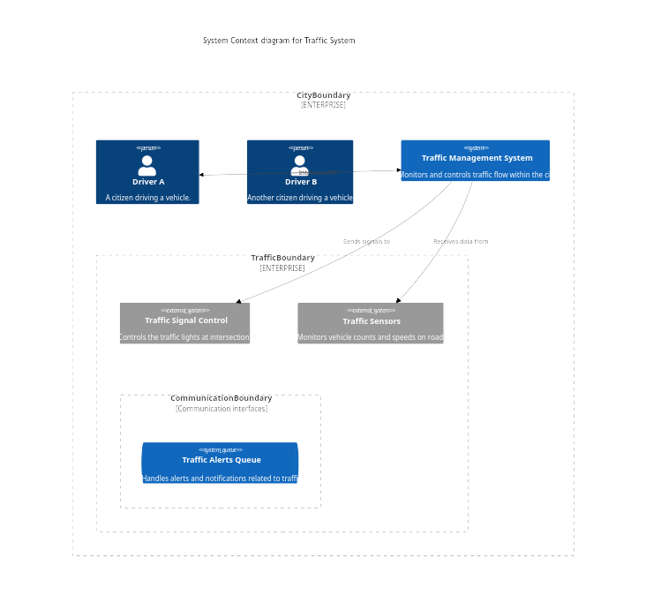Figure VII: Context Diagram

### 4.4Limitations of the Current System

Current traffic management systems face several limitations that affect their efficiency and adaptability.

Many rely on pre-programmed traffic light schedules and static rules, making them incapable of dynamically adjusting to real-time traffic conditions.

High latency is another issue, as centralized processing systems can cause delays in data transmission and decision-making, which are critical in time-sensitive scenarios.

Additionally, most systems lack advanced predictive capabilities, limiting their ability to foresee and address potential traffic congestion or accidents.

Scalability is a significant challenge as urban areas expand and traffic volumes grow, making it difficult for traditional systems to maintain performance and reliability.

Resource constraints, such as outdated networks or the absence of edge computing, further contribute to inefficiency.

Lastly, the lack of intuitive data visualization tools hampers the ability of stakeholders to interpret traffic patterns and make informed decisions.

Addressing these issues through modern AI-driven solutions can greatly enhance traffic management systems' effectiveness and scalability.

### 4.4 Requirements Definitions and Specifications of the Project

#### 4.4.1 User Requirements

1. The model should provide a simulated environment that models real-world traffic intersections and integrates an AI-based decision-making model to optimize traffic flow.
2. The model should provide easily interpretable results to users.

#### 4.4.2 Functional Requirements for the New System

The proposed smart traffic management system aims to leverage AI-driven technologies to enhance traffic efficiency and address the limitations of the current setup.

Advanced AI algorithms will process data from sensors and cameras to analyze traffic flow at intersections in real time, ensuring timely and informed decision-making.

Traffic lights will adjust dynamically based on real-time traffic conditions to reduce congestion and minimize waiting times for vehicles.

The system will utilize AI to identify incidents such as accidents or vehicle breakdowns by recognizing unusual traffic patterns and sensor data anomalies.

In response to detected incidents, the system will adapt traffic flow and recommend alternate routes to affected vehicles, reducing delays and enhancing road safety.

The system will simulate various traffic scenarios, such as rush hours, road accidents, or construction zones, enabling planners to evaluate and optimize traffic strategies effectively.

#### 4.4.3 Non-Functional Requirements

The system should be designed to expand seamlessly, accommodating larger intersections or city-wide implementations without significant performance degradation.

It must maintain continuous operation with minimal downtime, especially during peak traffic hours, to ensure consistent traffic management.

Real-time data processing is essential, enabling the system to adjust traffic signals instantly based on current traffic conditions and maintain smooth flow.

Robust mechanisms must safeguard collected traffic data, ensuring secure storage and compliance with privacy regulations to protect users' sensitive information.

The system should provide clear, real-time visualizations of traffic data and system status to support monitoring and decision-making by operators.

## Chapter 5-MODEL DESIGN

### ****5.1 Introduction****

This chapter provides a comprehensive overview of the system design for the traffic system simulation, it covers the design environment, system components, and detailed designs. The primary objective is to create a simulated environment that models real-world traffic intersections and integrates an AI-based decision-making model to optimize traffic flow. The design captures key elements such as vehicle behavior, traffic light operations, and centralized control logic. By systematically breaking down the design into its core components and subsystems, this chapter ensures clarity and a strong foundation for the system's implementation.

### ****5.2 System Architecture****

1. **Application Layer (Top Layer)**This layer will serve as the interface for user interaction and will manage the overall control logic of the system.

**Components:** The interface will enable users to interact with the system by configuring simulation parameters, observing results, and controlling the simulation. It will feature an intuitive design for ease of use. The logic will manage the behavior of vehicles, sensors, and traffic lights within the simulation. It will implement algorithms that mimic real-world traffic conditions to produce realistic outcomes. This component will display real-time results, such as vehicle flow and congestion levels, through graphical dashboards and charts. It will also support exportable reports for analysis.

**Data Flow**:User inputs will be captured and sent to the Network Layer for further processing. The system will render results received from the Service Layer for user interpretation.

1. **Network Layer (Middle Layer)**This layer will facilitate communication between the Application Layer and the Service Layer. It will ensure secure, reliable, and low-latency data transmission.

**Components**:Protocols will be used for data exchange between sensors, traffic lights, and the central control system. Custom protocols may also be developed for specific tasks. The system will include tools to monitor connectivity, manage bandwidth, and prioritize critical data flows to ensure smooth operation. Mechanisms will be implemented to detect, log, and recover from errors such as data packet loss, mismatched formats, or delayed transmissions.

**Data Flow**:Commands and data will be routed from the Application Layer to the Service Layer. Processed results and feedback will be relayed back to the Application Layer for user display.

1. **Service Layer (Bottom Layer):** This layer will provide the core functionalities of the system, interfacing directly with hardware components or virtual simulations.

**Components**:This component will collect data from sensors (real or simulated) and preprocess it for analysis. The service will manage traffic lights, ensuring that they respond dynamically to commands from the central control system. Machine learning models or rule-based systems will be deployed to analyze traffic data, predict congestion patterns, and optimize signal timings. Historical data will be stored in a database for future analysis, model improvements, and reporting.

**Data Flow**:Inputs from sensors will be processed and transmitted to the Network Layer. Commands from the Network Layer will be executed, such as adjusting traffic light timings.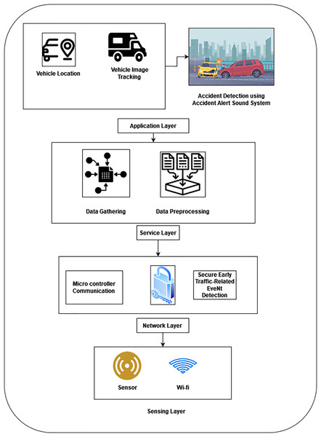

### ****5.3 System Components****

**Sensors** are a critical part of the system, as they detect vehicles' presence or movement. These could be virtual sensors in the simulation or real-world equivalents such as infrared or magnetic sensors.

**Traffic lights** serve as the primary mechanism for managing vehicle flow at intersections. Each traffic light can display red, yellow, or green signals based on control instructions.

The **AI Model** is a key innovation in the system, leveraging machine learning or rule-based approaches to predict traffic patterns and optimize signal timings. This model analyzes data inputs and generates decisions aimed at reducing congestion and improving overall traffic flow.

**Central Control System** acts as the coordinating unit, receiving inputs from sensors, processing them through the AI model, and sending commands to traffic lights, ensuring a cohesive operation of the system.

#### **5.3.1 ERD (Entity-Relationship Diagram)**:

Visual representation of sensor, traffic data, signal, and AI prediction entities and their relationships.

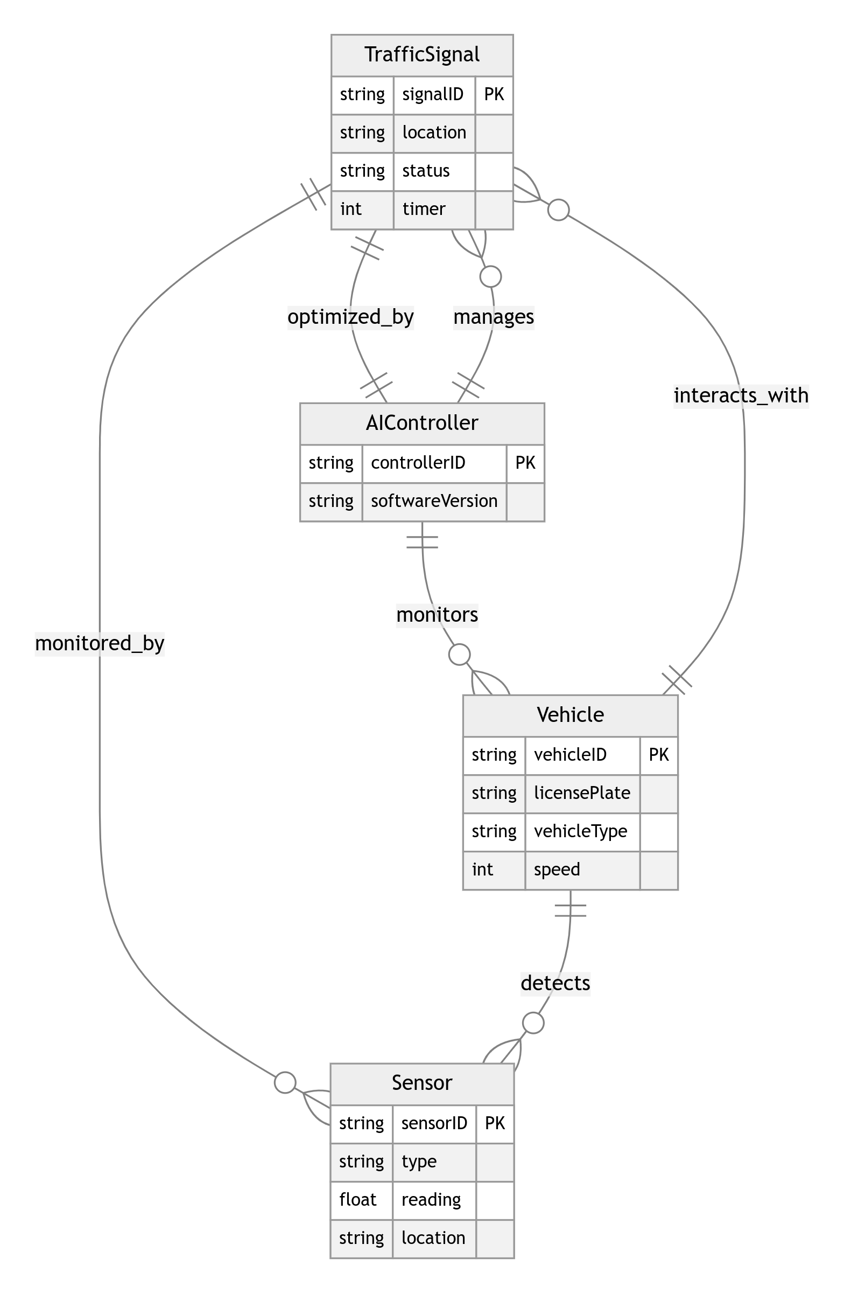Figure VIII: ERD diagram

### ****5.5 Data Flow and Interactions****

The flow of data and interactions between components is crucial for the system's functionality. The process begins when vehicles arrive at intersections and are detected by sensors. These sensors send real-time data, such as vehicle count and waiting times, to the central control system. The control system processes this information, using the AI model to analyze the current traffic scenario and predict the most efficient traffic light sequences. Based on the AI's output, the control system updates the traffic lights, signaling vehicles to either stop or proceed through the intersection. Vehicles respond accordingly, completing the interaction cycle. This continuous feedback loop ensures that traffic flows dynamically and adjusts to changing conditions.

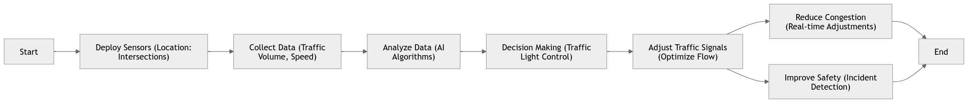Figure IX:Sequence Diagram.

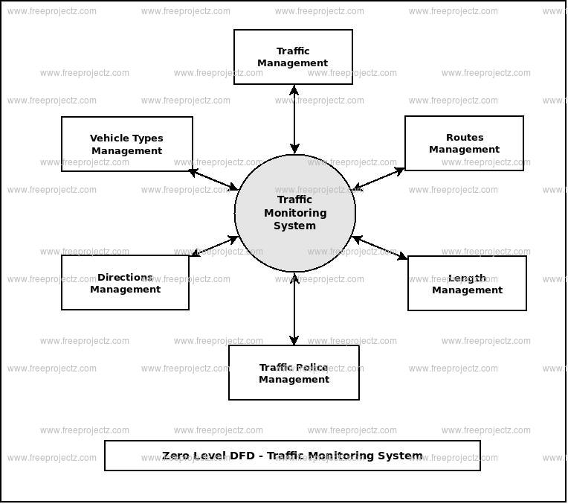Figure X: DFD Diagram

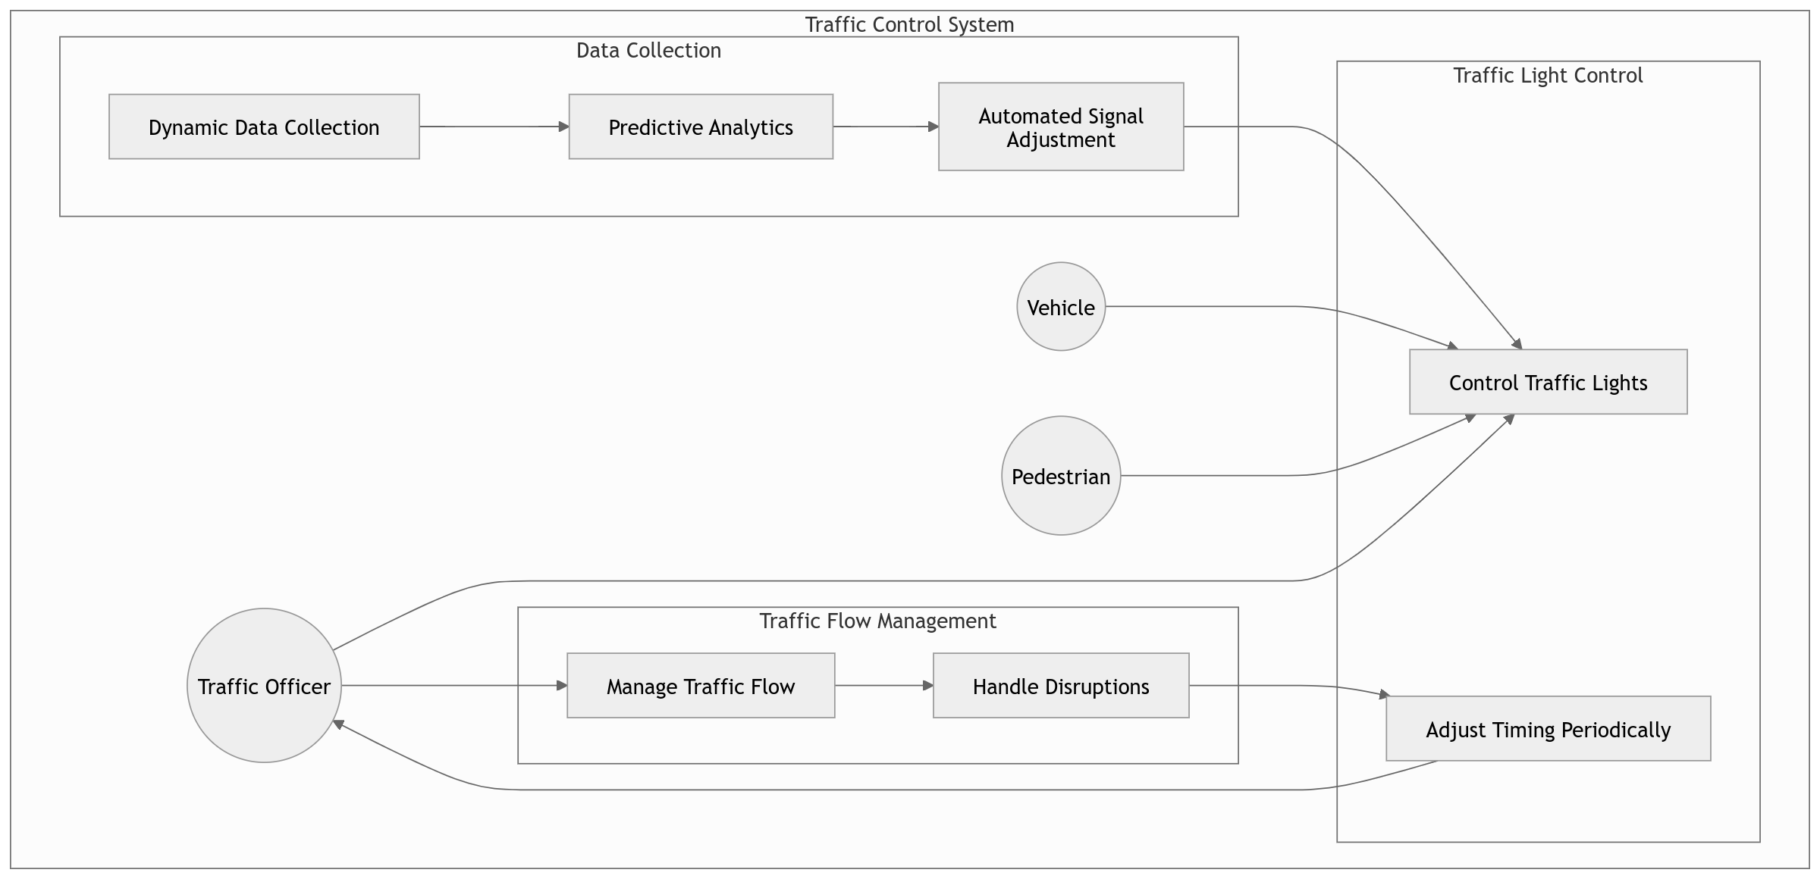Figure XI: UML Diagram

## Appendices and References

### Appendices

#### Project budget

|  |  |  |
| --- | --- | --- |
| Expenses | Description | Amount (KSH) |
| Software | SUMO, PYTORCH | Available |
| Laptop | Brand: Dell latitude E6420  Speed:2.4ghz  Processor: i5  Ram:8gb  HDD:500gb | 30000 |
| Internet services | Internet bundles | 1500 |
| Others | Printing and Binding | 500 |
| TOTAL |  | 32,000 |

#### References

Jones, T. (2022). Vulnerabilities in Centralized Traffic Control Systems: Lessons Learned from Los Angeles. *Journal of Urban Planning*, 18(2), 125-132.

Karanja, J., & Mwangi, M. (2020). Evaluating smart traffic solutions in East African cities: A case study of Nairobi. *International Journal of Traffic and Transportation Engineering*, 8(3), 45-58.

Lee, S. (2021). Data Privacy in Smart Traffic Systems: Risks and Mitigations. *Urban Technology Review*, 27(1), 99-115.

Mungai, R., & Kamau, J. (2022). The role of mobile technology in traffic management: Evidence from Nairobi. *Journal of Urban Technology*, 29(2), 75-89.

Odhiambo, A. (2023). Challenges of implementing smart traffic systems in Nairobi. *East African Journal of Infrastructure Studies*, 12(1), 15-30.

Smith, L., & Chang, P. (2020). Adaptive Signal Control in Los Angeles: A Case Study. *Transportation Research Record*, 2674(10), 115-124.

Tan, J., Wong, K., & Lim, S. (2021). Singapore's Intelligent Transport System: An Overview. *Journal of Transportation Engineering*, 147(4), 04021001.

**UN Habitat. (2020).** Nairobi: An Emerging Smart City. United Nations Human Settlements Programme. Retrieved from [https://www.unhabitat.org](https://www.unhabitat.org/)

**Zhang, Y., & Liu, L. (2021).** Machine Learning Applications for Traffic Flow Prediction: A Case Study of Real-Time Traffic Management in Beijing. Computers, Environment, and Urban Systems, 86, 101553.

**Mohan, K., & Gupta, S. (2020).** Overcoming Technological Barriers in Smart City Traffic Management. Smart City Technologies Journal, 15(4), 34-47.

**Sun, H., & Li, F. (2022).** A Survey on Real-Time Traffic Signal Control Using Reinforcement Learning. IEEE Access, 10, 75312-75329.

**Guan, W., & Wang, X. (2020).** Artificial Intelligence in Transportation: A Review of Recent Advances and Future Directions. Transport Reviews, 40(5), 669-685.