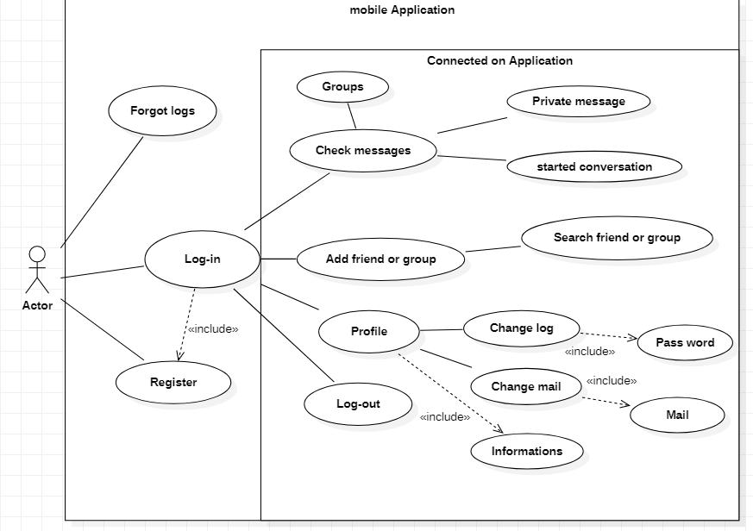UML (Use Case)

Description:

This Diagram describe what system does from the standpoint of an external observer. Use case diagrams is connected to scenarios. Here we can observe on the diagram one typical situation Firstly the actor/user will log-in on apps with UI. But he needed to be registered before. When the user is on the UI, he has 4 choice: check message, Add friend or group, consult profile and log-out. These actions are really basic for every mobil application. On the model there are the main choice to basic apps and with Use Case Diagram we can get an overview on the project. Here we get only the Point of view of users.

1. **Functional requirements**

After apps was opened by user:

**Log-in:** User enter ID and Password and if there are ok, he is logged.

**Forgot Logs:** User doesn’t remember logs he can go to forgot logs page and retake them with ID and e-mail.

**Register**: For new user he can create account with ID password and other personal information.

When user is logged, he gets only 4 options.

**Check message:** user can check and write easily messages with only one click on message button. After he will have 3 options : start conversation, look private message and see statues of groups.

**Add group or friend:** to start conversation the user needs to add friend or join/ create one group**.**

**Profile:** user can check personal profile and change information like Password, e-mail …