**Analyzing Adventure Works Data Warehouse using PowerPivot in MS Excel.**

Before you begin, you will need to make sure that the PowerPivot Extension is enabled in MS Excel:

1. Open a blank workbook in MS Excel on our virtual desktop.
2. Click on **File**.
3. Select **Options**.

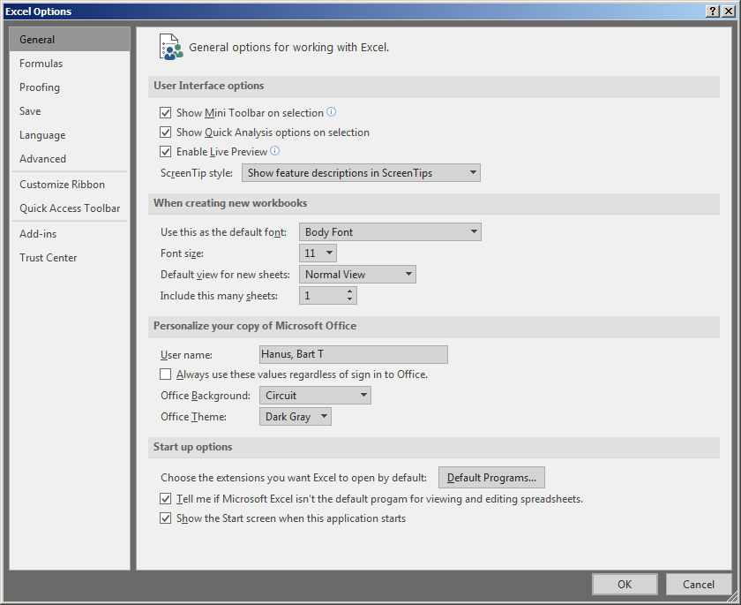

1. Click on **Add-ins**.

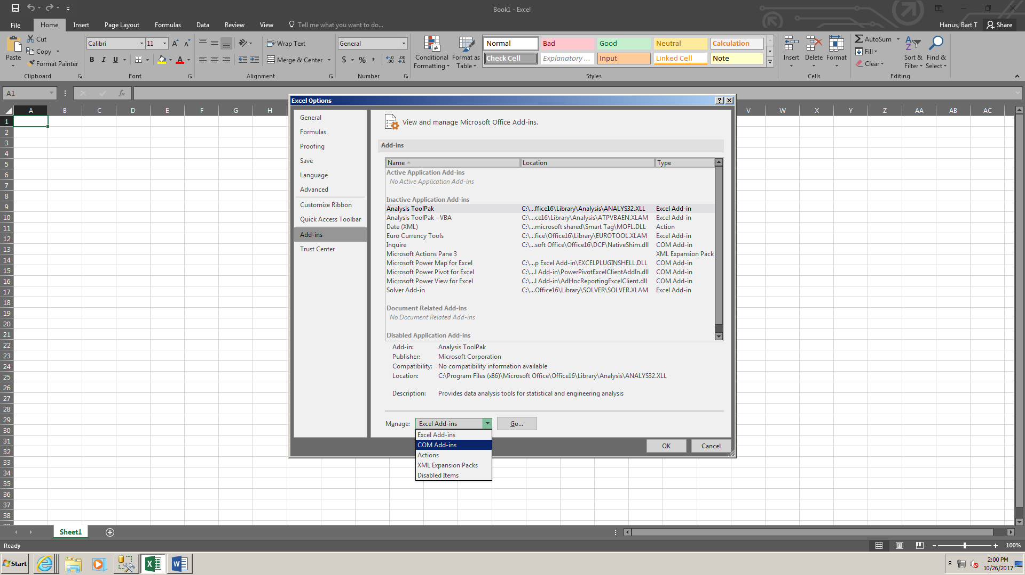

1. From the **Manage** menu, select **COM Add-ins** and click **Go**.

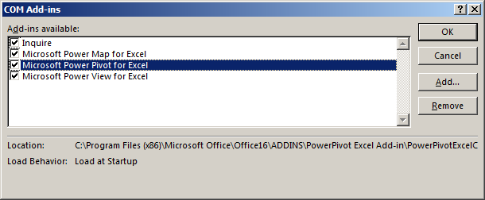

1. Select the checkbox next to **Microsoft Power Pivot for Excel**. You can also enable other add-ins, but for the purpose of this exercise, we will need only Power Pivot enabled.
2. Click **OK**. NOTE: Steps 1-7 need to be performed only once on a given computer. As of version 2016 of MS Office, Power Pivot is available only for MS Windows.

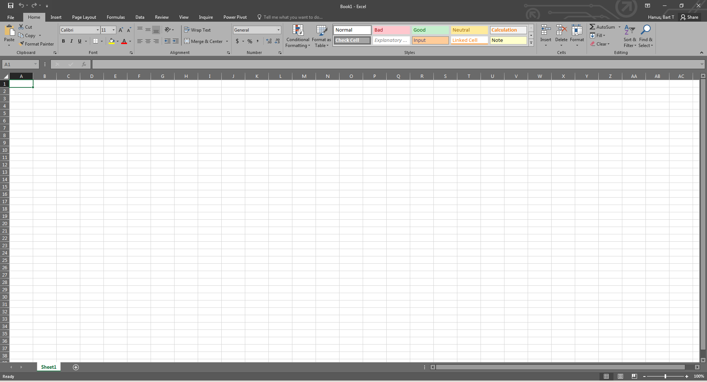

1. Power Pivot should now be visible as one of the tabs on the Excel menu.
2. Select **Power Pivot** on the menu.

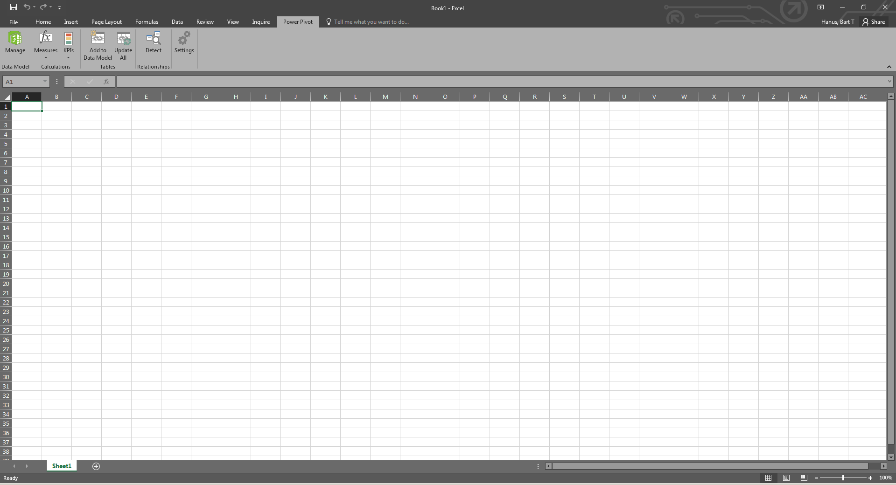

1. Click on **Manage**.

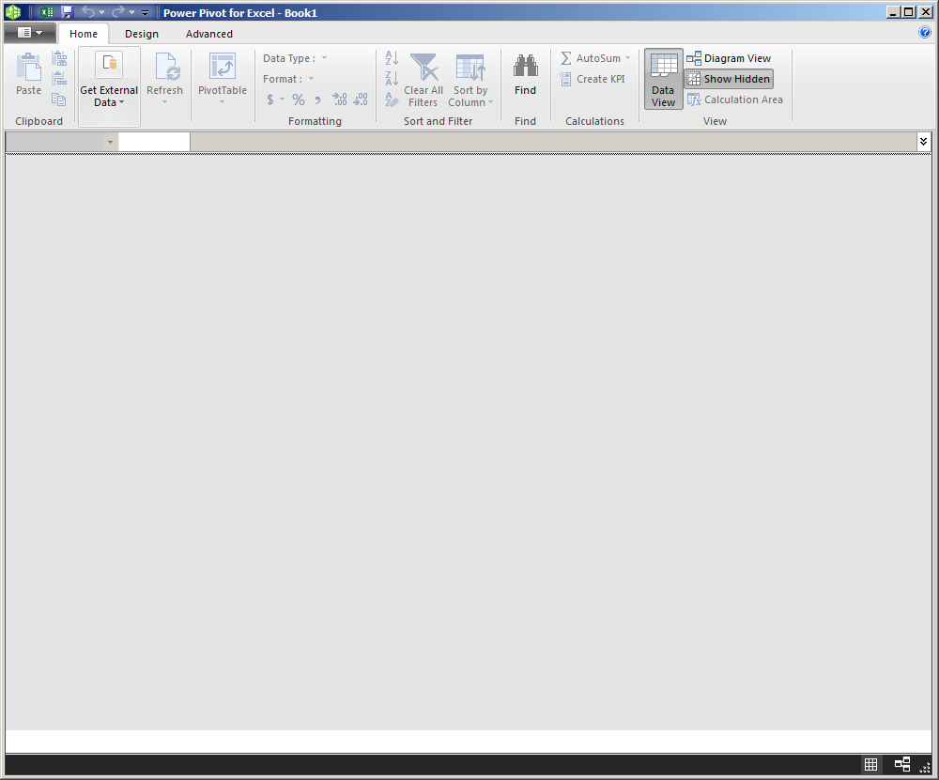

1. Click **Get External Data -> From Database -> From SQL Server**.

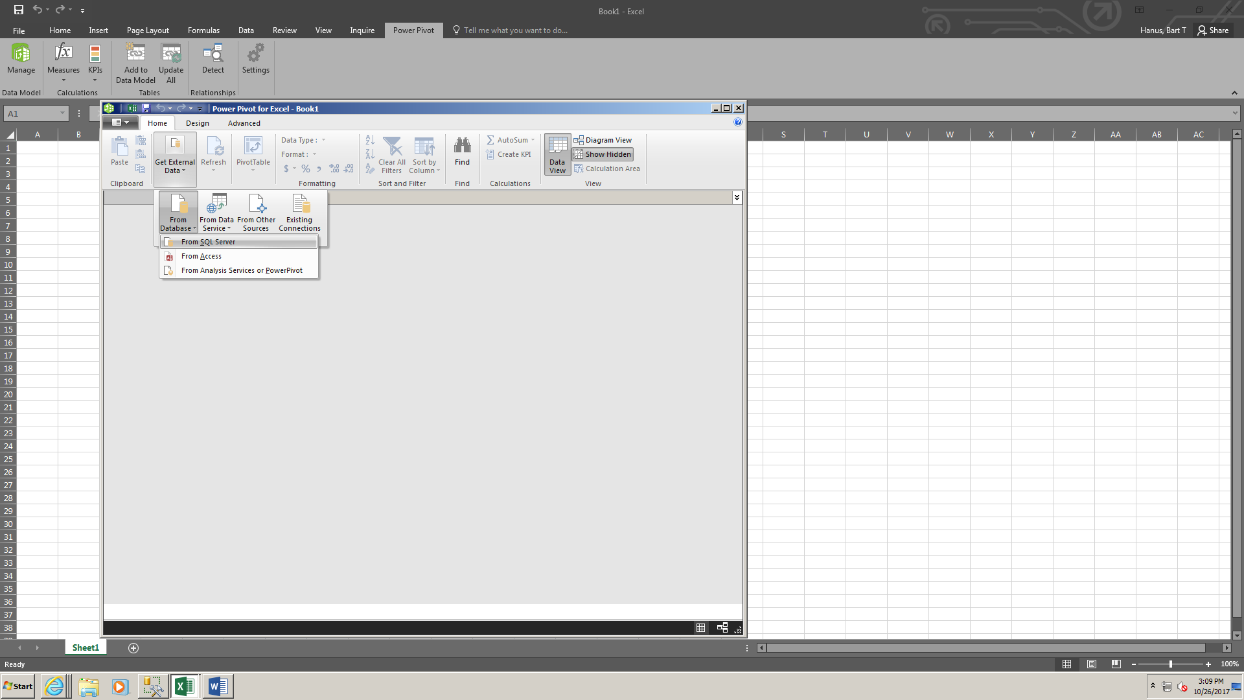

1. A new window, **Table Import Wizard,** opens. Enter the following information:
   1. **Friendly connection name**: *AdventureWorksDW2019* (or anything else you will remember)
   2. **Server name**: *localhost* (that’s the same instance that we use when connecting through SSMS)
   3. After you enter the Server name, you should be able to click on the dropdown menu next to the **Database name**. Select *AdventureWorksDW2019*.
2. Click on the **Test Connection** button. You should see the following message:

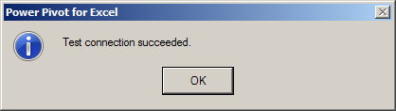

1. Back in the **Table Import Wizard** window, click **Next**.

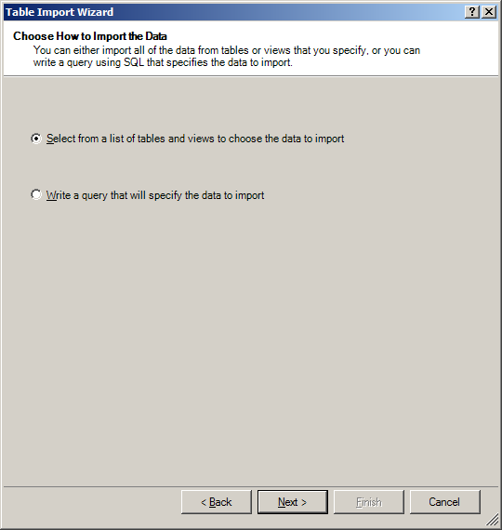

1. On the **Choose How to Import the Data** page, make sure that *Select from a list of tables and views to choose the data to import* option is selected. Click **Next**.
2. We can select the tables loaded into the Power Pivot data model on the Select Tables and Views page. Select the following:
   1. Dimension tables:
      1. *DimCurrency*, *DimCustomer*, *DimDate*, *DimGeography*, *DimProduct*, *DimProductCategory*, *DimProductSubcategory*, *DimPromotion*, *DimSalesTerritory*
   2. Fact table:
      1. *FactInternetSales*

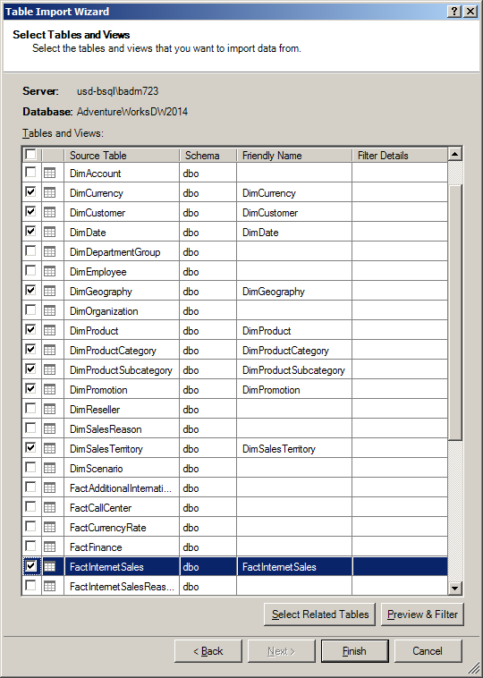

1. Click **Finish**. After you click the **Finish** button, you will see the **Importing** page. Note that it may take a few moments to complete the process. Once finished, you should see the following screen:

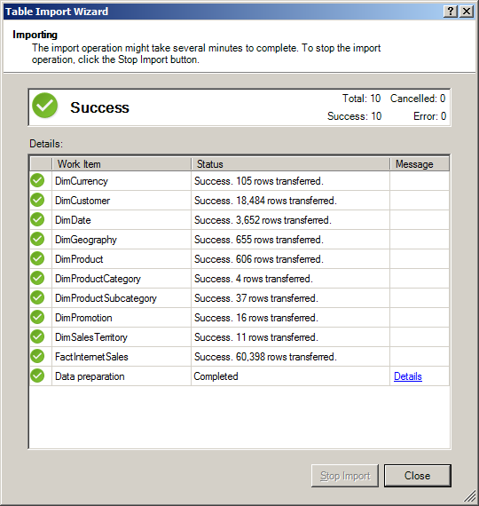

1. Click **Close**.
2. You are now back in the Power Pivot environment with the **Data View** option (see the image below). The tables that we have imported are listed at the bottom of the screen (again, see the image below). You can switch between them to look at the data in each one.

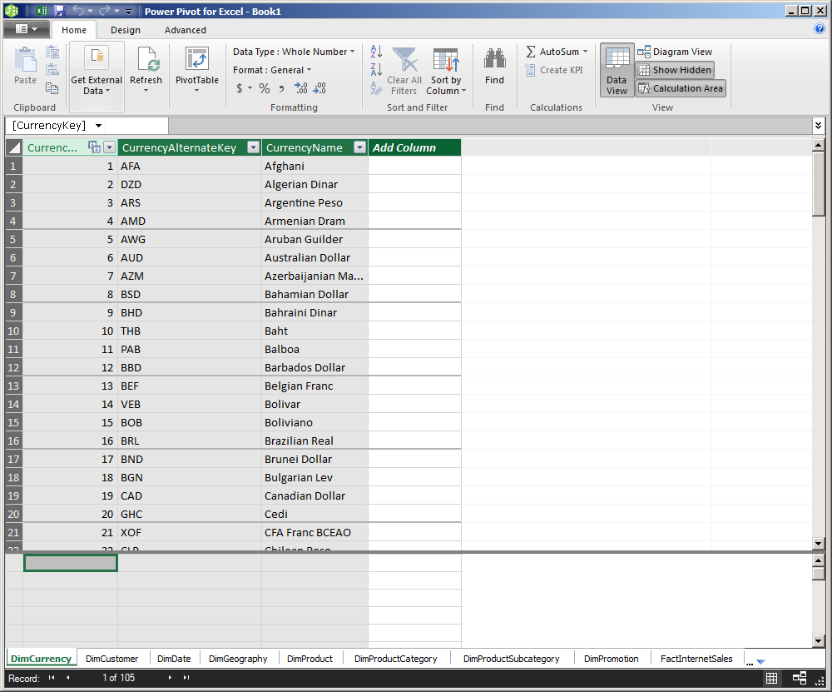

1. Now, click on the **Diagram View** button (as shown below). The view now shows the structure of all tables along with their relationships. If you point the mouse cursor over a relationship, Excel will highlight the fields between which that relationship is created.

NOTE that the **FactInternetSales** table is in the center, with the dimension tables linking to it. AdventureWorksDW is based on a dimensional model (star schema), as we saw in chapter 8.

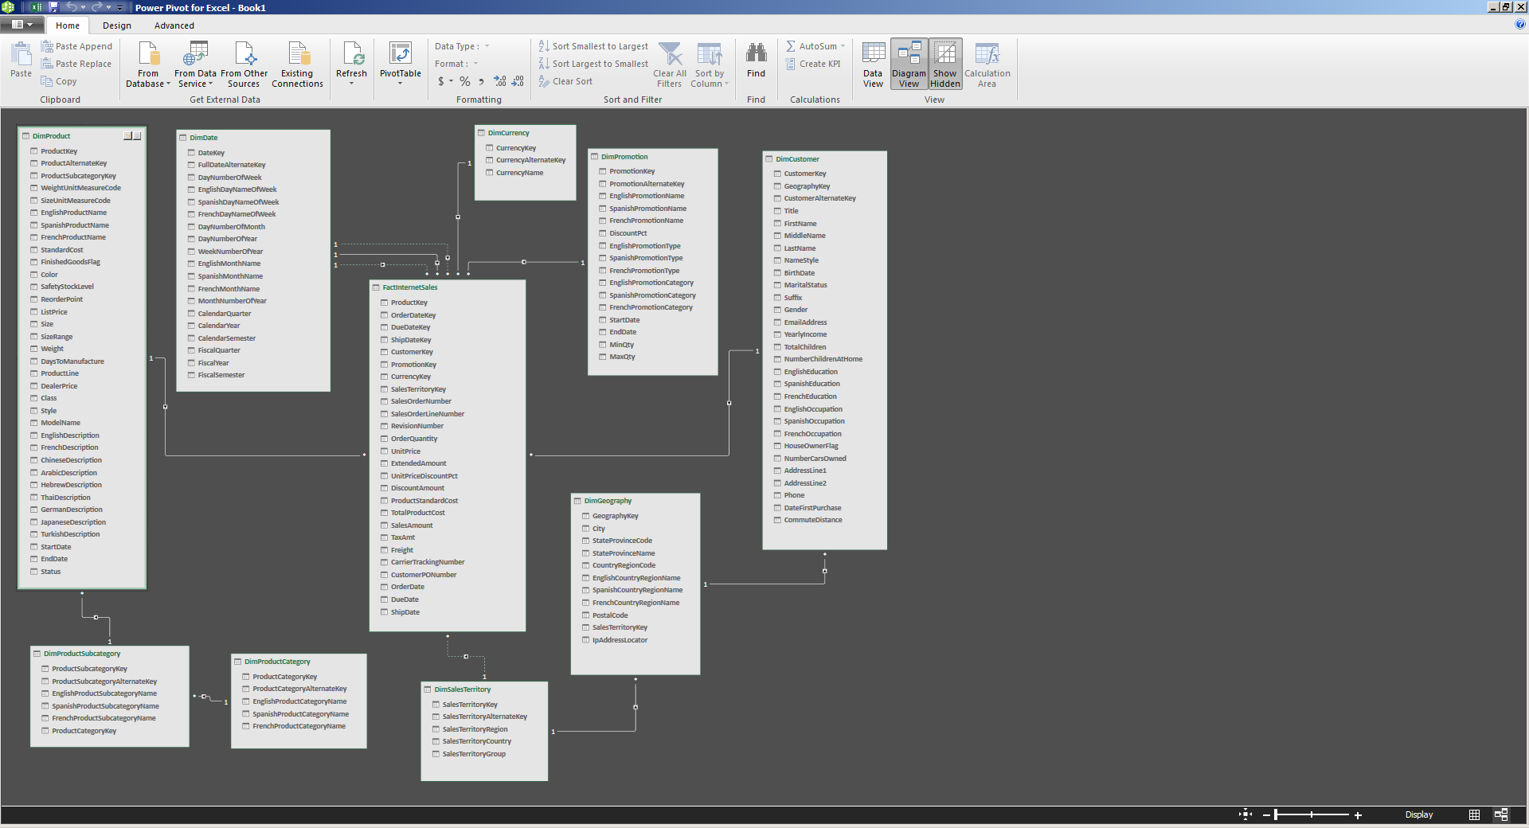

1. To review the exact structure of the relationships, click on the **Design** tab and select **Manage Relationships**.

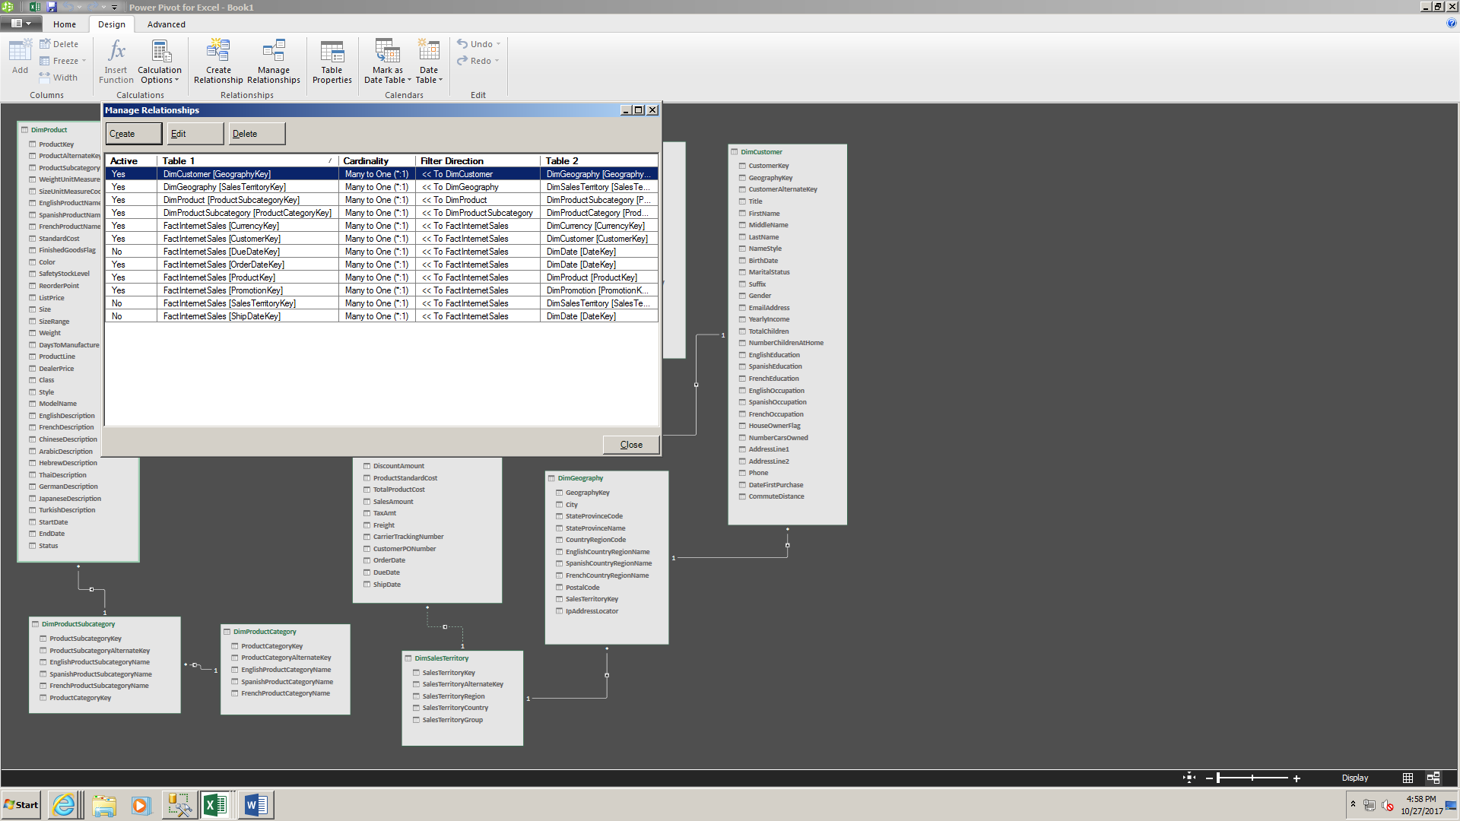

1. The **Manage Relationships** window lists all the relationships present in our data model. Notice that three relationships exist between DimDate and FactInternetSales, but only one (on **OrderDateKey**) is active. Power Pivot has a limitation – each table can participate once in a relationship as a related (i.e., “lookup”) table. We need to modify specific settings to make sure that the relationship between **FactInternetSales** and **DimSalesTerritory** becomes active,
2. First, we will deactivate the relationship between **DimGeography** and **DimSalesTerritory**. Select that relationship and click **Edit**.

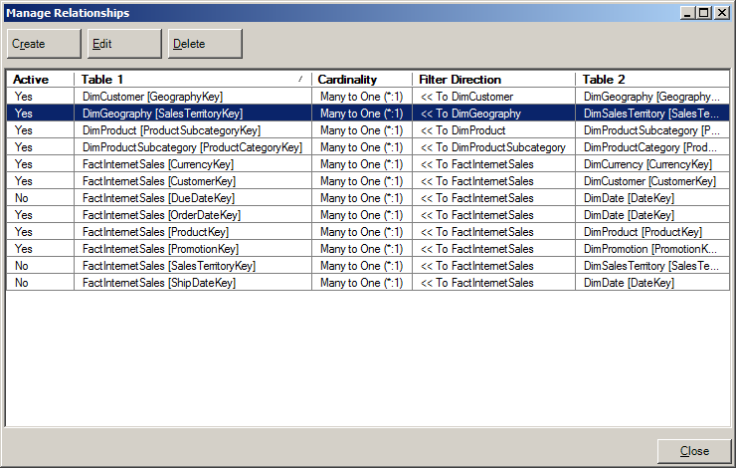

1. Uncheck the **Active** option and click **OK**.

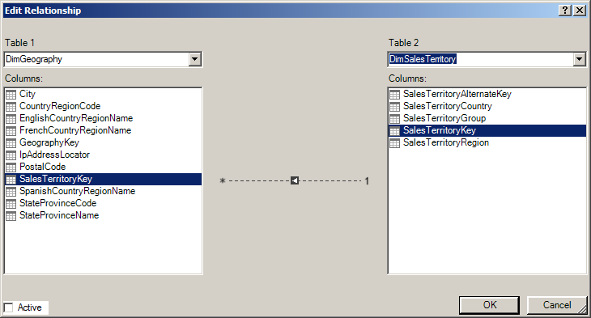

1. select the relationship between **FactInternetSales** and **DimSalesTerritory** and click **Edit**.

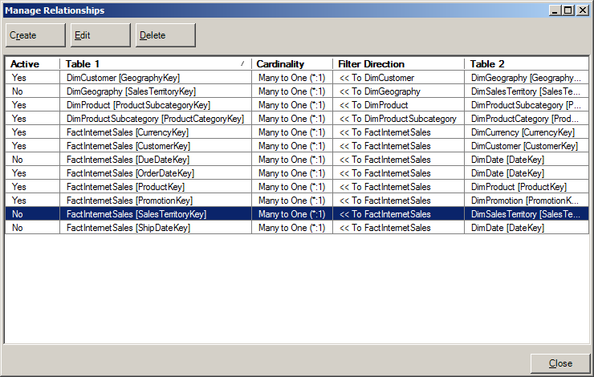

1. Check the **Active** box and click **OK**.

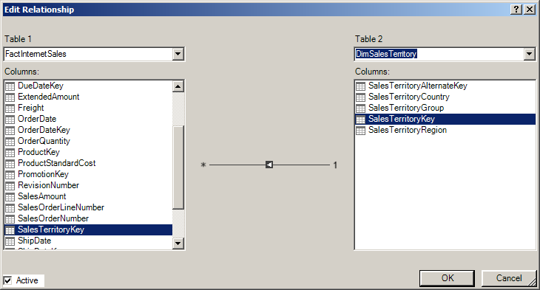

1. Back in **Manage Relationships**, click **Close**.
2. Back in the **Power Pivot for Excel** window, click on **Save**. This saves the whole Excel workbook, the data model, and the underlying data we have just created.
3. Close **the Power Pivot for Excel window. You should now be back in your** blank Excel workbook. We will now create a simple Pivot report based on our loaded data.
4. **[OPTIONAL] Create a copy of your Excel file in case anything goes wrong.**
5. Click on the **Insert** tab. Then click on the **Pivot Table** button.

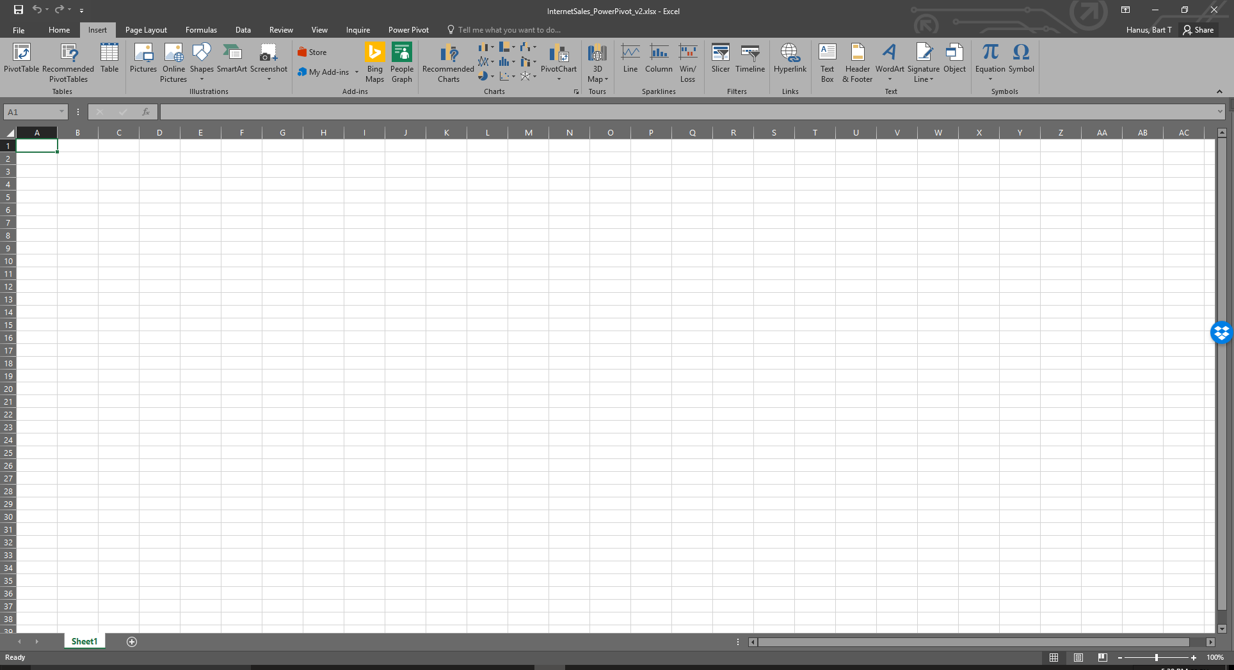

1. In the **Create PivotTable** dialog, select the following options:
   1. Use this workbook’s Data Model
   2. New Worksheet

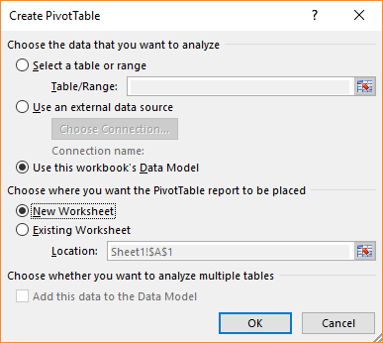

1. Click **OK**.

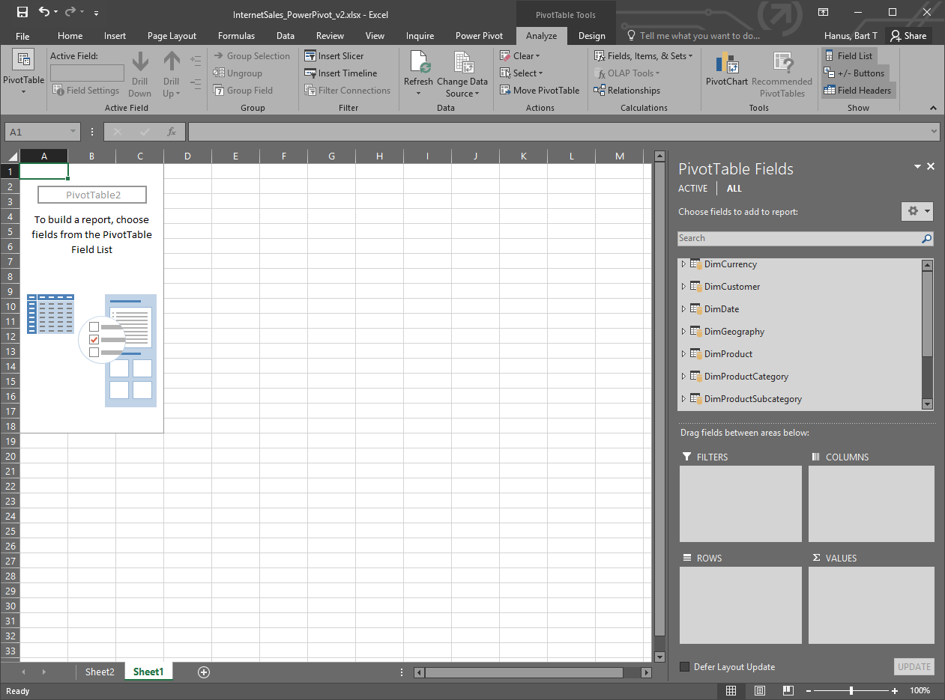

1. In the **PivotTable Fields** pane, you will find a list of all the tables that we have just imported. You can expand any table and drag any field to any of the four areas: FILTERS, COLUMNS, ROWS, and VALUES.

HINT: Rows and Columns can be used to store dimensions, against which we can model our facts

1. Your tasks:
   1. You should create a separate pivot table for each question (i.e., have each table placed on a separate sheet)
   2. Show the sales of Adventure Works products across different territories (e.g., countries)
   3. c. Have any currencies been used to pay for orders from countries outside the currency’s country of origin?
   4. Create a chart showing the monthly sales of Bikes in 2013. Can any trends be observed? What other information could we use to better understand bike sales? HINT: First, create a separate pivot table, then use it as a data source for a chart.