Basic ER Diagram (Assignment 1)

Vincent Mutungi

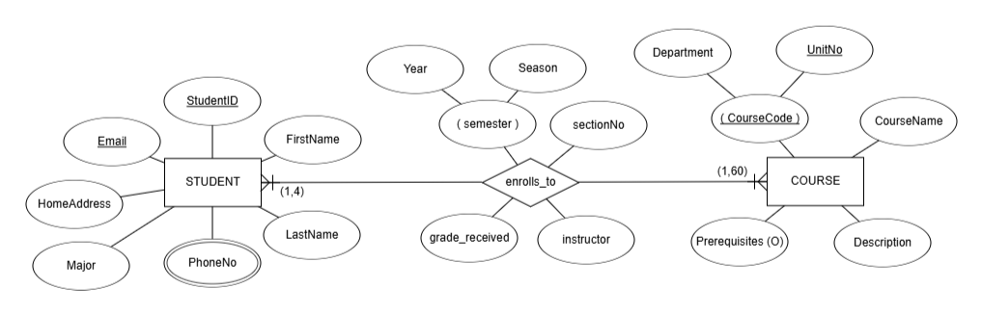

# Entities and their Attributes:

## STUDENT:

StudentID: A unique identifier for each student (e.g., student ID number).

FirstName: The student's first name.

LastName: The student's last name.

Email: The student's email address.

HomeAddress: The student's home address.

PhoneNo: The student's phone number.

Major: The student's declared major of study.

## COURSE:

CourseCode: A unique code to identify the course (e.g., "CS101").

CourseName: The course's full name (e.g., "Introduction to Computer Science").

Prerequisites (O): Indicates any prerequisite courses required before a student can enroll (the "(O)" likely signifies this is optional).

Description: A brief description of the course content.

Department: The academic department offering the course (e.g., "Computer Science").

UnitNo: A unique unit or section number within the department (e.g., "CS101-001").

# Relationship and its Attributes:

enrolls_to: This relationship connects the STUDENT and COURSE entities, representing the act of a student enrolling in a course;

semester: The semester in which the enrollment occurs (e.g., "Fall 2023").

sectionNo: The specific section number of the course the student is enrolled in.

instructor: The instructor teaching that section of the course.

grade_received: The grade the student received in the course.

Year: The academic year the enrollment occurred (e.g., "2023-2024").

Season: The season in which the course took place (e.g., "Fall", "Spring", "Summer").

# Cardinality:

(1,4) on the STUDENT side: This means a student can enroll in a minimum of 1 course and a maximum of 4 courses simultaneously.

(1,60) on the COURSE side: This means a course must have at least 1 student enrolled and can have a maximum of 60 students enrolled.

# Why the Attributes?

**STUDENT**: These attributes are essential for identifying, contacting, and managing student records. The "Major" attribute helps track student academic progress.

**COURSE**: These attributes provide a comprehensive description of a course, including its identification, name, prerequisites, content, and departmental association.

**enrolls_to**: These attributes capture the specific details of a student's enrollment in a course, including the semester, section, instructor, grade, and the academic year/season.