

**杭州电子科技大学**

**信息工程学院**

|  |  |
| --- | --- |
| **题目** | **高级程序设计报告之获取数据** |
| **专业** | **计算机技术与科学** |
| **班级** | **1班** |
| **学号** | **16905209** |
| **姓名** | **董柳平** |
| **任课老师** | **左光华** |
| **完成日期** | **2018.6.8** |

1. **实验内容**

根据所学的知识，利用python获取股票数据。

我使用的代码是601069，名称为西部黄金

1. **实验所需的包**

Tushare包

1. **代码段**

import tushare as ts

df = ts.get_h_data('601069', autype='hfq',start='2015-01-01',end='2017-12-31')

df.to_csv('D:/day/601069.csv')

df.to_csv('D:/day/601069.csv',columns=['open','high','close','low','volume','amount'])

1. **实验结果**

在D盘中的day文件夹中生成了所需的csv表格。

1. **实验感想**

通过本次实验进行了对股票数据的抓取并下载生成股票数据的csv表格，对利用python对股票的抓取有了一定的了解，更加深刻了解了抓取数据的方法。



**杭州电子科技大学**

**信息工程学院**

|  |  |
| --- | --- |
| **题目** | **高级程序设计报告之处理数据** |
| **专业** | **计算机技术与科学** |
| **班级** | **1班** |
| **学号** | **16905209** |
| **姓名** | **董柳平** |
| **任课老师** | **左光华** |
| **完成日期** | **2018.6.9** |

**1.实验内容**

根据所学方法获取26日股票均线，并获得所需要的内容。

我使用的股票代码是601069，名为西部黄金，使用资金为：$1000000。

买入10只股票。

**2.实验需求**

26日均线的作用是股价大于26日均线，后市向好；股价小于26日均线，后市向坏。

股票SMA：

MA是简单算术平均，MA(C,2)=(C1+C2)/2; MA(C,3)=(C1+C2+C3)/3;不分轻重，平均算。

**3.实验环境以及需要的包**

环境：Python2.7

包：tushare,numpy,pandas,pyalgotrade

导入：zwQTBox.py，zwSys.py，zwTools.py

1. **实验结果**

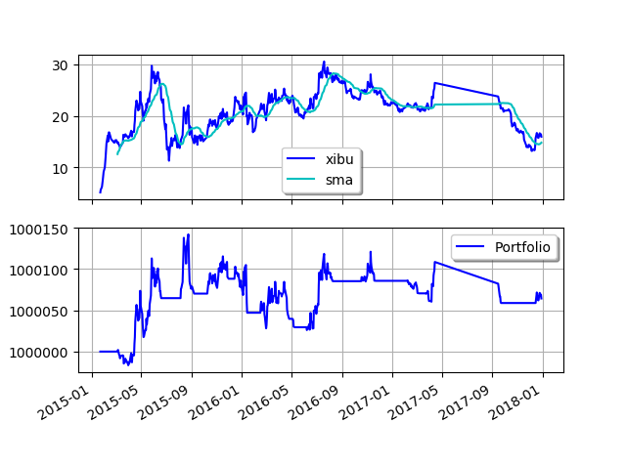

2015-03-06 00:00:00 strategy [INFO] BUY at $14.68

2015-03-16 00:00:00 strategy [INFO] SELL at $14.18

2015-03-17 00:00:00 strategy [INFO] BUY at $14.60

2015-03-18 00:00:00 strategy [INFO] SELL at $14.58

2015-03-20 00:00:00 strategy [INFO] BUY at $16.78

2015-05-08 00:00:00 strategy [INFO] SELL at $19.11

2015-05-11 00:00:00 strategy [INFO] BUY at $20.22

2015-06-17 00:00:00 strategy [INFO] SELL at $25.70

2015-06-18 00:00:00 strategy [INFO] BUY at $26.32

2015-06-19 00:00:00 strategy [INFO] SELL at $25.51

2015-08-06 00:00:00 strategy [INFO] BUY at $14.30

2015-08-28 00:00:00 strategy [INFO] SELL at $16.02

2015-08-31 00:00:00 strategy [INFO] BUY at $17.37

2015-09-01 00:00:00 strategy [INFO] SELL at $17.05

2015-09-02 00:00:00 strategy [INFO] BUY at $15.87

2015-09-07 00:00:00 strategy [INFO] SELL at $15.02

2015-10-12 00:00:00 strategy [INFO] BUY at $16.82

2015-11-30 00:00:00 strategy [INFO] SELL at $18.62

2015-12-15 00:00:00 strategy [INFO] BUY at $22.22

2016-01-05 00:00:00 strategy [INFO] SELL at $21.02

2016-01-06 00:00:00 strategy [INFO] BUY at $21.64

2016-01-14 00:00:00 strategy [INFO] SELL at $18.72

2016-02-16 00:00:00 strategy [INFO] BUY at $21.02

2016-03-01 00:00:00 strategy [INFO] SELL at $19.50

2016-03-02 00:00:00 strategy [INFO] BUY at $19.82

2016-03-30 00:00:00 strategy [INFO] SELL at $23.20

2016-03-31 00:00:00 strategy [INFO] BUY at $22.78

2016-04-08 00:00:00 strategy [INFO] SELL at $23.10

2016-04-11 00:00:00 strategy [INFO] BUY at $23.72

2016-04-19 00:00:00 strategy [INFO] SELL at $23.34

2016-04-20 00:00:00 strategy [INFO] BUY at $24.42

2016-04-21 00:00:00 strategy [INFO] SELL at $22.65

2016-04-22 00:00:00 strategy [INFO] BUY at $23.00

2016-04-25 00:00:00 strategy [INFO] SELL at $22.23

2016-05-04 00:00:00 strategy [INFO] BUY at $23.48

2016-05-05 00:00:00 strategy [INFO] SELL at $23.27

2016-05-06 00:00:00 strategy [INFO] BUY at $23.37

2016-05-09 00:00:00 strategy [INFO] SELL at $22.56

2016-06-07 00:00:00 strategy [INFO] BUY at $21.09

2016-06-08 00:00:00 strategy [INFO] SELL at $20.82

2016-06-13 00:00:00 strategy [INFO] BUY at $21.37

2016-08-05 00:00:00 strategy [INFO] SELL at $27.80

2016-08-08 00:00:00 strategy [INFO] BUY at $27.04

2016-08-09 00:00:00 strategy [INFO] SELL at $26.47

2016-10-18 00:00:00 strategy [INFO] BUY at $24.48

2016-11-21 00:00:00 strategy [INFO] SELL at $24.52

2017-02-07 00:00:00 strategy [INFO] BUY at $22.36

2017-02-16 00:00:00 strategy [INFO] SELL at $21.84

2017-02-17 00:00:00 strategy [INFO] BUY at $21.95

2017-02-21 00:00:00 strategy [INFO] SELL at $21.50

2017-02-22 00:00:00 strategy [INFO] BUY at $21.70

2017-03-06 00:00:00 strategy [INFO] SELL at $21.15

2017-03-24 00:00:00 strategy [INFO] BUY at $21.45

2017-03-27 00:00:00 strategy [INFO] SELL at $21.57

2017-03-28 00:00:00 strategy [INFO] BUY at $22.05

2017-03-31 00:00:00 strategy [INFO] SELL at $21.00

2017-04-06 00:00:00 strategy [INFO] BUY at $21.65

2017-09-20 00:00:00 strategy [INFO] SELL at $22.21

2017-09-21 00:00:00 strategy [INFO] BUY at $22.11

2017-09-22 00:00:00 strategy [INFO] SELL at $21.31

最终资产价值 Final portfolio value: $1000064.40

2017-12-18 00:00:00 strategy [INFO] BUY at $15.40

最终资产价值 Final portfolio value: $1000064.40

累计回报率 Cumulative returns: 0.01 %

夏普比率 Sharpe ratio: -491.93

最大回撤率 Max. drawdown: 0.01 %

最长回撤时间 Longest drawdown duration: 858 days, 0:00:00

**5.实验分析**

2016年1月1号到2017年12月31号，该股票进行了61次交易，其中31次，卖出30次。该股票资金从$1000000到 $1000064.40，累计回报率0.01%。该股票总体波动不大，两年内平稳。通过图中与sma进行对比该股票17年5月到17年9月盈利较大。

**6.我的结论**

通过本次试验，我明白了python对sma算法的实现，对sam有了很大的了解，以及对数据处理有了很大的了解，通过代码获取了近年来西部黄金的数据，获得了26日均线，对该股票的发展有了一定的了解。

**7.股票中的AI技术**

未来人工智能将在视觉、语音、自然语言、数据分析、经济金融等各类应用方面大显身手，并带动超级计算机、数据中心、智能手机、嵌入式设备等进一步智能化。

人工智能已经成为A股上市公司的重点发展对象，随着上市公司的发力，目前人工智能在各个产业领域迅速落地。

不过要在未来有巨大的突破，需要完善多传感融合技术，使用更多的算法。



**杭州电子科技大学**

**信息工程学院**

|  |  |
| --- | --- |
| **题目** | **高级程序设计报告之分析数据** |
| **专业** | **计算机技术与科学** |
| **班级** | **1班** |
| **学号** | **16905209** |
| **姓名** | **董柳平** |
| **任课老师** | **左光华** |
| **完成日期** | **2018.6.8** |

1. **实验内容**

对前两个实验获得的数据进行数据对比以及分析，通过本次实验获得自己的想法以及得出的结果。

1. **实验要求**
2. 对同一只股票使用不同的均线策略，得出最佳方案。
3. 对不同股票进行股票策略，得出最适宜股票。
4. **实验过程**
5. 首先对一只股票（投入10股）进行不同的均线策略。

一曲线是使用7日均线策略对“601069”的股票进行数据处理，如下：

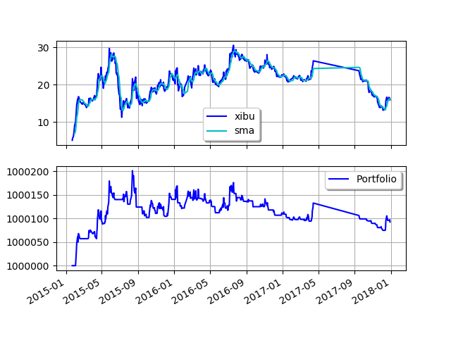

Final portfolio value: $1000092.60

Final portfolio value: $1000092.60

Cumulative returns: 0.01 %

Sharpe ratio: -515.78

Max. drawdown: 0.01 %

Longest drawdown duration: 869 days, 0:00:00

一曲线是使用14日均线策略对“601069”的股票进行数据处理，如下：

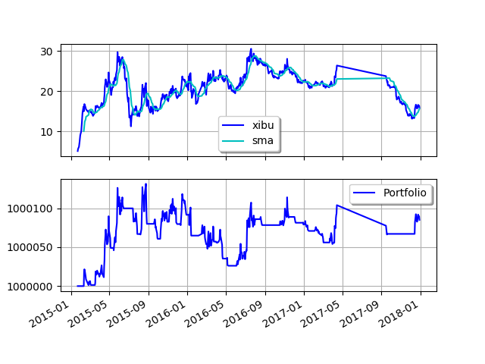

Final portfolio value: $1000085.00

Final portfolio value: $1000085.00

Cumulative returns: 0.01 %

Sharpe ratio: -505.91

Max. drawdown: 0.01 %

Longest drawdown duration: 858 days, 0:00:00

一曲线是使用26日均线策略对“601069”的股票进行数据处理，如下：

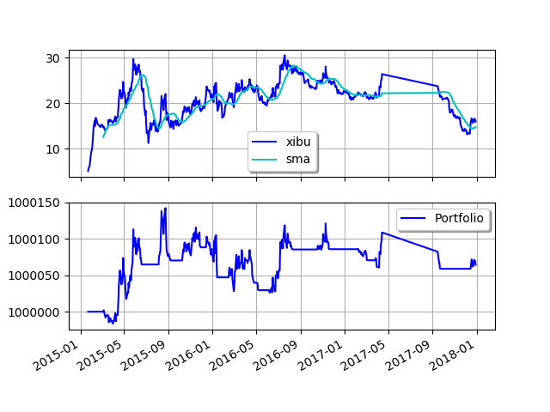

Final portfolio value: $1000064.40

Final portfolio value: $1000064.40

Cumulative returns: 0.01 %

Sharpe ratio: -491.93

Max. drawdown: 0.01 %

Longest drawdown duration: 858 days, 0:00:00

一曲线是使用30日均线策略对“601069”的股票进行数据处理，如下：

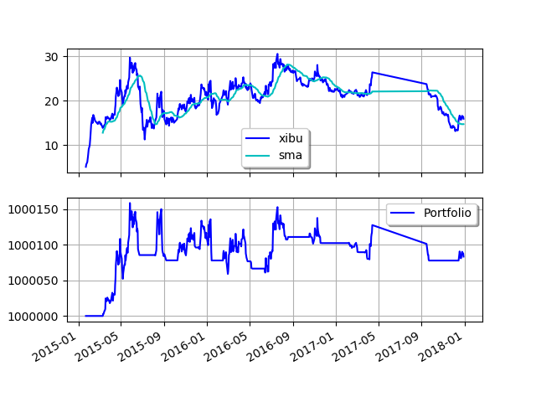

Final portfolio value: $1000083.30

Final portfolio value: $1000083.30

Cumulative returns: 0.01 %

Sharpe ratio: -476.60

Max. drawdown: 0.01 %

Longest drawdown duration: 947 days, 0:00:00

1. 对不同股票进行均线策略（26日，投入10股）。

“601318”的中国平安：

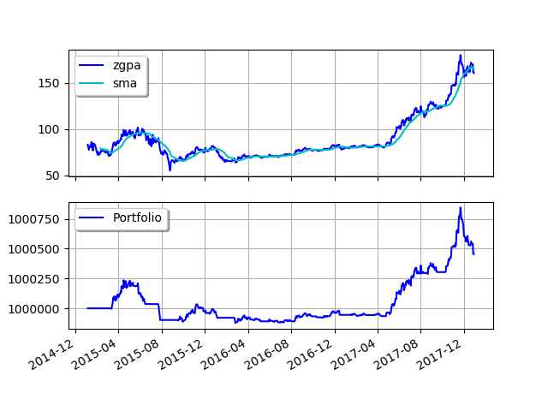

Final portfolio value: $1000455.10

Final portfolio value: $1000455.10

Cumulative returns: 0.05 %

Sharpe ratio: -208.18

Max. drawdown: 0.04 %

Longest drawdown duration: 804 days, 0:00:00

“300347”的泰格医药：

Final portfolio value: $1000959.20

Cumulative returns: 0.10 %

Sharpe ratio: -41.13

Max. drawdown: 0.20 %

Longest drawdown duration: 940 days, 0:00:00

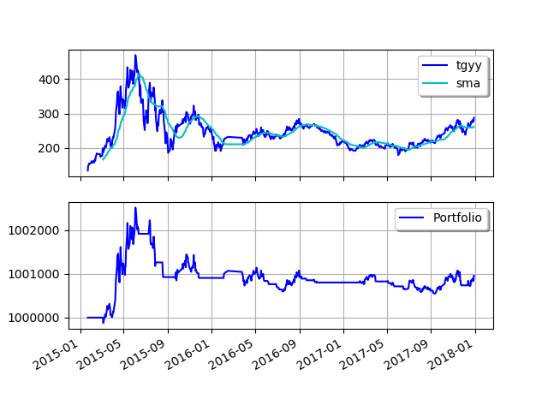

“000596”的古井贡酒：

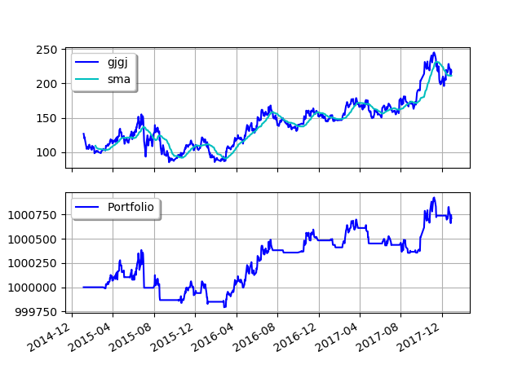

Final portfolio value: $1000712.10

Final portfolio value: $1000712.10

Cumulative returns: 0.07 %

Sharpe ratio: -100.64

Max. drawdown: 0.06 %

Longest drawdown duration: 354 days, 0:00:00

“600837”的海通证券：

Final portfolio value: $1011238.20

Cumulative returns: 1.12 %

Sharpe ratio: -4.81

Max. drawdown: 1.45 %

Longest drawdown duration: 947 days, 0:00:00

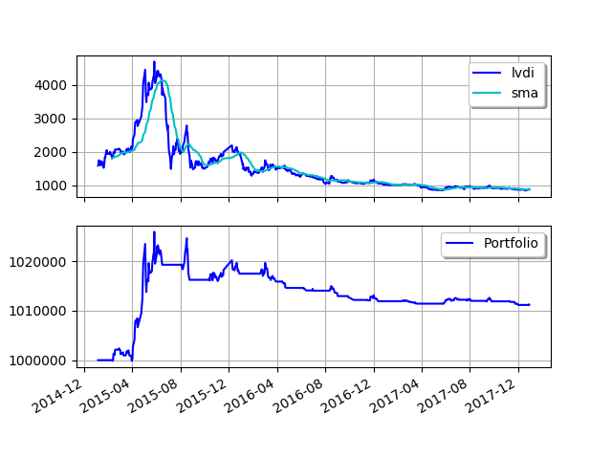

1. **实验结果**
2. **实验分析**
3. **实验感想**