Activity No. 2
ARRAYS, POINTERS AND DYNAMIC MEMORY ALLOCATION
Course Code: CPE010 | Program: Computer Engineering
Course Title: Data Structures and Algorithms | Date Performed: 8/7/25
Section: CPE21S4 | Date Submitted: 8/725
Name(s): Avila, Vince Gabriel V. | Instructor: Engr. Jimlord Quejado
6. Output
Discussion:

Part A.
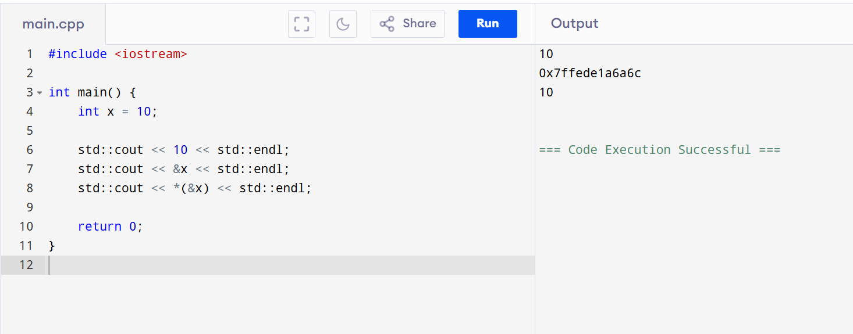

Part B.
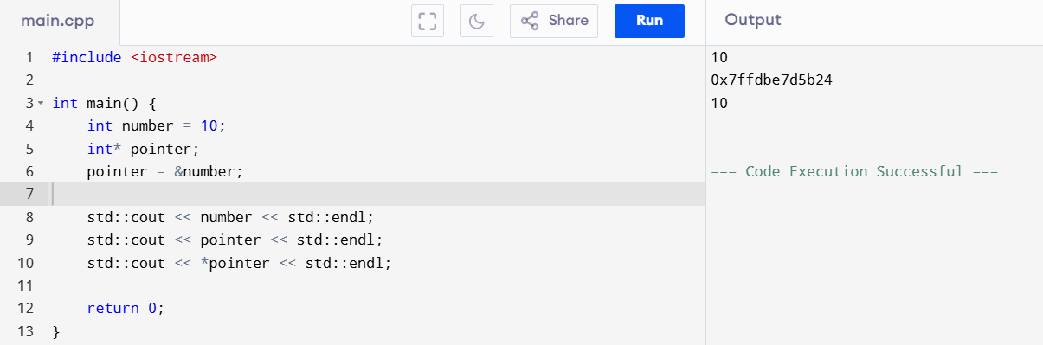

Part C.
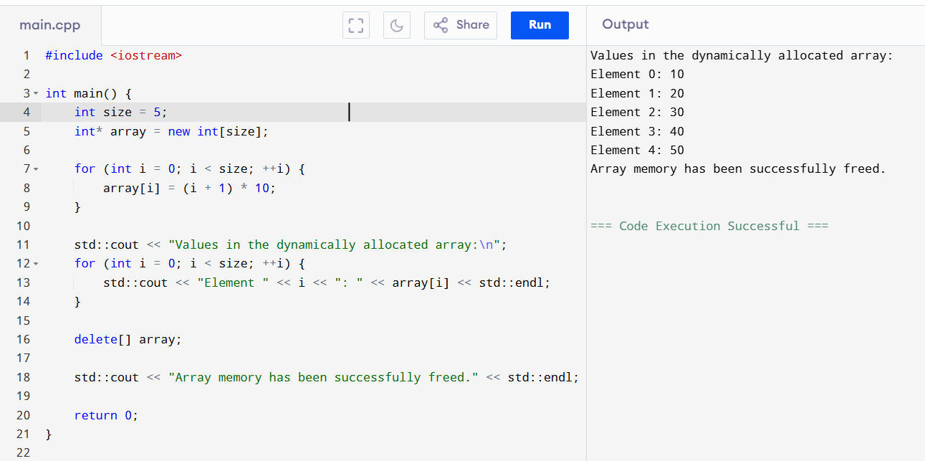

Part D.
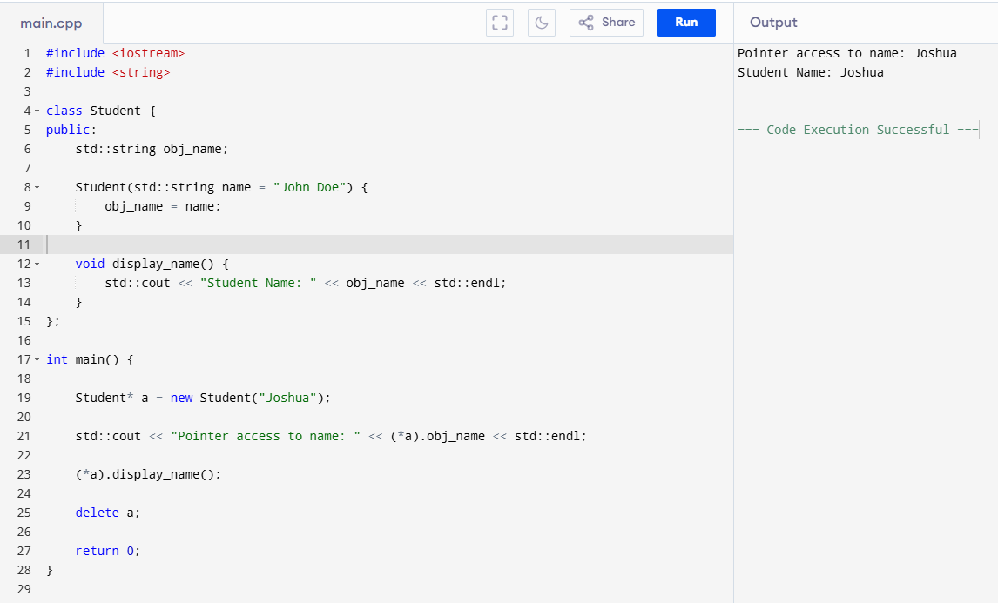

Procedure:

ILO A.
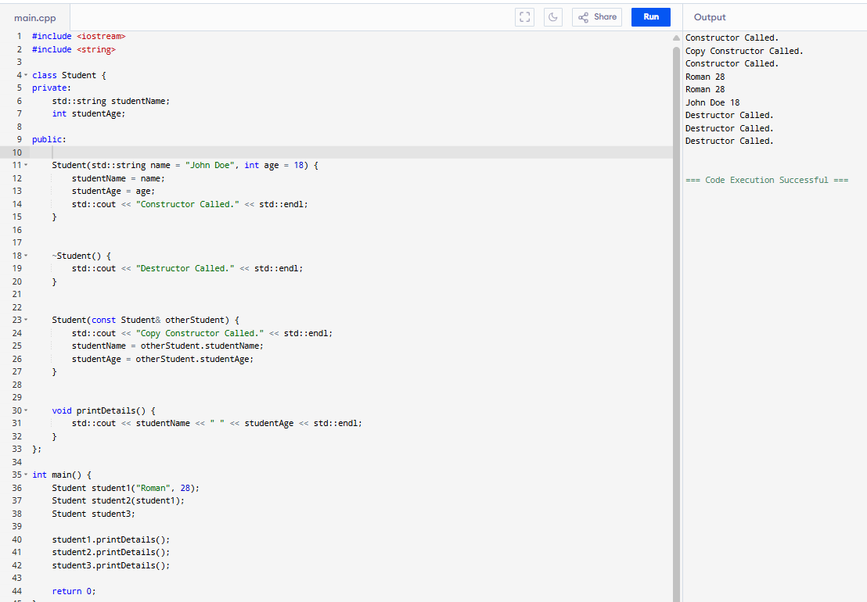

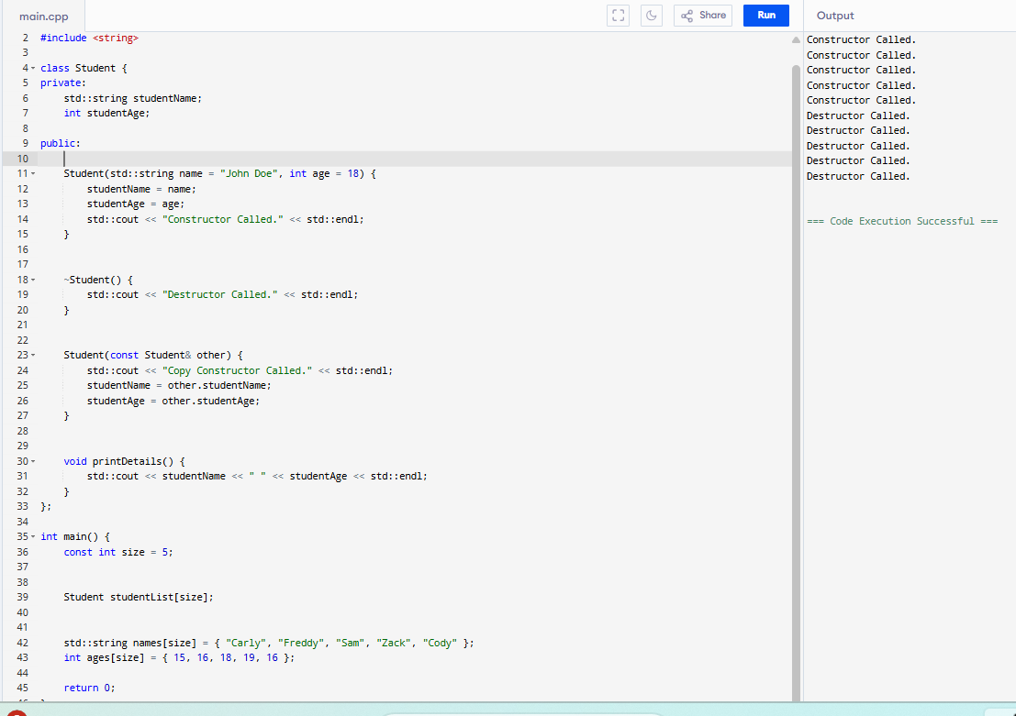
7. Supplementary Activity
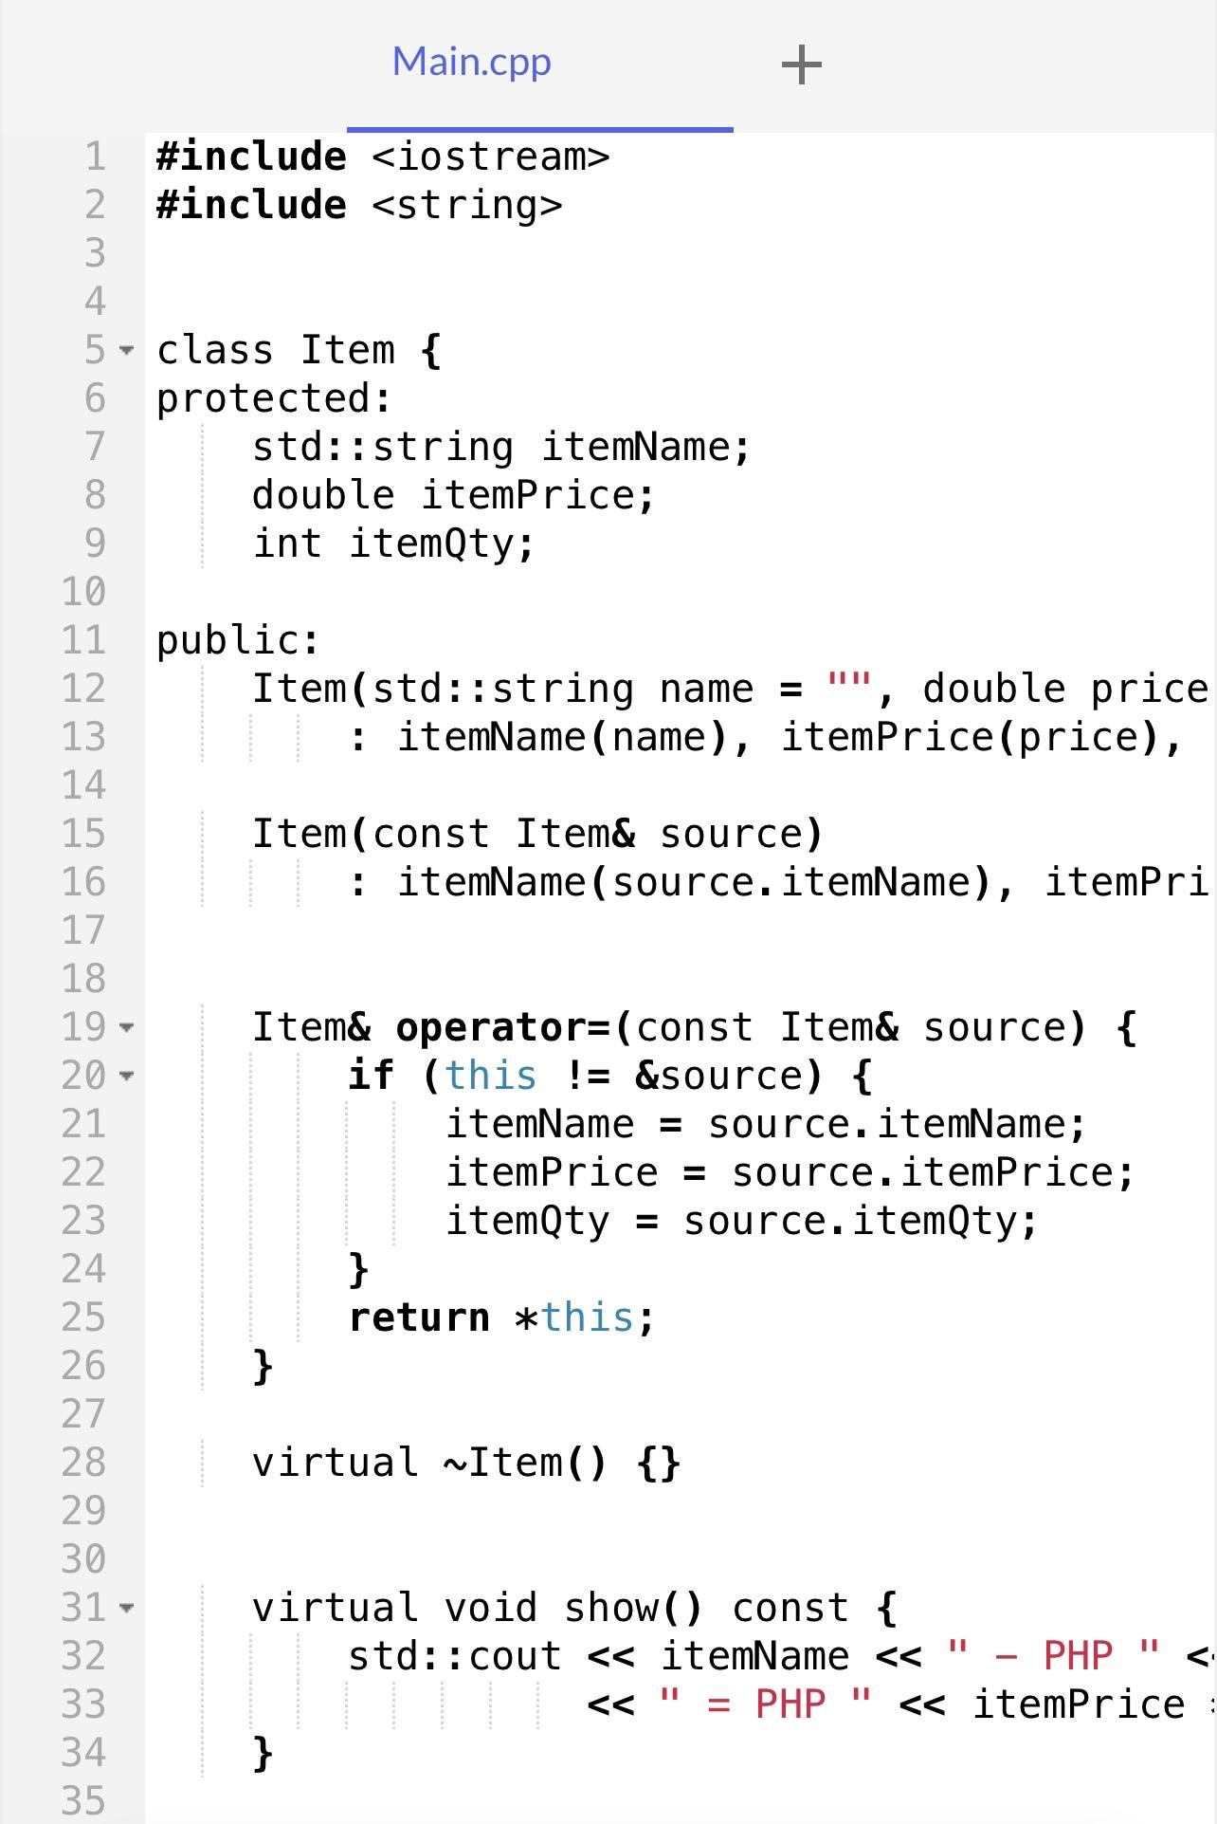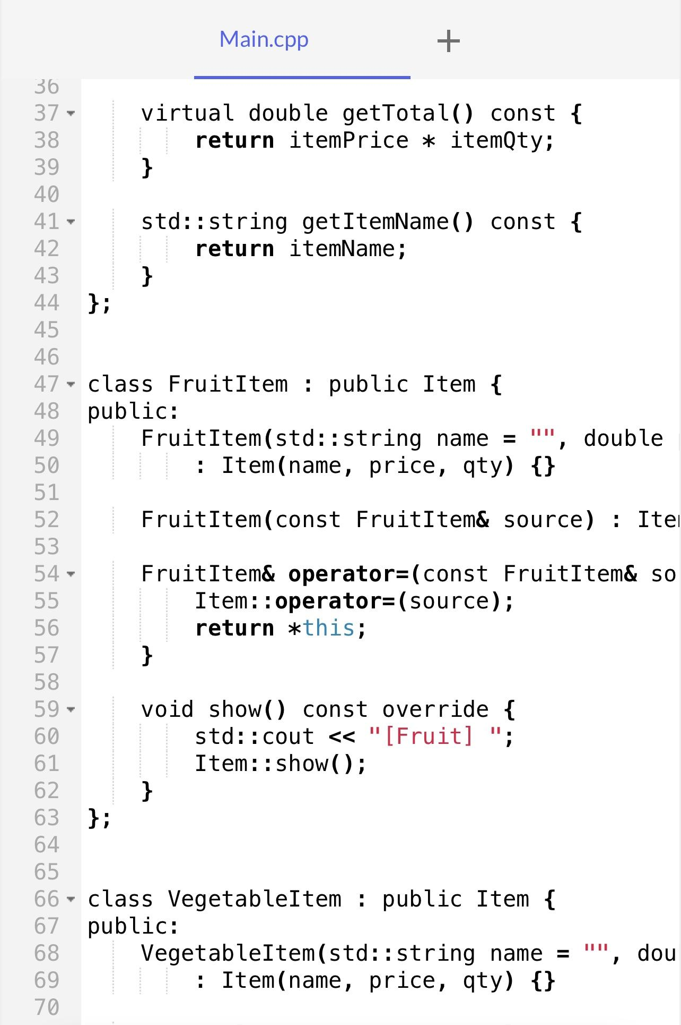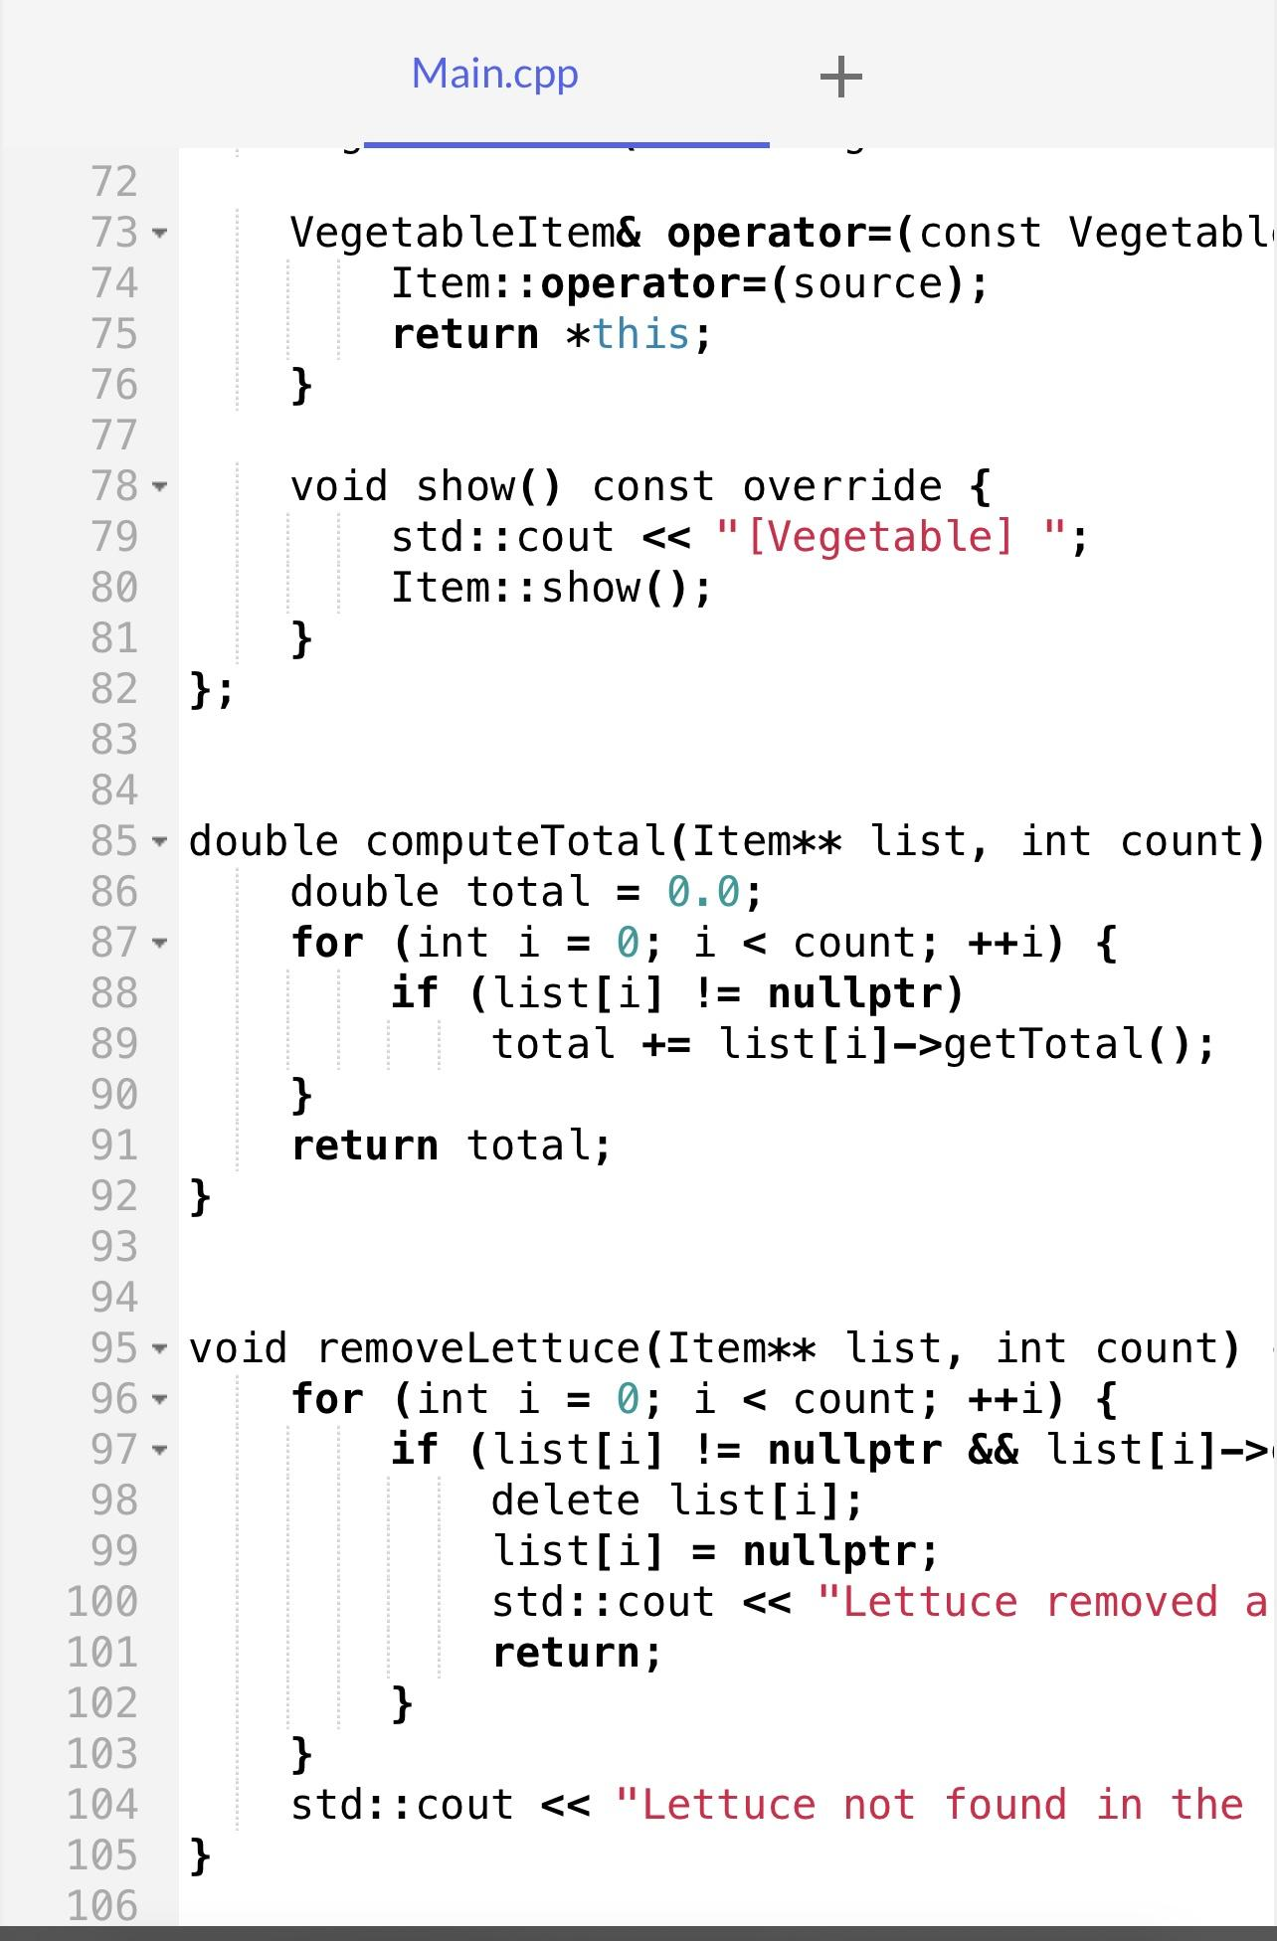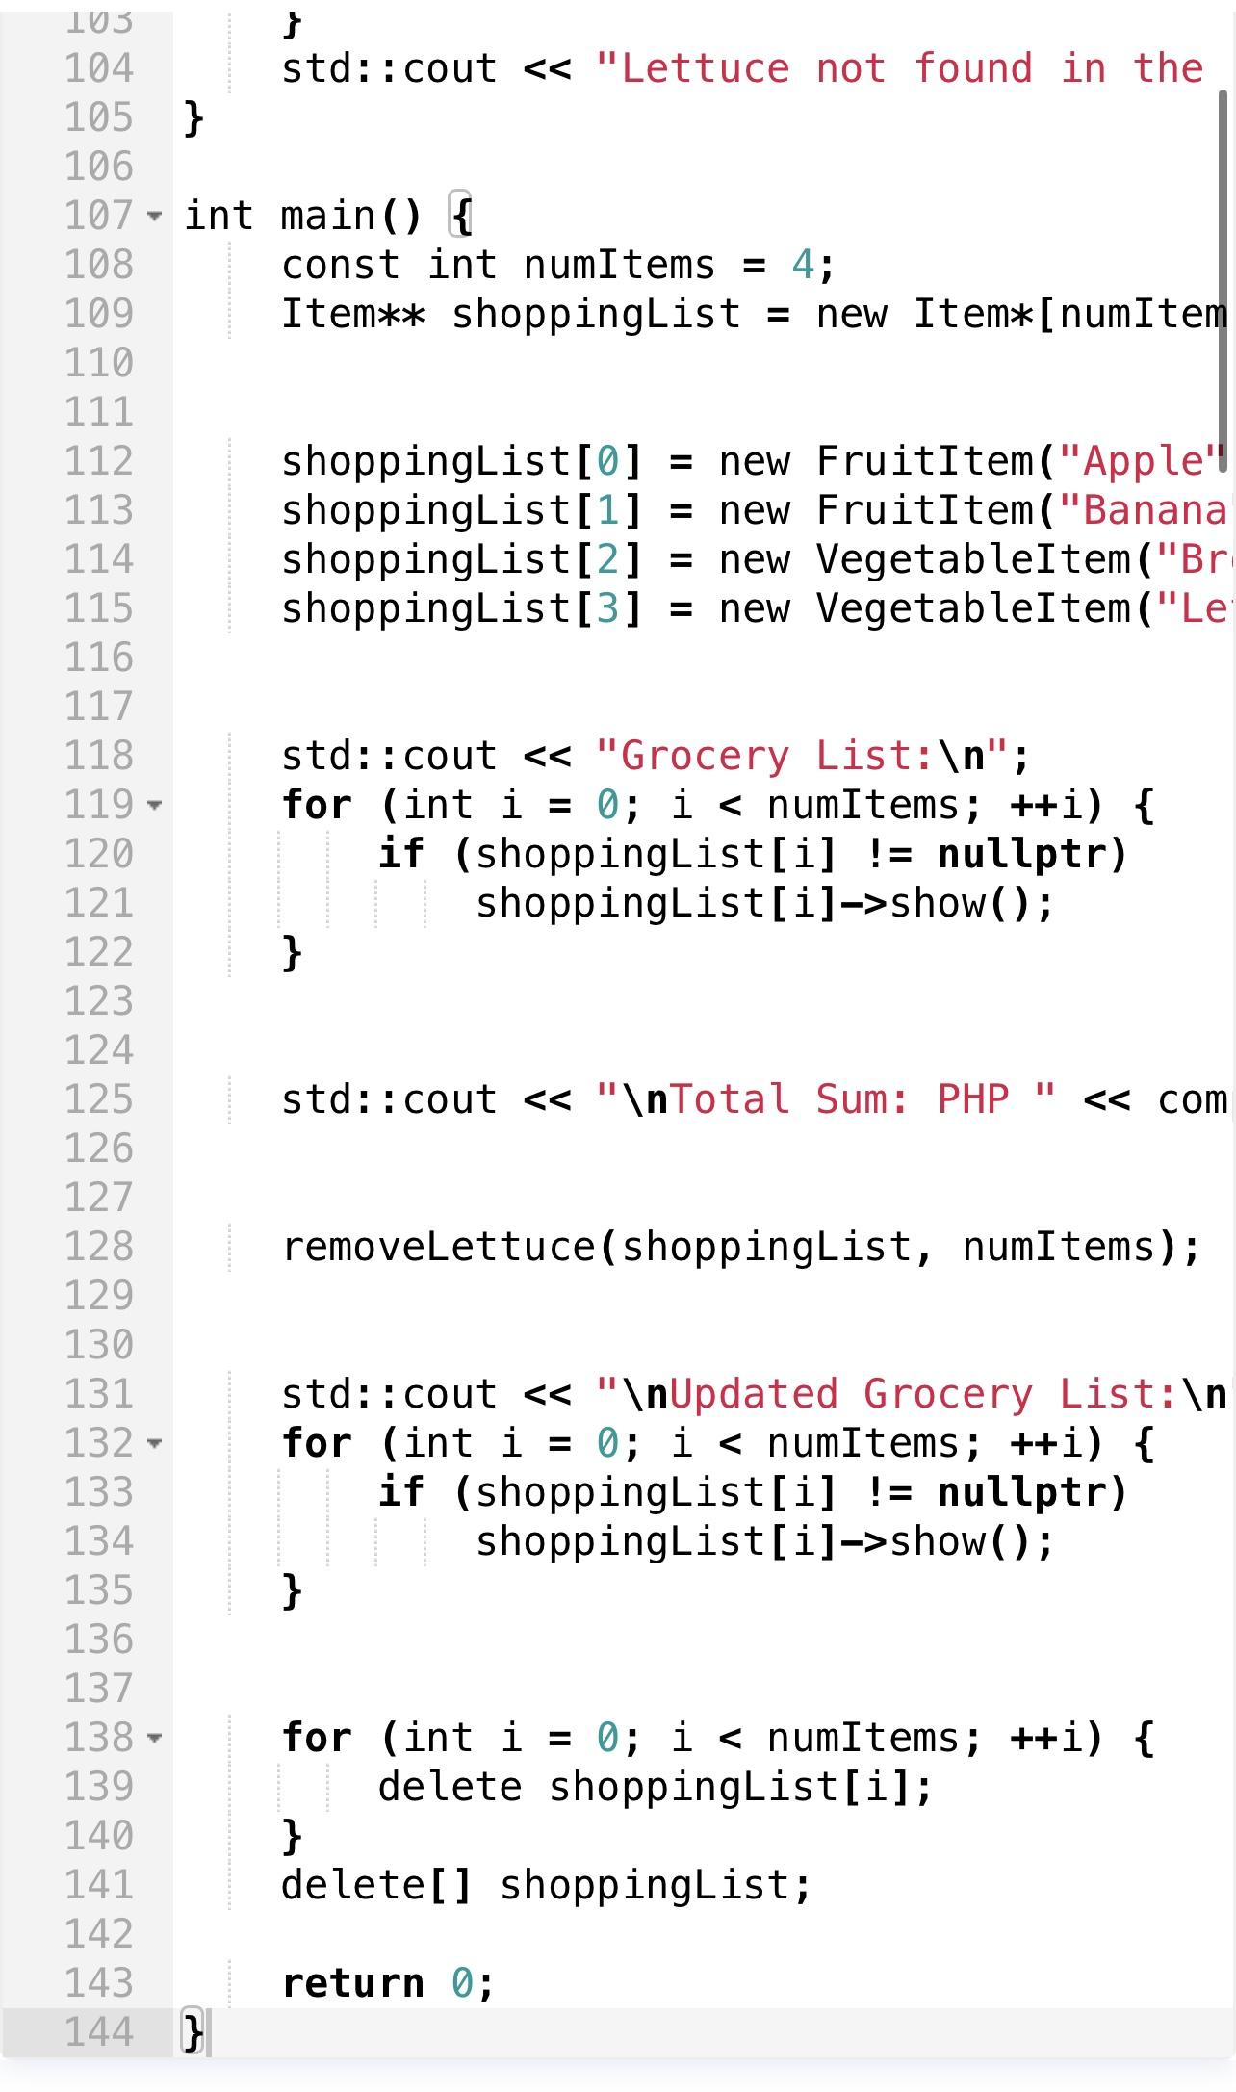

#include <iostream>
#include <string>

class Item {
protected:
std::string itemName;
double itemPrice;
int itemQty;

public:
Item(std::string name = "", double price = 0.0, int qty = 0)
: itemName(name), itemPrice(price), itemQty(qty) {}

Item(const Item& source)
: itemName(source.itemName), itemPrice(source.itemPrice), itemQty(source.itemQty) {}

Item& operator=(const Item& source) {
if (this != &source) {
itemName = source.itemName;
itemPrice = source.itemPrice;
itemQty = source.itemQty;
}
return *this;
}

virtual ~Item() {}

virtual void show() const {
std::cout << itemName << " - PHP " << itemPrice << " x" << itemQty
<< " = PHP " << itemPrice * itemQty << std::endl;
}

virtual double getTotal() const {
return itemPrice * itemQty;
}

std::string getItemName() const {
return itemName;
}
};

class FruitItem : public Item {
public:
FruitItem(std::string name = "", double price = 0.0, int qty = 0)
: Item(name, price, qty) {}

FruitItem(const FruitItem& source) : Item(source) {}

FruitItem& operator=(const FruitItem& source) {
Item::operator=(source);
return *this;
}

void show() const override {
std::cout << "[Fruit] ";
Item::show();
}
};

class VegetableItem : public Item {
public:
VegetableItem(std::string name = "", double price = 0.0, int qty = 0)
: Item(name, price, qty) {}

VegetableItem(const VegetableItem& source) : Item(source) {}

VegetableItem& operator=(const VegetableItem& source) {
Item::operator=(source);
return *this;
}

void show() const override {
std::cout << "[Vegetable] ";
Item::show();
}
};

double computeTotal(Item** list, int count) {
double total = 0.0;
for (int i = 0; i < count; ++i) {
if (list[i] != nullptr)
total += list[i]->getTotal();
}
return total;
}

void removeLettuce(Item** list, int count) {
for (int i = 0; i < count; ++i) {
if (list[i] != nullptr && list[i]->getItemName() == "Lettuce") {
delete list[i];
list[i] = nullptr;
std::cout << "Lettuce removed and memory deallocated." << std::endl;
return;
}
}
std::cout << "Lettuce not found in the list." << std::endl;
}

int main() {
const int numItems = 4;
Item** shoppingList = new Item*[numItems];

shoppingList[0] = new FruitItem("Apple", 10, 7);
shoppingList[1] = new FruitItem("Banana", 10, 8);
shoppingList[2] = new VegetableItem("Broccoli", 60, 12);
shoppingList[3] = new VegetableItem("Lettuce", 50, 10);

std::cout << "Grocery List:\n";
for (int i = 0; i < numItems; ++i) {
if (shoppingList[i] != nullptr)
shoppingList[i]->show();
}

std::cout << "\nTotal Sum: PHP " << computeTotal(shoppingList, numItems) << std::endl;

removeLettuce(shoppingList, numItems);

std::cout << "\nUpdated Grocery List:\n";
for (int i = 0; i < numItems; ++i) {
if (shoppingList[i] != nullptr)
shoppingList[i]->show();
}

for (int i = 0; i < numItems; ++i) {
delete shoppingList[i];
}
delete[] shoppingList;

return 0;
}

Output:
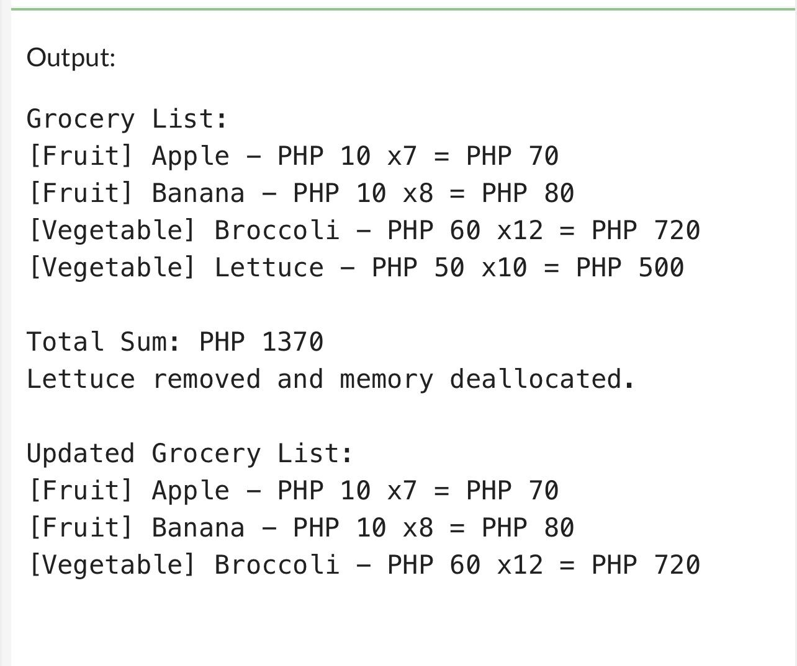

9. Conclusion

Summary of Lessons Learned: I nowhow dynamic memory allocation functions and its benefits when dealing with data of unknown sizes. It decreases memory overhead and increases its usefulness.

Analysis of the Procedure: This required learning how to employ memory functions like malloc and free, and using these functions appropriately to manage memory allocation and deallocation in the code.

Analysis of the Supplementary Activity: Participating in the extra activities gave me a better understanding of the topic which made memorizing memory management much easier in addition to applying my knowledge to programming projects.

Concluding Statement / Feedback: Because of my lack of experience with dynamic memory allocation, I sometimes find the concept challenging. I will work on it more, so I can improve my confidence and skills in this area.

8. Assessment Rubric

