[研究議題：Assessing the Relationship Between the Variability of Diagnostic Measures and the Risk of Diabetic Complications]

1. 目的:有助於早期預測糖尿病和相關併發症的發生
   1. 參考論文: Predictions of diabetes complications and mortality using hba1c variability: a 10‑year observational cohort study
2. Data preparation:
   1. 資料來源: 三院臨床資料庫
   2. 資料區間 : 2008-2019
   3. 目標病患: 糖尿病患者
   4. Index Date定義: 一年內有3次門診紀錄 或 1 次住院紀錄為新患的糖尿病患者符合條件下的首次看診日
   5. ICD CODE: 疾病碼
      1. 糖尿病:
         1. ICD9: 250, 251.8, 357.2, 362.01, 362.02, 366.41, 583.81
         2. ICD10: E08, E09, E10, E11, E12
      2. Outcome: **Eye complications**, **Cardiovascular disease, Cerebrovascular disease, Peripheral vascular disease, Nephropathy, Diabetic neuropathy**

|  |  |  |
| --- | --- | --- |
| **糖尿病相關併發症** | **ICD CODE** | **操作定義** |
| **Eye complications**  **眼部疾病** | **ICD9: 362.01、362.02、362.55、362.11、365.44、369、361、369.60**  **ICD10: H33.0, H33.10, H33.11, H33.19, H33.2, H33.3, H33.4, H33.8, E11.31, E11.32, E11.33, E11.34, E11.351, E11.359, H35.03, H35.38, H42, H54.0, H54.1, H54.2, H54.3, H54.8, H54.4, H54.5, H54.6, H54.7** | **一年內 3次門診 或 1 次住院。** |
| **Cardiovascular disease**  **心血管疾病** | **ICD9: 414.9、413.9、411.1、412、428、425、402**  **ICD10: I11, I20.0, I20.8, I20.9, I25.2, I25.9, I42, I43, I50.1, I50.2, I50.3, I50.4, I50.9** |
| **Cerebrovascular disease**  **腦血管疾病** | **ICD9: 435.9、434.91、432.9、437.1**  **ICD10: I62.9, I63.50, I63.511, I63.512, I63.519, I63.521, I63.522, I63.529, I63.531, I63.532, I63.539, I63.541, I63.542, I63.549, I63.59, I63.8, I63.9, I67.84, I67.81, I67.82, I67.89, G45.9** |
| **Peripheral vascular disease**  **周邊動脈疾病** | **ICD9: 440.2**  **ICD10: I70.2, I70.92, I75.01, I75.02** |
| **Nephropathy**  **腎臟病** | **ICD9: 583、585、V451**  **ICD10: E10.21, E11.21, N05.0, N05.1, N05.2, N05.3, N05.4, N05.5, N05.6, N05.7, N05.8, N05.9, N06.0, N06.1, N06.2, N06.3, N06.4, N06.5, N06.6, N06.7, N06.8, N06.9, N07.0, N07.1, N07.2, N07.3, N07.4, N07.5, N07.6, N07.7, N07.8, N07.9, N14, N15.0, N15.8, N15.9, N16, N17.1, N17.2, N18.4, N18.5, N18.6, N18.9** |
| **Diabetic neuropathy**  **神經病變** | **ICD9: 357.2、337.1、353**  **ICD10: E08.42, E09.42, E10.40, E10.42, E11.40, E11.42, E13.42, G54, G55, G99.0** |

|  |  |  |
| --- | --- | --- |
| **Comorbidity(共病):**   1. **Essential hypertension,** 2. **Peripheral enthesopathies and allied syndromes,** 3. **Other ill-defined and unknown causes of morbidity and mortality,** 4. **Disorders of lipoid metabolism,** 5. **Disorders of lipoid metabolism,** 6. **Acute upper respiratory infections of multiple or unspecified sites,** 7. **Other symptoms involving abdomen and pelvis,** 8. **Dermatophytosis,** 9. **General symptoms,** 10. **Symptoms involving respiratory system and other chest symptoms** 11. **Symptoms involving head and neck** 12. **Contact dermatitis and other eczema** 13. **Viral infection in conditions classified elsewhere and of unspecified site** 14. **Overweight, obesity and other hyperalimentation** 15. **Other and unspecified disorders of joint** 16. **Other disorders of soft tissues** 17. **Nonspecific findings on examination of blood** 18. **Disorders of refraction and accommodation** 19. **Disorders of conjunctiva** | | |
| **疾病名稱 / 簡寫** | **ICD CODE** | **操作定義** |
| **Essential hypertension**  **本態性高血壓** | **ICD9: 401**  **ICD10: I10** | **一年內3次門診 或 1 次住院** |
| **Peripheral enthesopathies and allied syndromes**  外周附著點病變及其相關聯症候群的疾病 | **ICD9: 726**  **ICD10: M25.70, M25.71, M25.72, M25.73, M25.74, M25.75, M25.76, M25.77, M66.21, M66.81, M70.1, M70.2, M70.3, M70.4, M70.5, M70.6, M70.7, M75.0, M75.10, M75.11, M75.2, M75.3, M75.4, M75.5, M75.8, M75.9, M76, M77** |
| **Other ill-defined and unknown causes of morbidity and mortality**  定義不明和未知原因的發病和死亡 | **ICD9: 799**  **ICD10: R09.0, R09.2, R41.89, R44.8, R44.9, R45.0, R45.3, R45.4, R45.87, R45.89, R46, R53.81, R64, R68.13, R68.19, R68.82, R68.89, R69** |
| **Disorders of lipoid metabolism**  脂質代謝障礙 | **ICD9: 272**  **ICD10: E71.30, E75.21, E75.22, E75.24, E75.3, E75.5, E75.6, E77, E78.0, E78.1, E78.2, E78.3, E78.4, E78.5, E78.5, E78.6, E78.70, E78.79, E78.8, E78.9, E88.1, E88.2, E88.89** |
| **Acute upper respiratory infections of multiple or unspecified sites**  多部位或未明確部位的急性上呼吸道感染 | **ICD9: 465**  **ICD10: J06** |
| **Other symptoms involving abdomen and pelvis**  腹部和骨盆的其他症狀 | **ICD9: 724、789**  **ICD10: M43.2, M43.8X9**  **M48.00, M48.04, M48.05, M48.06, M48.07, M48.08, M51.1, M53.2X7, M53.2X8, M53.3, M53.80, M53.84, M53.85, M53.86, M53.87, M53.88, M53.9, M54.03, M54.04, M54.05, M54.06, M54.07, M54.08, M54.09, M54.14, M54.15, M54.16, M54.17, M54.3, M54.4, M54.5, M54.6, M54.89, M54.9, M62.830, M99.22, M99.23, M99.24, M99.25, M99.26, M99.27, M99.28, M99.29, M99.32, M99.33, M99.34, M99.35, M99.36, M99.37, M99.38, M99.39, M99.42, M99.43, M99.44, M99.45, M99.46, M99.47, M99.48, M99.49, M99.52, M99.53, M99.54, M99.55, M99.56, M99.57, M99.58, M99.59, M99.62, M99.63, M99.64, M99.65, M99.66, M99.67, M99.68, M99.69, M99.72, M99.73, M99.74, M99.75, M99.76, M99.77, M99.78, M99.79, R10, R16, R18.8, R19.0, R19.3, R19.8** |
| **Dermatophytosis**  真菌引起的皮膚感染 | **ICD9: 110**  **ICD9: B35** |
| **General symptoms**  非特定的身體症狀 | **ICD9: 780**  **ICD10: E03.5, F51.8, G40.909, G47.0, G47.1, G47.20, G47.3, G47.5, G47.61, G47.69, G47.8, G47.9, G93.3, L74.51, L74.52, R40.0, R40.1, R40.20, R40.211, R40.212, R40.221, R40.222, R40.231, R40.232, R40.234, R40.3, R40.4, R41.0, R41.1, R41.2, R41.3, R41.82, R41.89, R41.9, R42, R44.0, R44.2, R44.3, R45.83, R45.84, R50.2, R50.81, R50.9, R52, R53.0, R53.1, R53.8, R55, R56, R61, R68.0, R68.11, R68.12, R68.81, R68.83, R68.89** |
| **Symptoms involving respiratory system and other chest symptoms**  呼吸系統和其他胸部症狀 | **ICD9: 786**  **ICD10: R04.2, R04.8, R04.9, R05, R06.00, R06.01, R06.02, R06.09, R06.1, R06.2, R06.3, R06.3, R06.4, R06.6, R06.8, R06.9, R07.1, R07.2, R07.8, R07.9, R09.3, R09.89, R22.2, R91.8** |
| **Symptoms involving head and neck**  頭部和頸部的症狀 | **ICD9: 784**  **ICD10: G44.05, G44.09, G44.1, G44.3, G44.4, G44.52, G44.53, G44.59, G44.81, G44.82, G44.83, G44.84, G44.85, G44.89, R04.0, R04.1, R06.5, R06.7, R07.0, R19.6, R22.0, R22.1, R47.0, R47.1, R47.81, R47.89, R47.9, R48.0, R48.1, R48.2, R48.8, R48.9, R49, R51, R90.0** |
| **Contact dermatitis and other eczema**  皮膚疾病 | **ICD9: 692**  **ICD10: L23, L24.0, L24.1, L24.2, L24.3, L24.4, L24.5, L24.6, L24.7, L24.8, L24.9, L25, L30.0, L30.2, L30.8, L30.9, L55, L56, L57.1, L57.5, L57.8, L57.9, L58, L59** |
| **Viral infection in conditions classified elsewhere and of unspecified site**  病毒引起的感染 | **ICD9: 79**  **ICD10: B34.9, E07.81, E79.0, I45.81, N39.0, O28, P09, R03, R09.0, R09.2, R19.5, R29.2, R41.81, R41.89, R44.8, R44.9, R45.0, R45.3, R45.4, R45.87, R45.89, R46, R53.81, R54, R64, R68.13, R68.19, R68.82, R68.89, R69, R70, R71, R73.01, R73.02, R73.09, R73.9, R74, R75, R76, R77, R78, R79.0, R79.1, R79.81, R79.82, R79.89, R79.9, R80.0, R80.1, R80.3, R80.8, R80.9, R81, R82, R83, R84, R85, R86, R87, R88, R89, R90.8, R91.8, R92.0, R92.1, R92.2, R92.8, R93, R94, R97, R99** |
| **Overweight, obesity and other hyperalimentation**  超重、肥胖及其他過度營養狀態 | **ICD9: 278**  **ICD10: E65, E66.0, E66.1, E66.2, E66.8, E66.9, E67, E68** |
| **Other and unspecified disorders of joint**  未明確指定的關節疾病 | **ICD9: 719**  **ICD10: M12.2, M12.3, M12.4, M25.0, M25.1, M25.4, M25.50, M25.51, M25.52, M25.53, M25.55, M25.56, M25.57, M25.60, M25.61, M25.62, M25.63, M25.64, M25.65, M25.66, M25.67, M25.8, M25.9, M79.643, M79.646, R26.2, R29.4, R29.898** |
| **Acute bronchitis and bronchiolitis**  呼吸道疾病 | **ICD9: 466**  **ICD10: J20.8, J20.9, J21** |
| **Other disorders of soft tissues**  其他軟組織的疾病 | **ICD9: 729**  **ICD10: G47.62, M35.6, M54.10, M54.18, M60.8, M60.9, M70.8, M70.9, M72.9, M79, R25.2, R29.898** |
| **Nonspecific findings on examination of blood**  血液檢查時發現的一些非特定性的異常或發現 | **ICD9: 790**  **ICD10: B34.9, E07.81, E79.0, R70, R71, R73.01, R73.02, R73.09, R73.9, R74, R77, R78, R79.0, R79.1, R79.81, R79.82, R79.89, R79.9, R97.2** |
| **Disorders of refraction and accommodation**  屈光和調節的疾病 | **ICD9: 367**  **ICD10: H52** |
| **Disorders of conjunctiva**  眼球表面覆蓋的結膜的各種疾病 | **ICD9: 372**  **ICD10: H10.0, H10.1, H10.2, H10.3, H10.4, H10.5, H10.81, H10.89, H10.9, H11** |

**資料流程圖:**

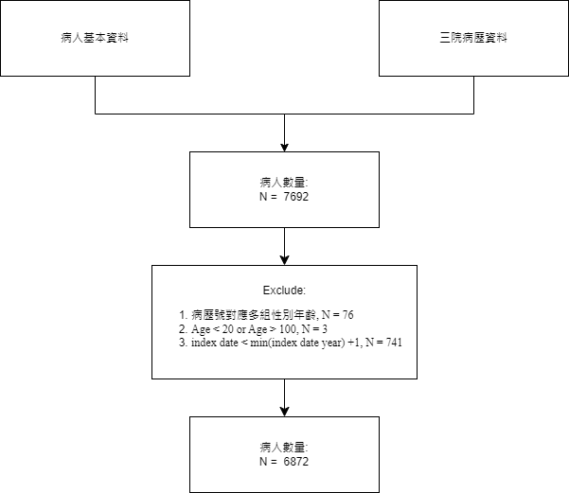

**三院病歷資料整理流程:**

|  |  |  |
| --- | --- | --- |
| 步驟 | 說明 | 患者數量 |
| 1 | 篩選就診紀錄的病例資料、議題相關疾病碼:  (糖尿病、相關併發症、控制疾病) 病例 |  |
| 2 | 篩選目標病患 (歸人)  操作定義: 一年內3次門診或1次住院疾病紀錄 | N = 7692 |
| 3. | 合併1. 病人基本資料、2.目標病患及相關病例資料 |  |
| 4 | Exclude:  病例資料對應多組性別年齡 (N = 76)  年齡 < 20 或 年齡 > 100 (N = 3)  index date < 2009(最早發病年後一年) (N = 741) | N = 6872 |

**Table1. 糖尿病患者基線特徵分布**

|  |  |  |
| --- | --- | --- |
|  | | overall(N=6872) |
| AGE | | |
|  | Mean(SD) | 68.23(12.23) |
| Median(IQR) | 68.35(17.64) |
| (Min, Max) | (21.63, 99.25) |
| Index_year | | |
|  | 2009 | 309(4.5%) |
| 2010 | 294(4.28%) |
| 2011 | 653(9.5%) |
| 2012 | 889(12.94%) |
| 2013 | 568(8.27%) |
| 2014 | 456(6.64%) |
| 2015 | 1399(20.36%) |
| 2016 | 1026(14.93%) |
| 2017 | 620(9.02%) |
| 2018 | 467(6.8%) |
| 2019 | 191(2.78%) |
| SEX_TYPE |  |  |
|  | 1 | 3823(55.63%) |
|  | 0 | 3049(44.37%) |
| AGE_GROUP |  |  |
|  | 20-30 | 17(0.25%) |
|  | 30-40 | 71(1.03%) |
|  | 40-50 | 394(5.73%) |
|  | 50-60 | 1294(18.83%) |
|  | 60-70 | 1974(28.73%) |
|  | 70-80 | 1843(26.82%) |
|  | 80-90 | 1120(16.3%) |
|  | 90-100 | 159(2.31%) |
| Hypertension_event |  |  |
|  | 1 | 1143(16.63%) |
|  | 0 | 5729(83.37%) |
| PeripheralEnthe_event |  |  |
|  | 1 | 95(1.38%) |
|  | 0 | 6777(98.62%) |
| UnknownCauses_event |  |  |
|  | 1 | 7(0.1%) |
|  | 0 | 6865(99.9%) |
| LipoidMetabDis_event |  |  |
|  | 1 | 992(14.44%) |
|  | 0 | 5880(85.56%) |
| AcuteURI_event |  |  |
|  | 1 | 33(0.48%) |
|  | 0 | 6839(99.52%) |
| AbdPelvicSymptoms_event |  |  |
|  | 1 | 135(1.96%) |
|  | 0 | 6737(98.04%) |
| Dermatophytosis_event |  |  |
|  | 1 | 102(1.48%) |
|  | 0 | 6770(98.52%) |
| GenSymptoms_event |  |  |
|  | 1 | 654(9.52%) |
|  | 0 | 6218(90.48%) |
| RespChestSymptoms_event |  |  |
|  | 1 | 196(2.85%) |
|  | 0 | 6676(97.15%) |
| HeadNeckSymptoms_event |  |  |
|  | 1 | 96(1.4%) |
|  | 0 | 6776(98.6%) |
| ContactDermEczema_event |  |  |
|  | 1 | 103(1.5%) |
|  | 0 | 6769(98.5%) |
| ViralInfection_event |  |  |
|  | 1 | 200(2.91%) |
|  | 0 | 6672(97.09%) |
| ObesityHyperal_event |  |  |
|  | 1 | 13(0.19%) |
|  | 0 | 6859(99.81%) |
| JointDisorders_event |  |  |
|  | 1 | 17(0.25%) |
|  | 0 | 6855(99.75%) |
| AcuteBronchitis_event |  |  |
|  | 1 | 35(0.51%) |
|  | 0 | 6837(99.49%) |
| SoftTissueDis_event |  |  |
|  | 1 | 191(2.78%) |
|  | 0 | 6681(97.22%) |
| BloodExamFindings_event |  |  |
|  | 1 | 82(1.19%) |
|  | 0 | 6790(98.81%) |
| RefractionDis_event |  |  |
|  | 1 | 9(0.13%) |
|  | 0 | 6863(99.87%) |
| ConjunctivaDis_event |  |  |
|  | 1 | 142(2.07%) |
|  | 0 | 6730(97.93%) |

**討論:**

**資料問題: 從Index_year可以看到三院的臨床資料糖尿病患者大多發生在2015和2016 ,之前分析也有發現相同的情況?**

**資料數從文獻中有看到檢測資料數隨年分增加**

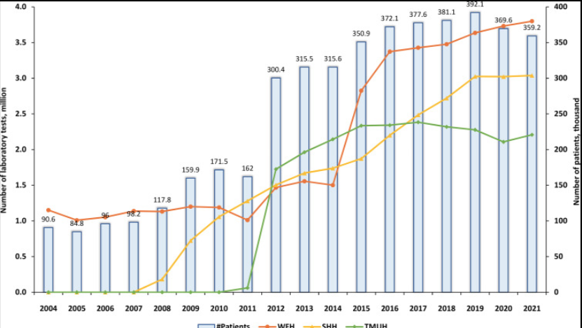

Reference:

Nguyen, P.-A., Hsu, M.-H., Chang, T.-H., Yang, H.-C., Huang, C.-W., Liao, C.-T., Lu, C. Y., & Hsu, J. C. (2024). Taipei Medical University Clinical Research Database: A Collaborative Hospital Ehr Database aligned with International Common Data Standards. *BMJ Health &amp; Care Informatics*, *31*(1). https://doi.org/10.1136/bmjhci-2023-100890

**Lab 資料整理: 檢驗結果報告**

1. **三院臨床資料庫架構: TODO**

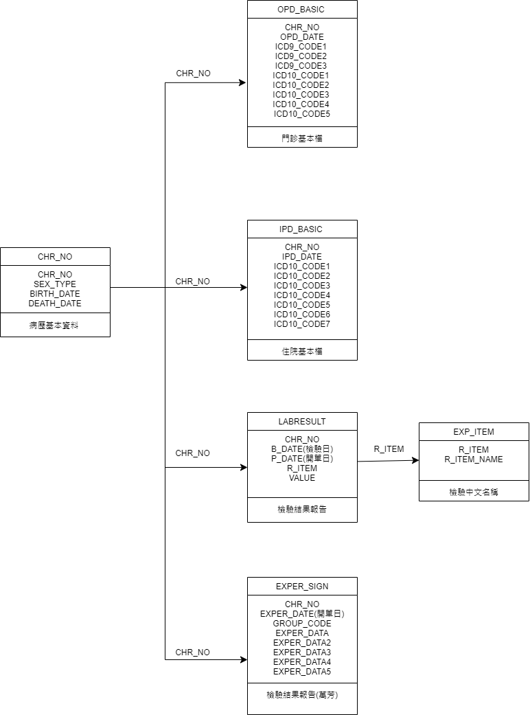

1. lab file處理: lab result 皆只有 test item id, 需要找對應的test name
   1. 資料來源: 萬芳與其他兩院儲存方式不同
   2. 萬芳: exper_sign_w
      1. 檢驗項目ID: GROUP_CODE (健保碼)
      2. 處理方式: 從萬芳的檢驗資訊查詢系統找檢驗項目的健保碼
   3. 雙和、北醫: labresult_s(t)
      1. 檢驗項目ID: R_ITEM
      2. 處理方式: 從exp_item_s(t) 找出對應 R_ITEM_NAME
   4. 資料整理流程:
      1. 先將兩院與萬芳lab資料做合併
      2. 保留ID、 檢驗日、檢驗項目、檢驗值並rename col
      3. 找尋所需的檢驗項目, ex: HbA1c, Albumin
      4. 將單位分開儲存同時排除無法辨識的資料, ex: <, >, NA
      5. 資料問題: 萬芳部分檢測項目無單位
      6. 僅保留quantile (0.01, 0.99) 的資料

Table2. 三院檢驗項目數值分佈

|  |  |  |  |  |  |  |  |  |  |  |  |
| --- | --- | --- | --- | --- | --- | --- | --- | --- | --- | --- | --- |
| Test | min | 1% | 5% | q1 | median | q3 | 95% | 99% | max | q1-1.5IQR | q3+1.5IQR |
| HbA1c | 2 | 4.9 | 5.3 | 5.9 | 6.6 | 7.5 | 9.9 | 12.2 | 19.1 | 3.5 | 9.9 |
| ALBUMIN | 0.3 | 2 | 2.5 | 3.3 | 3.8 | 4.1 | 4.6 | 4.9 | 5.6 | 2.1 | 5.3 |
| Uric | 0.6 | 2.6 | 3.6 | 5 | 6.1 | 7.4 | 9.4 | 11.5 | 4050 | 1.4 | 11 |
| HDL | 1 | 23 | 29 | 38 | 46 | 55 | 74 | 91 | 153 | 12.5 | 80.5 |
| LDL | 5 | 42 | 56 | 78 | 98 | 121 | 161 | 196 | 466 | 13.5 | 185.5 |
| Creatinine | 0 | 0.4 | 0.55 | 0.81 | 1.19 | 4.95 | 91.7 | 170.5 | 6320 | -5.4 | 11.16 |

1. 篩選要分析的糖尿病患者：
   1. 目的：避免在計算變異程度時受時間影響
   2. 在定義好的Index_date後的一年內，定期進行指定檢驗項目的患者
   3. 篩選方法：從Index_date開始，觀察該日期前後45天內是否有檢測紀錄，有的話記為1，沒有則記為0。接著每隔90天進行一次相同的觀察，直到觀察到第360天，確認患者整年是否有進行定期檢測。最終，所有觀察期間內都有檢測紀錄的患者作為分析的對象。

示意圖:

**Table3.糖尿病目標病患各季度HbA1c中位數及檢驗頻率(total)**

|  |  |  |  |  |  |  |
| --- | --- | --- | --- | --- | --- | --- |
| N = 1066 |  | S0 | S1 | S2 | S3 | S4 |
| Median | Mean(sd) | 7.75(1.52) | 7.24(1.21) | 7.21(1.22) | 7.2(1.19) | 7.19(1.19) |
| Median(IQR) | 7.38(2) | 7(1.4) | 6.9(1.34) | 6.9(1.4) | 6.9(1.3) |
| (Min, Max) | (5,12.2) | (5,12.2) | (5,12.1) | (5,12.1) | (5.1,12.2) |
| n | Mean(sd) | 1.32(0.54) | 1.18(0.41) | 1.12(0.35) | 1.09(0.3) | 1.08(0.28) |
| Median(IQR) | 1(1) | 1(0) | 1(0) | 1(0) | 1(0) |
| (Min, Max) | (1,4) | (1,4) | (1,3) | (1,3) | (1,3) |

**Table4. 糖尿病目標病患各季度Creatinine中位數及檢驗頻率(total)**

|  |  |  |  |  |  |  |
| --- | --- | --- | --- | --- | --- | --- |
| N = 1072 |  | S0 | S1 | S2 | S3 | S4 |
| Median | Mean(sd) | 6.47(14.57) | 7.85(15.69) | 9.68(18.53) | 8.74(16.64) | 11.23(19.21) |
| Median(IQR) | 1.26(2.24) | 1.33(4.42) | 1.41(6.82) | 1.4(6.41) | 1.6(9.54) |
| (Min, Max) | (0.4,150.2) | (0.4,159.4) | (0.4,156.8) | (0.4,156.4) | (0.4,109.7) |
| n | Mean(sd) | 3.28(3.31) | 2.67(3.02) | 2.64(3.11) | 2.81(4.07) | 2.7(4.1) |
| Median(IQR) | 2(3) | 2(2) | 2(2) | 2(2) | 2(2) |
| (Min, Max) | (1,36) | (1,38) | (1,39) | (1,66) | (1,70) |

**Outcome的整理流程:**

Exclude：

index date 前有發生Outcome

index date 後一年內發生Outcome

Table5: 糖尿病患者各併發症情況

|  |  |  |  |  |  |
| --- | --- | --- | --- | --- | --- |
| test | outcome | # of event | sum of follow up | N | IR% |
| HbA1c | EyeComp | 64 | 5676.915 | 989 | 1.127 |
| HbA1c | CardioDisease | 247 | 3796.921 | 744 | 6.505 |
| HbA1c | CerebroDisease | 136 | 5495.063 | 907 | 2.475 |
| HbA1c | PeripheralVascDisease | 10 | 6482.808 | 1062 | 0.154 |
| HbA1c | Nephropathy | 118 | 5628.518 | 975 | 2.096 |
| HbA1c | DiabeticNeuro | 71 | 5693.493 | 971 | 1.247 |
| Creatinine | EyeComp | 44 | 5198.627 | 988 | 0.846 |
| Creatinine | CardioDisease | 203 | 3133.041 | 657 | 6.479 |
| Creatinine | CerebroDisease | 130 | 4893.118 | 887 | 2.657 |
| Creatinine | PeripheralVascDisease | 9 | 5867.318 | 1059 | 0.153 |
| Creatinine | Nephropathy | 131 | 3924.871 | 794 | 3.338 |
| Creatinine | DiabeticNeuro | 53 | 5177.622 | 967 | 1.024 |

**資料整理完畢**

TODO:用timeline呈現資料

**變數處理:**

1. 解釋變數:
   1. 控制變數: SEX_TYPE, Index year, AGE_GROUP, baseline mean, 共病是否發生
      1. baseline mean: 各季檢測項目的平均值
      2. control disease (共病): Essential hypertension, Peripheral enthesopathies and allied syndromes, Other ill-defined and unknown causes of morbidity and mortality, Disorders of lipoid metabolism, Acute upper respiratory infections of multiple or unspecified sites, Other symptoms involving abdomen and pelvis, Dermatophytosis, General symptoms, Symptoms involving respiratory system and other chest symptoms, Symptoms involving head and neck, Contact dermatitis and other eczema, Viral infection in conditions classified elsewhere and of unspecified site, Overweight, obesity and other hyperalimentation, Other and unspecified disorders of joint, Other disorders of soft tissues, Nonspecific findings on examination of blood, Disorders of refraction and accommodation, Disorders of conjunctiva
   2. 其他變數組合: 不同檢驗項目的變異程度指標:SD, CV, RMS
      1. 計算方式:
         1. SD: (baseline , s1, s2, s3, s4)檢測項目平均值的SD
         2. CV: (baseline , s1, s2, s3, s4)檢測項目平均值的CV
         3. RMS: (baseline , s1, s2, s3, s4)檢測項目平均值的RMS
2. 反應變數: 病患追蹤日期、是否有發生併發症

**分析結果 :**

1. 模型: cox model
2. 模型指標: HR (Hazard ratios), 95% CI, P-value
3. P-value: *: p < 0.05, **: p < 0.01, ***: p < 0.001

Table5: Cox model 分析結果

Outcome: Eye complications、Test item: HbA1c (N = 989)

|  |  |  |  |  |
| --- | --- | --- | --- | --- |
| Models | Variables | HR | 95%CI | P-value |
| Model1 | Baseline | 1.188 | 1.012, 1.396 | * |
| Model2 | Baseline | 1.085 | 0.857, 1.375 |  |
| SD | 1.448 | 0.719, 2.916 |  |
| Model3 | Baseline | 1.142 | 0.922, 1.413 |  |
| CV | 4.408 | 0.026, 738.134 |  |
| Model4 | Baseline | 0.915 | 0.703, 1.19 |  |
| RMS | 1.604 | 1.138, 2.26 | ** |

Table6: Cox model 分析結果

Outcome: Cardiovascular disease、Test item: HbA1c (N = 744)

|  |  |  |  |  |
| --- | --- | --- | --- | --- |
| Models | Variables | HR | 95%CI | P-value |
| Model1 | Baseline | 0.981 | 0.9, 1.07 |  |
| Model2 | Baseline | 0.997 | 0.884, 1.123 |  |
| SD | 0.932 | 0.647, 1.342 |  |
| Model3 | Baseline | 1 | 0.898, 1.115 |  |
| CV | 0.443 | 0.03, 6.555 |  |
| Model4 | Baseline | 0.943 | 0.822, 1.081 |  |
| RMS | 1.074 | 0.889, 1.299 |  |

Table7: Cox model 分析結果

Outcome: Cerebrovascular disease、Test item: HbA1c (N = 907)

|  |  |  |  |  |
| --- | --- | --- | --- | --- |
| Models | Variables | HR | 95%CI | P-value |
| Model1 | Baseline | 1.011 | 0.904, 1.131 |  |
| Model2 | Baseline | 1.078 | 0.924, 1.256 |  |
| SD | 0.742 | 0.452, 1.216 |  |
| Model3 | Baseline | 1.061 | 0.925, 1.218 |  |
| CV | 0.117 | 0.003, 4.342 |  |
| Model4 | Baseline | 0.935 | 0.782, 1.118 |  |
| RMS | 1.147 | 0.903, 1.456 |  |

Table8: Cox model 分析結果

Outcome: Peripheral vascular disease、Test item: HbA1c (N = 1062)

|  |  |  |  |  |
| --- | --- | --- | --- | --- |
| Models | Variables | HR | 95%CI | P-value |
| Model1 | Baseline | 0.912 | 0.589, 1.414 |  |
| Model2 | Baseline | 0.696 | 0.468, 1.036 | . |
| SD | 3.342 | 1.211, 9.219 | * |
| Model3 | Baseline | 0.716 | 0.481, 1.068 |  |
| CV | 9836.151 | 4.079, 23720382.232 | * |
| Model4 | Baseline | 0.928 | 0.6, 1.437 |  |
| RMS | 0.966 | 0.501, 1.86 |  |

Table9: Cox model 分析結果

Outcome: Nephropathy、Test item: HbA1c (N = 975)

|  |  |  |  |  |
| --- | --- | --- | --- | --- |
| Models | Variables | HR | 95%CI | P-value |
| Model1 | Baseline | 1.094 | 0.969, 1.235 |  |
| Model2 | Baseline | 1.084 | 0.908, 1.294 |  |
| SD | 1.039 | 0.607, 1.778 |  |
| Model3 | Baseline | 1.098 | 0.936, 1.287 |  |
| CV | 0.867 | 0.017, 44.407 |  |
| Model4 | Baseline | 1.013 | 0.837, 1.225 |  |
| RMS | 1.153 | 0.885, 1.501 |  |

Table10: Cox model 分析結果

Outcome: Diabetic neuropathy、Test item: HbA1c (N = 971)

|  |  |  |  |  |
| --- | --- | --- | --- | --- |
| Models | Variables | HR | 95%CI | P-value |
| Model1 | Baseline | 0.941 | 0.797, 1.112 |  |
| Model2 | Baseline | 0.997 | 0.791, 1.258 |  |
| SD | 0.769 | 0.37, 1.6 |  |
| Model3 | Baseline | 1.002 | 0.812, 1.235 |  |
| CV | 0.074 | 0, 15.706 |  |
| Model4 | Baseline | 0.74 | 0.569, 0.961 | * |
| RMS | 1.533 | 1.104, 2.131 | * |

Table11: Cox model 分析結果 (分三類)

Outcome: Eye complications、Test item: Creatinine (N =)

|  |  |  |  |  |
| --- | --- | --- | --- | --- |
| Models | Variables | HR | 95%CI | P-value |
| Model1 | Baseline | 1.012 | 0.998, 1.026 | . |
| Model2 | Baseline | 1.007 | 0.991, 1.023 |  |
| SD | 1.015 | 0.989, 1.041 |  |
| Model3 | Baseline | 1.011 | 0.997, 1.025 |  |
| CV | 1.194 | 0.784, 1.819 |  |
| Model4 | Baseline | 1.006 | 0.987, 1.025 |  |
| RMS | 1.012 | 0.987, 1.037 |  |

Table12: Cox model 分析結果

Outcome: Cardiovascular disease、Test item: Creatinine (N =)

|  |  |  |  |  |
| --- | --- | --- | --- | --- |
| Models | Variables | HR | 95%CI | P-value |
| Model1 | Baseline | 1.008 | 0.999, 1.017 | . |
| Model2 | Baseline | 1.011 | 1.001, 1.021 | * |
| SD | 0.992 | 0.978, 1.007 |  |
| Model3 | Baseline | 1.008 | 0.999, 1.018 | . |
| CV | 0.987 | 0.806, 1.21 |  |
| Model4 | Baseline | 1.013 | 1.001, 1.025 | * |
| RMS | 0.993 | 0.98, 1.006 |  |

Table13: Cox model 分析結果

Outcome: Cerebrovascular disease、Test item: Creatinine (N = 887)

|  |  |  |  |  |
| --- | --- | --- | --- | --- |
| Models | Variables | HR | 95%CI | P-value |
| Model1 | Baseline | 0.998 | 0.987, 1.01 |  |
| Model2 | Baseline | 0.999 | 0.987, 1.012 |  |
| SD | 0.998 | 0.98, 1.016 |  |
| Model3 | Baseline | 0.999 | 0.988, 1.01 |  |
| CV | 0.908 | 0.693, 1.19 |  |
| Model4 | Baseline | 0.998 | 0.983, 1.012 |  |
| RMS | 1.001 | 0.986, 1.017 |  |

Table14: Cox model 分析結果

Outcome: Peripheral vascular disease、Test item: Creatinine (N =1059)

|  |  |  |  |  |
| --- | --- | --- | --- | --- |
| Models | Variables | HR | 95%CI | P-value |
| Model1 | Baseline | 1.021 | 0.988, 1.056 |  |
| Model2 | Baseline | 1.034 | 0.991, 1.079 |  |
| SD | 0.959 | 0.875, 1.051 |  |
| Model3 | Baseline | 1.023 | 0.989, 1.058 |  |
| CV | 0.74 | 0.247, 2.218 |  |
| Model4 | Baseline | 1.03 | 0.981, 1.082 |  |
| RMS | 0.986 | 0.928, 1.048 |  |

Table15: Cox model 分析結果

Outcome: Nephropathy、Test item: Creatinine (N = 794)

|  |  |  |  |  |
| --- | --- | --- | --- | --- |
| Models | Variables | HR | 95%CI | P-value |
| Model1 | Baseline | 1.02 | 1.011, 1.029 | *** |
| Model2 | Baseline | 1.016 | 1.005, 1.026 | ** |
| SD | 1.013 | 0.998, 1.029 | . |
| Model3 | Baseline | 1.02 | 1.011, 1.029 | *** |
| CV | 1.033 | 0.813, 1.313 |  |
| Model4 | Baseline | 1.003 | 0.991, 1.015 |  |
| RMS | 1.028 | 1.016, 1.041 | *** |

Table16: Cox model 分析結果

Outcome: Diabetic neuropathy、Test item: Creatinine (N = 967)

|  |  |  |  |  |
| --- | --- | --- | --- | --- |
| Models | Variables | HR | 95%CI | P-value |
| Model1 | Baseline | 0.996 | 0.979, 1.014 |  |
| Model2 | Baseline | 0.999 | 0.98, 1.02 |  |
| SD | 0.989 | 0.96, 1.019 |  |
| Model3 | Baseline | 0.998 | 0.98, 1.017 |  |
| CV | 0.676 | 0.423, 1.082 |  |
| Model4 | Baseline | 0.992 | 0.97, 1.015 |  |
| RMS | 1.007 | 0.984, 1.03 |  |

結論:

1. 預期結果: 變異程度大, 理論上風險上升HR > 1且顯著, 才可以說考慮這個生理數值是有意義的。
2. 模型結果顯示HbA1c的的變異程度對於Eye complications、 Nephropathy、 Diabetic neuropathy等併發症為重要因子, 符合其他文獻結果, 代表這份資料是具準確性。
3. 模型結果顯示Creatinine的的變異程度對於Nephropathy併發症為重要因子, 可以做後續延伸。
4. 資料不顯著的原因: 樣本數過小、發病率太低、baseline 每季只算一個mean資訊丟失部分資訊
5. 後續可以做的研究方向:
   1. 探索加入其他可能的變異性指標，如HVS
   2. Outlier定義
   3. 各季只考慮mean會丟失大部分的時間資訊在算平均時可以考慮 weighted average
   4. 找出與目標疾病不常做的檢驗項目
   5. 目前已驗證的數據準確性，進行與中風相關的分析
6. 討論:
   1. 架構是否需要調整

**討論細項:**

1. Outlier 的定義:
   1. 討論:
      1. 雙院以及萬芳有些資料單位不一致
      2. 各檢測項目合理的數值之前是如何訂的
   2. 三院檢驗項目數值分佈

|  |  |  |  |  |  |  |  |  |  |  |  |
| --- | --- | --- | --- | --- | --- | --- | --- | --- | --- | --- | --- |
| Test | 1% | 5% | q1 | median | q3 | 95% | 99% | q1-1.5IQR | q3-1.5IQR | max | min |
| HbA1c | 4.9 | 5.3 | 5.9 | 6.6 | 7.5 | 9.9 | 12.2 | 3.5 | 9.9 | 19.1 | 2 |
| ALBUMIN | 2 | 2.5 | 3.3 | 3.8 | 4.1 | 4.6 | 4.9 | 2.1 | 5.3 | 5.6 | 0.3 |
| Uric | 2.6 | 3.6 | 5 | 6.1 | 7.4 | 9.4 | 11.5 | 1.4 | 11 | 4050 | 0.6 |
| HDL | 23 | 29 | 38 | 46 | 55 | 74 | 91 | 12.5 | 80.5 | 153 | 1 |
| LDL | 42 | 56 | 78 | 98 | 121 | 161 | 196 | 13.5 | 185.5 | 466 | 5 |
| Creatinine | 0.4 | 0.55 | 0.81 | 1.19 | 4.95 | 91.7 | 170.5 | -5.4 | 11.16 | 6320 | 0 |

* 1. 檢驗項目的density plot(分三院、有針對outlier 進行壓縮):
     1. HbA1c Test ID: "014701", "F09006B", upper = 13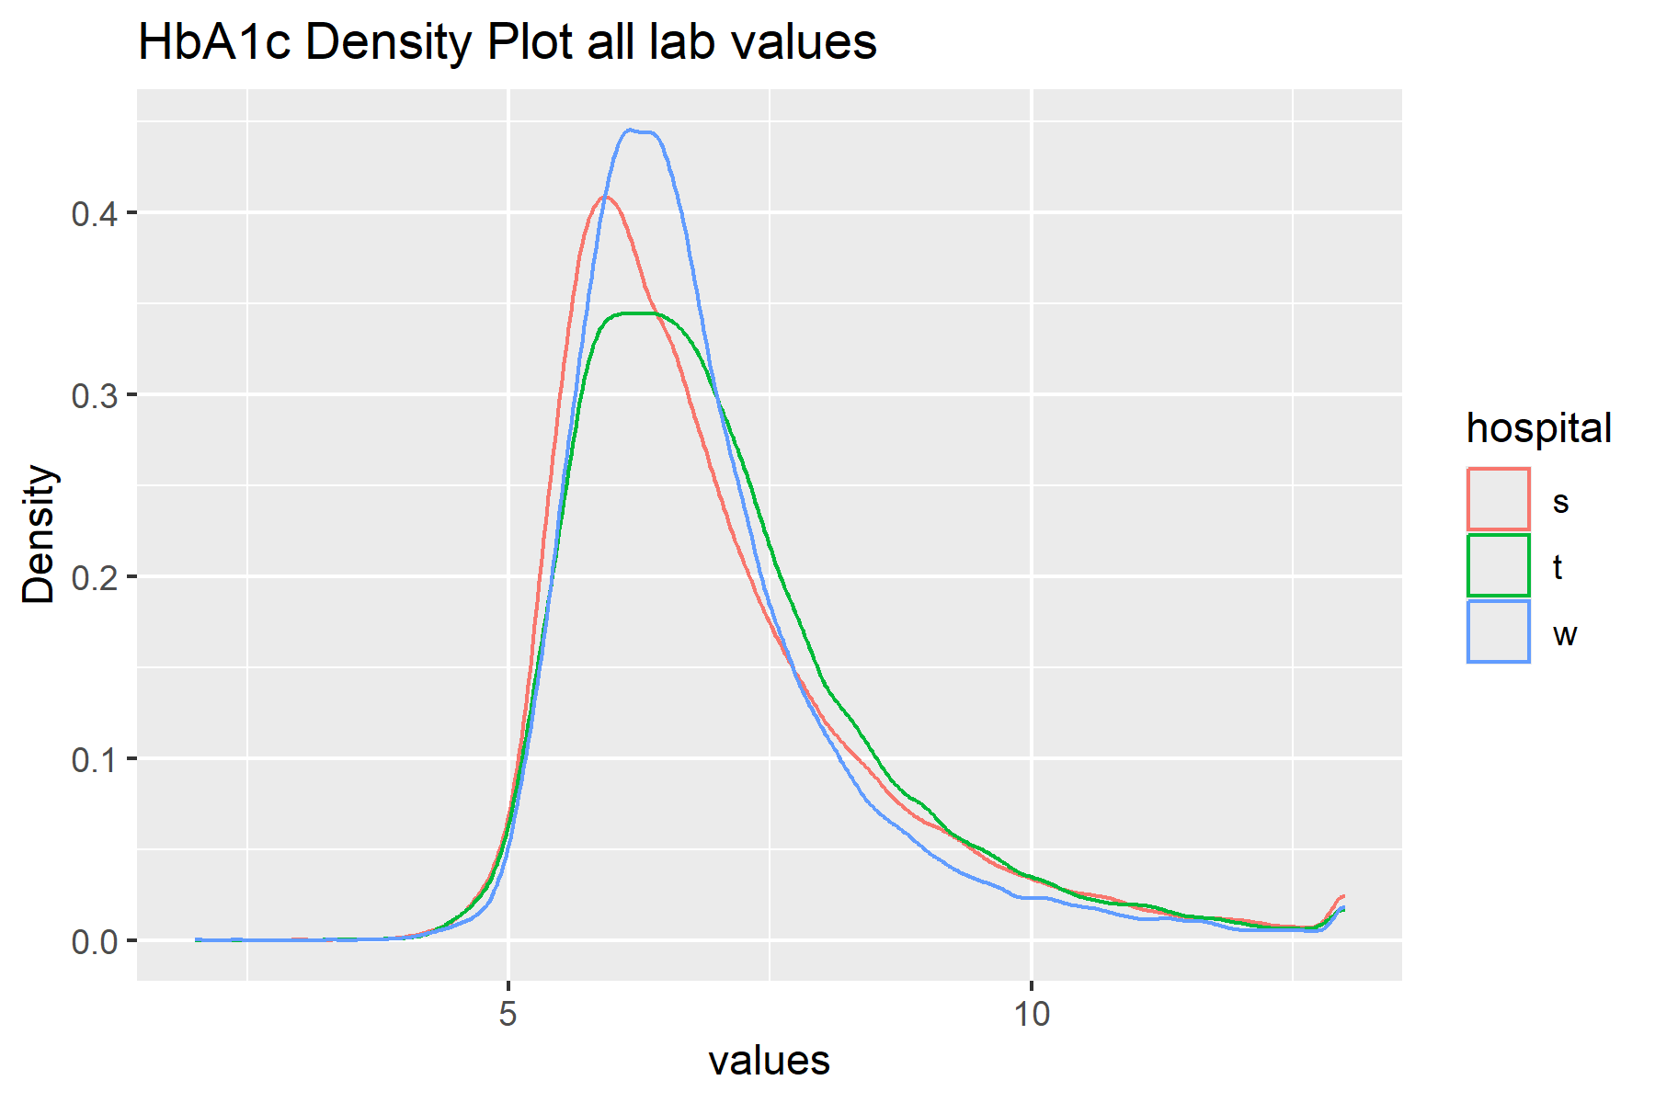
     2. ALBUMIN Test ID: "010301", "11D101", "F09038C", upper = 30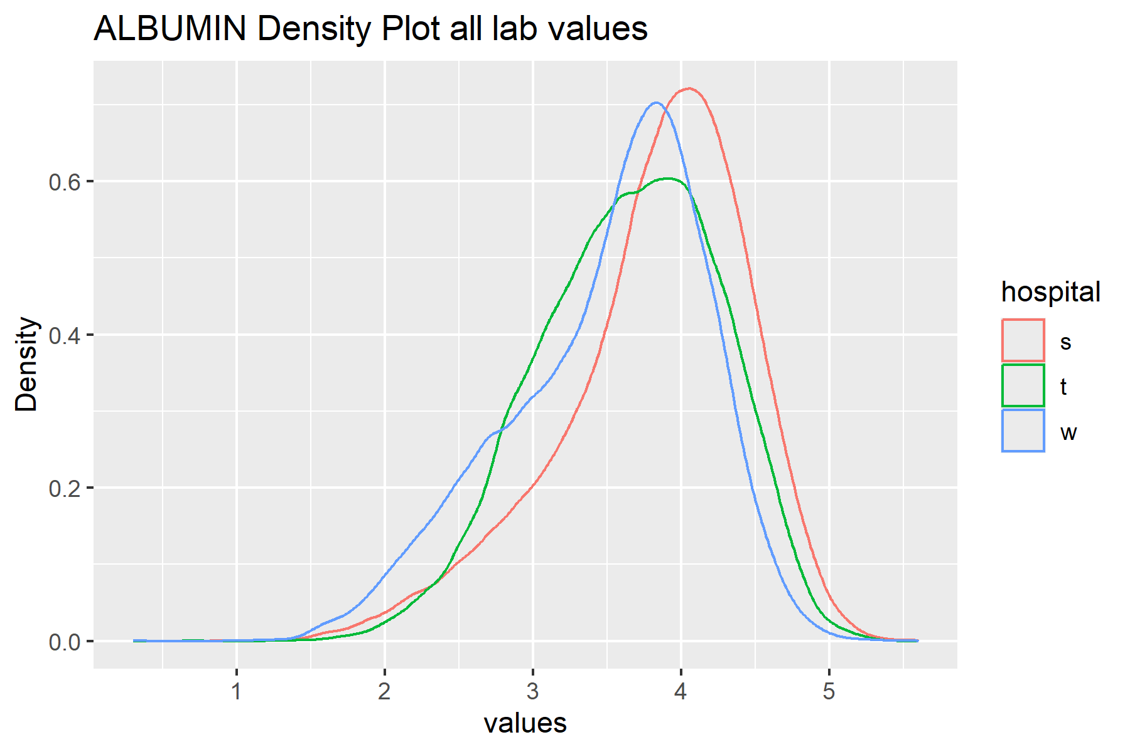
     3. Uric Test ID: "011001", ” F09013C” upper = 20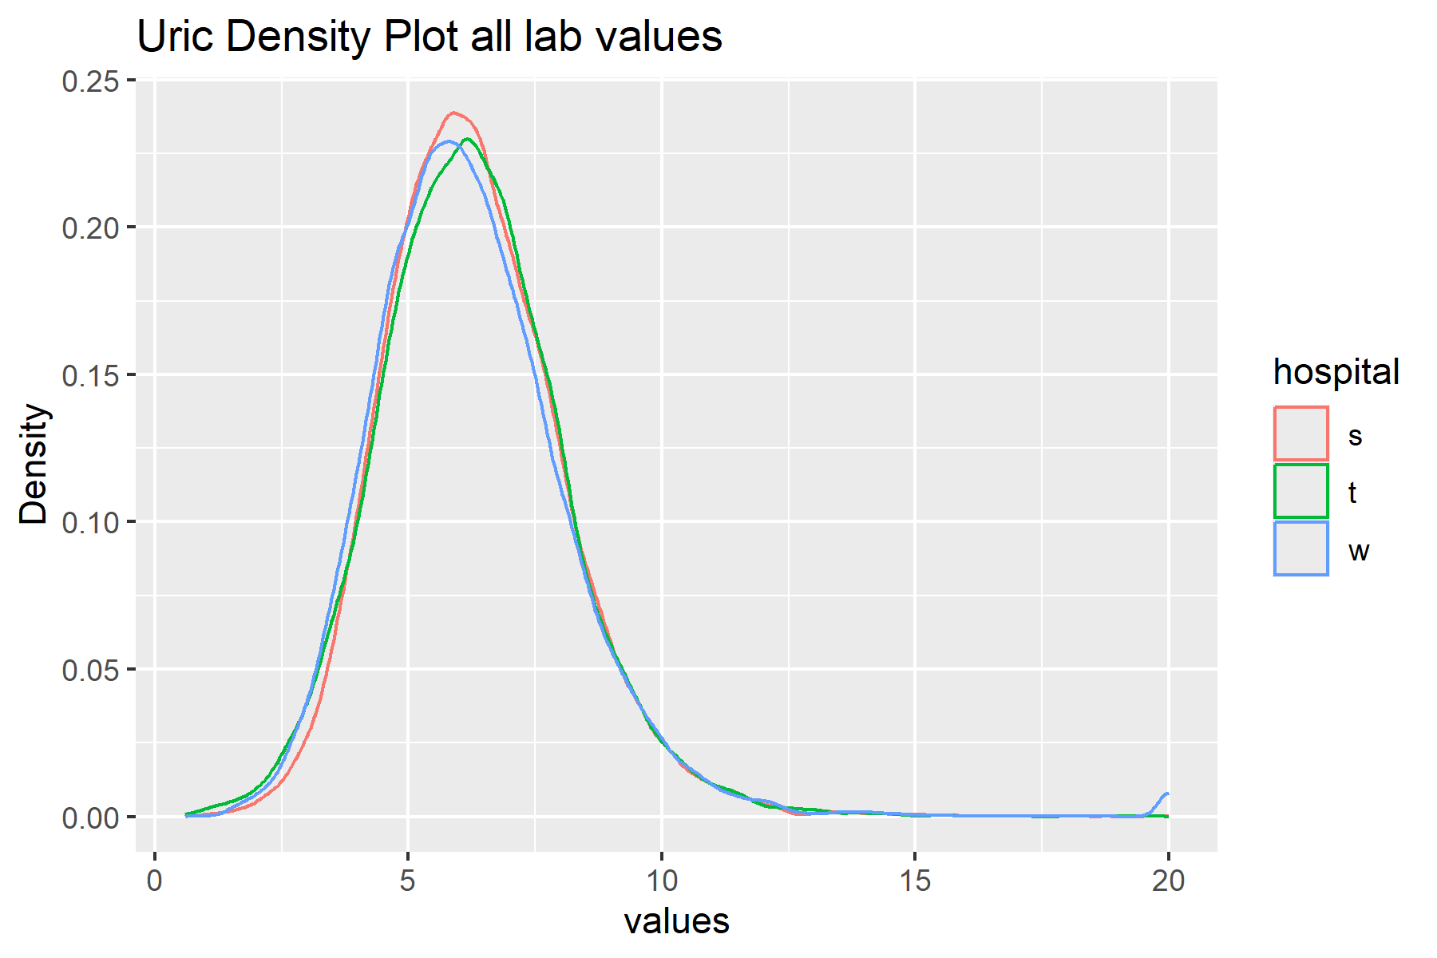
     4. HDL Test ID: "F09043A", "011301", upper = 120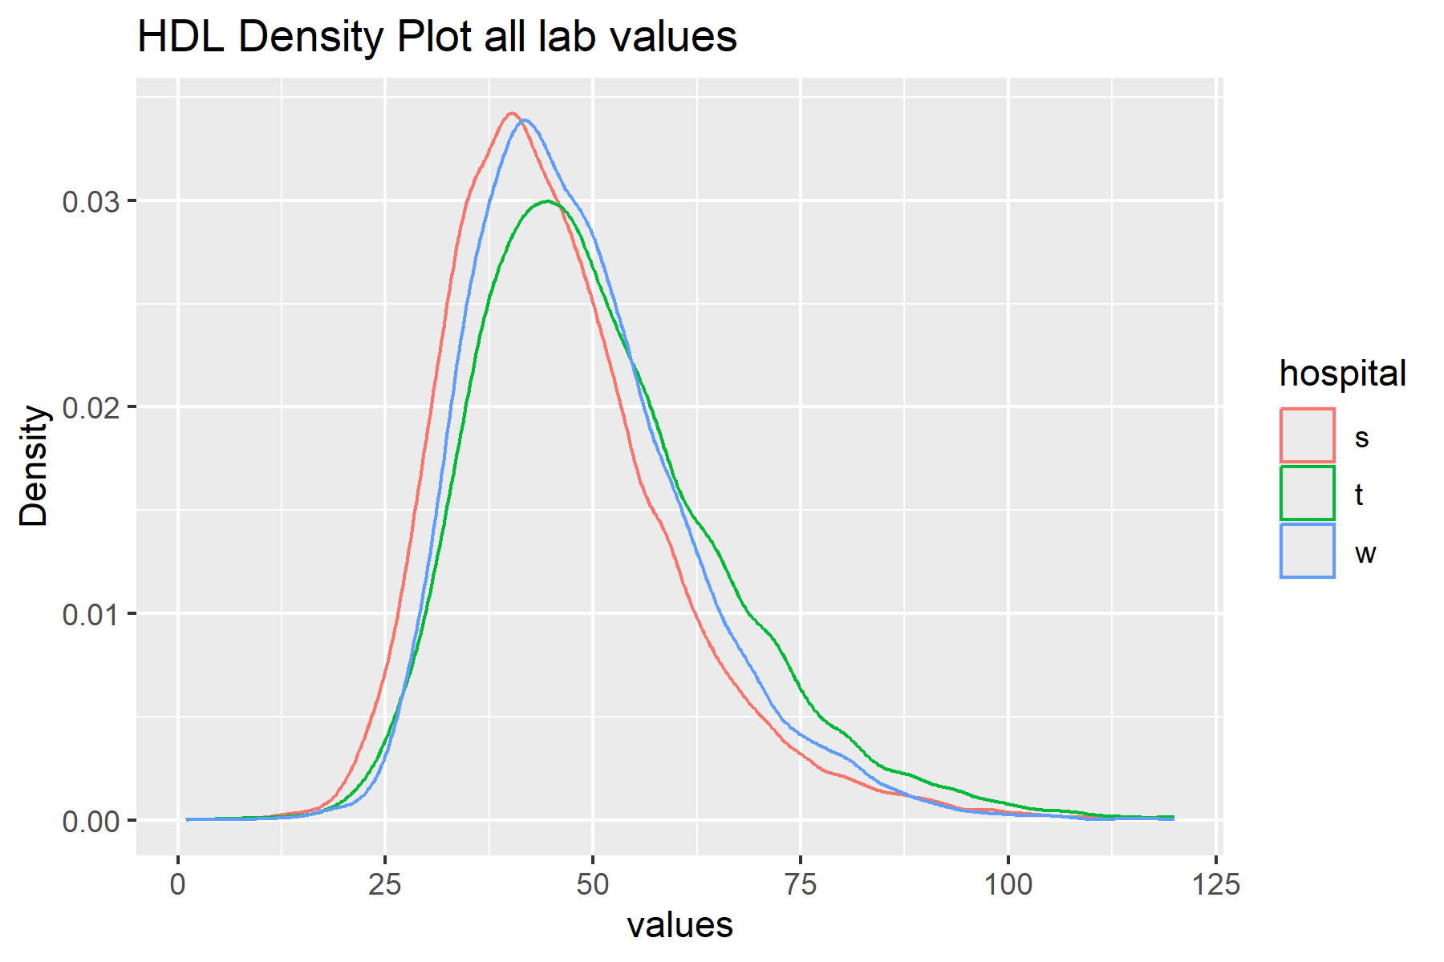
     5. LDL Test ID: "F09044A", "011401", upper = 200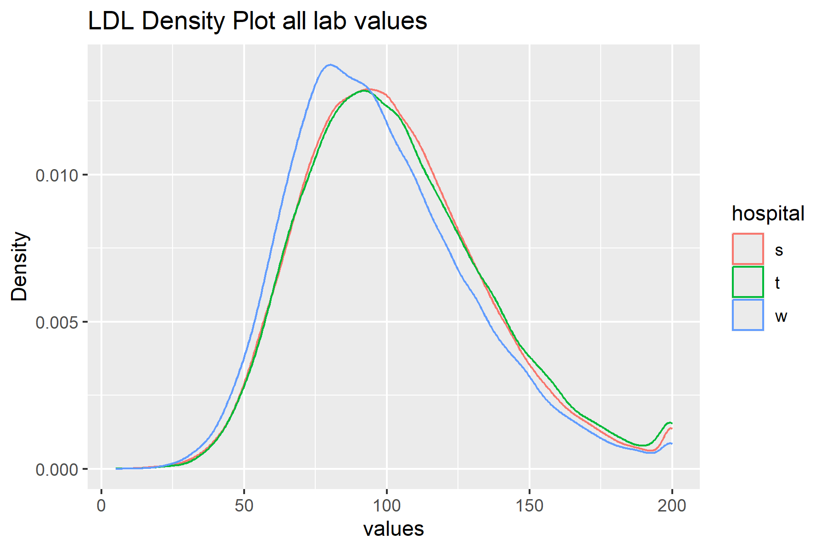
     6. Creatinine Test ID: "F09015C", "11D101", "11A201", "010801", "011C01"

Upper = 10

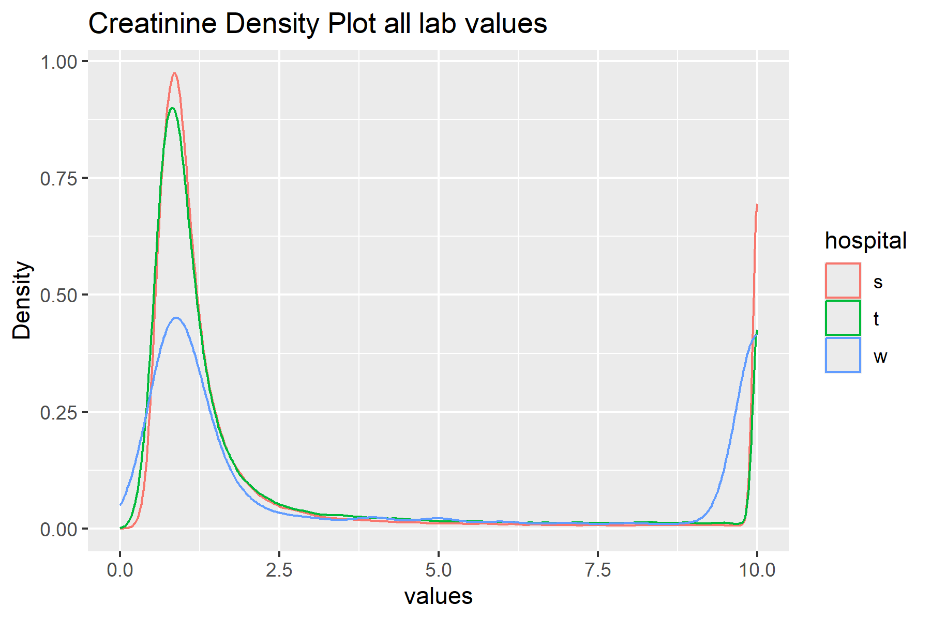

**心血管 (cardiovascular disease)相關主題:**

**自變量**：生理數值檢測項目的變異性

* 血壓變異性（如日間和夜間的血壓波動）
* 血糖變異性（如血糖的日間波動）
* 血脂變異性（如LDL和HDL的波動）

**因變量**：中風併發症

* **運動功能障礙**: Motor Function Impairment
* **語言障礙**: Speech Impairment
* **認知障礙**: Cognitive Impairment
* **情緒和心理問題**: Emotional and Psychological Problems
* **吞嚥困難**: Dysphagia
* **褥瘡**: Pressure Ulcers

**控制變量**：年齡、性別、控制疾病、生活方式因素（如吸煙、飲酒）、中風類型和嚴重程度等。

* **高脂血症**（Hyperlipidemia）
* **冠心病**（Coronary Artery Disease）
* **慢性腎病**（Chronic Kidney Disease）
* **慢性阻塞性肺病**（Chronic Obstructive Pulmonary Disease, COPD）
* **心房顫動**（Atrial Fibrillation）
* **周邊動脈疾病**（Peripheral Artery Disease）
* **肥胖**（Obesity）
* **代謝綜合徵**（Metabolic Syndrome）
* **睡眠呼吸暫停綜合徵**（Sleep Apnea Syndrome）
* **甲狀腺疾病**（Thyroid Disorders）
* **腦外傷史**（History of Traumatic Brain Injury）
* **抑鬱症**（Depression）
* **焦慮症**（Anxiety Disorders）
* **酒精使用障礙**（Alcohol Use Disorder）
* **藥物濫用**（Substance Abuse）
* **缺乏運動**（Physical Inactivity）
* **不良飲食習慣**（Unhealthy Dietary Habits）
* **家族中風史**（Family History of Stroke）
* 高血壓
* 糖尿病

**論文整理:**