[研究議題：**Risk of neurological and psychiatric disease following traumatic brain injury**]

**研究目的** : 不同程度的頭部外傷是否與病人癒後發生精神疾病的發生率相關。

**資料區間** : 2000-2018 全人口檔。

**目標病患** : TBI 患者

* ICD CODE
  + ICD-9 : 850-854
  + ICD-10 : S01 - S07
* 程度分類
  + 輕症 : 門診 ( 一年兩次) 或 急診 或 住院 ( 無手術 、加護病房)。
  + 重症 : 住院 且 有加護病房 或 手術。
* 使用之 手術 及 加護病房 之 健保給付碼 如下

|  |  |
| --- | --- |
| 手術 | "83011B", "83012B", "83013C", "83014C", "83015C", "83016B", "83036C", "83037C", "83038C", "83039B", "83063B", "83063A", "83080B" |
| ICU | "02011K", "02012A", "02013B", "03010E", "03010K", "03011A", "03011F", "03012B", "03012G", "03013B" "03013H", "03014A", "03015B", "03017A", "03025B", "03037A", "03038B", "03039B", "03041A", "03047E", "03048F", "03049G", "03050H", "03095A", "03096B" "03098A", "03104E", "03105F", "03106G" |

**Comparison** : 無任何 TBI 紀錄者

* 在資料區間內無頭部外傷紀錄者。(門診或住院檔出現一次TBI就不納入 Comparison 組)

**Outcome**

|  |  |  |
| --- | --- | --- |
| 精神疾病 | ICD CODE | 操作定義 |
| Sleep Disorders  睡眠障礙 | ICD9 : 307.4、780.5  ICD10 : G47 | 一年內兩次門診或住院一次 |
| Depression Disorder  憂鬱症 | ICD9 : 296.2、296.3、300.4、311  ICD10 : F32、F33、F34.1 |
| Psychiatric Disease  精神疾病 | 同時考慮  Sleep Disorders、Depression Disorder |

**Exclude**

* 性別年齡不詳。
* 小於 18 歲患者。
* Index year < 2001-01-01 (至少一年觀察期)。
* Index Date 前一年內有 Psychiatric Disease ( 排除Index date 前有 Outcome 患者)。
* Index Date 前一年內有下列疾病患者。

|  |  |  |
| --- | --- | --- |
| 疾病名稱 | ICD CODE | 操作定義 |
| 腦部腫瘤 | ICD9 :  191, 192, 225, 170.0, 173.4, 195.0, 198.3, 198.4, 213.0, 216.4, 239.6  ICD10 :  C41.0, C44.4, C4A.4, C70, C71, C72, C76.0, C79.3, C79.4, D16.4, D22.4, D23.4, D32, D33, D49.6 | 一年內 2次門診 或 1 次住院。 |
| 中風 | ICD9 :  433, 434  ICD10 :  I63, I65, I66 |
| 腦炎 | ICD9 :  013.6, 036.0, 036.1, 046.2, 047, 049.0, 049.1, 052.0, 054.3, 055.0, 062, 063, 064, 072.1, 072.2, 090.41, 094.81, 130.0, 320, 321, 322, 323  ICD10 :  A17.0, A17.1, A17.82, A17.83, A39, A50.42, A52.14, A81.1, A83, A84, A85, A86, A87, B00.4, B01.11, B05.0, B10.0, B26.1, B26.2, B58.2, B45.1, G00, G01, G02, G03, G04, G05, G373, G374, G92 |
| 腦神經病變 | ICD9 : 951  ICD10 : S04 |

* Index Date 前一年內曾住加護病房之患者。
* Index Date 後 90 天內有 精神疾病者。

**Matching**

* 使用 Propensity Score Matching
* 使用下列變數
  + 性別
  + 年齡
  + Index Date 之年份
  + Income
  + Index Date 前一年有下列疾病

|  |  |  |
| --- | --- | --- |
| 疾病名稱 | ICD CODE | 操作定義 |
| Hypertension  高血壓 | ICD9 :  401, 402, 403, 404, 405  ICD10 :  I10, I11, I12, I13, I15 | 一年內 2次門診 或 1 次住院。 |
| Diabetes Mellitus  糖尿病 | ICD9 :  250  ICD10 :  E08, E09, E10, E11, E13 |
| Asthma  氣喘 | ICD9 :  493  ICD10 :  J44, J45, R06.00, R06.01, R06.02, R06.09, R06.1, R06.2 |
| Peptic Ulcer  消化性潰瘍 | ICD9:  531, 532, 533, 534, 578  ICD10 :  K25, k26, k27, k28, K31.82, K92.0, K92.1,K92.2 |
| Gastroesophageal Reflux Disease  胃食道逆流 | ICD9:  530.11, 530.81  ICD10 :  K21 |
| Alcohol Use  飲酒 | ICD9:  291, 303, 357.5, 425.5, 571.0, 571.1, 571.2, 571.3, 535, 535.3  ICD10:  F10, G26.1, I42.6, K29.2, K70 |

**Figure 1. 流程圖**

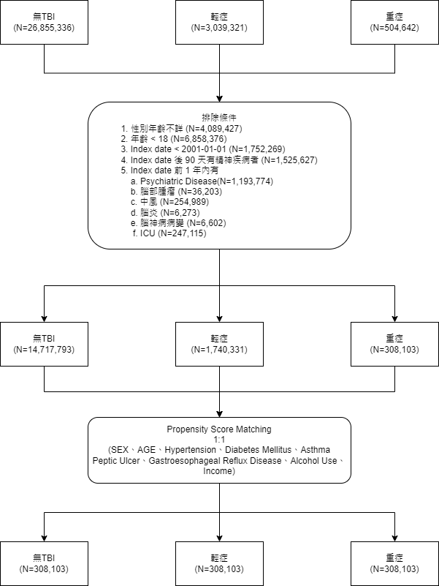

**Table 1. 病患之配對『前』基線分析**

|  |  |  |  |  |  |  |
| --- | --- | --- | --- | --- | --- | --- |
|  |  | **無TBI**  **(n=14717793)** | **輕症**  **(n=1740331)** | **重症**  **(n=308103)** | **p.value** | **overall**  **(n=16766227)** |
| **ID_S** |  |  |  |  | **<0.001** |  |
|  | **男** | **7435965(50.52%)** | **935759(53.77%)** | **186342(60.48%)** |  | **8558066(51.04%)** |
|  | **女** | **7281828(49.48%)** | **804572(46.23%)** | **121761(39.52%)** |  | **8208161(48.96%)** |
| **AGE** |  |  |  |  |  |  |
|  | **Mean(sd)** | **45.28(17.92)** | **45.27(20.04)** | **49.4(20.79)** | **<0.001** | **45.36(18.21)** |
|  | **Median(IQR)** | **43(26)** | **43(33)** | **49(36)** | **<0.001** | **43(26)** |
|  | **(Min,Max)** | **(18,100)** | **(18,100)** | **(18,100)** |  | **(18,100)** |
| **age_group** |  |  |  |  | **<0.001** |  |
|  | **18 - 30** | **3537051(24.03%)** | **541301(31.1%)** | **77629(25.2%)** |  | **4155981(24.79%)** |
|  | **31 - 40** | **3039341(20.65%)** | **265114(15.23%)** | **38613(12.53%)** |  | **3343068(19.94%)** |
|  | **41 - 50** | **2935448(19.94%)** | **259134(14.89%)** | **44185(14.34%)** |  | **3238767(19.32%)** |
|  | **51 - 60** | **2293695(15.58%)** | **244549(14.05%)** | **45457(14.75%)** |  | **2583701(15.41%)** |
|  | **61 - 70** | **1377123(9.36%)** | **189796(10.91%)** | **41660(13.52%)** |  | **1608579(9.59%)** |
|  | **71 以上** | **1535135(10.43%)** | **240437(13.82%)** | **60559(19.66%)** |  | **1836131(10.95%)** |
| **Income** |  |  |  |  | **<0.001** |  |
|  | **0** | **283887(1.93%)** | **131(0.01%)** | **31(0.01%)** |  | **284049(1.69%)** |
|  | **0-20,000** | **9236547(62.76%)** | **1206747(69.34%)** | **231026(74.98%)** |  | **10674320(63.67%)** |
|  | **20,000-40,000** | **3540463(24.06%)** | **379635(21.81%)** | **55872(18.13%)** |  | **3975970(23.71%)** |
|  | **40,000 以上** | **1656896(11.26%)** | **153818(8.84%)** | **21174(6.87%)** |  | **1831888(10.93%)** |
| **Index Year** |  |  |  |  | **<0.001** |  |
|  | **2001** | **848132(5.76%)** | **122491(7.04%)** | **29219(9.48%)** |  | **999842(5.96%)** |
|  | **2002** | **816974(5.55%)** | **116223(6.68%)** | **26572(8.62%)** |  | **959769(5.72%)** |
|  | **2003** | **796784(5.41%)** | **108727(6.25%)** | **24989(8.11%)** |  | **930500(5.55%)** |
|  | **2004** | **784222(5.33%)** | **98678(5.67%)** | **21444(6.96%)** |  | **904344(5.39%)** |
|  | **2005** | **773596(5.26%)** | **87212(5.01%)** | **18126(5.88%)** |  | **878934(5.24%)** |
|  | **2006** | **772043(5.25%)** | **76566(4.4%)** | **16657(5.41%)** |  | **865266(5.16%)** |
|  | **2007** | **767420(5.21%)** | **70886(4.07%)** | **14994(4.87%)** |  | **853300(5.09%)** |
|  | **2008** | **770918(5.24%)** | **66444(3.82%)** | **14960(4.86%)** |  | **852322(5.08%)** |
|  | **2009** | **770041(5.23%)** | **65676(3.77%)** | **14207(4.61%)** |  | **849924(5.07%)** |
|  | **2010** | **769603(5.23%)** | **65223(3.75%)** | **14199(4.61%)** |  | **849025(5.06%)** |
|  | **2011** | **770023(5.23%)** | **65507(3.76%)** | **13442(4.36%)** |  | **848972(5.06%)** |
|  | **2012** | **775054(5.27%)** | **63187(3.63%)** | **12211(3.96%)** |  | **850452(5.07%)** |
|  | **2013** | **774312(5.26%)** | **58597(3.37%)** | **11711(3.8%)** |  | **844620(5.04%)** |
|  | **2014** | **777630(5.28%)** | **57593(3.31%)** | **11331(3.68%)** |  | **846554(5.05%)** |
|  | **2015** | **779468(5.3%)** | **55129(3.17%)** | **11302(3.67%)** |  | **845899(5.05%)** |
|  | **2016** | **785794(5.34%)** | **168897(9.7%)** | **14342(4.65%)** |  | **969033(5.78%)** |
|  | **2017** | **791555(5.38%)** | **149780(8.61%)** | **14064(4.56%)** |  | **955399(5.7%)** |
|  | **2018** | **793230(5.39%)** | **142740(8.2%)** | **14248(4.62%)** |  | **950218(5.67%)** |
|  | **2019** | **600994(4.08%)** | **100775(5.79%)** | **10085(3.27%)** |  | **711854(4.25%)** |
| **Hypertension** |  |  |  |  | **<0.001** |  |
|  | **0** | **13039370(88.6%)** | **1455611(83.64%)** | **246067(79.87%)** |  | **14741048(87.92%)** |
|  | **1** | **1678423(11.4%)** | **284720(16.36%)** | **62036(20.13%)** |  | **2025179(12.08%)** |
| **Diabetes**  **Mellitus** |  |  |  |  | **<0.001** |  |
|  | **0** | **13897039(94.42%)** | **1590676(91.4%)** | **274181(88.99%)** |  | **15761896(94.01%)** |
|  | **1** | **820754(5.58%)** | **149655(8.6%)** | **33922(11.01%)** |  | **1004331(5.99%)** |
| **Asthma** |  |  |  |  | **<0.001** |  |
|  | **0** | **14486999(98.43%)** | **1695691(97.43%)** | **300114(97.41%)** |  | **16482804(98.31%)** |
|  | **1** | **230794(1.57%)** | **44640(2.57%)** | **7989(2.59%)** |  | **283423(1.69%)** |
| **peptic ulcer** |  |  |  |  | **<0.001** |  |
|  | **0** | **14241333(96.76%)** | **1660486(95.41%)** | **290031(94.13%)** |  | **16191850(96.57%)** |
|  | **1** | **476460(3.24%)** | **79845(4.59%)** | **18072(5.87%)** |  | **574377(3.43%)** |
| **Gastroesophagealreflux_disease** |  |  |  |  | **<0.001** |  |
|  | **0** | **14495700(98.49%)** | **1698687(97.61%)** | **302917(98.32%)** |  | **16497304(98.4%)** |
|  | **1** | **222093(1.51%)** | **41644(2.39%)** | **5186(1.68%)** |  | **268923(1.6%)** |
| **alcohol use** |  |  |  |  | **<0.001** |  |
|  | **0** | **14134086(96.03%)** | **1646144(94.59%)** | **287868(93.43%)** |  | **16068098(95.84%)** |
|  | **1** | **583707(3.97%)** | **94187(5.41%)** | **20235(6.57%)** |  | **698129(4.16%)** |

**Table 2. 病患之配對『後』基線分析**

|  |  |  |  |  |  |  |
| --- | --- | --- | --- | --- | --- | --- |
|  |  | **無TBI**  **(n=308103)** | **輕症**  **(n=308103)** | **重症**  **(n=308103)** | **p.value** | **overall**  **(n=924309)** |
| **ID_S** |  |  |  |  | **1** |  |
|  | **男** | **186342(60.48%)** | **186342(60.48%)** | **186342(60.48%)** |  | **559026(60.48%)** |
|  | **女** | **121761(39.52%)** | **121761(39.52%)** | **121761(39.52%)** |  | **365283(39.52%)** |
| **AGE** |  |  |  |  |  |  |
|  | **Mean(sd)** | **49.4(20.78)** | **49.39(20.77)** | **49.4(20.79)** | **0.989** | **49.4(20.78)** |
|  | **Median(IQR)** | **49(36)** | **49(36)** | **49(36)** | **0.998** | **49(36)** |
|  | **(Min,Max)** | **(18,100)** | **(18,100)** | **(18,100)** |  | **(18,100)** |
| **age_group** |  |  |  |  | **1** |  |
|  | **18 - 30** | **77614(25.19%)** | **77586(25.18%)** | **77629(25.2%)** |  | **232829(25.19%)** |
|  | **31 - 40** | **38619(12.53%)** | **38619(12.53%)** | **38613(12.53%)** |  | **115851(12.53%)** |
|  | **41 - 50** | **44184(14.34%)** | **44167(14.34%)** | **44185(14.34%)** |  | **132536(14.34%)** |
|  | **51 - 60** | **45453(14.75%)** | **45538(14.78%)** | **45457(14.75%)** |  | **136448(14.76%)** |
|  | **61 - 70** | **41705(13.54%)** | **41696(13.53%)** | **41660(13.52%)** |  | **125061(13.53%)** |
|  | **71 以上** | **60528(19.65%)** | **60497(19.64%)** | **60559(19.66%)** |  | **181584(19.65%)** |
| **Income** |  |  |  |  | **0.963** |  |
|  | **0** | **30(0.01%)** | **23(0.01%)** | **31(0.01%)** |  | **84(0.01%)** |
|  | **0-20,000** | **231035(74.99%)** | **231106(75.01%)** | **231026(74.98%)** |  | **693167(74.99%)** |
|  | **20,000-40,000** | **55872(18.13%)** | **55843(18.12%)** | **55872(18.13%)** |  | **167587(18.13%)** |
|  | **40,000 以上** | **21166(6.87%)** | **21131(6.86%)** | **21174(6.87%)** |  | **63471(6.87%)** |
| **Index Year** |  |  |  |  | **1** |  |
|  | **2001** | **29219(9.48%)** | **29219(9.48%)** | **29219(9.48%)** |  | **87657(9.48%)** |
|  | **2002** | **26572(8.62%)** | **26572(8.62%)** | **26572(8.62%)** |  | **79716(8.62%)** |
|  | **2003** | **24989(8.11%)** | **24989(8.11%)** | **24989(8.11%)** |  | **74967(8.11%)** |
|  | **2004** | **21444(6.96%)** | **21444(6.96%)** | **21444(6.96%)** |  | **64332(6.96%)** |
|  | **2005** | **18126(5.88%)** | **18126(5.88%)** | **18126(5.88%)** |  | **54378(5.88%)** |
|  | **2006** | **16657(5.41%)** | **16657(5.41%)** | **16657(5.41%)** |  | **49971(5.41%)** |
|  | **2007** | **14994(4.87%)** | **14994(4.87%)** | **14994(4.87%)** |  | **44982(4.87%)** |
|  | **2008** | **14960(4.86%)** | **14960(4.86%)** | **14960(4.86%)** |  | **44880(4.86%)** |
|  | **2009** | **14207(4.61%)** | **14207(4.61%)** | **14207(4.61%)** |  | **42621(4.61%)** |
|  | **2010** | **14199(4.61%)** | **14199(4.61%)** | **14199(4.61%)** |  | **42597(4.61%)** |
|  | **2011** | **13442(4.36%)** | **13442(4.36%)** | **13442(4.36%)** |  | **40326(4.36%)** |
|  | **2012** | **12211(3.96%)** | **12211(3.96%)** | **12211(3.96%)** |  | **36633(3.96%)** |
|  | **2013** | **11711(3.8%)** | **11711(3.8%)** | **11711(3.8%)** |  | **35133(3.8%)** |
|  | **2014** | **11331(3.68%)** | **11331(3.68%)** | **11331(3.68%)** |  | **33993(3.68%)** |
|  | **2015** | **11302(3.67%)** | **11302(3.67%)** | **11302(3.67%)** |  | **33906(3.67%)** |
|  | **2016** | **14342(4.65%)** | **14342(4.65%)** | **14342(4.65%)** |  | **43026(4.65%)** |
|  | **2017** | **14064(4.56%)** | **14064(4.56%)** | **14064(4.56%)** |  | **42192(4.56%)** |
|  | **2018** | **14248(4.62%)** | **14248(4.62%)** | **14248(4.62%)** |  | **42744(4.62%)** |
|  | **2019** | **10085(3.27%)** | **10085(3.27%)** | **10085(3.27%)** |  | **30255(3.27%)** |
| **Hypertension** |  |  |  |  | **1** |  |
|  | **0** | **246070(79.87%)** | **246065(79.86%)** | **246067(79.87%)** |  | **738202(79.87%)** |
|  | **1** | **62033(20.13%)** | **62038(20.14%)** | **62036(20.13%)** |  | **186107(20.13%)** |
| **Diabetes**  **Mellitus** |  |  |  |  | **0.999** |  |
|  | **0** | **274182(88.99%)** | **274193(88.99%)** | **274181(88.99%)** |  | **822556(88.99%)** |
|  | **1** | **33921(11.01%)** | **33910(11.01%)** | **33922(11.01%)** |  | **101753(11.01%)** |
| **Asthma** |  |  |  |  | **1** |  |
|  | **0** | **300114(97.41%)** | **300114(97.41%)** | **300114(97.41%)** |  | **900342(97.41%)** |
|  | **1** | **7989(2.59%)** | **7989(2.59%)** | **7989(2.59%)** |  | **23967(2.59%)** |
| **peptic ulcer** |  |  |  |  | **1** |  |
|  | **0** | **290032(94.13%)** | **290028(94.13%)** | **290031(94.13%)** |  | **870091(94.13%)** |
|  | **1** | **18071(5.87%)** | **18075(5.87%)** | **18072(5.87%)** |  | **54218(5.87%)** |
| **Gastroesophagealreflux_disease** |  |  |  |  | **1** |  |
|  | **0** | **302917(98.32%)** | **302919(98.32%)** | **302917(98.32%)** |  | **908753(98.32%)** |
|  | **1** | **5186(1.68%)** | **5184(1.68%)** | **5186(1.68%)** |  | **15556(1.68%)** |
| **alcohol use** |  |  |  |  | **0.999** |  |
|  | **0** | **287867(93.43%)** | **287874(93.43%)** | **287868(93.43%)** |  | **863609(93.43%)** |
|  | **1** | **20236(6.57%)** | **20229(6.57%)** | **20235(6.57%)** |  | **60700(6.57%)** |

**Figure1.** Sleep Disorders **K-M curve**

**0 = 無TBI; 1=輕症; 2=重症**

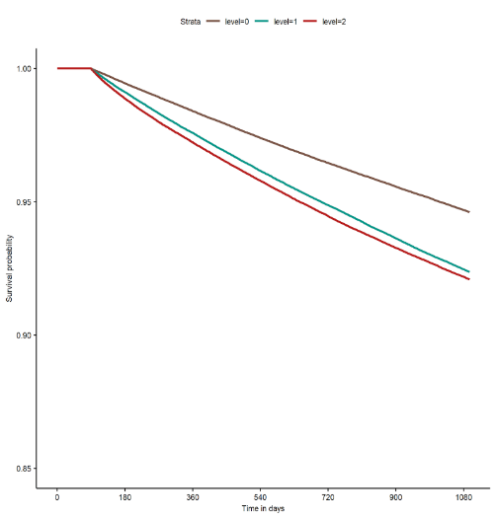

**Figure2.** Depression Disorder **K-M curve**

**0 = 無TBI; 1=輕症; 2=重症**

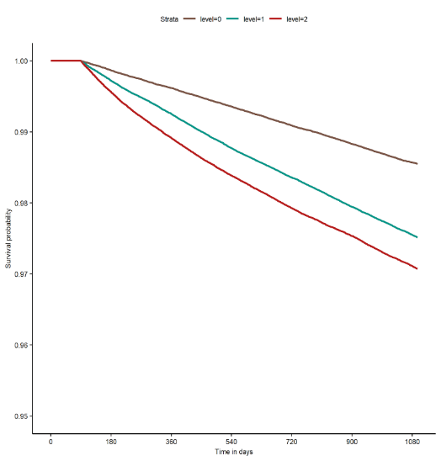

**Figure3.** Psychiatric Disease **K-M curve**

**0 = 無TBI; 1=輕症; 2=重症**

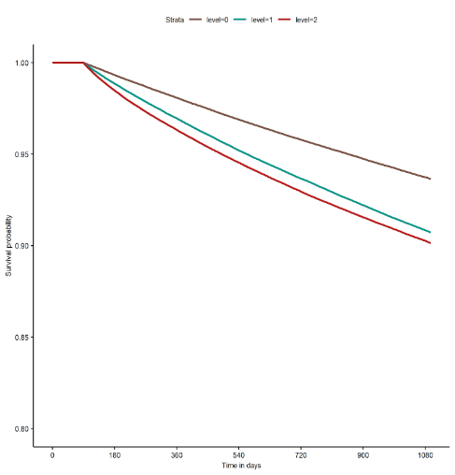

**Table 3. Cox Model**

|  |  |  |  |  |  |  |  |  |  |
| --- | --- | --- | --- | --- | --- | --- | --- | --- | --- |
|  |  | Ref = 無 TBI | | | | Ref = 輕症 | | | |
|  |  | 半年 | 1年 | 2年 | 3年 | 半年 | 1年 | 2年 | 3年 |
| Sleep Disorders |  |  |  |  |  |  |  |  |  |
|  | 輕症 | 1.61(1.51,1.71) *** | 1.53(1.47,1.58) *** | 1.46(1.43,1.5) *** | 1.44(1.41,1.47) *** |  |  |  |  |
|  | 重症 | 2.07(1.95,2.19) *** | 1.77(1.71,1.84) *** | 1.6(1.56,1.64) *** | 1.52(1.49,1.55) *** | 1.29(1.22,1.35) *** | 1.16(1.13,1.2) *** | 1.1(1.08,1.13) *** | 1.06(1.04,1.08) *** |
|  | trend test | <0.001 | <0.001 | <0.001 | <0.001 |  |  |  |  |
| Depression Disorder |  |  |  |  |  |  |  |  |  |
|  | 輕症 | 2.07(1.84,2.34) *** | 1.97(1.84,2.12) *** | 1.8(1.72,1.89) *** | 1.73(1.66,1.8) *** |  |  |  |  |
|  | 重症 | 3.29(2.95,3.68) *** | 2.86(2.68,3.06) *** | 2.3(2.2,2.41)  *** | 2.07(1.99,2.15) *** | 1.58(1.45,1.72) *** | 1.45(1.37,1.53) *** | 1.28(1.23,1.33) *** | 1.2(1.16,1.24) *** |
|  | trend test | <0.001 | <0.001 | <0.001 | <0.001 |  |  |  |  |
| Psychiatric Disease |  |  |  |  |  |  |  |  |  |
|  | 輕症 | 1.71(1.62,1.81) *** | 1.61(1.55,1.66) *** | 1.53(1.49,1.56) *** | 1.49(1.46,1.52) *** |  |  |  |  |
|  | 重症 | 2.3(2.18,2.42) *** | 1.96(1.89,2.02) *** | 1.73(1.69,1.77) *** | 1.62(1.59,1.66) *** | 1.34(1.28,1.4) *** | 1.22(1.19,1.25) *** | 1.14(1.11,1.16) *** | 1.09(1.07,1.11) *** |
|  | trend test | <0.001 | <0.001 | <0.001 | <0.001 |  |  |  |  |

1. Hazard Ratio(95% lower_bound, 95% upper_bound)

2. *p<0.05, **p<0.01, *** p<0.001

**補充**

**探討 Low income 是否為Outcome的risk factor**

**分析方法 ；**

1. **研究群體與上述分析一致，在 Matching 時不納入 Income 變數。**
2. **一樣 使用 Cox Model 進行分析。並探討下列三種狀況**
   1. **將 Income 分為 2 組 ( 20,000 以下/ 40,000以上) 分析 無TBI / 輕症 / 重症 三者後續各精神疾病之風險。**
   2. **將 Income 分為 3 組 ( 20,000 以下/ 20,000 - 40,000/ 40,000以上) 分析 無TBI / 輕症 / 重症 三者後續各精神疾病之風險。**

**Table 4. 病患之配對『後』基線分析**

|  |  |  |  |  |  |  |
| --- | --- | --- | --- | --- | --- | --- |
|  |  | **無TBI**  **(n=308103)** | **輕症**  **(n=308103)** | **重症**  **(n=308103)** | **p.value** | **overall**  **(n=924309)** |
| **ID_S** |  |  |  |  | **1** |  |
|  | **男** | **186342(60.48%)** | **186342(60.48%)** | **186342(60.48%)** |  | **559026(60.48%)** |
|  | **女** | **121761(39.52%)** | **121761(39.52%)** | **121761(39.52%)** |  | **365283(39.52%)** |
| **AGE** |  |  |  |  |  |  |
|  | **Mean(sd)** | **49.4(20.79)** | **49.4(20.78)** | **49.4(20.79)** | **1** | **49.4(20.79)** |
|  | **Median(IQR)** | **49(36)** | **49(36)** | **49(36)** | **1** | **49(36)** |
|  | **(Min,Max)** | **(18,100)** | **(18,100)** | **(18,100)** |  | **(18,100)** |
| **age_group** |  |  |  |  | **1** |  |
|  | **18 - 30** | **77620(25.19%)** | **77599(25.19%)** | **77629(25.2%)** |  | **232848(25.19%)** |
|  | **31 - 40** | **38615(12.53%)** | **38615(12.53%)** | **38613(12.53%)** |  | **115843(12.53%)** |
|  | **41 - 50** | **44183(14.34%)** | **44164(14.33%)** | **44185(14.34%)** |  | **132532(14.34%)** |
|  | **51 - 60** | **45465(14.76%)** | **45502(14.77%)** | **45457(14.75%)** |  | **136424(14.76%)** |
|  | **61 - 70** | **41677(13.53%)** | **41669(13.52%)** | **41660(13.52%)** |  | **125006(13.52%)** |
|  | **71 以上** | **60543(19.65%)** | **60554(19.65%)** | **60559(19.66%)** |  | **181656(19.65%)** |
| **Income** |  |  |  |  | **<0.001** |  |
|  | **0** | **5316(1.73%)** | **13(0%)** | **31(0.01%)** |  | **5360(0.58%)** |
|  | **0-20,000** | **197489(64.1%)** | **215578(69.97%)** | **231026(74.98%)** |  | **644093(69.68%)** |
|  | **20,000-40,000** | **69464(22.55%)** | **64384(20.9%)** | **55872(18.13%)** |  | **189720(20.53%)** |
|  | **40,000 以上** | **35834(11.63%)** | **28128(9.13%)** | **21174(6.87%)** |  | **85136(9.21%)** |
| **Index Year** |  |  |  |  | **1** |  |
|  | **2001** | **29219(9.48%)** | **29219(9.48%)** | **29219(9.48%)** |  | **87657(9.48%)** |
|  | **2002** | **26572(8.62%)** | **26572(8.62%)** | **26572(8.62%)** |  | **79716(8.62%)** |
|  | **2003** | **24989(8.11%)** | **24989(8.11%)** | **24989(8.11%)** |  | **74967(8.11%)** |
|  | **2004** | **21444(6.96%)** | **21444(6.96%)** | **21444(6.96%)** |  | **64332(6.96%)** |
|  | **2005** | **18126(5.88%)** | **18126(5.88%)** | **18126(5.88%)** |  | **54378(5.88%)** |
|  | **2006** | **16657(5.41%)** | **16657(5.41%)** | **16657(5.41%)** |  | **49971(5.41%)** |
|  | **2007** | **14994(4.87%)** | **14994(4.87%)** | **14994(4.87%)** |  | **44982(4.87%)** |
|  | **2008** | **14960(4.86%)** | **14960(4.86%)** | **14960(4.86%)** |  | **44880(4.86%)** |
|  | **2009** | **14207(4.61%)** | **14207(4.61%)** | **14207(4.61%)** |  | **42621(4.61%)** |
|  | **2010** | **14199(4.61%)** | **14199(4.61%)** | **14199(4.61%)** |  | **42597(4.61%)** |
|  | **2011** | **13442(4.36%)** | **13442(4.36%)** | **13442(4.36%)** |  | **40326(4.36%)** |
|  | **2012** | **12211(3.96%)** | **12211(3.96%)** | **12211(3.96%)** |  | **36633(3.96%)** |
|  | **2013** | **11711(3.8%)** | **11711(3.8%)** | **11711(3.8%)** |  | **35133(3.8%)** |
|  | **2014** | **11331(3.68%)** | **11331(3.68%)** | **11331(3.68%)** |  | **33993(3.68%)** |
|  | **2015** | **11302(3.67%)** | **11302(3.67%)** | **11302(3.67%)** |  | **33906(3.67%)** |
|  | **2016** | **14342(4.65%)** | **14342(4.65%)** | **14342(4.65%)** |  | **43026(4.65%)** |
|  | **2017** | **14064(4.56%)** | **14064(4.56%)** | **14064(4.56%)** |  | **42192(4.56%)** |
|  | **2018** | **14248(4.62%)** | **14248(4.62%)** | **14248(4.62%)** |  | **42744(4.62%)** |
|  | **2019** | **10085(3.27%)** | **10085(3.27%)** | **10085(3.27%)** |  | **30255(3.27%)** |
| **Hypertension** |  |  |  |  | **1** |  |
|  | **0** | **246067(79.87%)** | **246063(79.86%)** | **246067(79.87%)** |  | **738197(79.86%)** |
|  | **1** | **62036(20.13%)** | **62040(20.14%)** | **62036(20.13%)** |  | **186112(20.14%)** |
| **Diabetes**  **Mellitus** |  |  |  |  | **1** |  |
|  | **0** | **274182(88.99%)** | **274191(88.99%)** | **274181(88.99%)** |  | **822554(88.99%)** |
|  | **1** | **33921(11.01%)** | **33912(11.01%)** | **33922(11.01%)** |  | **101755(11.01%)** |
| **Asthma** |  |  |  |  | **1** |  |
|  | **0** | **300114(97.41%)** | **300114(97.41%)** | **300114(97.41%)** |  | **900342(97.41%)** |
|  | **1** | **7989(2.59%)** | **7989(2.59%)** | **7989(2.59%)** |  | **23967(2.59%)** |
| **peptic ulcer** |  |  |  |  | **1** |  |
|  | **0** | **290031(94.13%)** | **290029(94.13%)** | **290031(94.13%)** |  | **870091(94.13%)** |
|  | **1** | **18072(5.87%)** | **18074(5.87%)** | **18072(5.87%)** |  | **54218(5.87%)** |
| **Gastroesophagealreflux_disease** |  |  |  |  | **1** |  |
|  | **0** | **302917(98.32%)** | **302919(98.32%)** | **302917(98.32%)** |  | **908753(98.32%)** |
|  | **1** | **5186(1.68%)** | **5184(1.68%)** | **5186(1.68%)** |  | **15556(1.68%)** |
| **alcohol use** |  |  |  |  | **0.999** |  |
|  | **0** | **287867(93.43%)** | **287875(93.43%)** | **287868(93.43%)** |  | **863610(93.43%)** |
|  | **1** | **20236(6.57%)** | **20228(6.57%)** | **20235(6.57%)** |  | **60699(6.57%)** |

**Table 5. Income 兩組 、TBI 三組 之 Cox Model**

|  |  |  |  |  |  |  |
| --- | --- | --- | --- | --- | --- | --- |
|  |  |  | 半年 | 1年 | 2年 | 3年 |
| Sleep Disorders |  |  |  |  |  |  |
|  | Income |  |  |  |  |  |
|  |  | < =20,000 (ref) |  |  |  |  |
|  |  | >20,000 | 0.92(0.87,0.98)  * | 0.93(0.9,0.97)  *** | 0.91(0.89,0.94)  *** | 0.91(0.89,0.93)  *** |
|  | TBI |  |  |  |  |  |
|  |  | 無TBI(ref) |  |  |  |  |
|  |  | 輕症 | 1.64(1.54,1.74)  *** | 1.54(1.49,1.6) *** | 1.48(1.44,1.52) *** | 1.45(1.42,1.48)  *** |
|  |  | 重症 | 2.07(1.95,2.19)  *** | 1.77(1.71,1.83) *** | 1.61(1.57,1.66) *** | 1.53(1.5,1.56)  *** |
| Depression Disorder |  |  |  |  |  |  |
|  | Income |  |  |  |  |  |
|  |  | < =20,000 (ref) |  |  |  |  |
|  |  | >20,000 | 0.95(0.85,1.06) | 0.96(0.9,1.03) | 0.95(0.9,0.99) * | 0.95(0.91,0.99) ** |
|  | TBI |  |  |  |  |  |
|  |  | 無TBI(ref) |  |  |  |  |
|  |  | 輕症 | 1.93(1.71,2.17)  *** | 1.95(1.81,2.09) *** | 1.79(1.71,1.88) *** | 1.74(1.68,1.82) *** |
|  |  | 重症 | 3.09(2.77,3.44)  *** | 2.89(2.7,3.09)  *** | 2.33(2.22,2.44) *** | 2.11(2.03,2.2) *** |
| Psychiatric Disease |  |  |  |  |  |  |
|  | Income |  |  |  |  |  |
|  |  | < =20,000 (ref) |  |  |  |  |
|  |  | >20,000 | 0.93(0.88,0.99)  * | 0.94(0.91,0.97)  *** | 0.92(0.89,0.94) *** | 0.92(0.9,0.94)  *** |
|  | TBI |  |  |  |  |  |
|  |  | 無TBI(ref) |  |  |  |  |
|  |  | 輕症 | 1.72(1.62,1.81)  *** | 1.62(1.56,1.67)  *** | 1.54(1.5,1.57)  *** | 1.5(1.47,1.53)  *** |
|  |  | 重症 | 2.28(2.16,2.4)  *** | 1.96(1.9,2.03)  *** | 1.74(1.7,1.78)  *** | 1.64(1.6,1.67)  *** |

1. Hazard Ratio(95% lower_bound, 95% upper_bound)

2. *p<0.05, **p<0.01, *** p<0.001

**Table 6. Income 三組 、TBI 三組 之 Cox Model**

|  |  |  |  |  |  |  |
| --- | --- | --- | --- | --- | --- | --- |
|  |  |  | 半年 | 1年 | 2年 | 3年 |
| Sleep Disorders |  |  |  |  |  |  |
|  | Income |  |  |  |  |  |
|  |  | < =20,000 (ref) |  |  |  |  |
|  |  | 20,000 - 40,000 | 0.94(0.87,1.01) | 0.94(0.9,0.98) ** | 0.92(0.89,0.95) *** | 0.92(0.9,0.95) *** |
|  |  | >= 40,000 | 0.89(0.81,0.99) * | 0.92(0.87,0.98) * | 0.9(0.86,0.94)  *** | 0.89(0.86,0.92) *** |
|  | TBI |  |  |  |  |  |
|  |  | 無TBI(ref) |  |  |  |  |
|  |  | 輕症 | 1.64(1.54,1.74) *** | 1.54(1.49,1.6)  *** | 1.48(1.44,1.52) *** | 1.45(1.41,1.48) *** |
|  |  | 重症 | 2.06(1.95,2.19) *** | 1.77(1.71,1.83)  *** | 1.61(1.57,1.66) *** | 1.53(1.5,1.56) *** |
| Depression Disorder |  |  |  |  |  |  |
|  | Income |  |  |  |  |  |
|  |  | < =20,000 (ref) |  |  |  |  |
|  |  | 20,000 - 40,000 | 1.01(0.89,1.15) | 0.98(0.9,1.06) | 0.94(0.89,0.99) * | 0.94(0.9,0.99) * |
|  |  | >= 40,000 | 0.83(0.69,0.99) * | 0.93(0.83,1.04) | 0.97(0.9,1.05) | 0.96(0.9,1.03) |
|  | TBI |  |  |  |  |  |
|  |  | 無TBI(ref) |  |  |  |  |
|  |  | 輕症 | 1.92(1.71,2.16) *** | 1.95(1.81,2.09)  *** | 1.79(1.71,1.88) *** | 1.75(1.68,1.82) *** |
|  |  | 重症 | 3.08(2.76,3.43) *** | 2.89(2.7,3.09)  *** | 2.33(2.22,2.44) *** | 2.12(2.04,2.2) *** |
| Psychiatric Disease |  |  |  |  |  |  |
|  | Income |  |  |  |  |  |
|  |  | < =20,000 (ref) |  |  |  |  |
|  |  | 20,000 - 40,000 | 0.96(0.9,1.03) | 0.95(0.91,0.98) ** | 0.92(0.89,0.95) *** | 0.92(0.9,0.95) *** |
|  |  | >= 40,000 | 0.87(0.8,0.96) ** | 0.92(0.87,0.98) ** | 0.91(0.88,0.95) *** | 0.91(0.88,0.94) *** |
|  | TBI |  |  |  |  |  |
|  |  | 無TBI(ref) |  |  |  |  |
|  |  | 輕症 | 1.71(1.62,1.81) *** | 1.62(1.56,1.67) *** | 1.54(1.5,1.57) *** | 1.5(1.47,1.53) *** |
|  |  | 重症 | 2.27(2.16,2.4) *** | 1.96(1.9,2.02) *** | 1.74(1.7,1.78) *** | 1.64(1.6,1.67) *** |

1. Hazard Ratio(95% lower_bound, 95% upper_bound)

2. *p<0.05, **p<0.01, *** p<0.001

**結論 ；**

1. **從 Table 5 得知 在相同的 TBI 嚴重程度下 Income > 20,000 較於 Income <= 20,000 後續患有精神疾病之風險較低(HR < 1)。其中不管 Sleep Disorders 或Psychiatric Diseas 在三年內都有顯著差異。而Depression Disorder 在 1 年內是無差異，但看三年是有差異。主要原因可能在於 1年內 Outcome 人數過少，導致不顯著。**
2. **從 Table 6 可以看到 Sleep Disorders 及 Psychiatric Diseas Income 越高 風險越低。而在Depression Disorder 並無明顯的趨勢。**