[研究議題：Assessing the Relationship Between the Variability of Diagnostic Measures and the Risk of Diabetic complications]

1. 大綱:
   1. 目的
   2. 資料來源與疾病定義
   3. 資料處理流程
   4. 分析方法
   5. 分析結果
   6. 結論與討論
2. 目的: 評估檢驗項目的變異性與糖尿病併發症風險的關係
   1. 參考論文: Predictions of diabetes complications and mortality using hba1c variability: a 10‑year observational cohort study
3. 資料來源與疾病定義:
   1. 資料集: 三院臨床資料庫
   2. 目標病患: 糖尿病患者
   3. 資料區間: 2008-2019
   4. 檢樣項目: HbA1c, ALBUMIN, Uric Acid, HDL, LDL, Creatinine
   5. 糖尿病相關併發症和共病列表:

|  |  |
| --- | --- |
| 類別 | 疾病名稱 |
| 併發症 | Eye complications眼部疾病 |
| Cardiovascular disease心血管疾病 |
| Cerebrovascular disease腦血管疾病 |
| Peripheral vascular disease周邊動脈疾病 |
| Nephropathy腎臟病 |
| Diabetic neuropathy神經病變 |
| 共病  目前19種 | Essential hypertension本態性高血壓 |
| Peripheral enthesopathies and allied syndromes  外周附著點病變及其相關聯症候群的疾病 |
| Other ill-defined and unknown causes of morbidity and mortality  定義不明和未知原因的發病和死亡 |
| Disorders of lipoid metabolism脂蛋白的代謝異常 |
| Acute upper respiratory infections of multiple or unspecified sites  多部位或未明確部位的急性上呼吸道感染 |
| Other symptoms involving abdomen and pelvis  腹部和骨盆的其他症狀 |
| Dermatophytosis 真菌引起的皮膚感染 |
| General symptoms非特定的身體症狀 |
| Symptoms involving respiratory system and other chest symptoms  呼吸系統和其他胸部症狀 |
| Symptoms involving head and neck 頭部和頸部的症狀 |
| Contact dermatitis and other eczema皮膚疾病 |
| Viral infection in conditions classified elsewhere and of unspecified site  病毒引起的感染 |
| Overweight, obesity and other hyperalimentation超重, 肥胖及其他過度營養狀態 |
| Other and unspecified disorders of joint未明確指定的關節疾病 |
| Acute bronchitis and bronchiolitis呼吸道疾病 |
| Other disorders of soft tissues其他軟組織的疾病 |
| Nonspecific findings on examination of blood  血液檢查時發現的一些非特定性的異常或發現 |
| Disorders of refraction and accommodation屈光和調節的疾病 |
| Disorders of conjunctiva 眼球表面覆蓋的結膜的各種疾病 |

* 1. 糖尿病患者發病定義: 一年內有3次門診紀錄或1次住院紀錄為糖尿病患者
     1. Index Date定義: 符合條件下的首次看診日
  2. 併發症發病定義: 一年內有3次門診紀錄或1次住院紀錄
  3. 共病的發病定義: 糖尿病患者Index_date前一年內有3次門診紀錄或1次住院紀錄
  4. ICD CODE:
     1. 糖尿病:

ICD9: 250, 251.8, 357.2, 362.01, 362.02, 366.41, 583.81

ICD10: E08, E09, E10(type 1 糖尿病), E11, ~~E12(無此疾病),~~ E13

* + 1. 併發症:

|  |  |  |
| --- | --- | --- |
| 糖尿病相關併發症 | ICD CODE | 操作定義 |
| Eye complications  眼部疾病 | ICD9: 362.01, 362.02, 362.55, 362.11, 365.44, 369, 361, 369.60  ICD10: H33.0, H33.10, H33.11, H33.19, H33.2, H33.3, H33.4, H33.8, E11.31, E11.32, E11.33, E11.34, E11.351, E11.359, H35.03, H35.38, H42, H54.0, H54.1, H54.2, H54.3, H54.8, H54.4, H54.5, H54.6, H54.7 | 一年內3次門診或1次住院 |
| Cardiovascular disease  心血管疾病 | ICD9: 414.9, 413.9, 411.1, 412, 428, 425, 402  ICD10: I11, I20.0, I20.8, I20.9, I25.2, I25.9, I42, I43, I50.1, I50.2, I50.3, I50.4, I50.9 |
| Cerebrovascular disease  腦血管疾病 | ICD9: 435.9, 434.91, 432.9, 437.1  ICD10: I62.9, I63.50, I63.511, I63.512, I63.519, I63.521, I63.522, I63.529, I63.531, I63.532, I63.539, I63.541, I63.542, I63.549, I63.59, I63.8, I63.9, I67.84, I67.81, I67.82, I67.89, G45.9 |
| Peripheral vascular disease  周邊動脈疾病 | ICD9: 440.2  ICD10: I70.2, I70.92, I75.01, I75.02 |
| Nephropathy  腎臟病 | ICD9: 583, 585, V451  ICD10: E10.21, E11.21, N05.0, N05.1, N05.2, N05.3, N05.4, N05.5, N05.6, N05.7, N05.8, N05.9, N06.0, N06.1, N06.2, N06.3, N06.4, N06.5, N06.6, N06.7, N06.8, N06.9, N07.0, N07.1, N07.2, N07.3, N07.4, N07.5, N07.6, N07.7, N07.8, N07.9, N14, N15.0, N15.8, N15.9, N16, N17.1, N17.2, N18.4, N18.5, N18.6, N18.9 |
| Diabetic neuropathy  神經病變 | ICD9: 357.2, 337.1, 353  ICD10: E08.42, E09.42, E10.40, E10.42, E11.40, E11.42, E13.42, G54, G55, G99.0 |

* + 1. 共病:

|  |  |  |
| --- | --- | --- |
| 糖尿病相關共病 | ICD CODE | 操作定義 |
| Essential hypertension  本態性高血壓 | ICD9: 401  ICD10: I10 | 一年內3次門診或1 次住院 |
| Peripheral enthesopathies and allied syndromes  外周附著點病變及其相關聯症候群的疾病 | ICD9: 726  ICD10: M25.70, M25.71, M25.72, M25.73, M25.74, M25.75, M25.76, M25.77, M66.21, M66.81, M70.1, M70.2, M70.3, M70.4, M70.5, M70.6, M70.7, M75.0, M75.10, M75.11, M75.2, M75.3, M75.4, M75.5, M75.8, M75.9, M76, M77 |
| Other ill-defined and unknown causes of morbidity and mortality  定義不明和未知原因的發病和死亡 | ICD9: 799  ICD10: R09.0, R09.2, R41.89, R44.8, R44.9, R45.0, R45.3, R45.4, R45.87, R45.89, R46, R53.81, R64, R68.13, R68.19, R68.82, R68.89, R69 |
| Disorders of lipoid metabolism  脂蛋白的代謝異常 | ICD9: 272  ICD10: E71.30, E75.21, E75.22, E75.24, E75.3, E75.5, E75.6, E77, E78.0, E78.1, E78.2, E78.3, E78.4, E78.5, E78.5, E78.6, E78.70, E78.79, E78.8, E78.9, E88.1, E88.2, E88.89 |
| Acute upper respiratory infections of multiple or unspecified sites  多部位或未明確部位的急性上呼吸道感染 | ICD9: 465  ICD10: J06 |
| Other symptoms involving abdomen and pelvis  腹部和骨盆的其他症狀 | ICD9: 724, 789  ICD10: M43.2, M43.8X9  M48.00, M48.04, M48.05, M48.06, M48.07, M48.08, M51.1, M53.2X7, M53.2X8, M53.3, M53.80, M53.84, M53.85, M53.86, M53.87, M53.88, M53.9, M54.03, M54.04, M54.05, M54.06, M54.07, M54.08, M54.09, M54.14, M54.15, M54.16, M54.17, M54.3, M54.4, M54.5, M54.6, M54.89, M54.9, M62.830, M99.22, M99.23, M99.24, M99.25, M99.26, M99.27, M99.28, M99.29, M99.32, M99.33, M99.34, M99.35, M99.36, M99.37, M99.38, M99.39, M99.42, M99.43, M99.44, M99.45, M99.46, M99.47, M99.48, M99.49, M99.52, M99.53, M99.54, M99.55, M99.56, M99.57, M99.58, M99.59, M99.62, M99.63, M99.64, M99.65, M99.66, M99.67, M99.68, M99.69, M99.72, M99.73, M99.74, M99.75, M99.76, M99.77, M99.78, M99.79, R10, R16, R18.8, R19.0, R19.3, R19.8 |
| Dermatophytosis  真菌引起的皮膚感染 | ICD9: 110  ICD9: B35 |
| General symptoms  非特定的身體症狀 | ICD9: 780  ICD10: E03.5, F51.8, G40.909, G47.0, G47.1, G47.20, G47.3, G47.5, G47.61, G47.69, G47.8, G47.9, G93.3, L74.51, L74.52, R40.0, R40.1, R40.20, R40.211, R40.212, R40.221, R40.222, R40.231, R40.232, R40.234, R40.3, R40.4, R41.0, R41.1, R41.2, R41.3, R41.82, R41.89, R41.9, R42, R44.0, R44.2, R44.3, R45.83, R45.84, R50.2, R50.81, R50.9, R52, R53.0, R53.1, R53.8, R55, R56, R61, R68.0, R68.11, R68.12, R68.81, R68.83, R68.89 |
| Symptoms involving respiratory system and other chest symptoms  呼吸系統和其他胸部症狀 | ICD9: 786  ICD10: R04.2, R04.8, R04.9, R05, R06.00, R06.01, R06.02, R06.09, R06.1, R06.2, R06.3, R06.3, R06.4, R06.6, R06.8, R06.9, R07.1, R07.2, R07.8, R07.9, R09.3, R09.89, R22.2, R91.8 |
| Symptoms involving head and neck  頭部和頸部的症狀 | ICD9: 784  ICD10: G44.05, G44.09, G44.1, G44.3, G44.4, G44.52, G44.53, G44.59, G44.81, G44.82, G44.83, G44.84, G44.85, G44.89, R04.0, R04.1, R06.5, R06.7, R07.0, R19.6, R22.0, R22.1, R47.0, R47.1, R47.81, R47.89, R47.9, R48.0, R48.1, R48.2, R48.8, R48.9, R49, R51, R90.0 |
| Contact dermatitis and other eczema  皮膚疾病 | ICD9: 692  ICD10: L23, L24.0, L24.1, L24.2, L24.3, L24.4, L24.5, L24.6, L24.7, L24.8, L24.9, L25, L30.0, L30.2, L30.8, L30.9, L55, L56, L57.1, L57.5, L57.8, L57.9, L58, L59 |
| Viral infection in conditions classified elsewhere and of unspecified site  病毒引起的感染 | ICD9: 79  ICD10: B34.9, E07.81, E79.0, I45.81, N39.0, O28, P09, R03, R09.0, R09.2, R19.5, R29.2, R41.81, R41.89, R44.8, R44.9, R45.0, R45.3, R45.4, R45.87, R45.89, R46, R53.81, R54, R64, R68.13, R68.19, R68.82, R68.89, R69, R70, R71, R73.01, R73.02, R73.09, R73.9, R74, R75, R76, R77, R78, R79.0, R79.1, R79.81, R79.82, R79.89, R79.9, R80.0, R80.1, R80.3, R80.8, R80.9, R81, R82, R83, R84, R85, R86, R87, R88, R89, R90.8, R91.8, R92.0, R92.1, R92.2, R92.8, R93, R94, R97, R99 |
| Overweight, obesity and other hyperalimentation  超重, 肥胖及其他過度營養狀態 | ICD9: 278  ICD10: E65, E66.0, E66.1, E66.2, E66.8, E66.9, E67, E68 |
| Other and unspecified disorders of joint  未明確指定的關節疾病 | ICD9: 719  ICD10: M12.2, M12.3, M12.4, M25.0, M25.1, M25.4, M25.50, M25.51, M25.52, M25.53, M25.55, M25.56, M25.57, M25.60, M25.61, M25.62, M25.63, M25.64, M25.65, M25.66, M25.67, M25.8, M25.9, M79.643, M79.646, R26.2, R29.4, R29.898 |
| Acute bronchitis and bronchiolitis  呼吸道疾病 | ICD9: 466  ICD10: J20.8, J20.9, J21 |
| Other disorders of soft tissues  其他軟組織的疾病 | ICD9: 729  ICD10: G47.62, M35.6, M54.10, M54.18, M60.8, M60.9, M70.8, M70.9, M72.9, M79, R25.2, R29.898 |
| Nonspecific findings on examination of blood  血液檢查時發現的一些非特定性的異常或發現 | ICD9: 790  ICD10: B34.9, E07.81, E79.0, R70, R71, R73.01, R73.02, R73.09, R73.9, R74, R77, R78, R79.0, R79.1, R79.81, R79.82, R79.89, R79.9, R97.2 |
| Disorders of refraction and accommodation  屈光和調節的疾病 | ICD9: 367  ICD10: H52 |
| Disorders of conjunctiva  眼球表面覆蓋的結膜的各種疾病 | ICD9: 372  ICD10: H10.0, H10.1, H10.2, H10.3, H10.4, H10.5, H10.81, H10.89, H10.9, H11 |

1. 資料處理流程:
   1. 病歷資料歸人
      1. 流程圖:

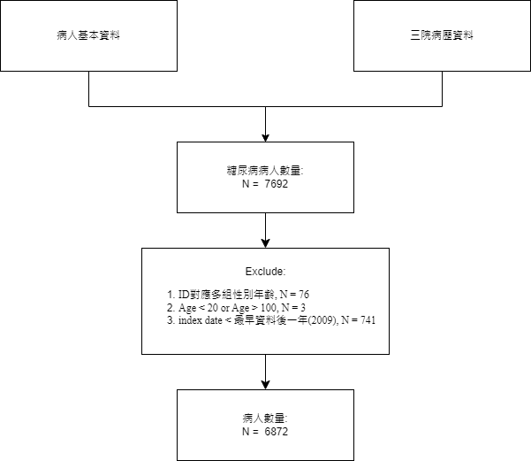

Table1. 糖尿病患者基線特徵分布

|  |  |  |
| --- | --- | --- |
|  | | overall(N=6872) |
| AGE | | |
|  | Mean(SD) | 68.23(12.23) |
| Median(IQR) | 68.35(17.64) |
| (Min, Max) | (21.63, 99.25) |
| AGE_GROUP |  |  |
|  | 20-30 | 17(0.25%) |
|  | 30-40 | 71(1.03%) |
|  | 40-50 | 394(5.73%) |
|  | 50-60 | 1294(18.83%) |
|  | 60-70 | 1974(28.73%) |
|  | 70-80 | 1843(26.82%) |
|  | 80-90 | 1120(16.3%) |
|  | 90-100 | 159(2.31%) |
| Index_year | | |
|  | 2009 | 309(4.5%) |
| 2010 | 294(4.28%) |
| 2011 | 653(9.5%) |
| 2012 | 889(12.94%) |
| 2013 | 568(8.27%) |
| 2014 | 456(6.64%) |
| 2015 | 1399(20.36%) |
| 2016 | 1026(14.93%) |
| 2017 | 620(9.02%) |
| 2018 | 467(6.8%) |
| 2019 | 191(2.78%) |
| SEX_TYPE |  |  |
|  | male | 3823(55.63%) |
|  | female | 3049(44.37%) |
| Hypertension_event | 1 | 1143(16.63%) |
| PeripheralEnthe_event | 1 | 95(1.38%) |
| UnknownCauses_event | 1 | 7(0.1%) |
| LipoidMetabDis_event | 1 | 992(14.44%) |
| AcuteURI_event | 1 | 33(0.48%) |
| AbdPelvicSymptoms_event | 1 | 135(1.96%) |
| Dermatophytosis_event | 1 | 102(1.48%) |
| GenSymptoms_event | 1 | 654(9.52%) |
| RespChestSymptoms_event | 1 | 196(2.85%) |
| HeadNeckSymptoms_event | 1 | 96(1.4%) |
| ContactDermEczema_event | 1 | 103(1.5%) |
| ViralInfection_event | 1 | 200(2.91%) |
| ObesityHyperal_event | 1 | 13(0.19%) |
| JointDisorders_event | 1 | 17(0.25%) |
| AcuteBronchitis_event | 1 | 35(0.51%) |
| SoftTissueDis_event | 1 | 191(2.78%) |
| BloodExamFindings_event | 1 | 82(1.19%) |
| RefractionDis_event | 1 | 9(0.13%) |
| ConjunctivaDis_event | 1 | 142(2.07%) |

* + 1. 討論:
       1. 資料問題: 從Index year可以看到三院的臨床資料糖尿病患者大多發生在2015和2016 , 是否之前分析也有發現相同的情況?
       2. 資料數從文獻中有看到資料數有隨年分增加的趨勢

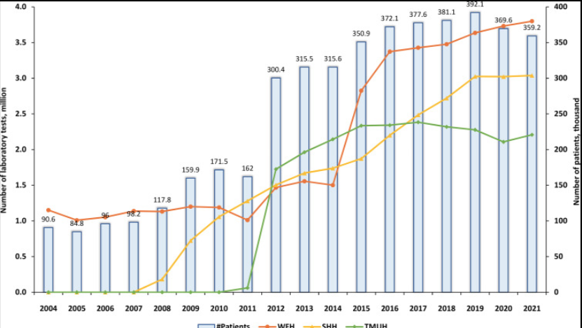

Reference:

Nguyen, P.-A., Hsu, M.-H., Chang, T.-H., Yang, H.-C., Huang, C.-W., Liao, C.-T., Lu, C. Y., & Hsu, J. C. (2024). Taipei Medical University Clinical Research Database: A Collaborative Hospital Ehr Database aligned with International Common Data Standards. *BMJ Health &amp; Care Informatics*, *31*(1). https://doi.org/10.1136/bmjhci-2023-100890

* 1. 檢驗結果資料整理:
     1. 儲存方式: 萬芳與其他兩院分成兩個檢驗結果檔
     2. 問題: 檢驗結果皆只有檢驗項目ID, 需要找對應的檢驗名稱
     3. 三院臨床資料庫架構: 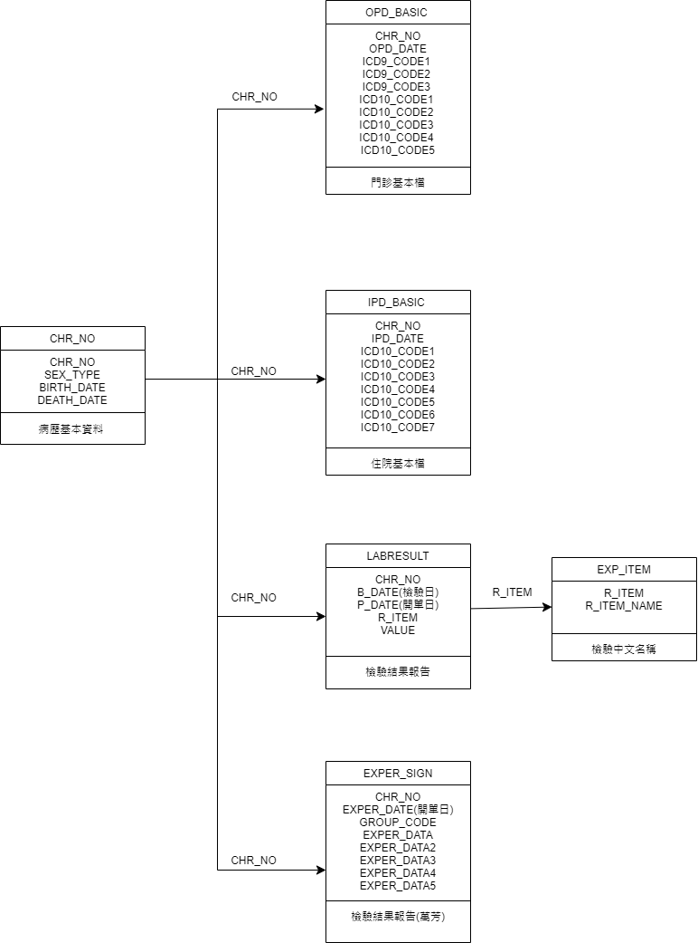

|  |  |  |
| --- | --- | --- |
| 醫院 | 檢驗項目ID | 處理方式 |
| 萬芳  exper_sign_w | GROUP_CODE(健保碼) | 從萬芳的檢驗資訊查詢系統找檢驗項目的健保碼 |
| 北醫, 雙和  Labresult_s(t) | R_ITEM | 從exp_item_s(t)找出對應的R_ITEM_NAME |

* + 1. 資料情況:

將兩份檢驗結果檔案合併為三院檢驗結果檔(含檢驗項目的中文名稱)

三院檢驗數值分佈狀況: 確認三院分佈情況是否一致

三院各檢驗項目對應ID:

|  |  |
| --- | --- |
| Test item | Test ID |
| HbA1c | 萬芳: "F09006B"  兩院: "014701" |
| ALBUMIN | 萬芳: “F09038C”  兩院: "010301", "11D101" |
| Uric Acid | 萬芳: "F09013C"  兩院: "011001","11D801" |
| HDL | 萬芳: "F09043A"  兩院: "011301" |
| LDL | 萬芳: "F09044A"  兩院: "011401" |
| Creatinine | 萬芳: "F09015C"  兩院: "11A201", "010801" |

各檢驗項目三院數值分佈圖: (數值是有壓縮過的)

|  |  |
| --- | --- |
| HbA1c | ALBUMIN |
| Uric acid | HDL |
| LDL | Creatinine |

分佈圖顯示Creatinine在萬芳的資料分佈與其他不一致可能單位不一致, 因此, 目前先排除Creatinine在萬芳的資料。

Table2. 三院全體檢驗項目數值分佈 (處理outlier)

|  |  |  |  |  |  |  |  |  |  |
| --- | --- | --- | --- | --- | --- | --- | --- | --- | --- |
| Test | min | 1% | 5% | q1 | median | q3 | 95% | 99% | max |
| HbA1c | 2 | 4.9 | 5.3 | 5.9 | 6.6 | 7.5 | 9.9 | 12.2 | 19.1 |
| ALBUMIN | 0.3 | 2 | 2.5 | 3.3 | 3.8 | 4.1 | 4.6 | 4.9 | 5.6 |
| Uric acid | 0.5 | 2.6 | 3.6 | 5 | 6.1 | 7.4 | 9.5 | 11.6 | 4050 |
| HDL | 1 | 23 | 29 | 38 | 46 | 55 | 74 | 91 | 153 |
| LDL | 5 | 42 | 56 | 78 | 98 | 121 | 161 | 196 | 466 |
| Creatinine | 0 | 0.4 | 0.54 | 0.8 | 1.11 | 2.97 | 70 | 120 | 6320 |

* + 1. 檢驗結果資料整理流程:

|  |  |
| --- | --- |
| 步驟 | 說明 |
| 1 | 將兩院(雙和、北醫)與萬芳檢驗結果資料做合併 |
| 2 | 保留Test ID, 檢驗日, 檢驗項目, 檢驗值並重新命名欄位 |
| 3 | 找尋欲分析的檢驗項目 |
| 4 | 將單位分開儲存同時排除無法辨識的資料, ex: <, >, NA |
| 5 | 分佈狀況不一樣: Creatinine不考慮萬芳 |
| 6 | Outlier 存在:  保留quantile (0.01, 0.99)的資料 |

三院檢驗項目清整完畢

* 1. 進一步篩選要分析的糖尿病患者：
     1. 目標: 在定義的Index_date後的一年內，定期進行指定檢驗項目的患者
     2. Why一年? 討論變異程度，同一個觀察範圍(一年)下做比較
     3. Why定期? 避免在計算變異程度時受時間影響
     4. 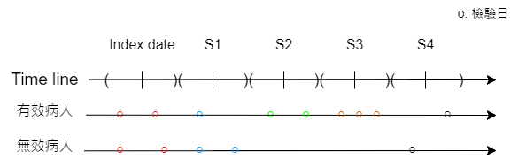示意圖:
     5. 校正方法：從Index_date開始，觀察該日期前後45天內是否有檢測紀錄，有的話記為1，沒有則記為0。接著每隔90天進行一次相同的觀察，直到觀察到第360天，確認患者整年是否有進行定期檢測。最終，所有觀察期間內都有檢測紀錄的患者作為分析的對象
  2. 符合條件的糖尿病病患檢驗項目各個時間區間下的數值

Table3. 糖尿病目標病患各季度HbA1c中位數及檢驗次數(N = 1066)

|  |  |  |  |  |  |  |
| --- | --- | --- | --- | --- | --- | --- |
|  |  | Index date | S1 | S2 | S3 | S4 |
| Median | Mean(sd) | 7.75(1.52) | 7.24(1.21) | 7.21(1.22) | 7.2(1.19) | 7.19(1.19) |
| Median(IQR) | 7.38(2) | 7(1.4) | 6.9(1.34) | 6.9(1.4) | 6.9(1.3) |
| (Min, Max) | (5,12.2) | (5,12.2) | (5,12.1) | (5,12.1) | (5.1,12.2) |
| 檢驗次數 | Mean(sd) | 1.32(0.54) | 1.18(0.41) | 1.12(0.35) | 1.09(0.3) | 1.08(0.28) |
| Median(IQR) | 1(1) | 1(0) | 1(0) | 1(0) | 1(0) |
| (Min, Max) | (1,4) | (1,4) | (1,3) | (1,3) | (1,3) |

Table4. 糖尿病目標病患各季度ALBUMIN中位數及檢驗頻率(N = 174)

|  |  |  |  |  |  |  |
| --- | --- | --- | --- | --- | --- | --- |
|  |  | Index date | S1 | S2 | S3 | S4 |
| Median | Mean(sd) | 3.75(0.53) | 3.85(0.48) | 3.88(0.5) | 3.84(0.52) | 3.85(0.49) |
| Median(IQR) | 3.85(0.74) | 3.9(0.6) | 3.9(0.6) | 3.9(0.6) | 3.9(0.65) |
| (Min, Max) | (2.3,4.8) | (2.5,4.8) | (2,4.9) | (2.1,4.9) | (2.25,4.8) |
| 檢驗次數 | Mean(sd) | 2.24(1.47) | 2.27(1.25) | 2.23(1.24) | 2.33(1.48) | 2.25(1.33) |
| Median(IQR) | 2(2) | 2(2) | 2(2) | 2(2) | 2(2) |
| (Min, Max) | (1,11) | (1,9) | (1,11) | (1,12) | (1,8) |

Table5. 糖尿病目標病患各季度Uric acid中位數及檢驗頻率 (N = 258)

|  |  |  |  |  |  |  |
| --- | --- | --- | --- | --- | --- | --- |
|  |  | Index date | S1 | S2 | S3 | S4 |
| Median | Mean(sd) | 6.67(1.77) | 6.62(1.69) | 6.57(1.72) | 6.52(1.71) | 6.42(1.61) |
| Median(IQR) | 6.6(2.5) | 6.55(2.37) | 6.6(2.5) | 6.3(2.37) | 6.2(2.4) |
| (Min, Max) | (2.8,11.4) | (3,11.6) | (3.1,11.05) | (2.7,11) | (3.1,11) |
| 檢驗次數 | Mean(sd) | 1.57(0.76) | 1.54(0.86) | 1.53(0.86) | 1.45(0.79) | 1.4(0.8) |
| Median(IQR) | 1(1) | 1(1) | 1(1) | 1(1) | 1(0) |
| (Min, Max) | (1,4) | (1,5) | (1,5) | (1,5) | (1,6) |

Table6. 糖尿病目標病患各季度HDL中位數及檢驗頻率(N = 103)

|  |  |  |  |  |  |  |
| --- | --- | --- | --- | --- | --- | --- |
|  |  | Index date | S1 | S2 | S3 | S4 |
| Median | Mean(sd) | 42.36(12.29) | 42.17(10.37) | 42.58(11.02) | 43.63(12.3) | 43.74(12.55) |
| Median(IQR) | 39.5(13) | 39.5(12) | 40(13.5) | 40(15.5) | 40(15) |
| (Min, Max) | (26,85) | (24,75) | (24,75) | (26,87) | (25,86) |
| 檢驗次數 | Mean(sd) | 1.23(0.51) | 1.08(0.27) | 1.05(0.22) | 1.06(0.24) | 1.02(0.14) |
| Median(IQR) | 1(0) | 1(0) | 1(0) | 1(0) | 1(0) |
| (Min, Max) | (1,3) | (1,2) | (1,2) | (1,2) | (1,2) |

Table7. 糖尿病目標病患各季度LDL中位數及檢驗頻率 (N = 479)

|  |  |  |  |  |  |  |
| --- | --- | --- | --- | --- | --- | --- |
|  |  | Index date | S1 | S2 | S3 | S4 |
| Median | Mean(sd) | 104.87(30.47) | 99.56(30.93) | 98.88(29.98) | 97.07(29.67) | 96.78(28.27) |
| Median(IQR) | 104.5(42) | 95(44.75) | 97(42.5) | 93(40.25) | 93(38) |
| (Min, Max) | (43,196) | (42,195) | (45,190) | (43,196) | (43,178) |
| 檢驗次數 | Mean(sd) | 1.33(0.56) | 1.17(0.38) | 1.11(0.34) | 1.11(0.32) | 1.08(0.3) |
| Median(IQR) | 1(1) | 1(0) | 1(0) | 1(0) | 1(0) |
| (Min, Max) | (1,4) | (1,3) | (1,3) | (1,3) | (1,4) |

Table8. 糖尿病目標病患各季度Creatinine中位數及檢驗頻率 (N = 865)

|  |  |  |  |  |  |  |
| --- | --- | --- | --- | --- | --- | --- |
|  |  | Index date | S1 | S2 | S3 | S4 |
| Median | Mean(sd) | 1.92(2.08) | 1.98(2.16) | 2.06(2.26) | 2.13(2.33) | 2.18(2.4) |
| Median(IQR) | 1.19(1.02) | 1.2(1.03) | 1.24(1.08) | 1.23(1.12) | 1.21(1.2) |
| (Min, Max) | (0.4,11.6) | (0.4,11.95) | (0.4,12.1) | (0.4,11.62) | (0.4,11.8) |
| 檢驗次數 | Mean(sd) | 2.68(2.41) | 2.19(2.1) | 2.12(2.17) | 2.14(2.57) | 2.12(2.66) |
| Median(IQR) | 2(2) | 1(2) | 1(1) | 1(1) | 1(1) |
| (Min, Max) | (1,20) | (1,19) | (1,30) | (1,34) | (1,31) |

* 1. 併發症整理流程:
     1. Exclude：
        1. index date 前有發生併發症
        2. index date 後一年內發生併發症

|  |  |  |  |  |  |
| --- | --- | --- | --- | --- | --- |
| Table9: 糖尿病患者相關併發症情況 | | | | | |
| test | Outcome | Event | Total person years | N | Incidence rate (Per 100 person-years) |
| HbA1c | Eye complications | 64 | 5676.915 | 989 | 1.127 |
| Cardiovascular disease | 247 | 3796.921 | 744 | 6.505 |
| Cerebrovascular disease | 136 | 5495.063 | 907 | 2.475 |
| Peripheral vascular disease | 10 | 6482.808 | 1062 | 0.154 |
| Nephropathy | 118 | 5628.518 | 975 | 2.096 |
| Diabetic neuropathy | 71 | 5693.493 | 971 | 1.247 |
| ALBUMIN | Eye complications | 9 | 745.011 | 151 | 1.208 |
| Cardiovascular disease | 36 | 404.8822 | 93 | 8.891 |
| Cerebrovascular disease | 22 | 783.2247 | 150 | 2.809 |
| Peripheral vascular disease | 4 | 926.5945 | 173 | 0.432 |
| Nephropathy | 16 | 158.6192 | 43 | 10.087 |
| Diabetic neuropathy | 8 | 857.8575 | 161 | 0.933 |
| Uric acid | Eye complications | 9 | 1177.901 | 234 | 0.764 |
| Cardiovascular disease | 62 | 528.4521 | 132 | 11.732 |
| Cerebrovascular disease | 27 | 1175.386 | 221 | 2.297 |
| Peripheral vascular disease | 4 | 1370.707 | 256 | 0.292 |
| Nephropathy | 25 | 633.7123 | 137 | 3.945 |
| Diabetic neuropathy | 13 | 1259.515 | 240 | 1.032 |
| HDL | Eye complications | 2 | 482.2356 | 98 | 0.415 |
| Cardiovascular disease | 12 | 225.4932 | 49 | 5.322 |
| Cerebrovascular disease | 12 | 435.3041 | 90 | 2.757 |
| Peripheral vascular disease | 0 | 514.189 | 102 | 0 |
| Nephropathy | 6 | 402.4219 | 82 | 1.491 |
| Diabetic neuropathy | 4 | 461.3562 | 94 | 0.867 |
| LDL | Eye complications | 18 | 2326.603 | 447 | 0.774 |
| Cardiovascular disease | 105 | 1527.485 | 326 | 6.874 |
| Cerebrovascular disease | 49 | 2158.455 | 389 | 2.27 |
| Peripheral vascular disease | 2 | 2611.321 | 478 | 0.077 |
| Nephropathy | 38 | 2306.959 | 434 | 1.647 |
| Diabetic neuropathy | 23 | 2374.389 | 447 | 0.969 |
| Creatinine | Eye complications | 32 | 4187.726 | 789 | 0.764 |
| Cardiovascular disease | 176 | 2597.178 | 541 | 6.777 |
| Cerebrovascular disease | 109 | 4020.027 | 727 | 2.711 |
| Peripheral vascular disease | 7 | 4766.362 | 854 | 0.147 |
| Nephropathy | 110 | 3139.51 | 633 | 3.504 |
| Diabetic neuropathy | 41 | 4222.186 | 785 | 0.971 |

以上檢驗項目及糖尿病相關併發症清整結果和發病情況的摘要

1. 資料分析:
   1. 變數處理:
      1. 控制變數: SEX, Index year, AGE_GROUP, Baseline mean, 共病是否發生

|  |  |
| --- | --- |
| 變數名稱 | 描述 |
| Baseline mean | Index Date區間下的檢驗值平均 |
| 共病是否發生 | Essential hypertension本態性高血壓 |
| Peripheral enthesopathies and allied syndromes  外周附著點病變及其相關聯症候群的疾病 |
| Other ill-defined and unknown causes of morbidity and mortality  定義不明和未知原因的發病和死亡 |
| Disorders of lipoid metabolism脂蛋白的代謝異常 |
| Acute upper respiratory infections of multiple or unspecified sites  多部位或未明確部位的急性上呼吸道感染 |
| Other symptoms involving abdomen and pelvis 腹部和骨盆的其他症狀 |
| Dermatophytosis 真菌引起的皮膚感染 |
| General symptoms非特定的身體症狀 |
| Symptoms involving respiratory system and other chest symptoms  呼吸系統和其他胸部症狀 |
| Symptoms involving head and neck 頭部和頸部的症狀 |
| Contact dermatitis and other eczema皮膚疾病 |
| Viral infection in conditions classified elsewhere and of unspecified site  病毒引起的感染 |
| Overweight, obesity and other hyperalimentation  超重, 肥胖及其他過度營養狀態 |
| Other and unspecified disorders of joint未明確指定的關節疾病 |
| Acute bronchitis and bronchiolitis呼吸道疾病 |
| Other disorders of soft tissues其他軟組織的疾病 |
| Nonspecific findings on examination of blood  血液檢查時發現的一些非特定性的異常或發現 |
| Disorders of refraction and accommodation屈光和調節的疾病 |
| Disorders of conjunctiva 眼球表面覆蓋的結膜的各種疾病 |

* 1. 其他變數組合: 不同檢驗項目的變異程度指標: SD, CV, RMS
     1. 計算方式: 為了避免有病患在特定季節集中做檢驗
        1. 對各病患計算每一季的檢測項目平均值: Index Date, S1, S2, S3, S4
        2. 針對這些平均值，計算標準差, 變異係數以及均方根
        3. 圖例:

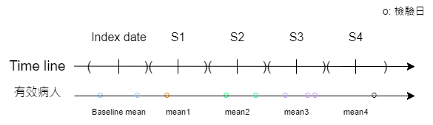

* + 1. 標準差(SD) 計算方式:

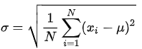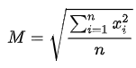

* + 1. 變異係數(CV) 計算方式:
    2. 均方根(RMS) 計算方式:
  1. 反應變數: 病患追蹤日期, 是否有發生併發症
  2. 模型: cox model
  3. 模型指標: HR (Hazard ratios), 95% CI, P-value

1. 分析結果: (以HbA1c為主, 以及其他檢驗項目變異程度有顯著的結果)
   1. P-value: .: p < 0.1, *: p < 0.05, **: p < 0.01, ***: p < 0.001

Table10: Eye complications與HbA1c檢驗結果分析 (N = 989)

|  |  |  |  |  |
| --- | --- | --- | --- | --- |
| Models | Variables | HR | 95%CI | P-value |
| Model1 | Baseline | 1.188 | 1.012, 1.396 | * |
| Model2 | Baseline | 1.085 | 0.857, 1.375 |  |
| SD | 1.448 | 0.719, 2.916 |  |
| Model3 | Baseline | 1.142 | 0.922, 1.413 |  |
| CV | 4.408 | 0.026, 738.134 |  |
| Model4 | Baseline | 0.915 | 0.703, 1.19 |  |
| RMS | 1.604 | 1.138, 2.26 | ** |

Table11: Cardiovascular disease與HbA1c檢驗結果分析 (N = 744)

|  |  |  |  |  |
| --- | --- | --- | --- | --- |
| Models | Variables | HR | 95%CI | P-value |
| Model1 | Baseline | 0.981 | 0.9, 1.07 |  |
| Model2 | Baseline | 0.997 | 0.884, 1.123 |  |
| SD | 0.932 | 0.647, 1.342 |  |
| Model3 | Baseline | 1 | 0.898, 1.115 |  |
| CV | 0.443 | 0.03, 6.555 |  |
| Model4 | Baseline | 0.943 | 0.822, 1.081 |  |
| RMS | 1.074 | 0.889, 1.299 |  |

Table12: Cerebrovascular disease與HbA1c檢驗結果分析 (N = 907)

|  |  |  |  |  |
| --- | --- | --- | --- | --- |
| Models | Variables | HR | 95%CI | P-value |
| Model1 | Baseline | 1.011 | 0.904, 1.131 |  |
| Model2 | Baseline | 1.078 | 0.924, 1.256 |  |
| SD | 0.742 | 0.452, 1.216 |  |
| Model3 | Baseline | 1.061 | 0.925, 1.218 |  |
| CV | 0.117 | 0.003, 4.342 |  |
| Model4 | Baseline | 0.935 | 0.782, 1.118 |  |
| RMS | 1.147 | 0.903, 1.456 |  |

Table13: Peripheral vascular disease與 HbA1c檢驗結果分析 (N = 1062) (發生很少)

|  |  |  |  |  |
| --- | --- | --- | --- | --- |
| Models | Variables | HR | 95%CI | P-value |
| Model1 | Baseline | 0.912 | 0.589, 1.414 |  |
| Model2 | Baseline | 0.696 | 0.468, 1.036 | . |
| SD | 3.342 | 1.211, 9.219 | * |
| Model3 | Baseline | 0.716 | 0.481, 1.068 |  |
| CV | 9836.151 | 4.079, 23720382.232 | * |
| Model4 | Baseline | 0.928 | 0.6, 1.437 |  |
| RMS | 0.966 | 0.501, 1.86 |  |

Table14: Nephropathy與HbA1c檢驗結果分析 (N = 975)

|  |  |  |  |  |
| --- | --- | --- | --- | --- |
| Models | Variables | HR | 95%CI | P-value |
| Model1 | Baseline | 1.094 | 0.969, 1.235 |  |
| Model2 | Baseline | 1.084 | 0.908, 1.294 |  |
| SD | 1.039 | 0.607, 1.778 |  |
| Model3 | Baseline | 1.098 | 0.936, 1.287 |  |
| CV | 0.867 | 0.017, 44.407 |  |
| Model4 | Baseline | 1.013 | 0.837, 1.225 |  |
| RMS | 1.153 | 0.885, 1.501 |  |

Table15: Diabetic neuropathy與HbA1c檢驗結果分析 (N = 971)

|  |  |  |  |  |
| --- | --- | --- | --- | --- |
| Models | Variables | HR | 95%CI | P-value |
| Model1 | Baseline | 0.941 | 0.797, 1.112 |  |
| Model2 | Baseline | 0.997 | 0.791, 1.258 |  |
| SD | 0.769 | 0.37, 1.6 |  |
| Model3 | Baseline | 1.002 | 0.812, 1.235 |  |
| CV | 0.074 | 0, 15.706 |  |
| Model4 | Baseline | 0.74 | 0.569, 0.961 | * |
| RMS | 1.533 | 1.104, 2.131 | * |

Table16: Nephropathy與HDL檢驗結果分析 (N = 82)

|  |  |  |  |  |
| --- | --- | --- | --- | --- |
| Models | Variables | HR | 95%CI | P-value |
| Model1 | Baseline | 1.193 | 1.109,1.283 | *** |
| Model2 | Baseline | 1.309 | 1.218,1.407 | *** |
| SD | 2.555 | 2.108,3.098 | *** |
| Model3 | Baseline | 1.513 | 1.402,1.633 | *** |
| CV | Inf | Inf ,Inf | *** |
| Model4 | Baseline | Inf | 0.652,Inf | . |
| RMS | 0 | 0,8.621 | . |

Table17: Diabetic neuropathy與uric acid檢驗結果分析 (N = 240)

|  |  |  |  |  |
| --- | --- | --- | --- | --- |
| Models | Variables | HR | 95%CI | P-value |
| Model1 | Baseline | 0.896 | 0.645, 1.246 |  |
| Model2 | Baseline | 0.786 | 0.573, 1.077 |  |
| SD | 2.353 | 1.036, 5.341 | * |
| Model3 | Baseline | 0.843 | 0.614, 1.159 |  |
| CV | 105.966 | 0.359, 31276.269 |  |
| Model4 | Baseline | 0.743 | 0.531, 1.041 | . |
| RMS | 1.333 | 0.889, 2 |  |

Table18: Eye complications與Creatinine檢驗結果分析 (N = 789)

|  |  |  |  |  |
| --- | --- | --- | --- | --- |
| Models | Variables | HR | 95%CI | P-value |
| Model1 | Baseline | 1.091 | 0.941, 1.265 |  |
| Model2 | Baseline | 0.955 | 0.779, 1.171 |  |
| SD | 2.609 | 1.108, 6.141 | * |
| Model3 | Baseline | 1.091 | 0.94, 1.265 |  |
| CV | 11.082 | 0.396, 309.897 |  |
| Model4 | Baseline | 0.425 | 0.232, 0.78 | ** |
| RMS | 2.498 | 1.489, 4.191 | *** |

Table19: Nephropathy與Creatinine檢驗結果分析 (N = 633)

|  |  |  |  |  |
| --- | --- | --- | --- | --- |
| Models | Variables | HR | 95%CI | P-value |
| Model1 | Baseline | 2.554 | 2.113, 3.087 | *** |
| Model2 | Baseline | 2.464 | 1.928, 3.15 | *** |
| SD | 1.179 | 0.579, 2.401 |  |
| Model3 | Baseline | 2.515 | 2.068, 3.06 | *** |
| CV | 1.737 | 0.268, 11.258 |  |
| Model4 | Baseline | 1.29 | 0.737, 2.259 |  |
| RMS | 1.865 | 1.164, 2.989 | ** |

結論:

1. 模型顯示HbA1c的變異程度對於Eye complications, Nephropathy, Diabetic neuropathy等併發症為重要因子, 符合文獻結果
2. 其他顯著的檢驗項目:

|  |  |  |
| --- | --- | --- |
| 併發症 | 檢驗項目 | 變異程度指標 |
| Eye complications | Creatinine | SD, RMS |
| Nephropathy | HDL | SD |
| Nephropathy | Creatinine | RMS |
| Diabetic neuropathy | Uric acid | SD, CV |

1. 資料不顯著可能的原因: 人數太少, 每季只考慮平均值會損失部分訊息, 資料本身是以中風的條件下去篩選的
2. 後續可以做的研究方向:
   1. 考慮其他的變異性指標，ex: $HVS=\frac{\sum_{2}^{n}{I(∣{ΔHbA1c}_{i}​∣>0.5\%)×100\%}}{n}$ ​,
 $$其中, {ΔHbA1c}_{i}={HbA1c}_{i}{-HbA1c}_{i-1}​​$$

  2. Outlier定義
   3. 多考慮各個時間區間內的變異: weighted SD

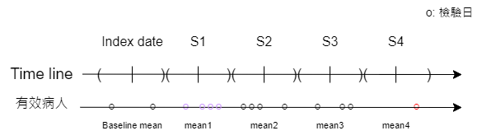

* 1. 控制各季的平均數mean(mean1, mean2, mean3, mean4), 來確保變異程度指標在模型的合理性

1. 目前已驗證的方法可行性，可以進行與心血管相關的分析方法

心血管 (cardiovascular disease)相關主題:

心血管相關檢測項目：

* 血壓變異性（如日間和夜間的血壓波動）
* 血糖變異性（如血糖的日間波動）
* 血脂變異性（如LDL和HDL的波動）
* Heart rate

心血管相關併發症：

* 運動功能障礙: Motor Function Impairment
* 語言障礙: Speech Impairment
* 認知障礙: Cognitive Impairment
* 情緒和心理問題: Emotional and Psychological Problems
* 吞嚥困難: Dysphagia
* 褥瘡: Pressure Ulcers

共病:

* 高脂血症（Hyperlipidemia）
* 冠心病（Coronary Artery Disease）
* 慢性腎病（Chronic Kidney Disease）
* 慢性阻塞性肺病（Chronic Obstructive Pulmonary Disease, COPD）
* 心房顫動（Atrial Fibrillation）
* 周邊動脈疾病（Peripheral Artery Disease）
* 肥胖（Obesity）
* 代謝綜合徵（Metabolic Syndrome）
* 睡眠呼吸暫停綜合徵（Sleep Apnea Syndrome）
* 甲狀腺疾病（Thyroid Disorders）
* 腦外傷史（History of Traumatic Brain Injury）
* 抑鬱症（Depression）
* 焦慮症（Anxiety Disorders）
* 酒精使用障礙（Alcohol Use Disorder）
* 藥物濫用（Substance Abuse）
* 缺乏運動（Physical Inactivity）
* 不良飲食習慣（Unhealthy Dietary Habits）
* 家族中風史（Family History of Stroke）
* 高血壓
* 糖尿病