SMART HEALTHCARE CLINIC MANAGEMENT SYSTEM
Summary of Panel Revisions & Visual Software Showcase
Accudetek Health Diagnostics — System & Manuscript Revision Compliance

I. Summary of Revisions & Compliance Matrix
# | Panel Recommendation / Revision Item | Category | Action Taken / Implementation | Module / Chapter
1 | Modify the system to allow the storage and management of individual patient records. | System & Paper | Implemented the Patients Module with full individual patient profiles, automatic age-bracket calculation (Child, Adult, Senior), demographic tracking, and linked consultation histories. | /patients  Chapters 1, 3, 4
2 | Develop a fully functional online appointment system for scheduling and managing patient appointments. | System & Paper | Built the 5-step Online Patient Portal (branch & schedule selection, patient info, services/packages, consultation reasons, OTP verification, and reference ID tracking). | /patient-portal  /track-appointment  Chapters 1, 3, 4
3 | Manage daily appointments and walk-ins directly in the system (without relying on Excel uploads). | System & Paper | Built the Admin Appointments & Walk-In Module allowing direct walk-in booking, one-click consultation completion, and direct patient consultation logging into the database. | /appointments  /appointments/new  /records
4 | Support multi-branch clinic operations and management. | System & Paper | Added Multi-Branch Management allowing branch-level isolation and switching of patients, staff rosters, services, appointments, and demand forecasts. | /branches  Chapters 1, 3, 4
5 | Improve the predictive analytics feature to identify what type of doctor or medical specialist is needed. | System & Paper | Implemented the Two-Tier Diagnosis-to-Specialist Attribution Engine mapping forecasted diagnoses to specific physician and specialist roles (Internal Medicine, General Physicians, Pathologists, Radiologists, RMTs, RRTs, Lab Technicians). | /resources  /predict  Chapters 3 & 4
6 | Allow the predictive analytics to generate daily forecasts of the types of doctors needed. | System & Paper | Added the 14-Day Daily Specialist Demand Forecast (Current 7 Days & Next 7 Days) with daily stacked role charts and day-by-day needed vs. available specialist breakdowns. | /resources  Chapter 4
7 | Allow the predictive analytics to generate monthly forecasts of the types of doctors needed, supported by appointment and patient data. | System & Paper | Integrated monthly Random Forest forecasts with live patient consultations and scheduled appointments to compute monthly specialist headcount requirements and staffing gaps. | /predict  /resources  Chapters 3 & 4
8 | Implement medical staff allocation with automated email notifications. | System | Added the Staff Allocations & Staffing Plans modules with automated SMTP email notifications for tentative shift advisories, approved schedules, and specialist gap alerts. | /staff-allocations  /staffing-plans  /staff
9 | Reduce study limitations in the manuscript. | Paper | Updated Scope and Limitations to remove resolved constraints (individual patient records, online appointments, walk-in entry, multi-branch support, and specialist forecasting). | Chapter 1 & Chapter 5
10 | Use tabular presentation for age brackets, demographic segments, and forecasting results. | Paper | Added structured academic tables for Age Brackets (Child, Adult, Senior), Sex Distributions, Daily/Monthly Specialist Allocation, and Model Validation Metrics. | Chapters 3, 4 & Appendices D, E

II. Visual Showcase of Implemented Software Revisions

Revision 1: Individual Patient Record Storage and Management
Panel Requirement: Modify the system to allow the storage and management of individual patient records.
System Route / Code Location: /patients, /patients/new, /patients/<id>, /patients/<id>/consultations/new (app.py, Lines 5316–5520)
Administrators and clinic staff can register, search, filter (by Age Group, Sex, and Status), view, and edit individual patient profiles. Each patient profile automatically computes the age bracket (Child: 0–17, Adult: 18–59, Senior: ≥60), displays recent appointments with recommended staff, and lists all linked clinical consultation records with a direct 'Add Consultation' workflow.
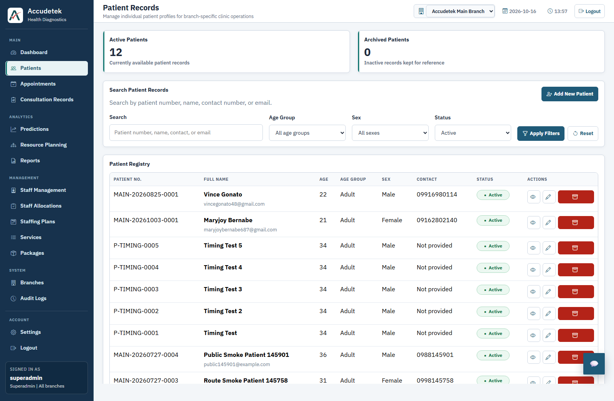
Figure 1.1: Individual Patient Registry (/patients) with Search, Age Bracket, and Sex Filters.
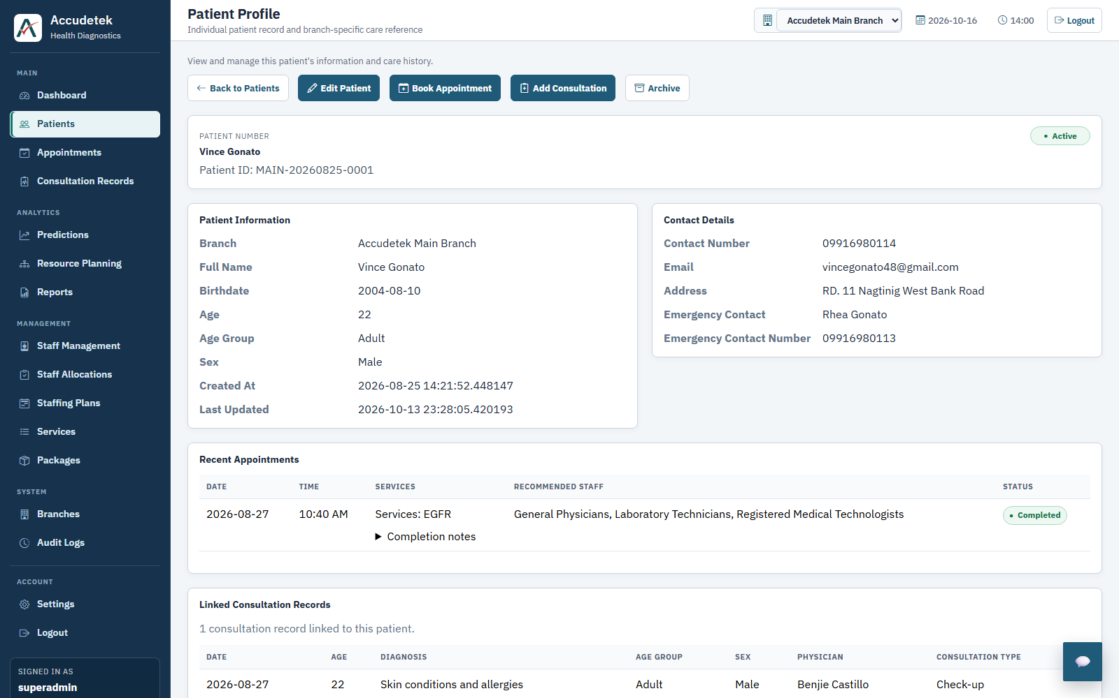
Figure 1.2: Individual Patient Profile (/patients/<id>) showing Demographics, Recent Appointments, and Linked Consultation Records.

Revision 2: Fully Functional Online Appointment System
Panel Requirement: Develop a fully functional online appointment system for scheduling and managing patient appointments.
System Route / Code Location: /patient-portal, /track-appointment (app.py, Lines 4247–4810)
Patients can book a clinic visit online through a 5-step guided portal: (1) Branch & Schedule Selection, (2) Patient Information with automatic age-bracket calculation, (3) Diagnostic Packages & Services, (4) Check-up Reasons, and (5) Review & Submit. Patients receive email confirmation and can track their appointment status online using their unique reference ID (APT-XXXXXXXX) and email OTP verification.
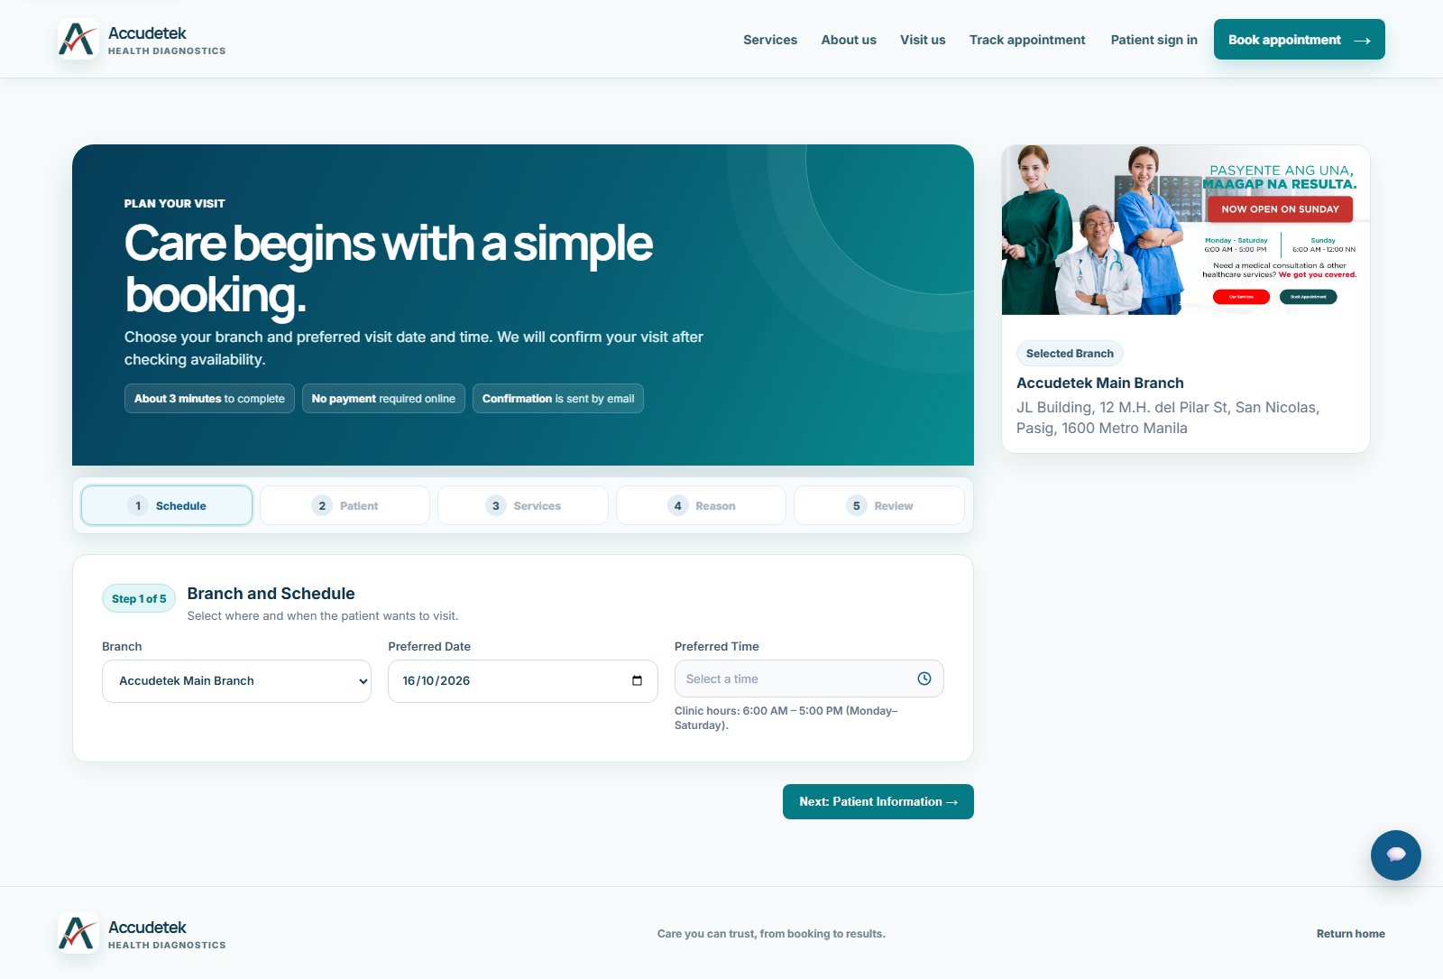
Figure 2.1: Public 5-Step Online Appointment Booking Portal (/patient-portal).
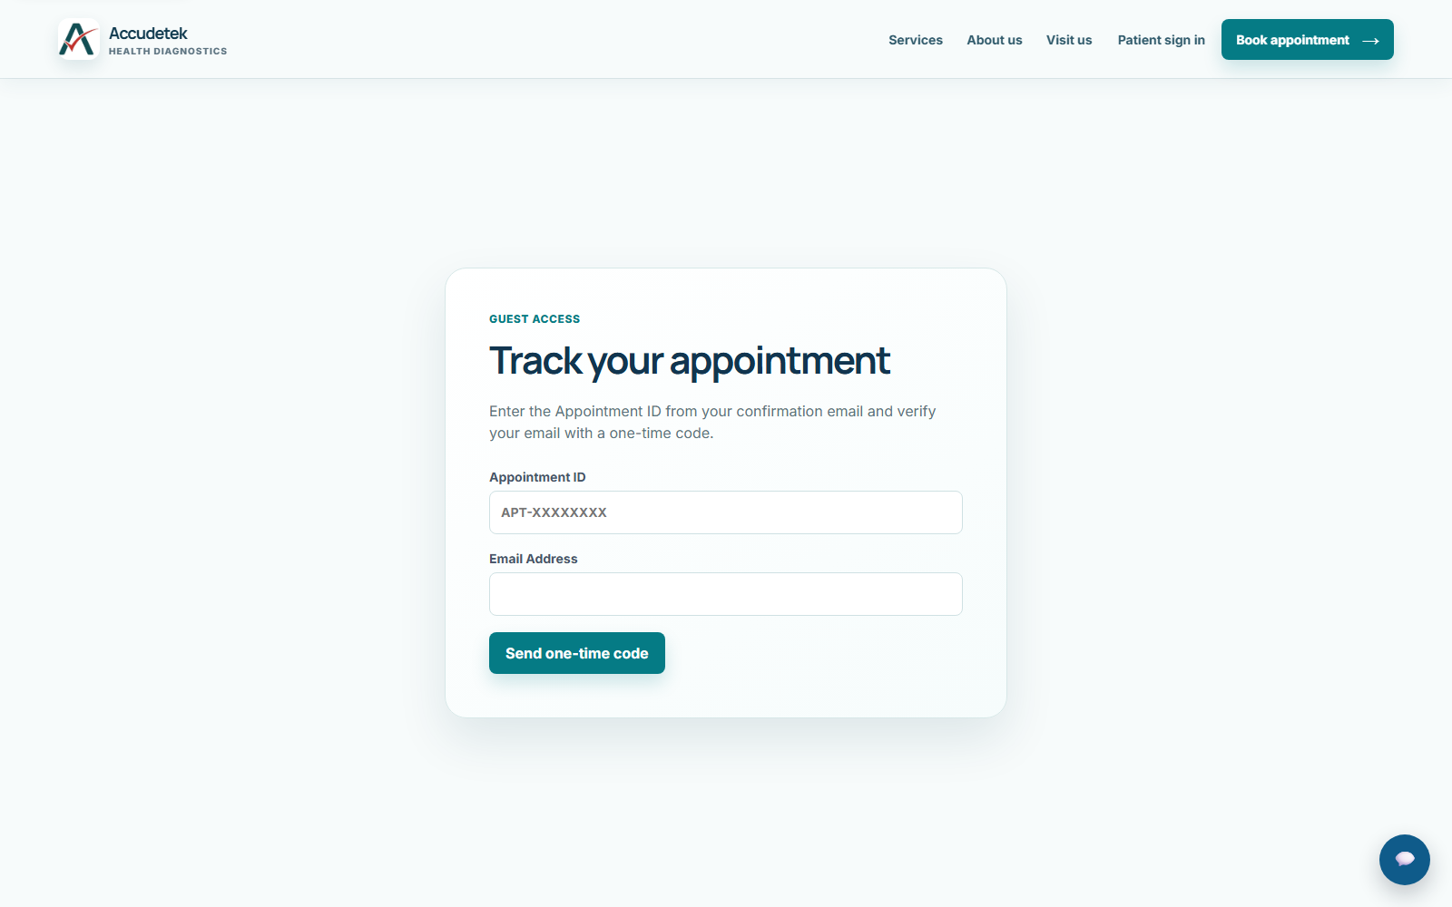
Figure 2.2: Online Appointment Reference ID & One-Time Code Tracking Page (/track-appointment).

Revision 3: Manage Daily Appointments & Walk-Ins (Without Excel Uploads)
Panel Requirement: Manage daily appointments and walk-in consultations directly in the system instead of relying on Excel/CSV uploads.
System Route / Code Location: /appointments, /appointments/new, /appointments/<id>/complete, /records (app.py, Lines 5523–5747)
Clinic staff can manage daily scheduled appointments and walk-in patients directly in the web application. Creating an appointment or walk-in at /appointments/new previews the required medical specialists and diagnostic equipment in real time. Marking a visit as 'Completed' automatically generates linked ConsultationRecord entries in the database without requiring spreadsheet uploads. Staff can also log individual walk-in consultations directly via the 'Add Patient Consultation' button on /records.
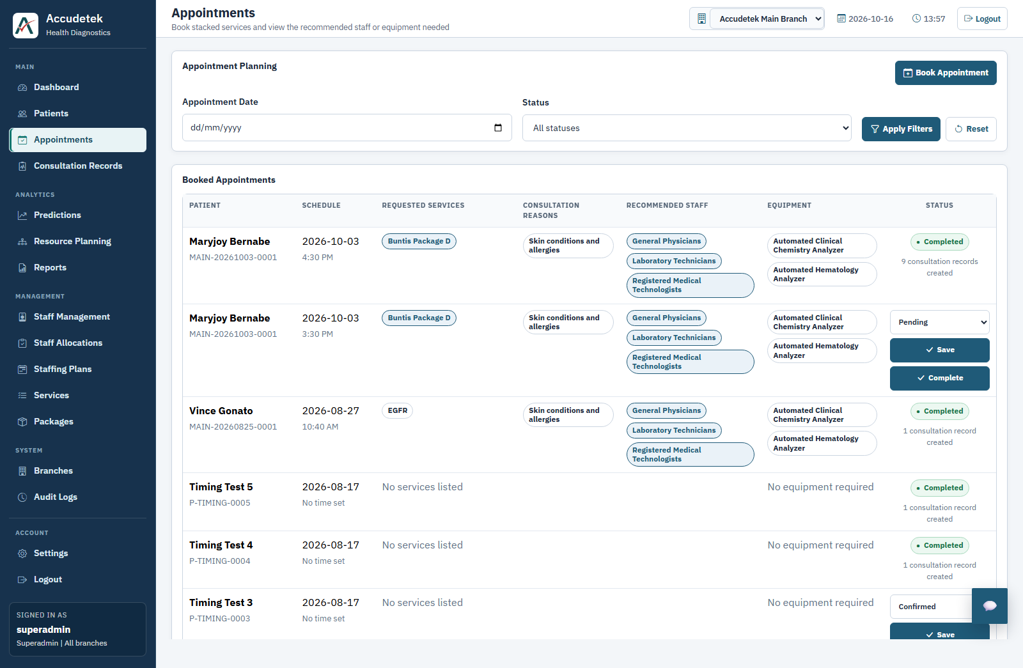
Figure 3.1: Daily Appointments & Walk-In Management (/appointments) with Recommended Staff, Equipment, and One-Click Completion.
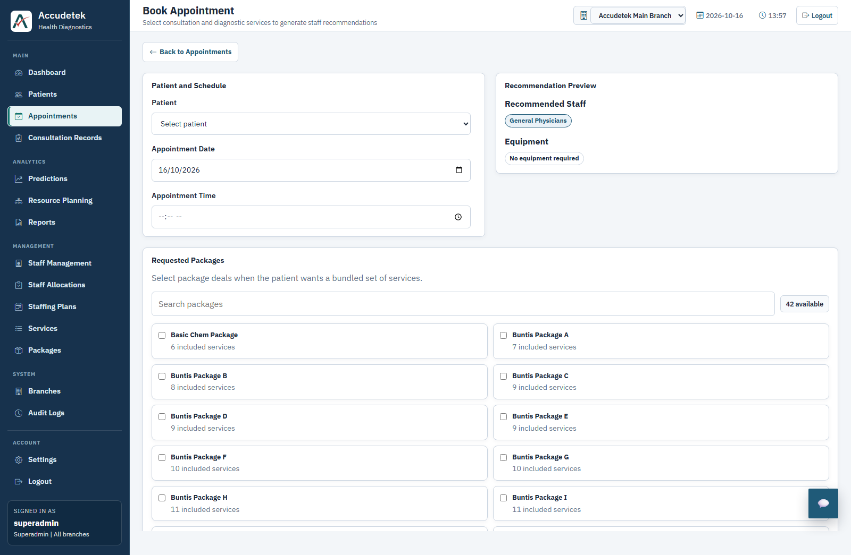
Figure 3.2: Direct Walk-In & Appointment Booking Form (/appointments/new) with Live Specialist & Equipment Recommendation Preview.
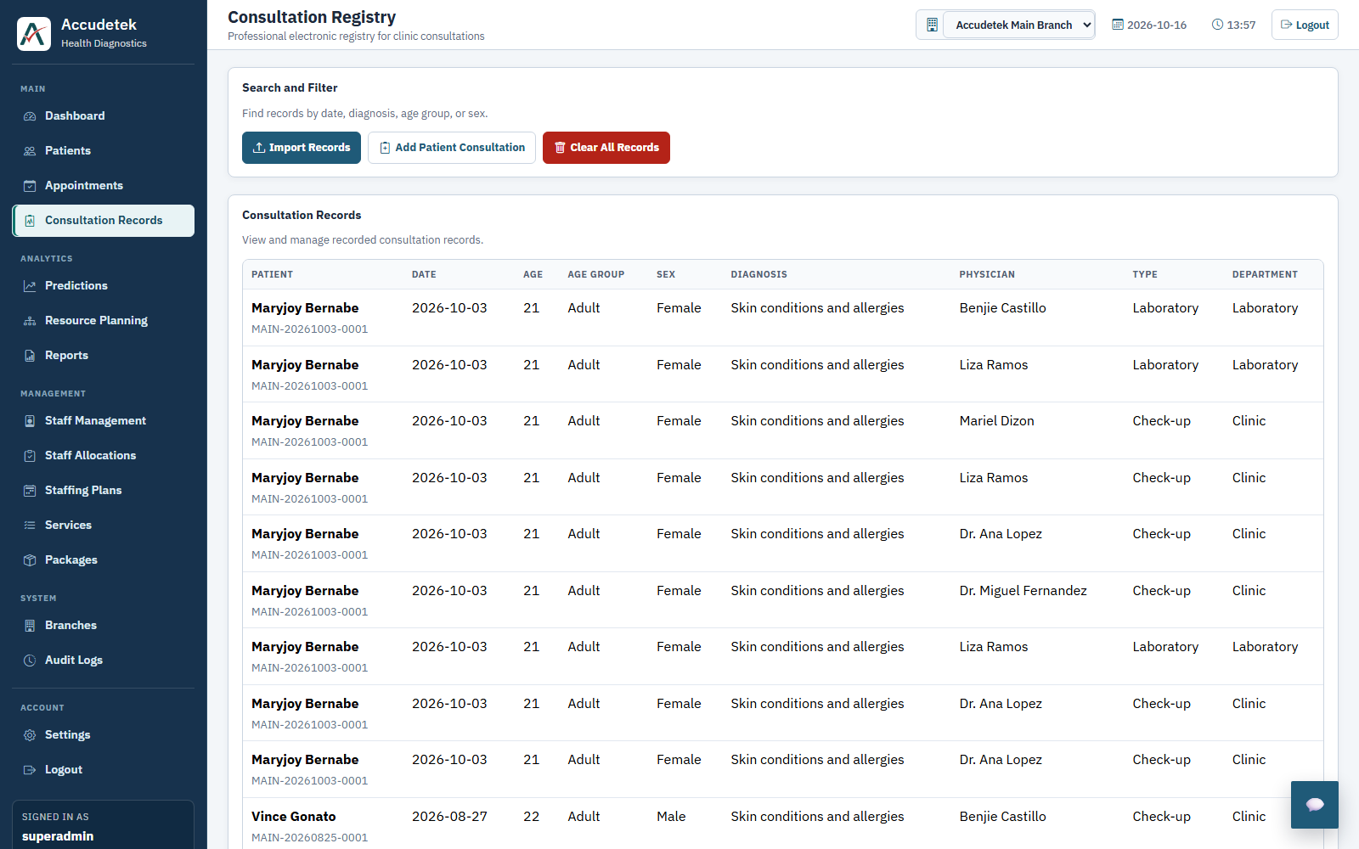
Figure 3.3: Consultation Registry (/records) with Direct 'Add Patient Consultation' Entry Stored in the Live Database.

Revision 4: Multi-Branch Clinic Management
Panel Requirement: Support multiple clinic branches with branch-specific operations, staff rosters, patients, and forecasts.
System Route / Code Location: /branches, /branches/select, /branches/new (app.py, Lines 4939–5315)
The system supports multi-branch clinic operations. Superadmins can create and manage clinic branches, assign Branch Managers and Head Doctors, monitor daily branch throughput (Active Doctors, On-Duty Staff, Scheduled Appointments, Patient Queue, Completed Consultations), switch the active branch context from the top bar, and manage branch-assigned administrator and staff accounts.
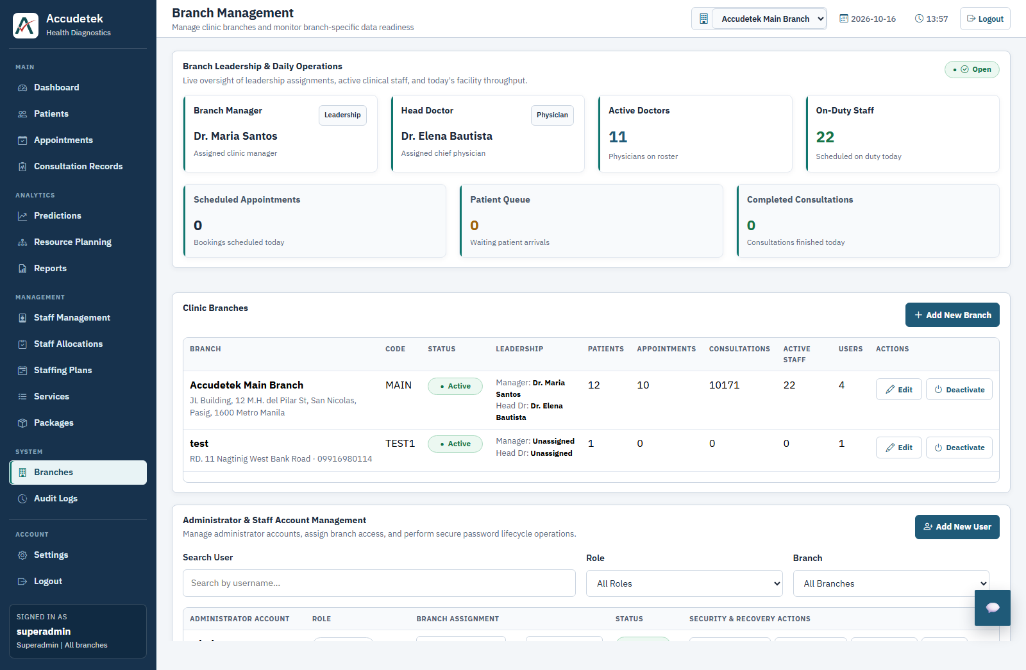
Figure 4.1: Multi-Branch Clinic Management Dashboard (/branches) and User Branch Access Control.

Revision 5: Identify What Type of Doctor or Medical Specialist Is Needed
Panel Requirement: Improve the predictive analytics feature to identify what type of doctor or medical specialist is needed.
System Route / Code Location: /resources, /predict (app.py, Lines 6088–6097 & 6259–6286)
The system translates Random Forest consultation demand forecasts into specific medical specialist roles (Internal Medicine Physicians, General Physicians, Pathologists, Radiologists, Registered Medical Technologists, Registered Radiologic Technologists, and Laboratory Technicians) using a two-tier attribution engine: (1) Historical Physician-to-Role matching from actual clinic consultations, and (2) Text-Similarity / Clinical Keyword fallback.
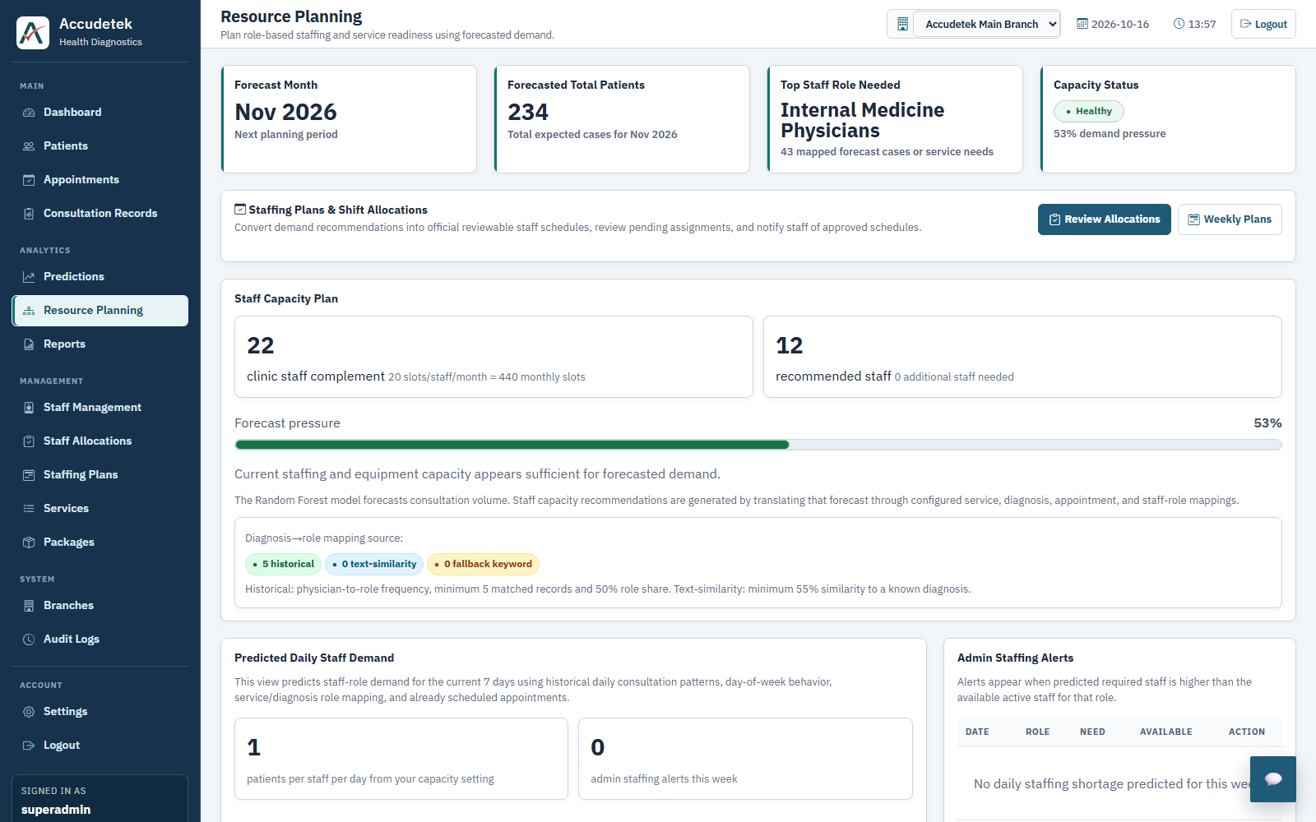
Figure 5.1: Resource Planning Overview (/resources) Identifying the Top Specialist Role Needed and Diagnosis-to-Role Mapping Source.
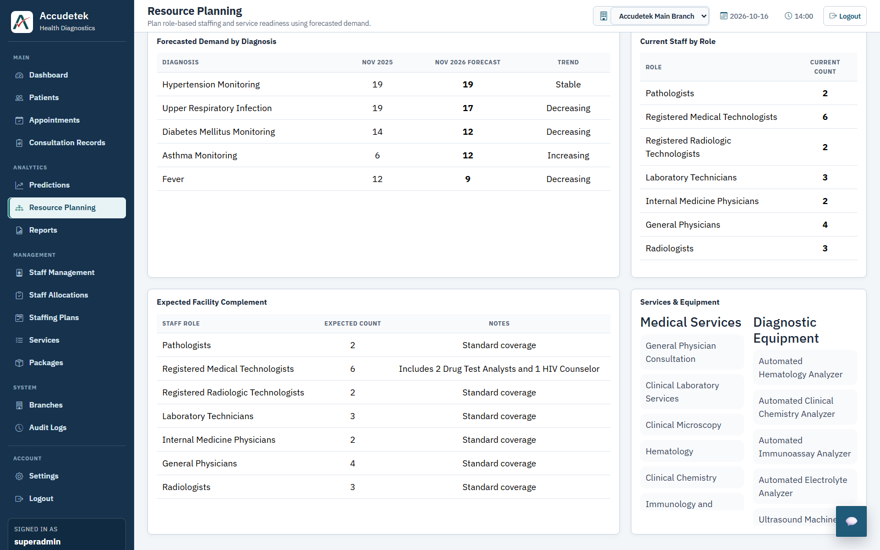
Figure 5.2: Expected Facility Specialist Complement, Current Staff by Role, and Mapped Diagnostic Equipment (/resources).

Revision 6: Generate Daily Forecasts of the Types of Doctors Needed
Panel Requirement: Allow the predictive analytics to generate daily forecasts of the types of doctors needed.
System Route / Code Location: /resources — Predicted Daily Staff Demand (templates/resources/index.html)
The Resource Planning module generates a 14-day daily specialist forecast (Current 7 Days and Next 7 Days) using historical day-of-week consultation patterns, diagnosis-to-role attribution, and already scheduled appointments. It displays both a stacked daily bar chart by specialist role and a day-by-day schedule table listing Predicted Patients, Booked Appointments, Staff Needed/Available, Role Breakdown, and Readiness Status.
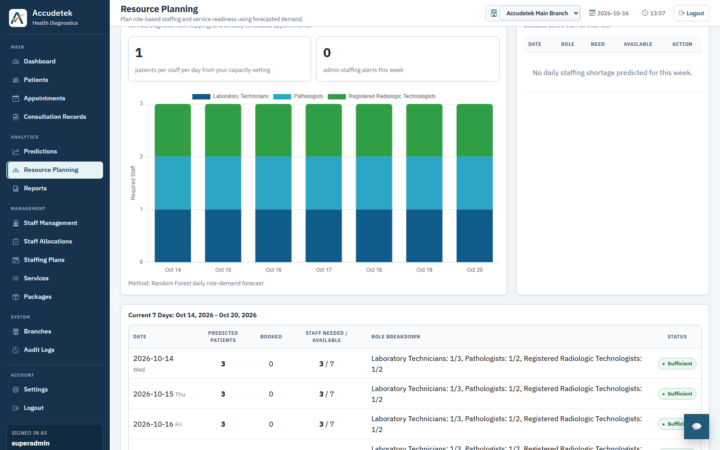
Figure 6.1: Predicted Daily Specialist Demand Stacked Bar Chart and Current 7-Day Daily Role Breakdown (/resources).
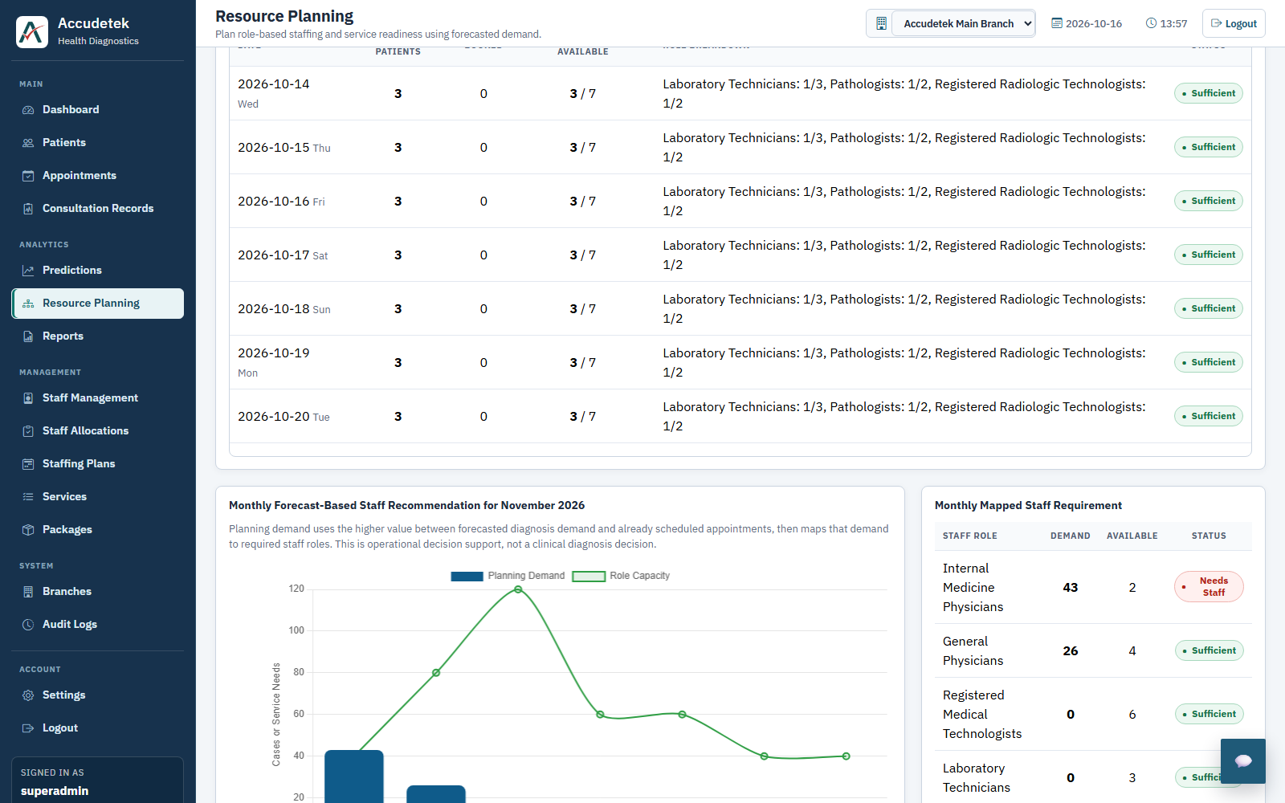
Figure 6.2: Daily Specialist Schedule Table Paired with Monthly Forecast-Based Staff Recommendation (/resources).

Revision 7: Generate Monthly Forecasts of the Types of Doctors Needed (Supported by Patient & Appointment Data)
Panel Requirement: Allow the predictive analytics to generate monthly forecasts of the types of doctors needed, and use appointment and patient data to support the system's predictions on which doctors or specialists should be added or made available.
System Route / Code Location: /predict, /resources (app.py, Lines 6259–6339)
The Prediction Center (/predict) and Resource Planning (/resources) modules combine the monthly Random Forest demand forecast with live patient consultations and booked appointments (taking the higher operational demand between forecasted cases and scheduled bookings per role). The Mapped Staff Role Demand table highlights Available vs. Required specialists and flags exact staffing gaps (e.g., Internal Medicine Physicians: 43 planning demand, 2 available, 3 required, Gap: 1 — 'Needs Staff').
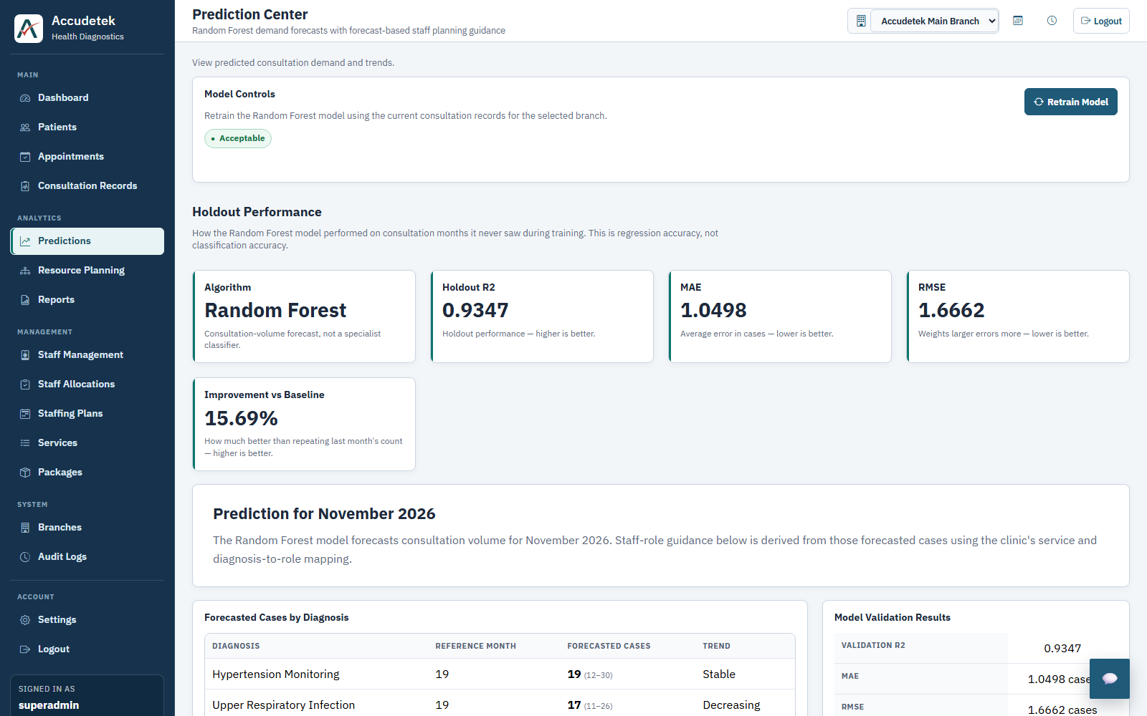
Figure 7.1: Monthly Random Forest Prediction Center (/predict) with Holdout Validation Metrics and Diagnosis Volume Forecast.
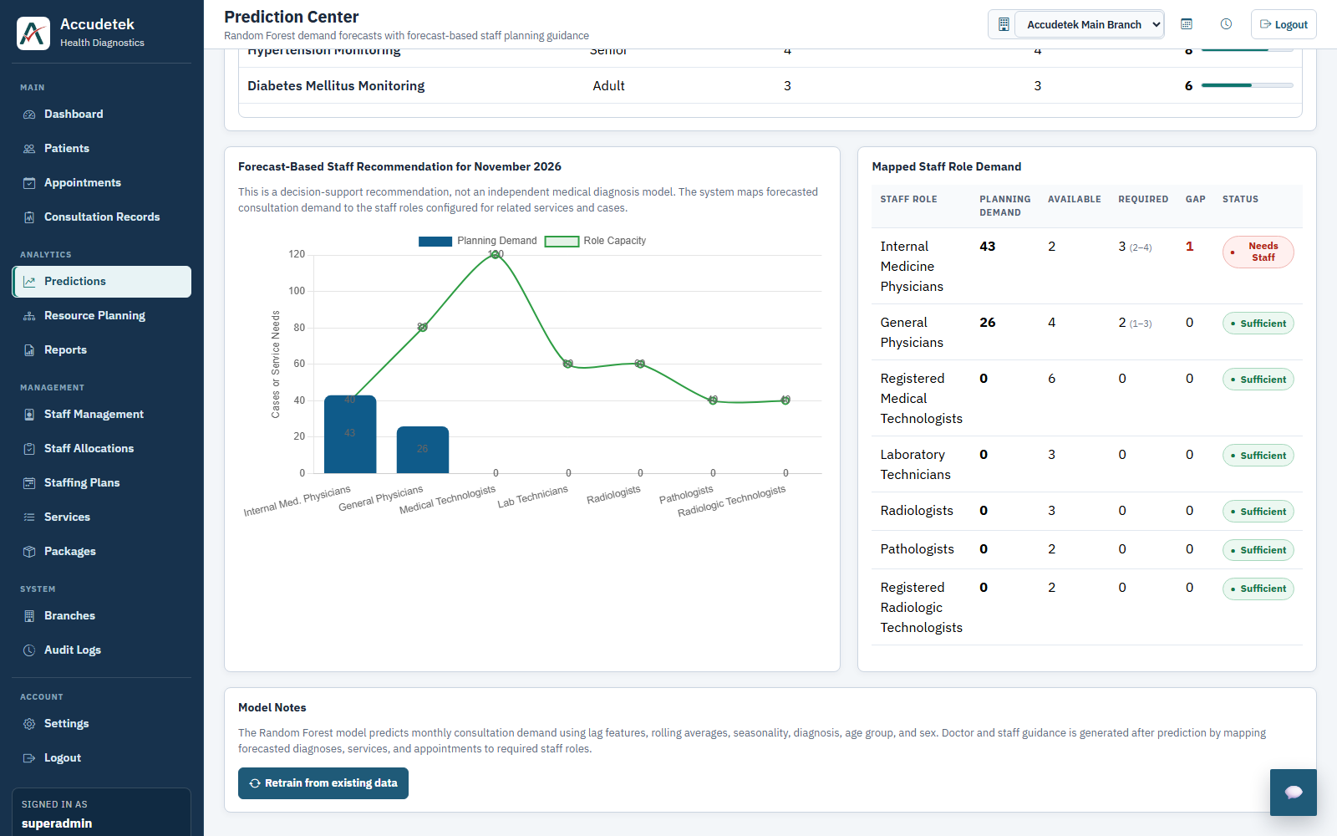
Figure 7.2: Monthly Forecast-Based Staff Recommendation Chart & Mapped Specialist Role Gap Table (/predict).

Revision 8: Medical Staff Allocation with Automated Email Notification
Panel Requirement: Implement medical staff allocation with automated email notifications for shift schedules and coverage gaps.
System Route / Code Location: /staff-allocations, /staff-allocations/new, /staffing-plans, /staff (app.py, Lines 6576–7305)
Administrators can convert specialist demand recommendations into official shift allocations (/staff-allocations/new), automatically send tentative advisory emails to allocated staff, and click 'Approve & Notify' (/staff-allocations) to send official schedule confirmation emails via SMTP. Administrators can also generate full weekly staffing plans (/staffing-plans) and trigger targeted email notifications directly from the Staff Management roster (/staff).
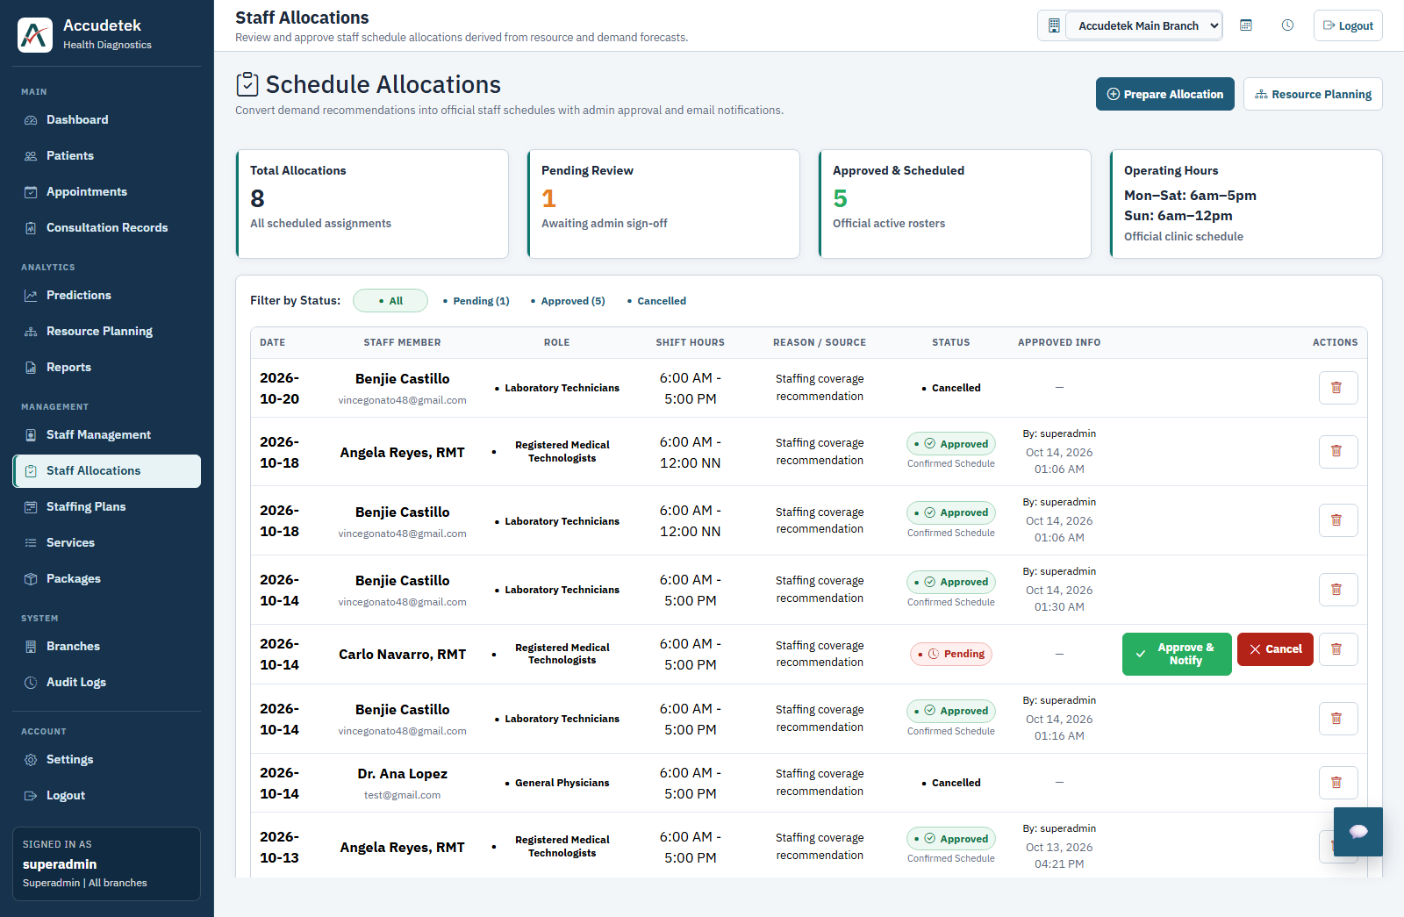
Figure 8.1: Schedule Allocations Dashboard (/staff-allocations) with One-Click 'Approve & Notify' Email Dispatch.
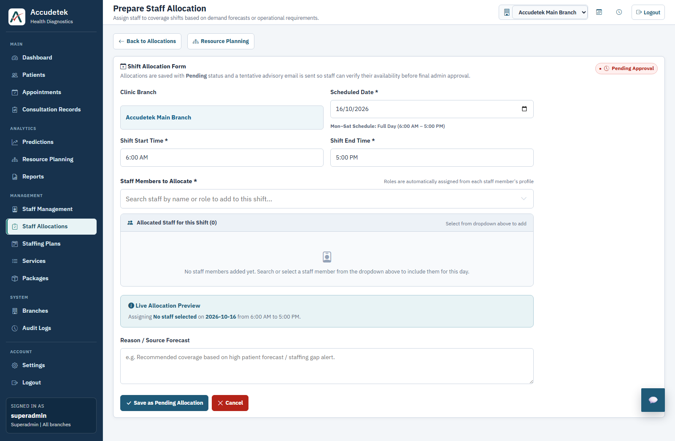
Figure 8.2: Prepare Staff Allocation Form (/staff-allocations/new) with Automated Advisory Email Notification.
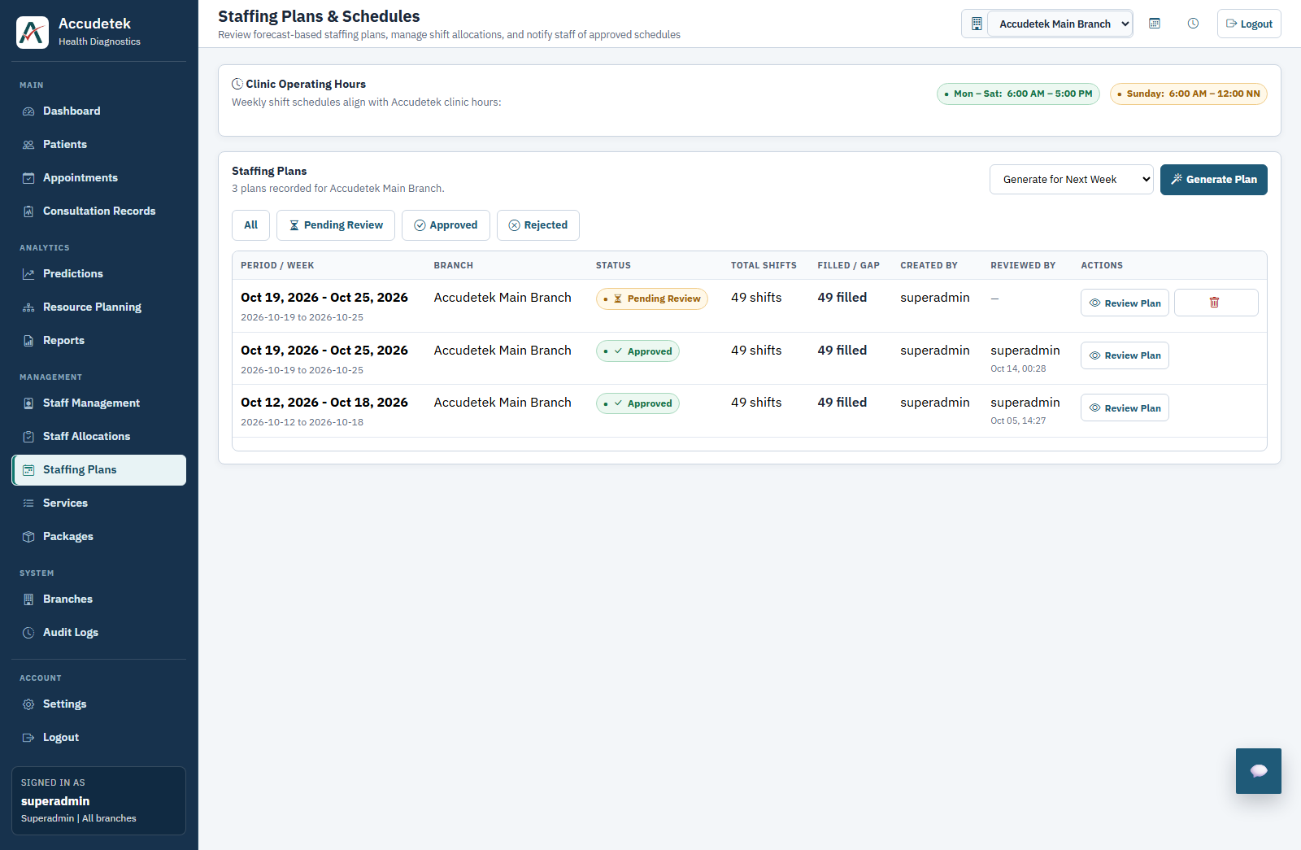
Figure 8.3: Forecast-Based Weekly Staffing Plans & Approval Workflow (/staffing-plans).
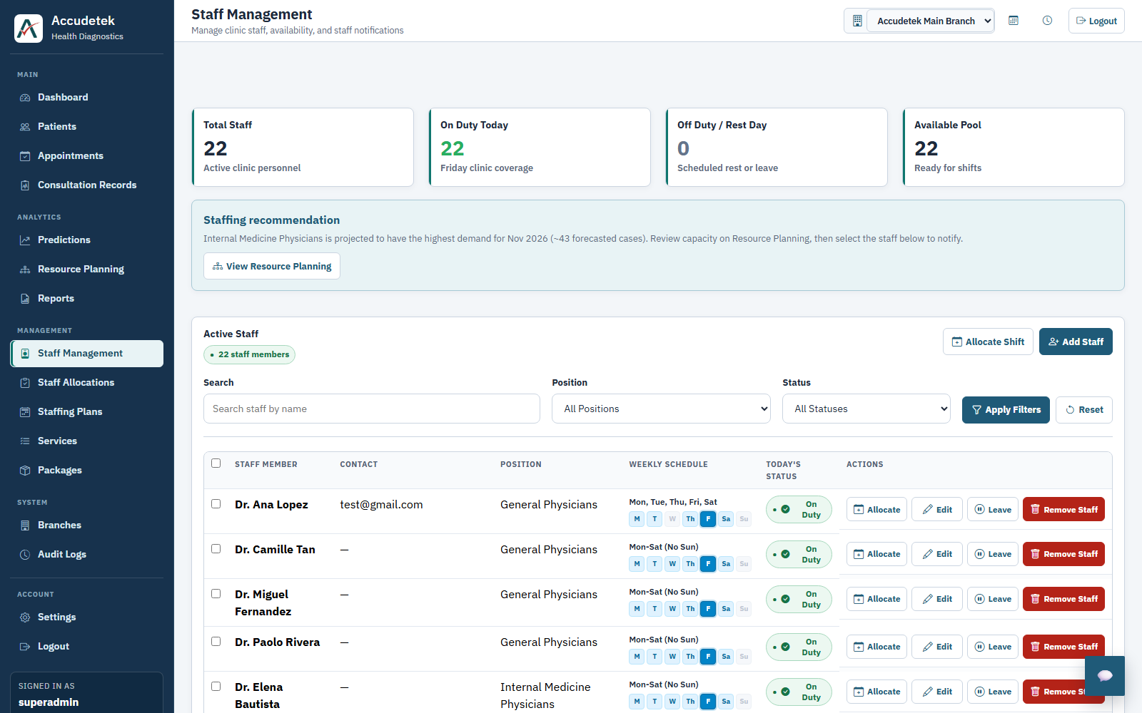
Figure 8.4: Staff Management Roster (/staff) with Forecast-Driven Specialist Recommendation Banner & Direct Shift Allocation.

