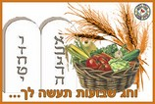

HAG CHAVOUOTH SAME'AH

