**Requirements Documentation**

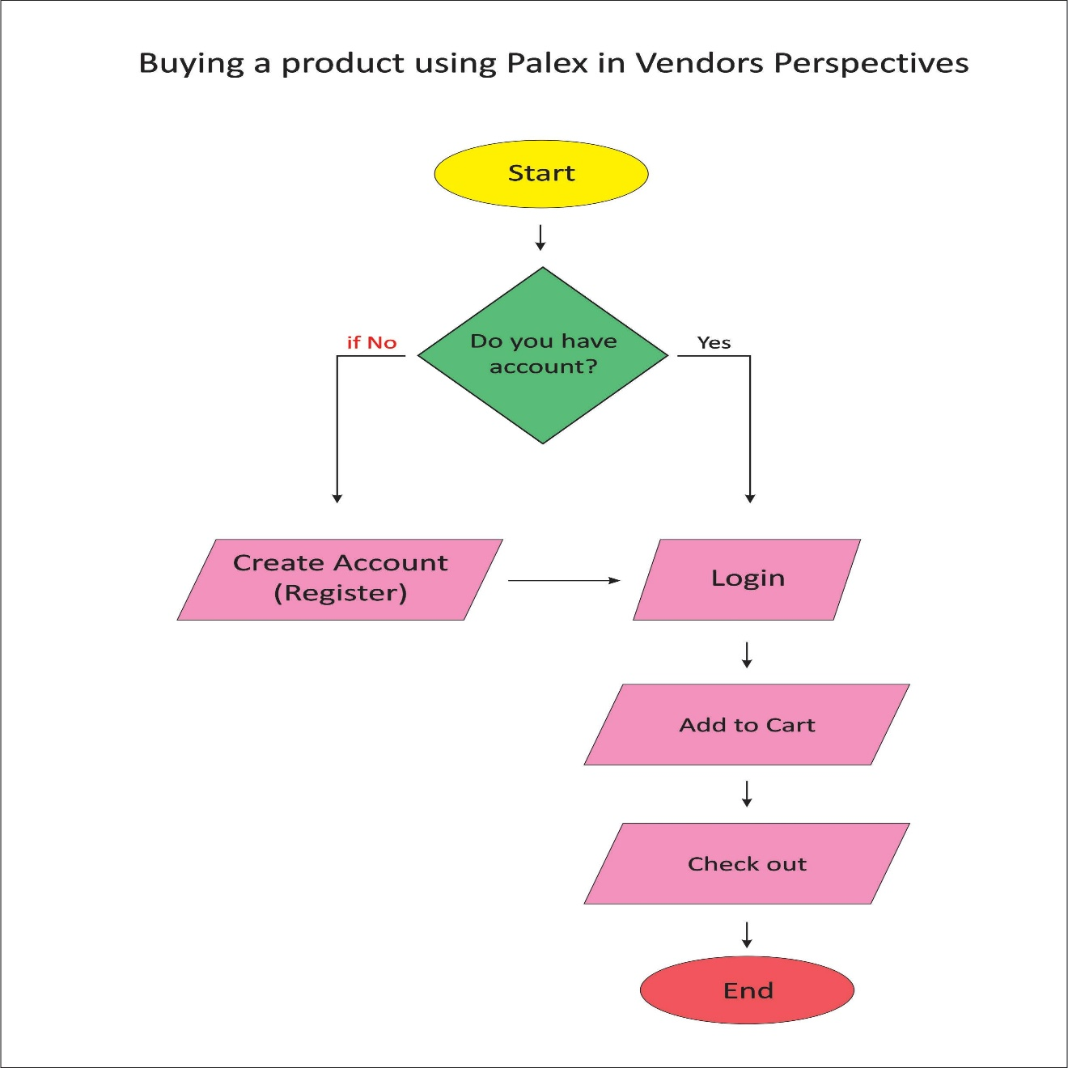Requirements Documentation is based on Requirement Analysis that the researchers gathered.

Figure 1. Buying a product using PalEx in Vendors Perspectives

Figure 1. It shows the Activity Diagram of the Current System for the steps on how vendors buying a product to the PalEx.

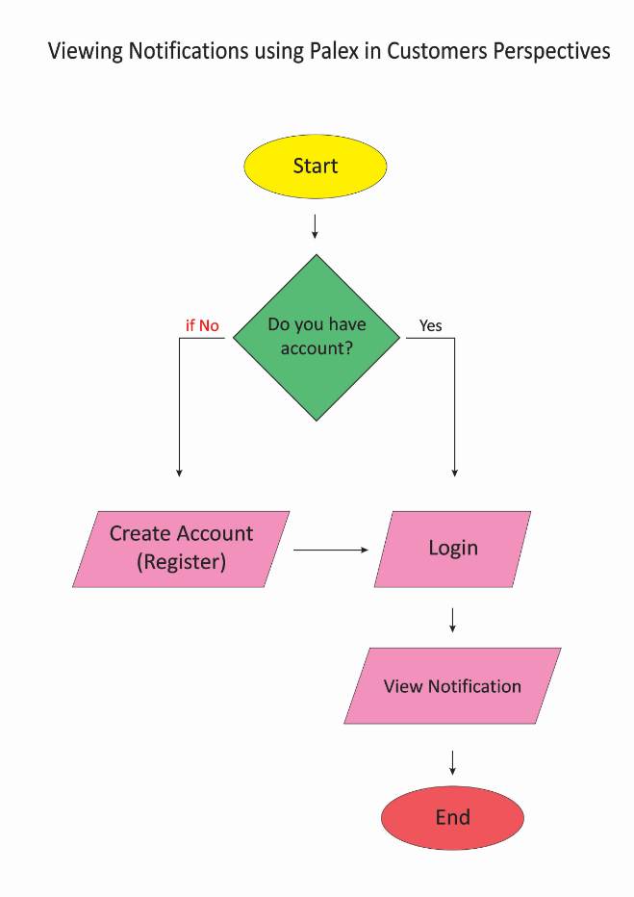

Figure 2. Viewing Notification using PalEx in Customers Perspectives

Figure 2. It shows the Activity Diagram of the Current System for the Process on how customer viewing notification. Market admin can access and send a notification to the vendors and customers for the important information.

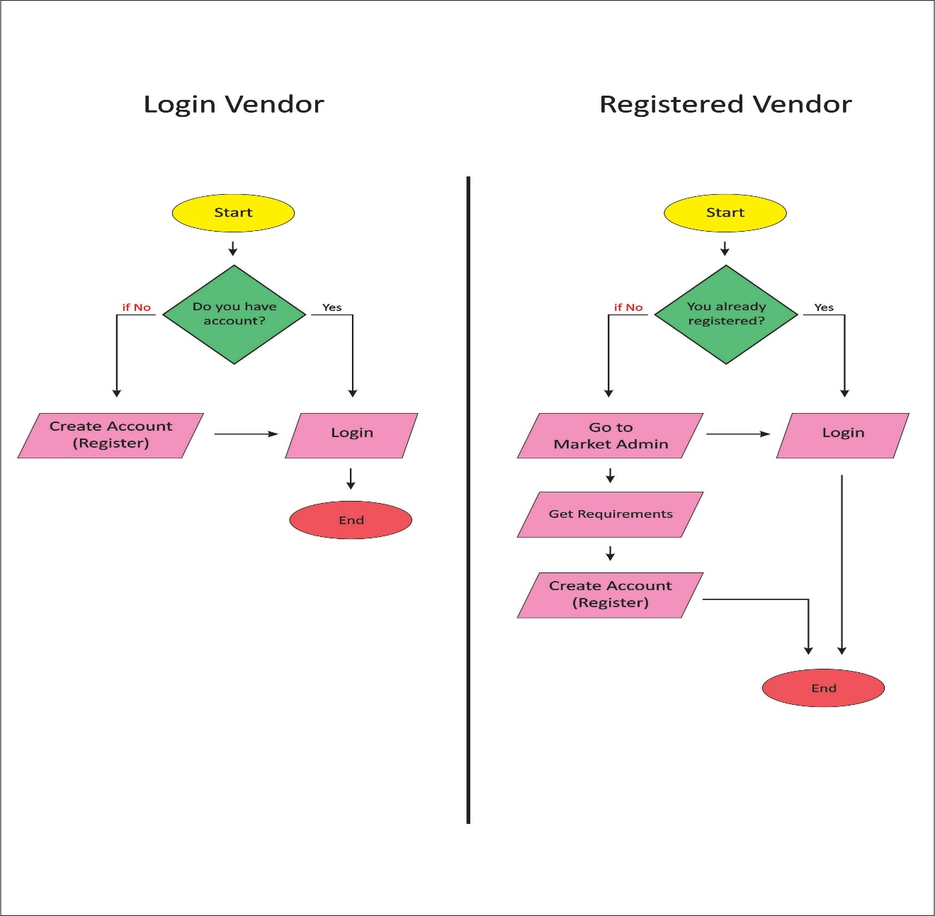

Figure 3. Login Vendor and Registered Vendor

Figure 3. It shows the Activity Diagram of the Current System for the Process on how to register as a vendor. If the vendor does not have an account, the vendor must go to market admin and the market admin will give a requirement to the vendor. After completing the requirements, the market admin can create an account for the vendor.

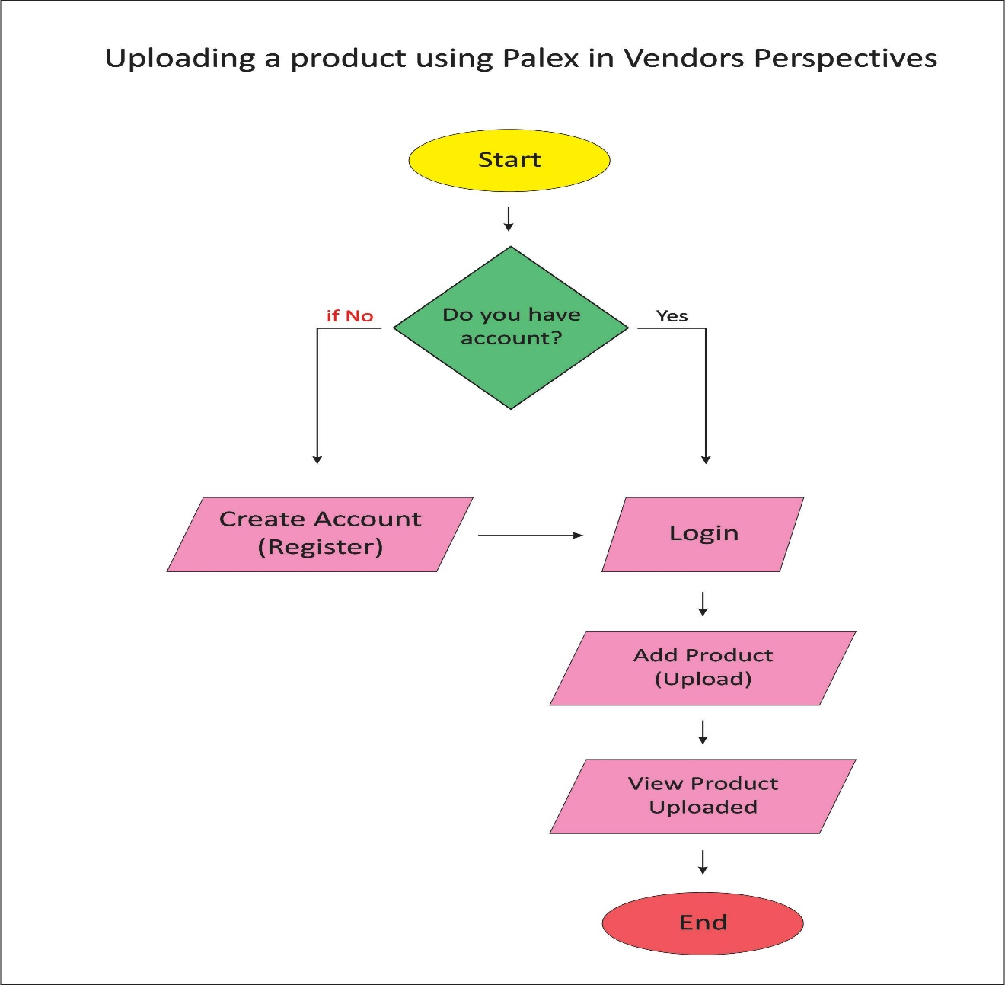

Figure 4. Uploading a product using PalEx in Vendors Perspectives

Figure 4. It shows the Activity Diagram of the Current System for the Process on How to Upload a product using PalEx in vendor's perspectives. It shows that the vendor has to update their product, add price, add quality and the kilogram of the product then after uploading, the vendor views the product they created and the customer shows the product of the vendor.

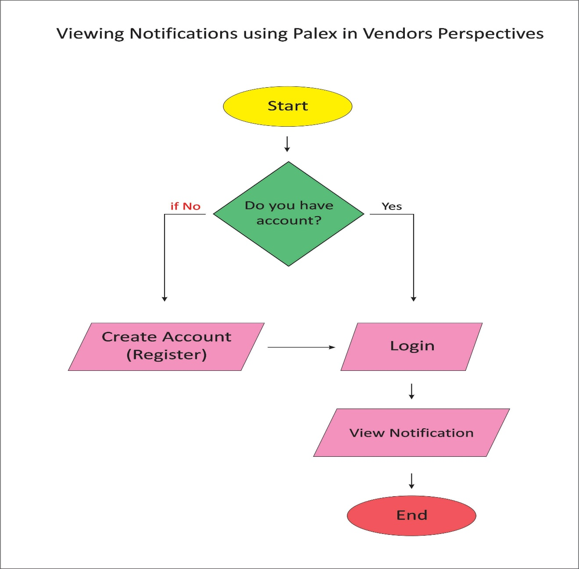

Figure 5. Viewing Notification using PalEx in Vendors Perspectives

Figure 5. It shows the Activity Diagram of the Current System for the Process of the vendor viewing Notification using PalEx. To look for the vendor’s products and check them.

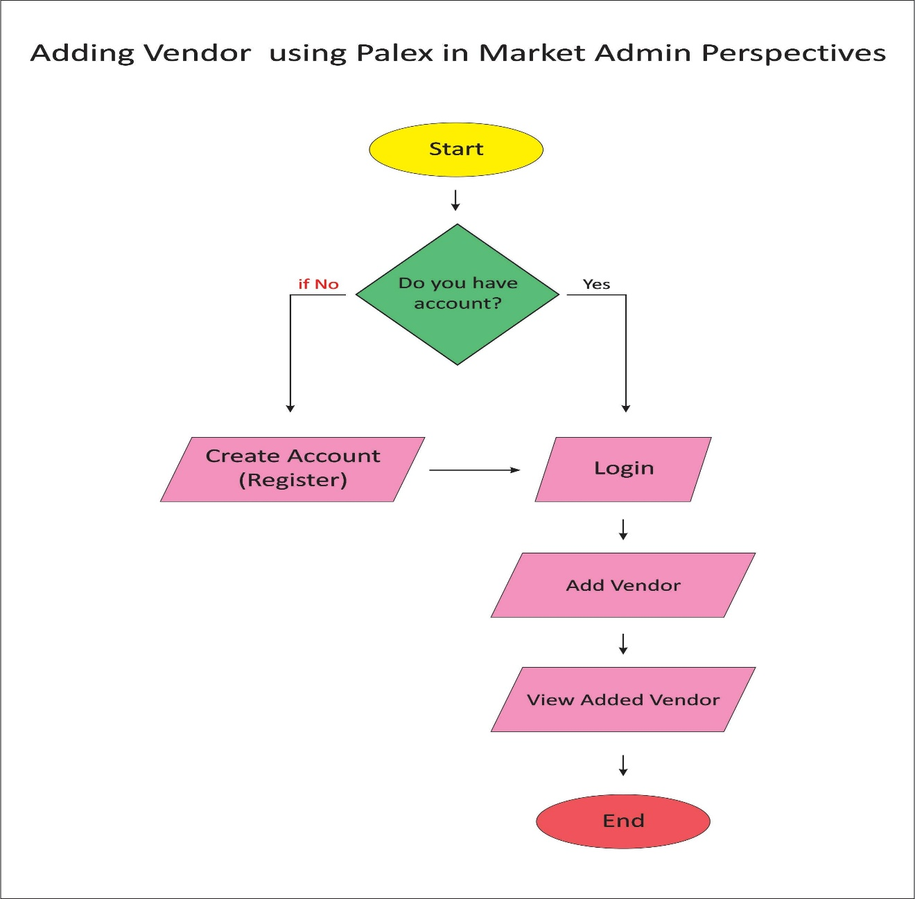

Figure 6. Adding Vendor using PalEx in Market Admin Prepectives

Figure 6. It shows the Activity Diagram of the Current System for the Process of Market Admin Adding Vendor using PalEx. Market admin logs in the system. Then the market checks the vendor’s requirements before the market admin adds the vendor into the system and view the added vendor.

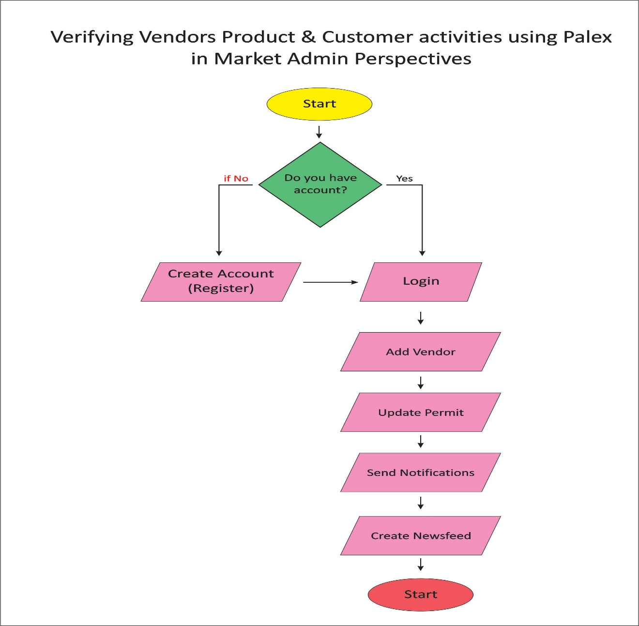

Figure 7. Verifying Vendors Product & Customer activities using PalEx in Market Admin Perspectives

Figure 7. It shows the Activity Diagram of the Current System for the Process on Verifying the vendors of their product and also customer activities and the market admin can add vendor, update the business permit of the vendor. If the vendor has an expired business permit, the market admin will send a notification to let the vendor know that their business permit has already expired. The market admin will create newsfeeds to the vendor.

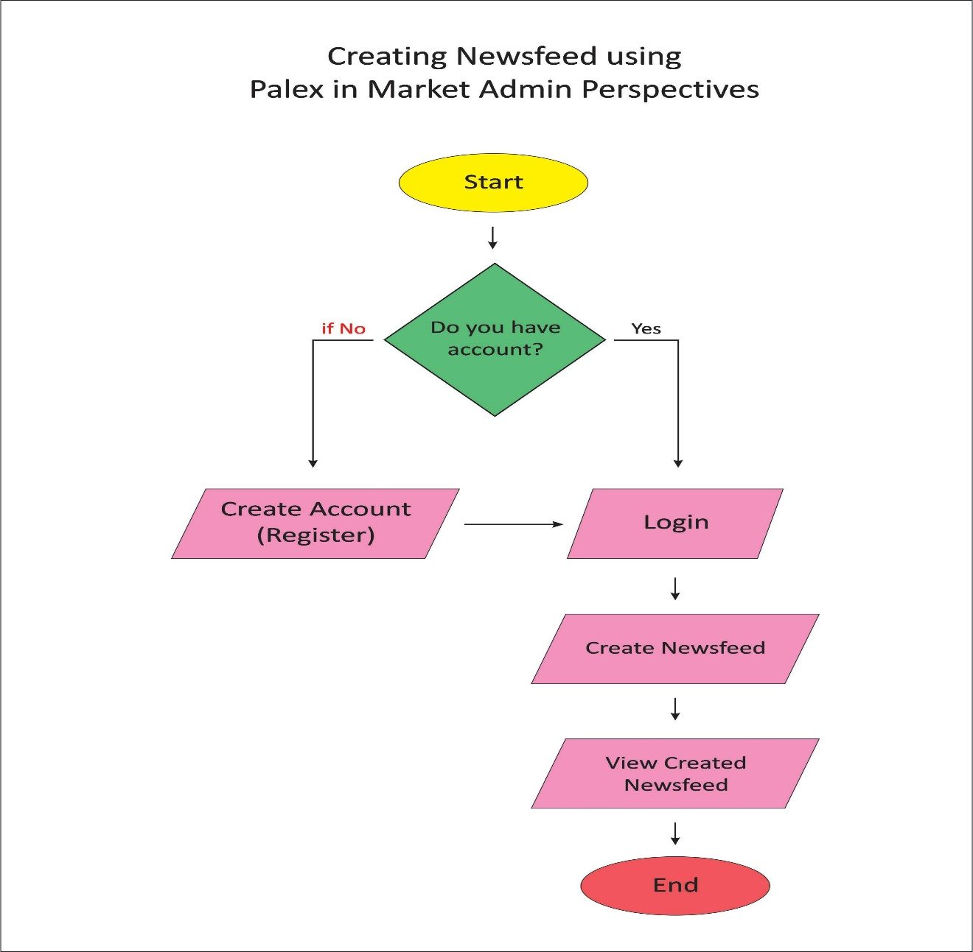

Figure 8. Creating Newsfeed using PalEx in Market Admin Perspectives

Figure 8. It shows the Activity Diagram of the Current System for the Process on creating newsfeed in market admin perspectives. It shows the market admin creates newsfeed to announce to the vendor and customer the important message from the market admin and other information.

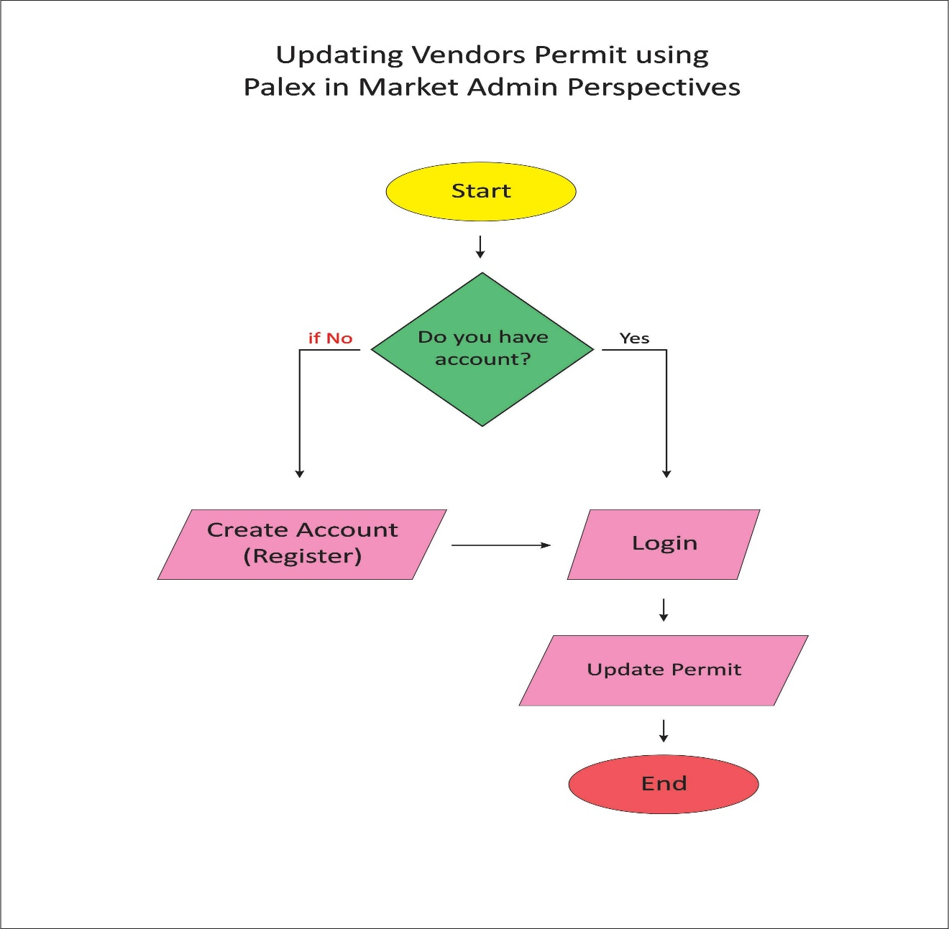

Figure 9. Updating Vendors Permit Using PalEx in Market Admin Perspectives

Figure 9. It shows the Activity Diagram of the Current System for the Process of updating a vendor’s permit. Market admin has access to all of the vendors in the market. Market admin checks the vendor’s business permit.

**Functional Requirements**

***Registration Market***

1. *Accepting Registration made by the Market Admin*
2. *The system should accept registration made by Market Admin*
3. *The following data are also necessary for the registration*
4. *Awardee Profile Ledger*
   * 1. ***Personal Data***

*1. Name2. ML*

*3. Surname*

*4. Home Address*

*5. Spouse Name*

*6. ML*

*7. Surname*

*8. Children*

*9. Name*

*10. Birthdate*

*11. Age*

***ii. Employees Data***

1. *Name*
2. *Date of Birth*
3. *Age*
   * 1. ***Stall Data***
4. *Stall No*
5. *Section*
6. *Contract Period*
7. *Monthly Rental*
8. *Type of stall*
9. *Electric Consumption*
10. *Rate/KW*
11. *Mon. Rate*
12. *Water Consumption*
13. *Rate/CU.M*
14. *Mon. Rate*

* + 1. ***Business Information***

*1. Business Permit No.*

*2. Business Plate No.*

*3. Business Started*

*4. Capital*

*5. Line of Business*

***Documentary Requirements for Renewal Application***

1. *Business Permit*

Figure 11. Conceptual Design Framework of the Study

It shows the Conceptual Framework Diagram of the Current System for the Process on how to input the market admin encodes information and vendor encode information. After the process of information, PalEx Application process all the information that the market admin and vendor created. Only the market admin can approve of updating business permit for vendor and after updating or processing the customer sees all of the information that the market admin and vendor has created.

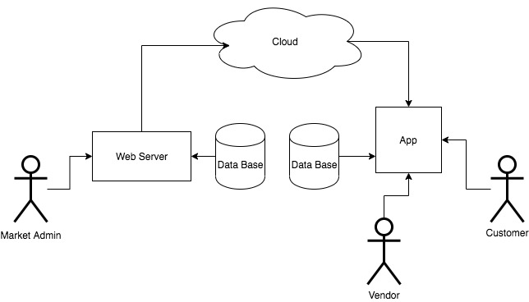Figure 12. System architecture

In this diagram, you can see the two databases. Each database is connected to the user which is the first figure database from the left is connected to the Market Admin and the other one database is connected to the Customer and Vendor. The web server and Application are connected to the cloud. Market admin is connected to the webserver to see the information of the database and also the customer and the vendor must be connected to the Application.

Vendor’s profile which consists of Personal Data, Employees Date, Stall Data, Business Information and Lease of Contract, Customer profile which consists of First Name, Last Name, Username, Password, Email, Contact Number, all of that information must be done both customer and vendor for the security of both sides. For Mobile application (Android and ios) researchers used Flutter, Server (web base) composed of Php, Html, JavaScript, Css and also Laravel. All of that programming languages are used to complete the interface in the web base which is the server. Also about the Database, researchers only used the MySQL, by which all data like transactions of both vendors, customers and all the import data from the goods of the vendors being sold in the application.

**Development and Testing**

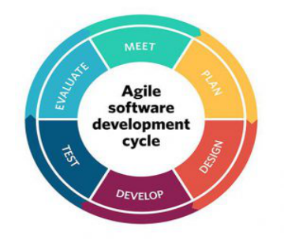Software Process Model

Figure 13. Agile Process Model

Agile model believes that every project needs to be handled differently and the existing methods need to be tailored to best suit the project requirements. In Agile, the tasks are divided into time boxes (small time frames) to deliver specific features for a release. The iterative approach is taken and working software build is delivered after each iteration. Each build is incremental in terms of features; the final build holds all the features required by the customer.

Screenshots for Admin Users

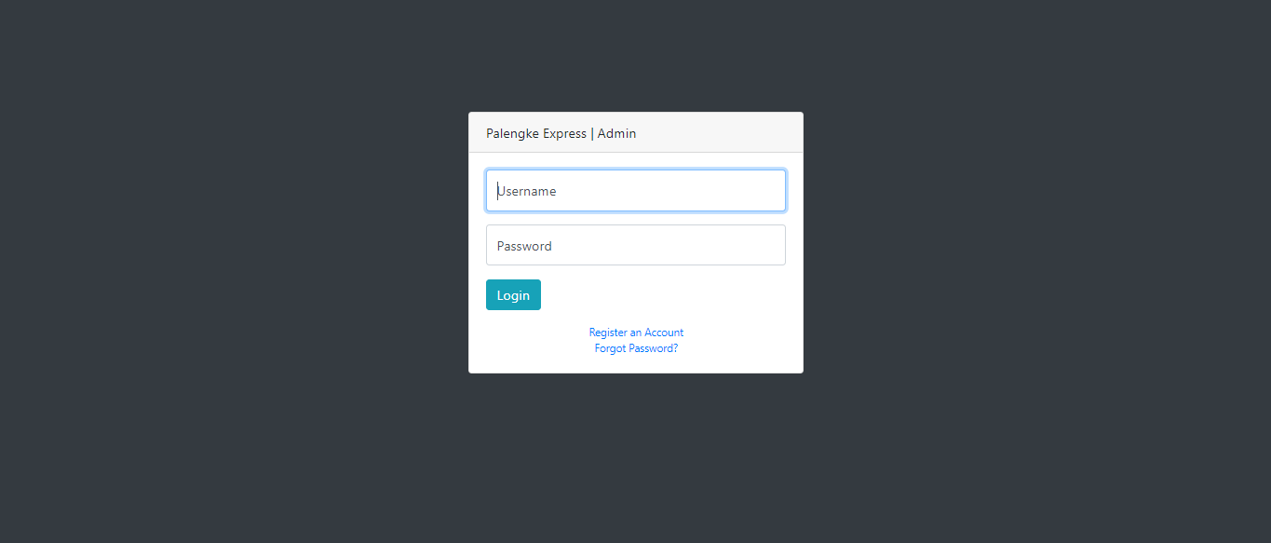

Login for Market Admin

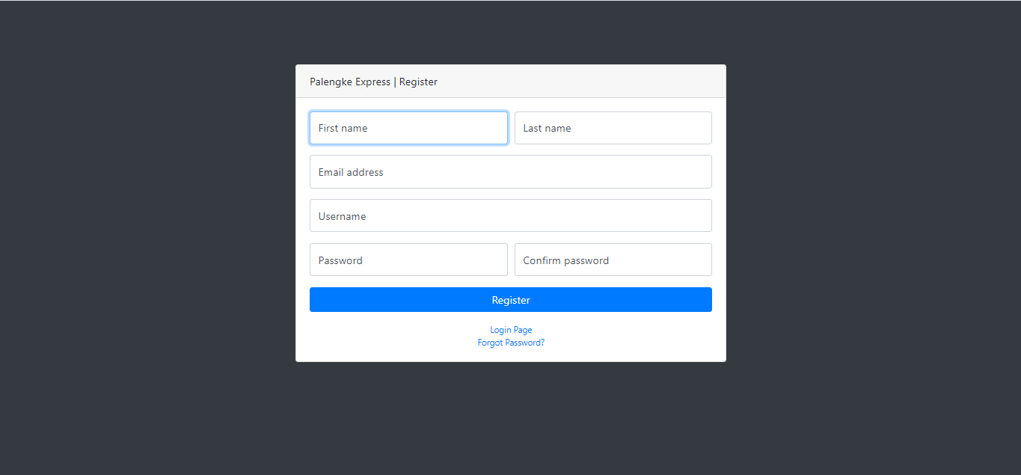

Register for Market Admin

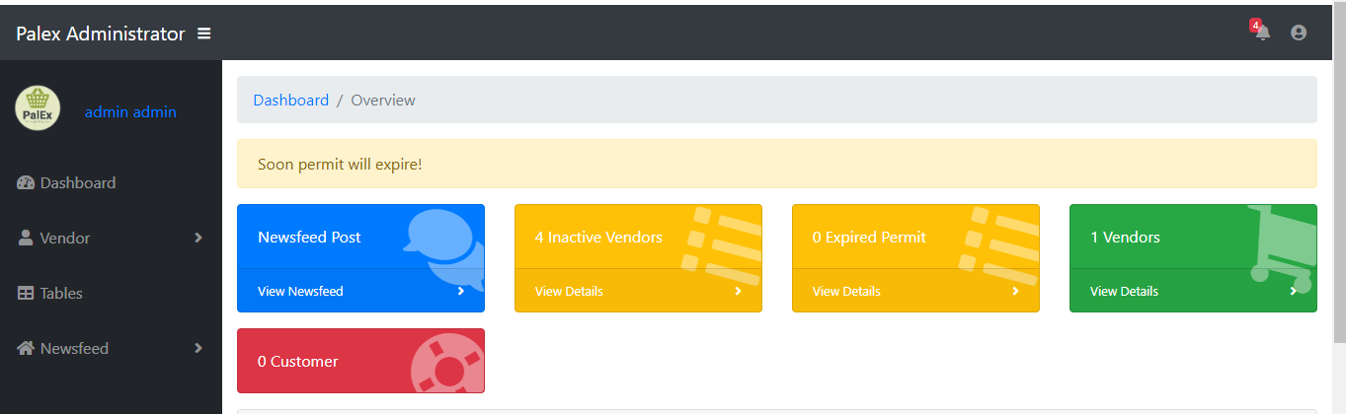

Dashbaord for Market Admin

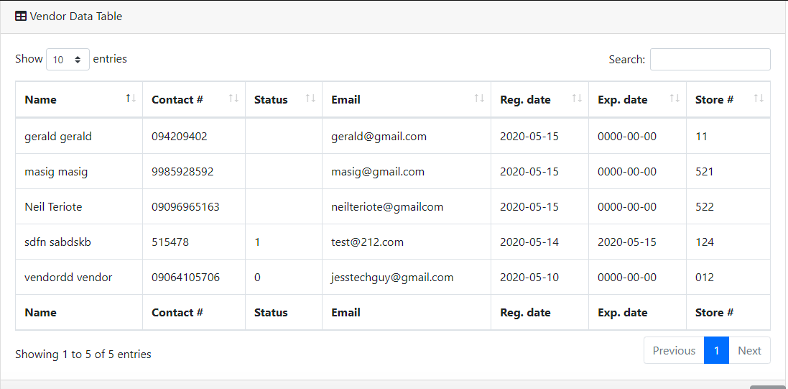

All registered vendor

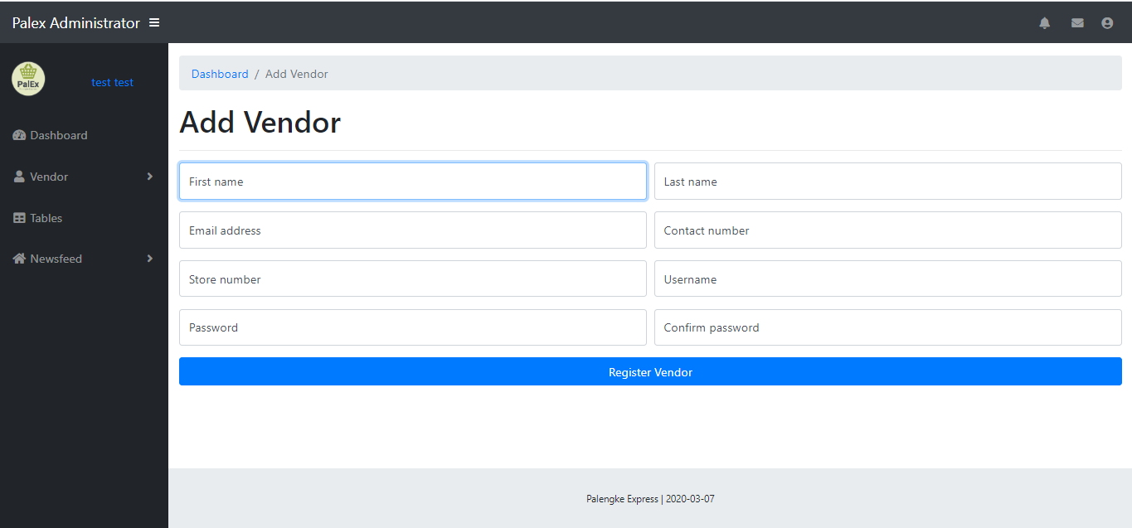

Add vendor

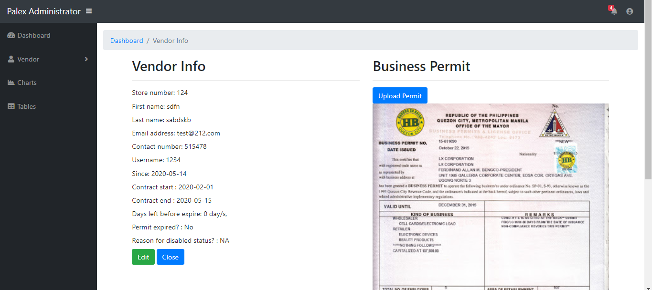

View vendor profile and Business permit

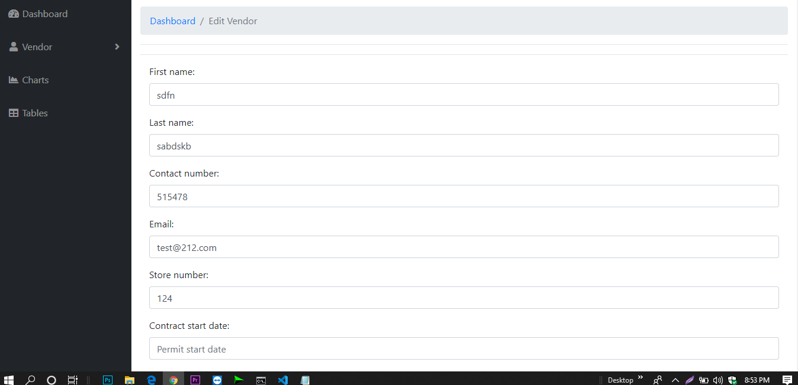

Edit vendor profile

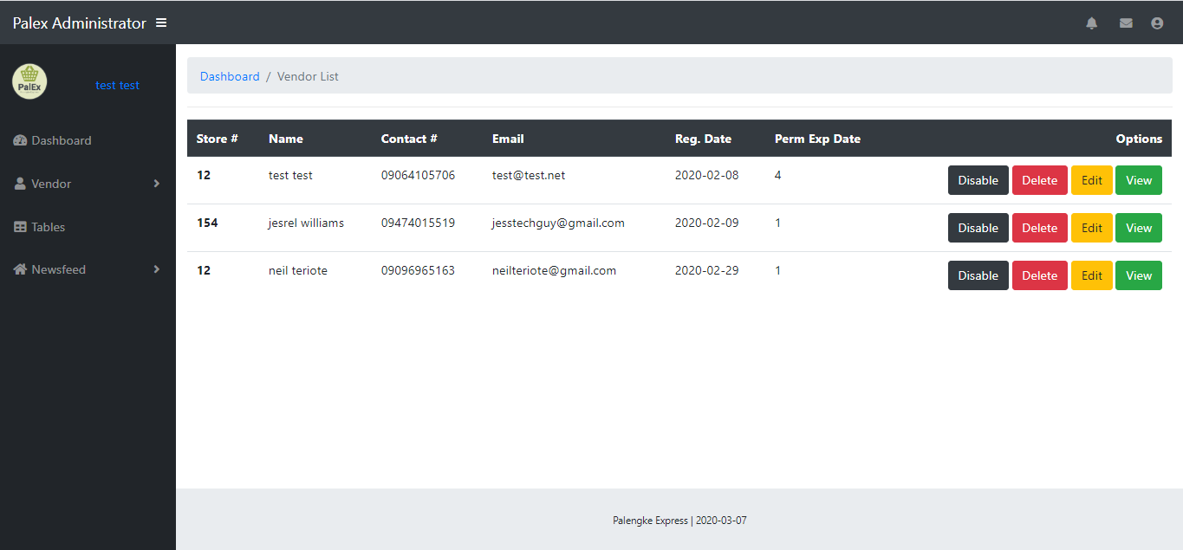

All enable vendor

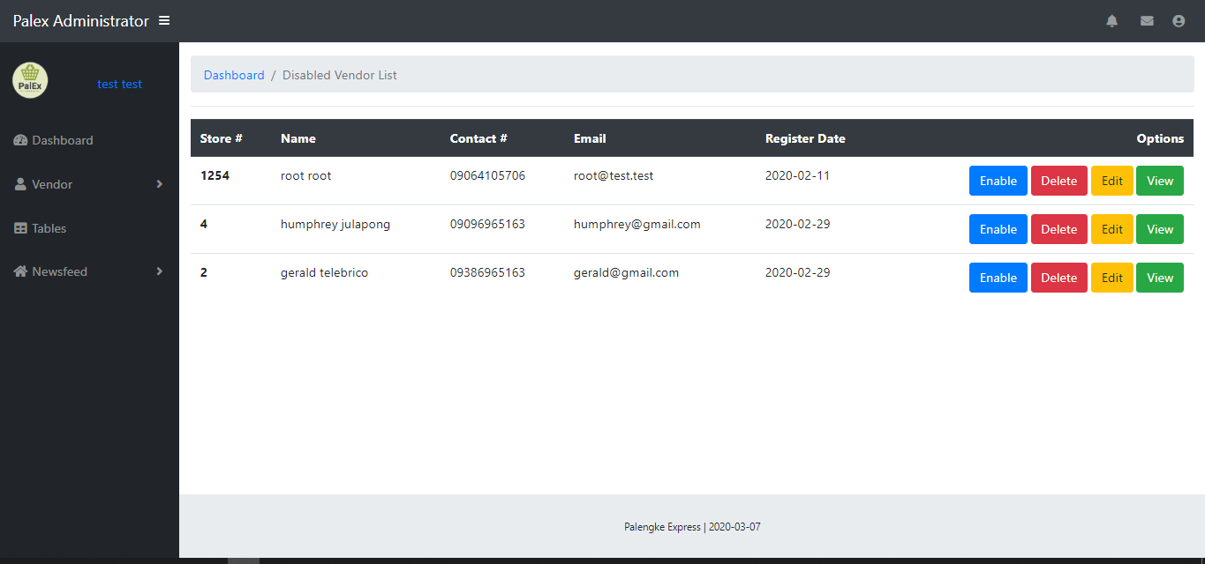

All inactive vendor

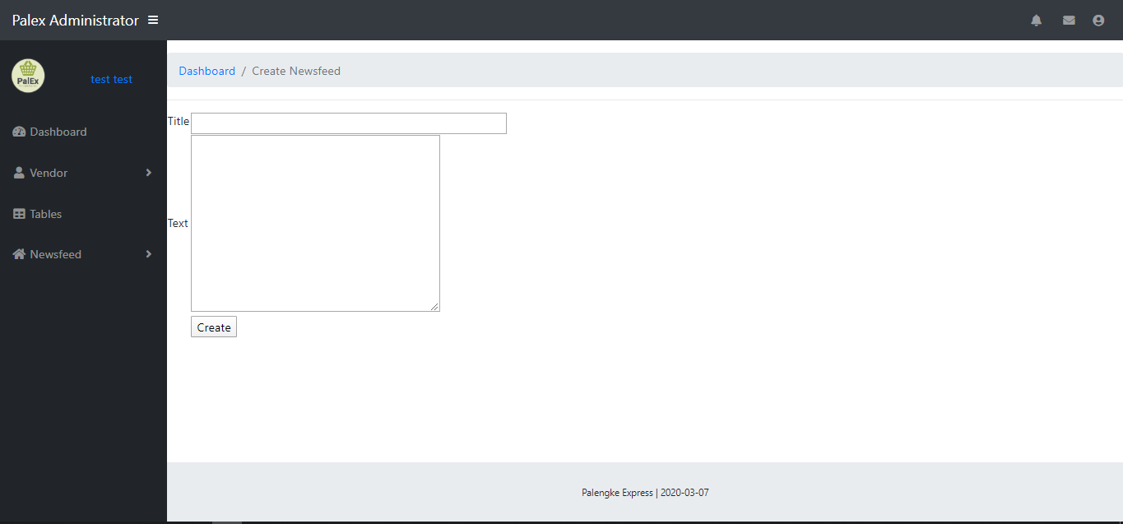

Create newsfeed

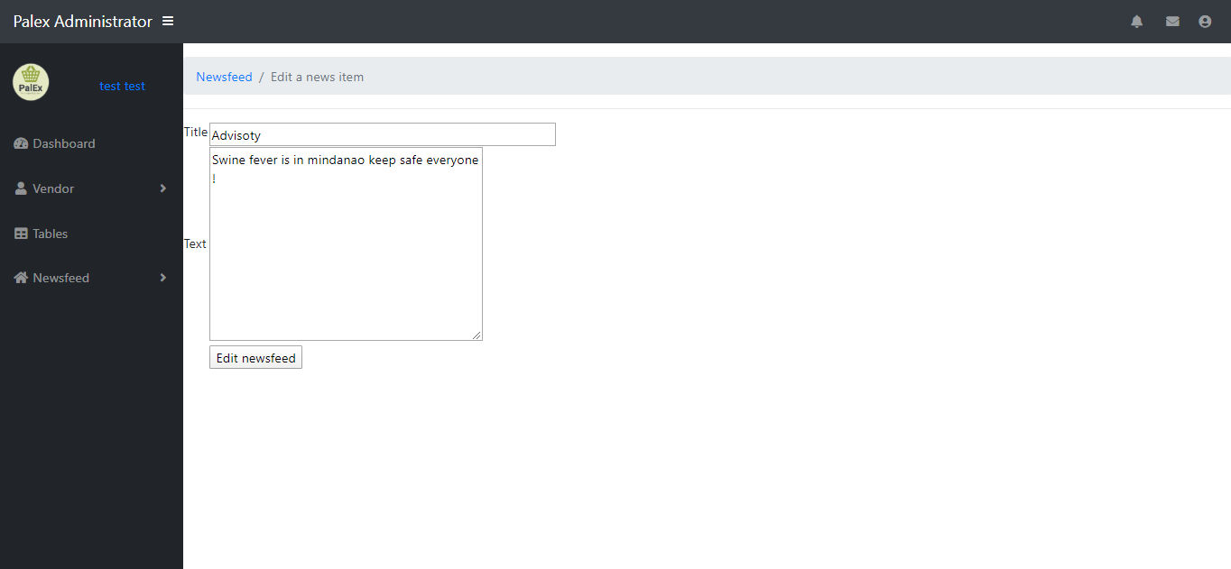

Edit newsfeed

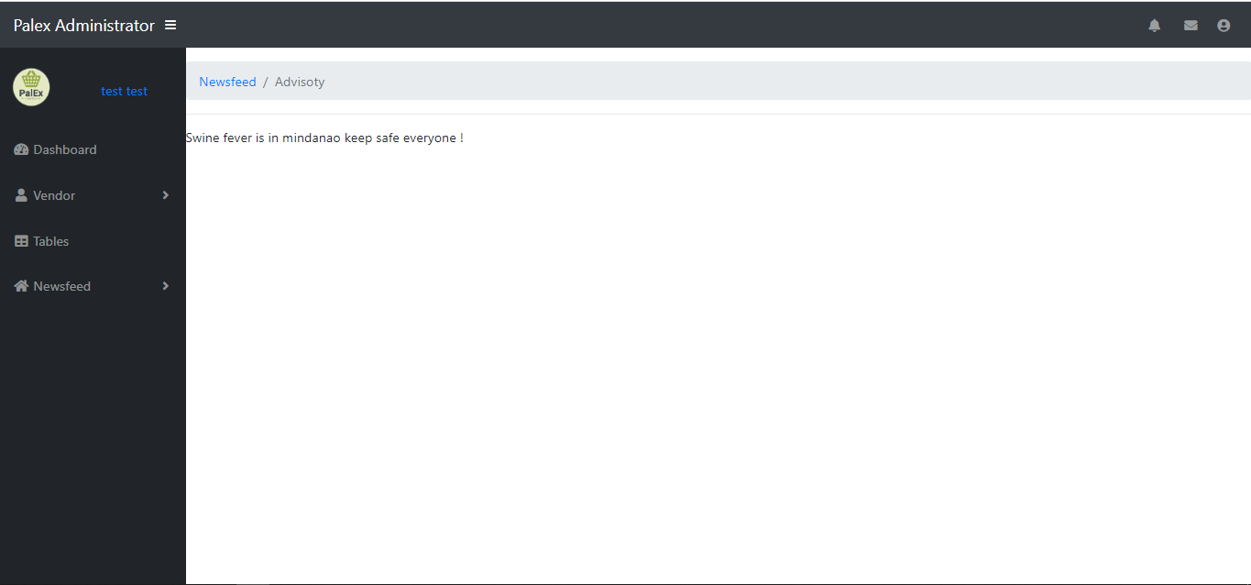

View newsfeed

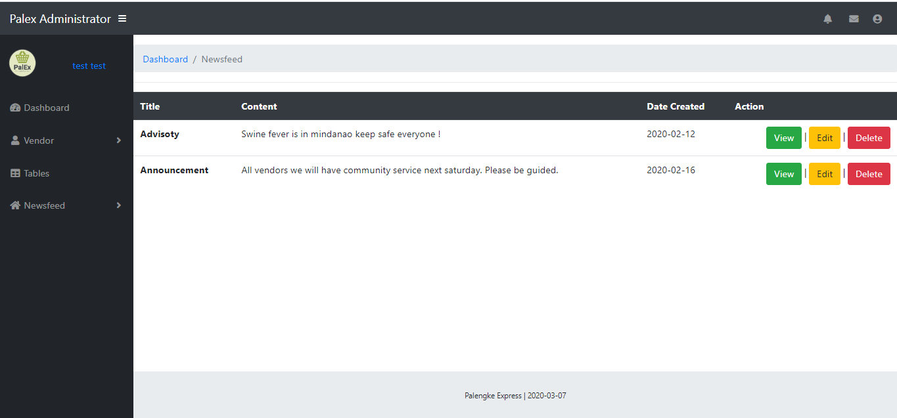

All newsfeed created

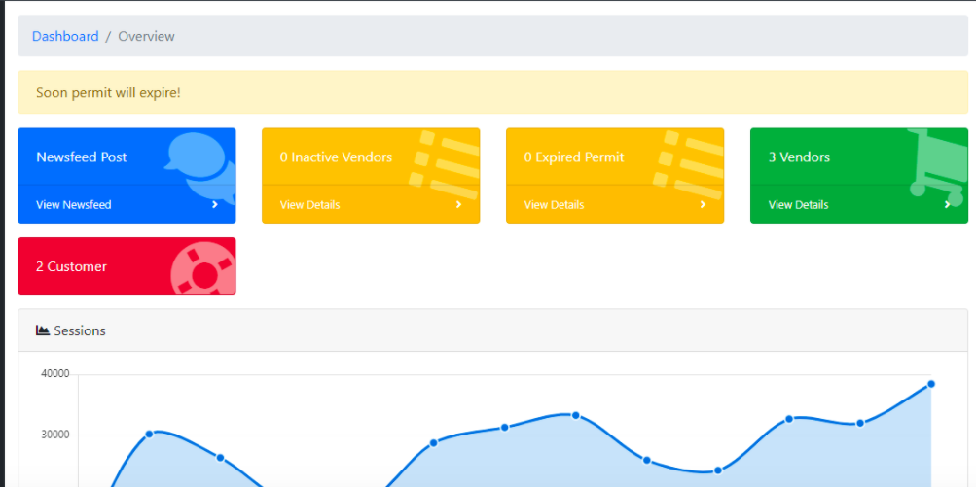

Nofity expire permit

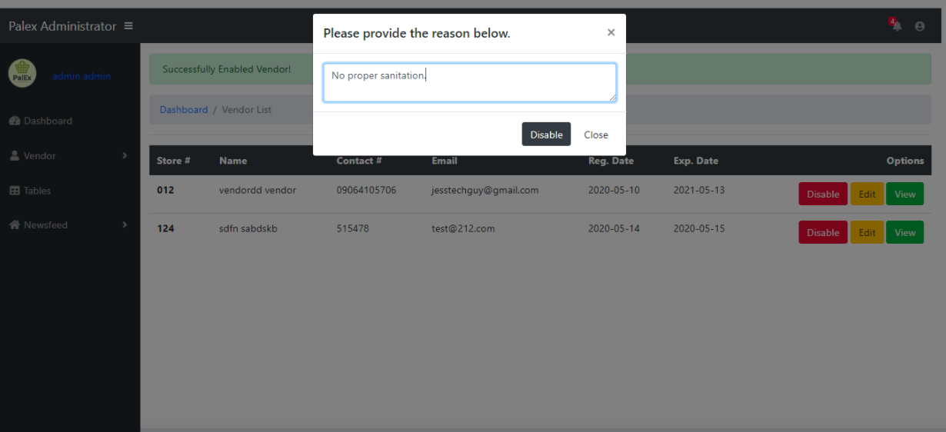

Disable Vendors

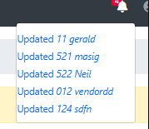

Notification

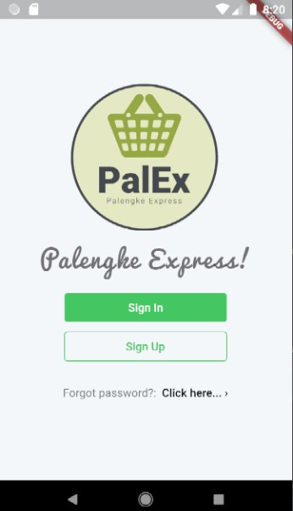Screenshots for Mobile Application

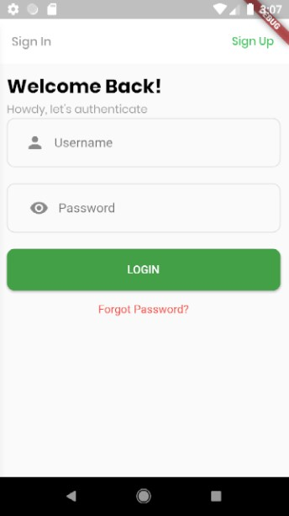

Sign in for Customer and Vendor Sign up for Customer

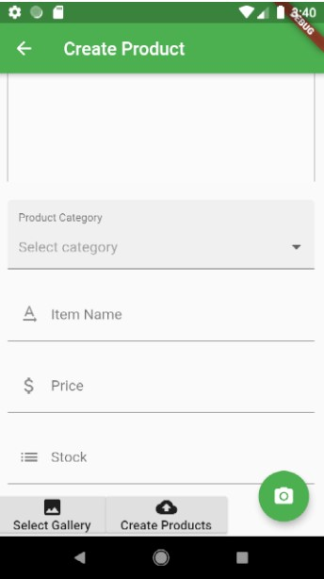

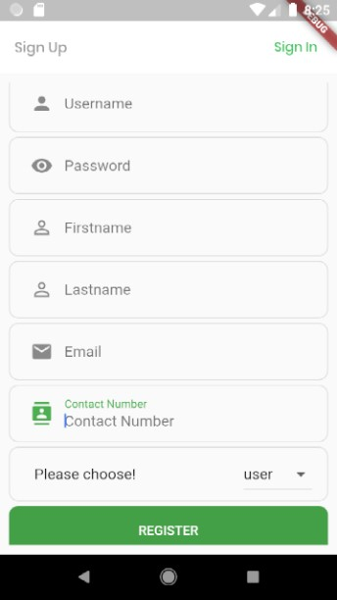

Customer Register Create Products

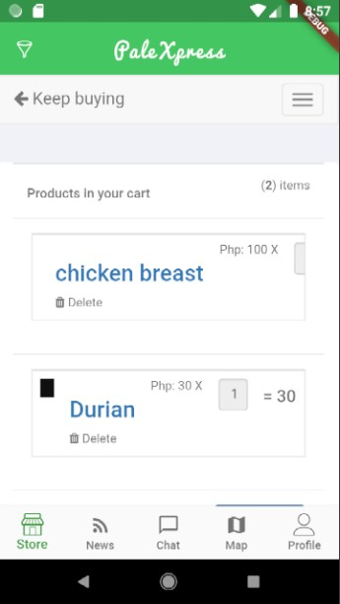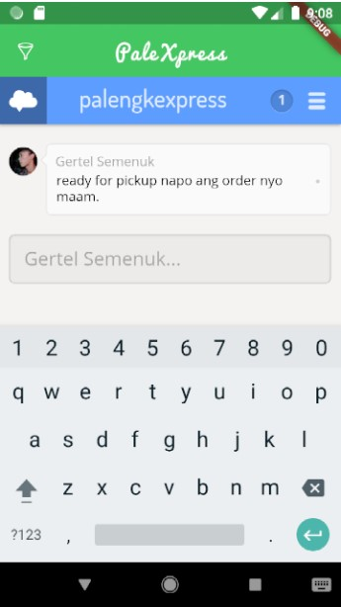

Chat box for customer and vendor Add to Cart

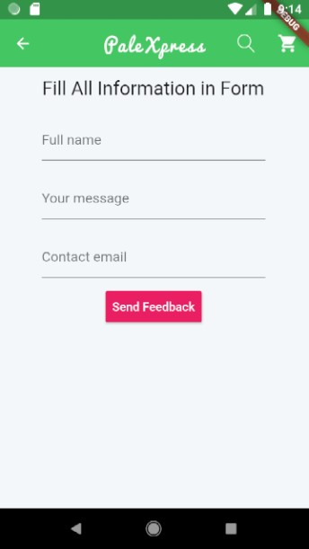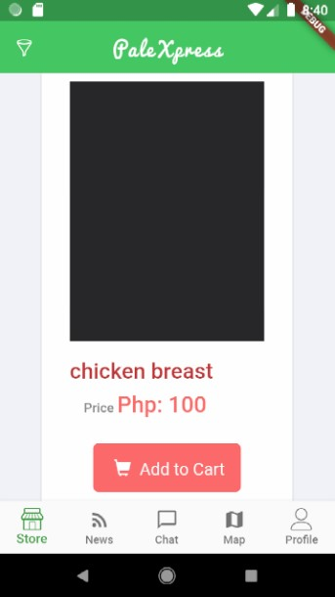

Store Vendor Feedback

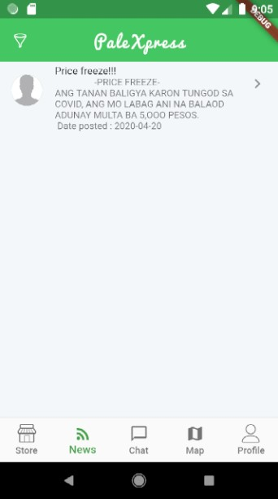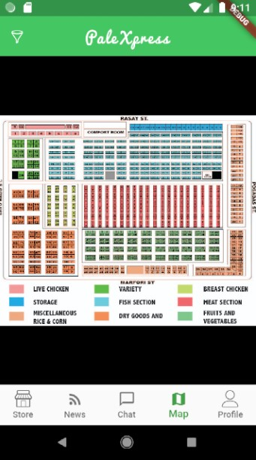

Virtual map Newsfeed to vendor and customer

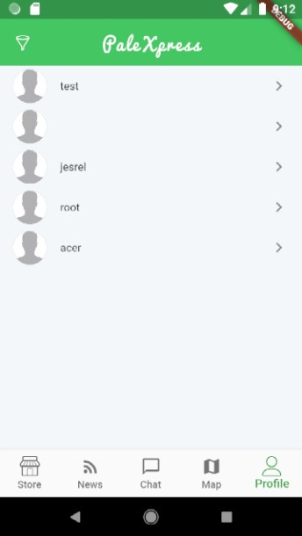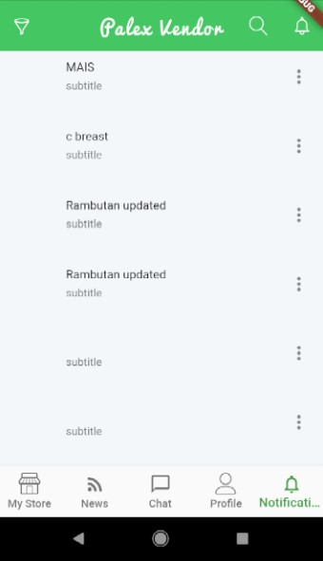

Vendor Notification Vendor Profile

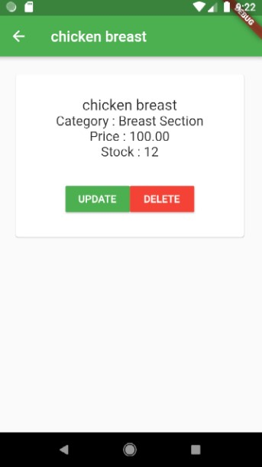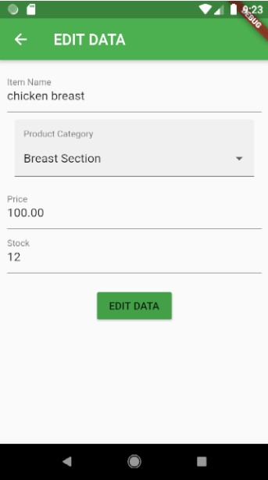

Update Product Product Details

