ELEC 475 PostLab 2

Vince Song

20341597

October 22nd, 2026

Architectural Specifications

Base LeNet-5 and Modernized LeNet
Describe the exact implementation used in models/lenet.py and models/lenet_modern.py. Include each convolution or pooling operation, channel count, kernel, stride, padding, output tensor shape, classifier dimensions, and trainable parameter count. Use the shapes produced by the code rather than assuming they match a textbook LeNet.
Model | Activation / pooling | Parameter count
Base LeNet-5 | Tanh; average pooling (as implemented) | 338,486 (0.3385 M)
Modernized LeNet | ReLU; overlapping max pooling | 446,006 (0.4460 M)

Full AlexNet-64 architecture
The supplied specification uses a 64×64 RGB input and five convolutional stages. For the normalization ablation, the normalization operation is configurable: identity (none), LocalResponseNorm, or BatchNorm2d. The spatial sizes below follow the specified kernel, stride, and padding values.
Stage | Operation | Output shape (C×H×W)
Input | RGB image | 3×64×64
1 | Conv 5×5, s=2, p=2, 64 filters → norm → ReLU → MaxPool 3×3, s=2 | 64×15×15
2 | Conv 5×5, s=1, p=2, 192 filters → norm → ReLU → MaxPool 3×3, s=2 | 192×7×7
3 | Conv 3×3, s=1, p=1, 384 filters → norm → ReLU | 384×7×7
4 | Conv 3×3, s=1, p=1, 384 filters → norm → ReLU | 384×7×7
5 | Conv 3×3, s=1, p=1, 256 filters → norm → ReLU → MaxPool 3×3, s=2 | 256×3×3
Classifier | Flatten 2304 → Dropout(.5) → FC 1024 → ReLU → Dropout(.5) → FC 1024 → ReLU → FC classes | num_classes

Spatial-size calculation for a convolution or pooling layer: output = floor((input + 2×padding − kernel_size)/stride) + 1. For example, stage 1 convolution gives floor((64 + 4 − 5)/2)+1 = 32; its 3×3, stride-2 pool gives floor((32 − 3)/2)+1 = 15. The final pooled tensor contains 256×3×3 = 2,304 features.

Parameter and receptive-field analysis
For a convolution with bias, trainable parameters = out_channels × (in_channels × kernel_height × kernel_width + 1). For a linear layer, parameters = out_features × (in_features + 1). BatchNorm adds learnable scale and offset per channel (2C parameters); LRN and identity normalization add no trainable parameters. State whether the profiler reports parameters, MACs, or FLOPs, and use one convention consistently. Some tools count one multiply-add as one MAC or as two FLOPs.
Receptive field: for each layer l, track receptive-field size r_l and effective stride j_l. Initialize r_0=1 and j_0=1. For kernel k_l and stride s_l, r_l = r_(l−1) + (k_l−1)j_(l−1), and j_l = j_(l−1)s_l. Apply this recursively through convolution and pooling layers; padding affects boundary coverage but not this nominal receptive-field recurrence.
Model / layer | Calculated parameters or RF | Code/profiler value | Difference / explanation
Base LeNet-5 | 456 + 2,416 + 324,600 + 10,164 + 850 = 338,486 | 338,486; 3.586M MACs; 7.172M FLOPs | Exact parameter match; FLOPs = 2× MACs.
Modernized LeNet | 456 + 2,416 + 432,120 + 10,164 + 850 = 446,006 | 446,006; 4.593M MACs; 9.185M FLOPs | Exact match; larger flattened feature map increases FC parameters.
AlexNet-64 conv stages | 4,864 + 307,392 + 663,936 + 1,327,488 + 884,992 = 3,188,672 | 3,188,672 conv; BN adds 2,560 | Convolutional parameters agree with layer profile.
AlexNet-64 classifier | 2,360,320 + 1,049,600 + 10,250 = 3,420,170 | 3,420,170 classifier | Conv + FC + BN = 6,611,402 total.
PyTorch Zoo AlexNet | Conv layers: 23,296 + 307,392 + 663,936 + 884,992 + 590,080; FC layers: 37,752,832 + 16,781,312 + 40,970 | 57,044,810 parameters; 94.136M MACs; 188.272M FLOPs | Measured exact layer breakdown from 10-class torchvision AlexNet (64×64 input); FLOPs = 2× MACs.

Normalization results (measured)
Metric | No norm | LRN | BatchNorm
Final train loss | 0.8417 | 0.8283 | 0.5900
Final validation loss | 0.7994 | 0.7846 | 0.5826
Train accuracy (%) | 71.13 | 71.65 | 80.47
Validation accuracy (%) | 72.89 | 73.24 | 79.62
Validation macro F1 (%) | 72.82 | 73.38 | 79.40
Mean epoch time (s) | 215.54 | 249.33 | 208.41
Parameters (M) | 6.6088 | 6.6088 | 6.6114
FLOPs (M) and counting convention | 436.70 (2× MACs) | 436.70 (2× MACs) | 437.97 (2× MACs)

Performance Improvement: Did incorporating Batch Normalization yield an improvement in validation accuracy and Macro \(F_1\) over No Normalization and LRN? (Yes / No). If Yes: Explain the underlying mathematical and optimization reasons. How does normalizing mini-batch activations reduce internal covariate shift and smooth the optimization landscape? If No or Marginal: Discuss what experimental parameters (e.g., choice of learning rate, batch size, or short 10-epoch horizon) may have limited the observable gains.

BatchNorm improved both validation metrics: 79.62% accuracy and 79.40% macro F1, versus 72.89% / 72.82% for
no normalization and 73.24% / 73.38% for LRN. The improvements were +6.73 percentage points accuracy and
+6.58 points F1 relative to none, and +6.38 points accuracy and +6.02 points F1 relative to LRN. LRN exceeded no
normalization by only +0.35 points accuracy and +0.56 points F1.Loss and stability: Final validation loss was 0.5826
with BatchNorm, compared with 0.7846 for LRN and 0.7994 without normalization. This lower loss is consistent
with more effective optimization; it does not by itself prove smoother epoch-to-epoch trajectories or more stable
gradients. The provided results are single-seed (42) runs, so run-to-run stability and loss variance across repeated
trainings have not been measured.

Computational Overhead: Did the addition of LRN or BatchNorm2d measurably alter your training poch wall-clock time and arithmetic FLOPs? (Yes / No). Contrast the computational overhead of element-wise normalization against the convergence benefit.

Computational cost: Mean epoch times were 215.54 s (none), 249.33 s (LRN), and 208.41 s (BatchNorm). LRN took
about 15.7% longer than none, while BatchNorm took about 3.3% less time. Reported FLOPs were 436.70M
(none), 436.70M (LRN), and 437.97M (BatchNorm). Normalization operates on activations without changing
convolution output shapes; BatchNorm adds channel-wise affine parameters and operations. FLOP estimates may
omit or approximate some normalization operations, especially LRN. CPU wall-clock time also depends on kernel
implementation, memory access, data loading, and hardware, so FLOPs alone do not predict runtime.

Convergence Stability: Compare the variance and smoothness of the training loss trajectories across the three variants. Which normalization scheme demonstrated the most stable gradient progression?

Interpretation of small differences: The marginal LRN advantage could reflect the short 10-epoch horizon, learning
rate 0.001, batch size 128, and stochastic training variation. Although seed 42 was held fixed, one seed cannot
establish a reliable average benefit. Repeated runs with multiple seeds and reporting mean ± standard deviation
would better establish reproducibility.

Generalization gap
Calculate Δ = training accuracy − validation accuracy, using the same accuracy scale for both values (percentage points if accuracies are percentages).
Metric | BatchNorm, no augmentation | BatchNorm + augmentation
Epochs | 15 | 15
Final training accuracy (%) | 90.34 | 84.66
Final validation accuracy (%) | 81.66 | 81.95
Generalization gap Δ (percentage points) | 8.68 | 2.71
Validation macro F1 (%) | 81.82 | 82.21
Mean epoch time (s) | 217.36 | 221.56

Generalization Gap Reduction — Yes
At epoch 15, without augmentation, training accuracy was 90.34% and validation accuracy was 81.66%, giving Δ = 90.34 − 81.66 = 8.68 percentage points. With augmentation, training accuracy was 84.66% and validation accuracy was 81.95%, giving Δ = 84.66 − 81.95 = 2.71 percentage points. Augmentation therefore reduced the gap by 5.97 percentage points (approximately 68.8%). The lower training accuracy and smaller gap are consistent with stronger regularization and reduced overfitting.

Validation Metric Improvement — Yes (marginal)
Final validation accuracy increased from 81.66% without augmentation to 81.95% with augmentation (+0.29 percentage points), while macro F1 increased from 81.82% to 82.21% (+0.39 percentage points). Random crops, horizontal flips, and color jitter create label-preserving variation that encourages convolutional filters to recognize semantic patterns across changes in object position, orientation, and appearance instead of memorizing specific training-image configurations.
The improvements in final validation metrics were modest, even though the generalization gap decreased substantially. The augmented model reached a higher best validation accuracy of 83.50% at epoch 14, before finishing at 81.95% at epoch 15, indicating validation fluctuations. Additional training might help the model assimilate the augmented distribution, but the current results do not establish that more epochs are required or that transformations caused underfitting.

Dual-Dataset Evaluation: CIFAR-10 and Tiny ImageNet

Metric | CIFAR-10 | Tiny ImageNet / subset
Number of classes | 10 | 200
Validation accuracy (%) | 79.62 (10 epochs); 81.95 (15 epochs, aug.) | 31.92 (10 epochs)
Validation macro F1 (%) | 79.40 (10 epochs); 82.21 (15 epochs, aug.) | 29.95
Final validation loss | 0.5473 (15 epochs, aug.) | 2.8586
Random-guess accuracy baseline | 10% (balanced classes) | 0.5% for 200 classes
Epoch where validation loss plateaus/diverges | Not established by 15 epochs | Not established by 10 epochs

Architectural complexity and timing
Model | Conv depth | Normalization / regularization | Augmentation | Params (M) | FLOPs (M) | Mean epoch (s) | Latency (ms)
Base LeNet-5 | 2 | None; as implemented |  | 0.3385 | 7.17 | 48.54 | 0.17
Modernized LeNet | 2 | ReLU + overlapping MaxPool |  | 0.4460 | 9.19 | 52.24 | 0.20
AlexNet (no norm) | 5 | Dropout p=0.5; Identity normalization |  | 6.6088 | 436.70 | 215.54 | 1.31
AlexNet + LRN | 5 | LRN + Dropout p=0.5 |  | 6.6088 | 436.70 | 249.33 | 2.28
AlexNet + BatchNorm | 5 | BatchNorm2d + Dropout p=0.5 |  | 6.6114 | 437.97 | 208.41 | 1.41
AlexNet + BN + Aug | 5 | BatchNorm2d + Dropout p=0.5 |  | 6.6114 | 437.97 | 221.56 | 1.41
PyTorch Zoo AlexNet | 5 | Torchvision AlexNet; Dropout p=0.5 |  | 57.0448 | 188.27 | 160.79 | 3.09

Predictive performance across datasets
Model | CIFAR-10 val acc (%) | CIFAR-10 macro F1 (%) | Tiny ImageNet val acc (%) | Tiny ImageNet macro F1 (%)
Base LeNet-5 | 52.78 | 52.70 | 11.29 (5 epochs) | 8.59 (5 epochs)
Modernized LeNet | 66.66 | 66.00 | 19.97 (5 epochs) | 17.37 (5 epochs)
AlexNet (no norm) | 72.89 | 72.82
AlexNet + LRN | 73.24 | 73.38
AlexNet + BatchNorm | 79.62 | 79.40 | 31.92 (10 epochs) | 29.95 (10 epochs)
AlexNet + BN + Aug | 81.95 | 82.21
PyTorch Zoo AlexNet | 63.90 | 63.05

Figures

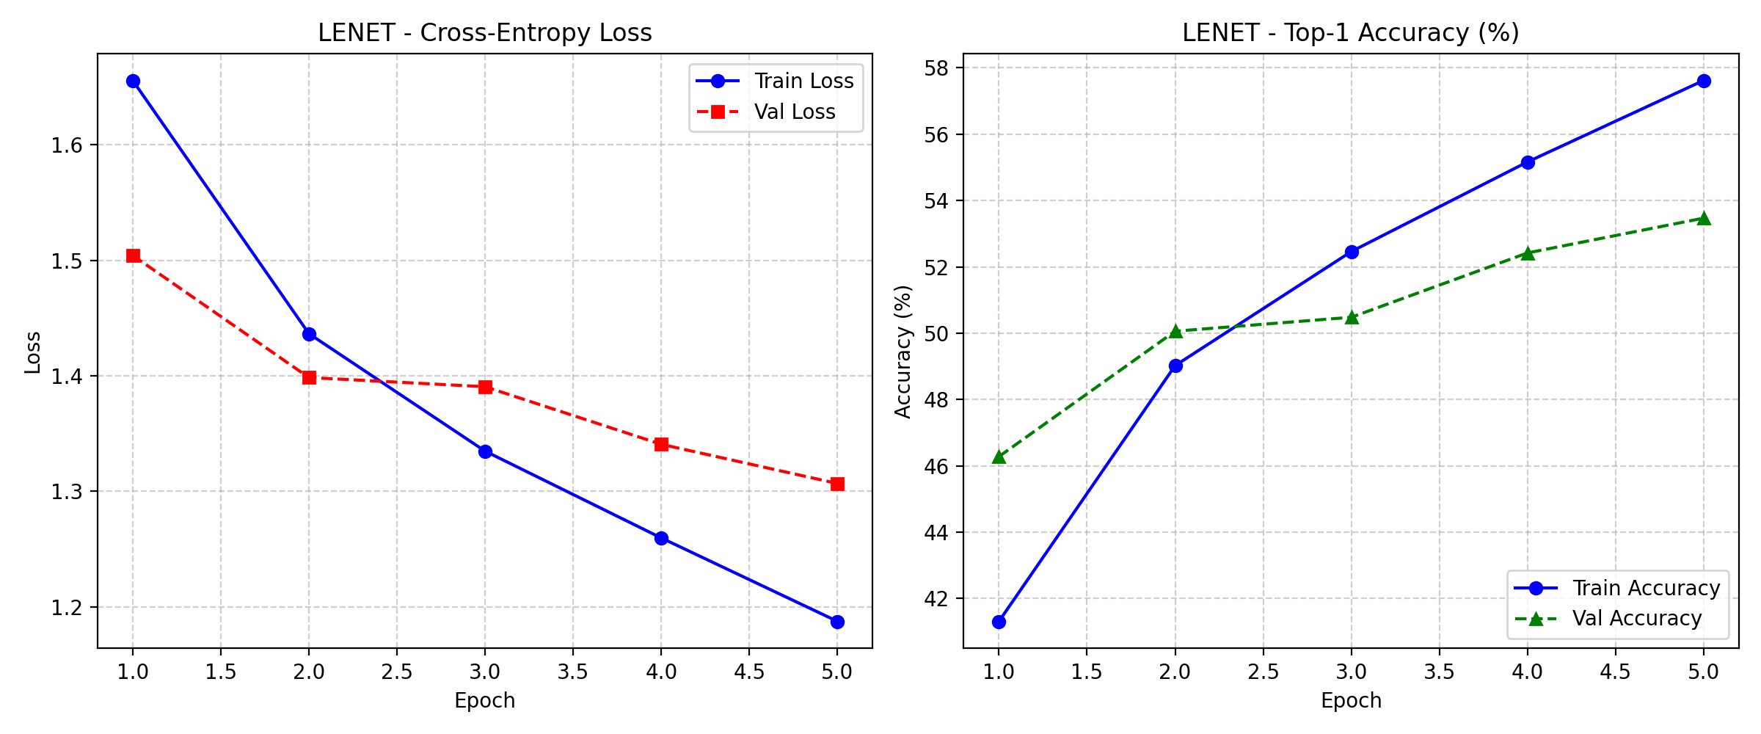
Figure 1: loss_lenet.png

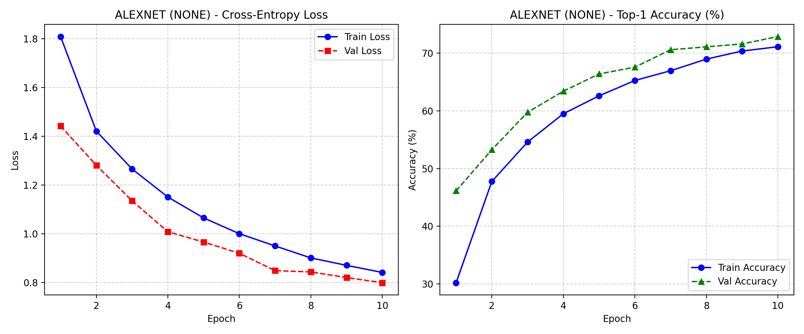
Figure 2: loss_lenet_modern.png

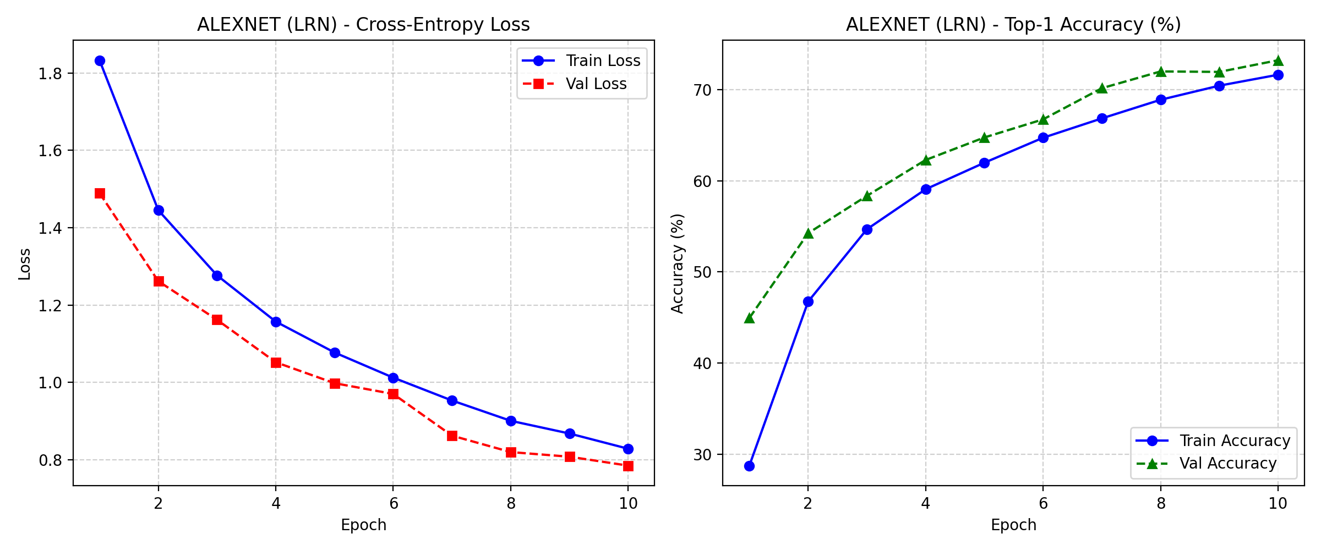
Figure 3: loss_alexnet_none.png

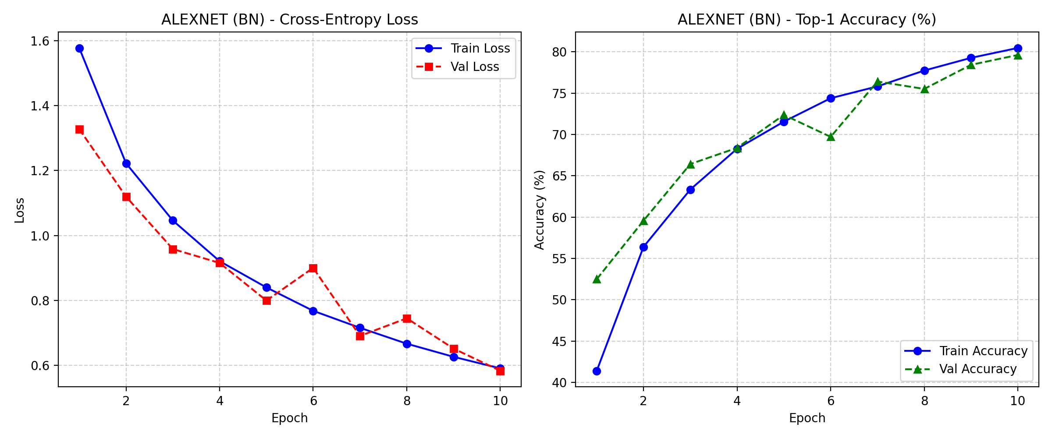
Figure 4: loss_alexnet_lrn.png

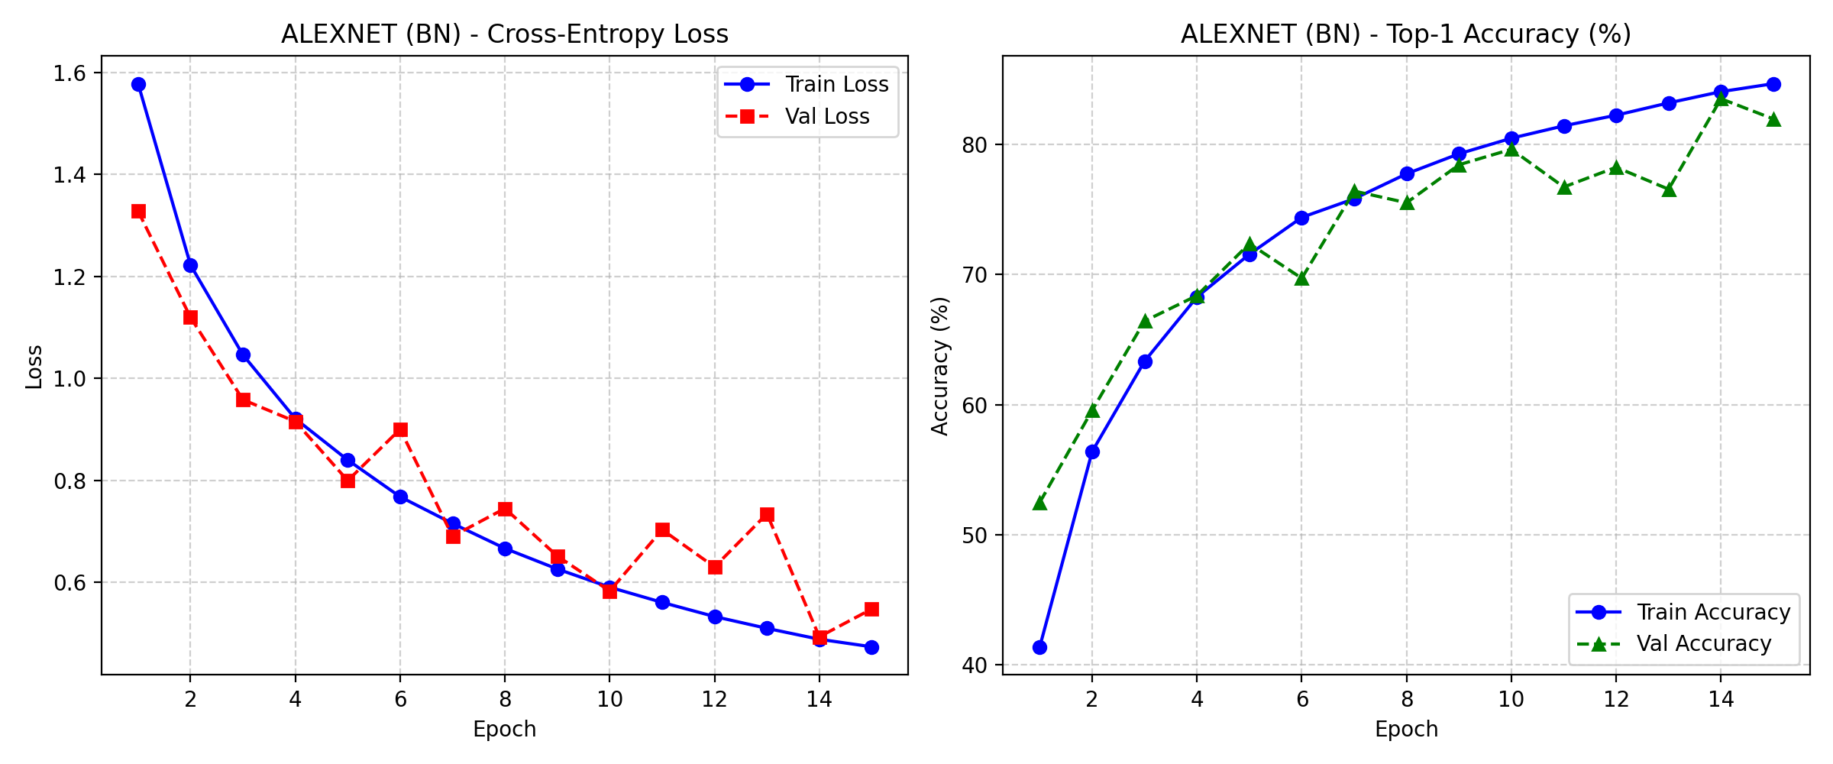
Figure 5: loss_alexnet_bn.png

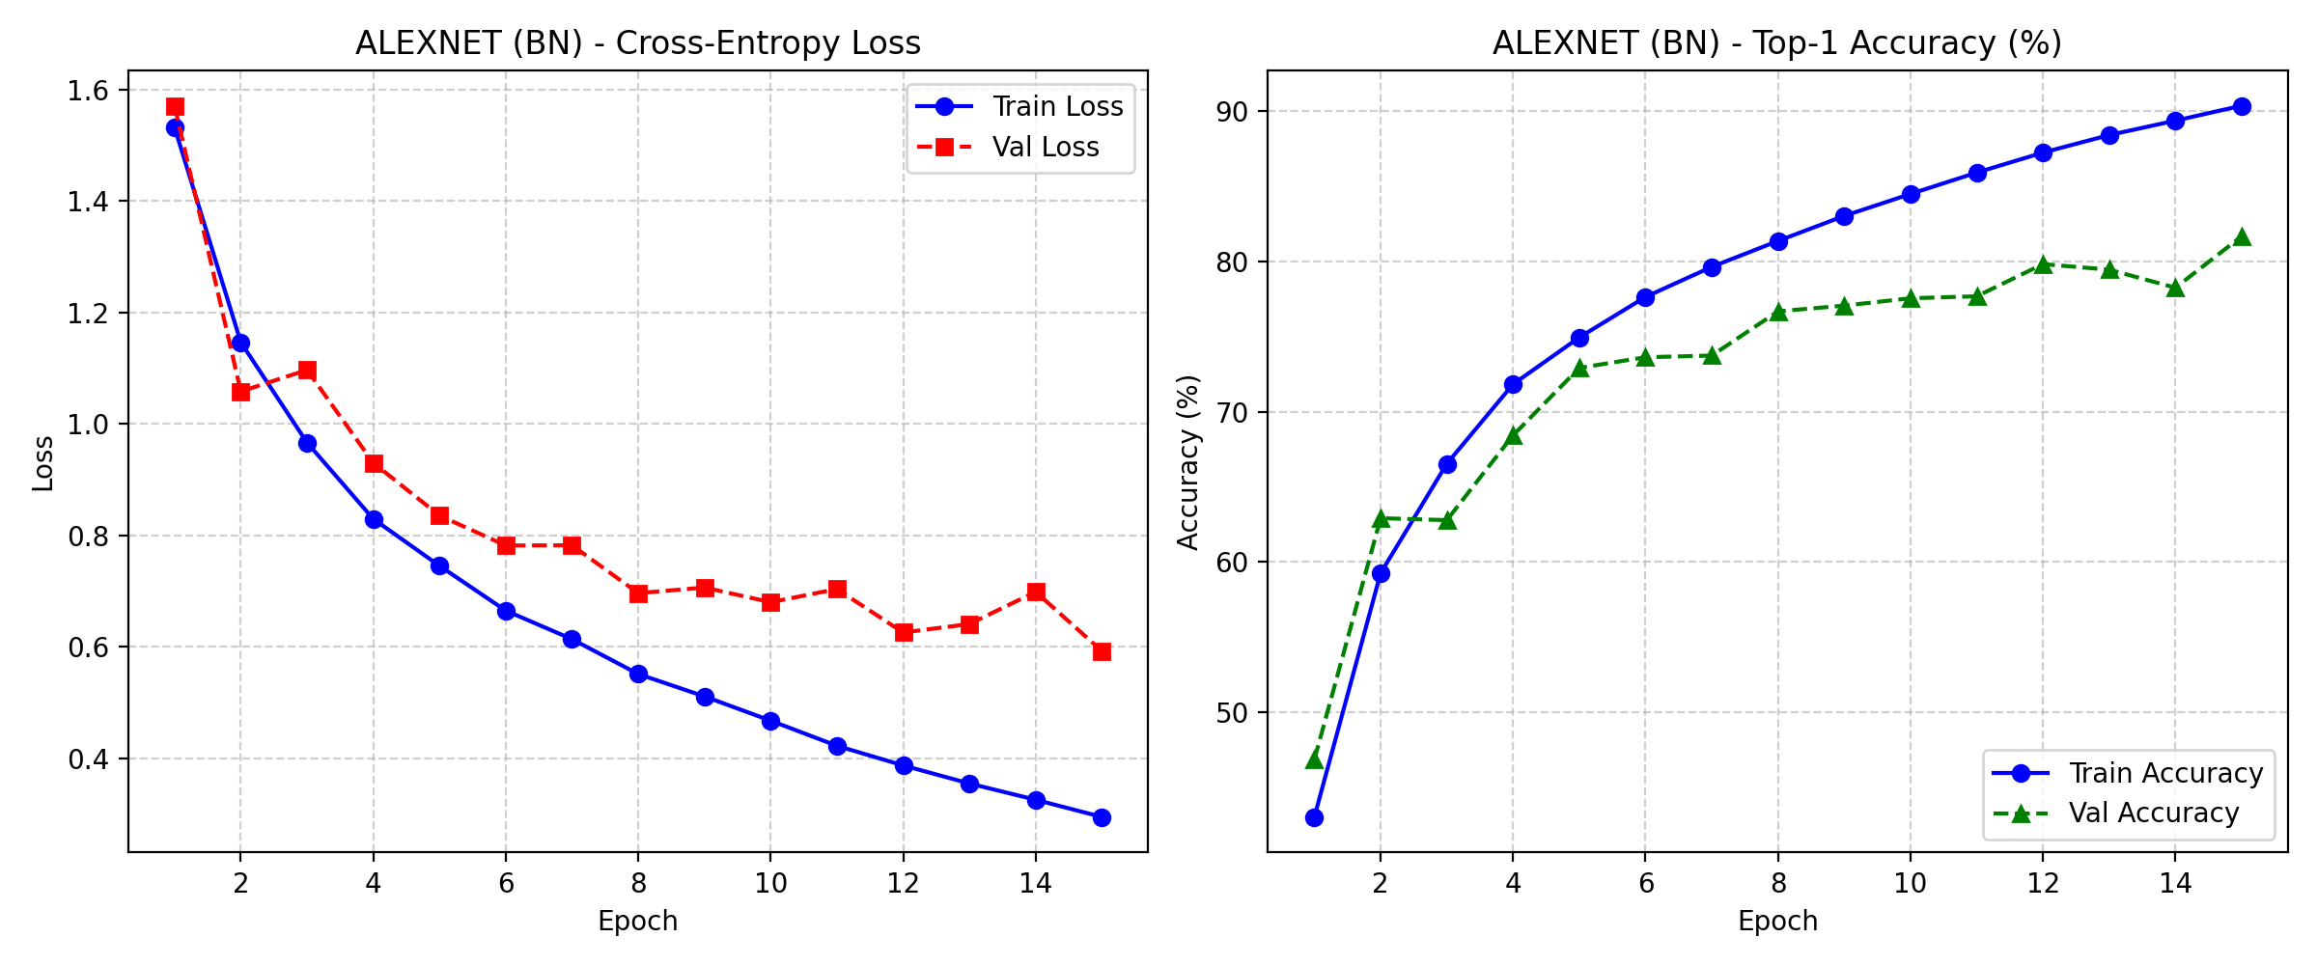
Figure 6: loss_no_aug.png

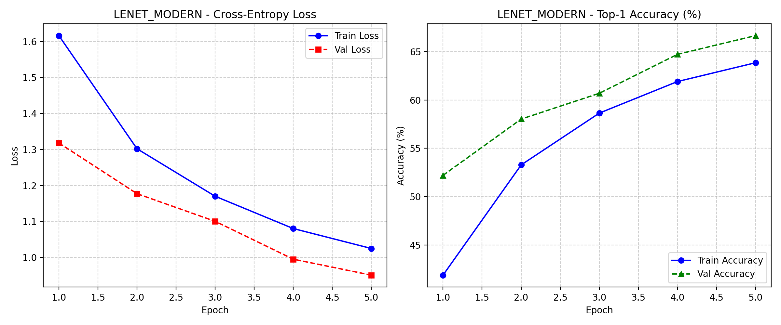
Figure 7: loss_with_aug.png

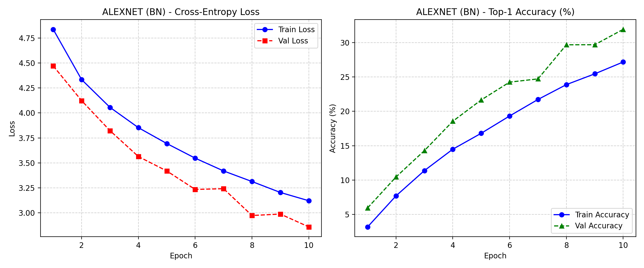
Figure 8: loss_tiny_imagenet.pn
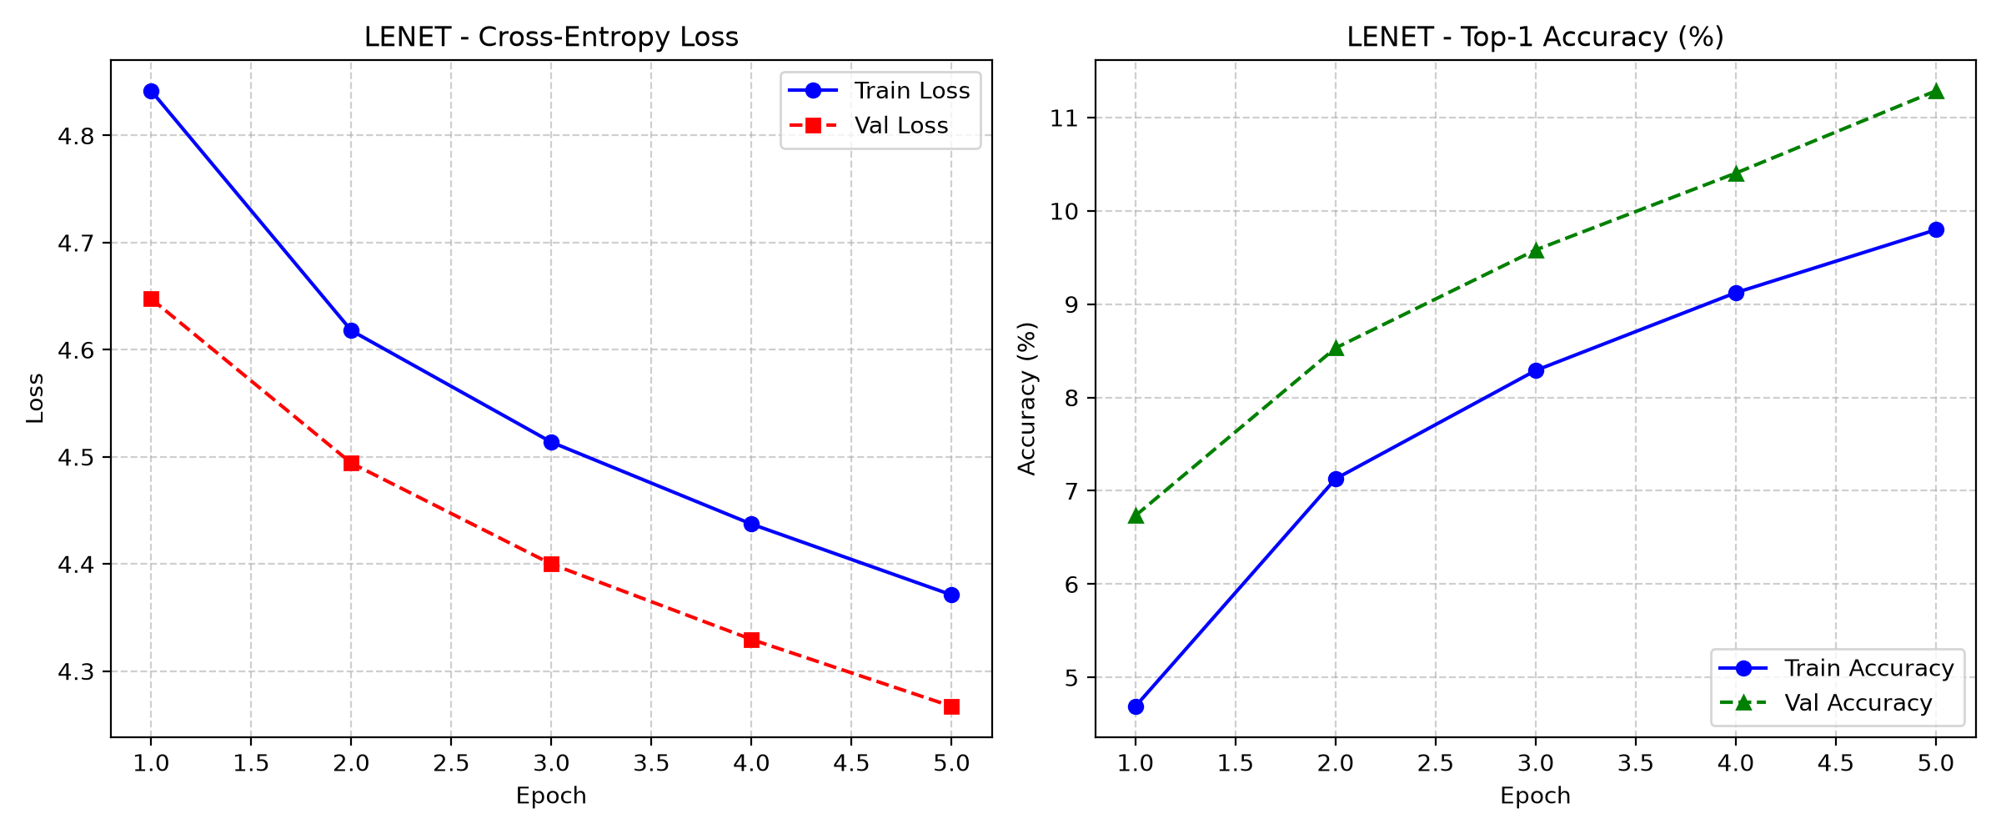
Figure 9: loss_lenet_tiny.png

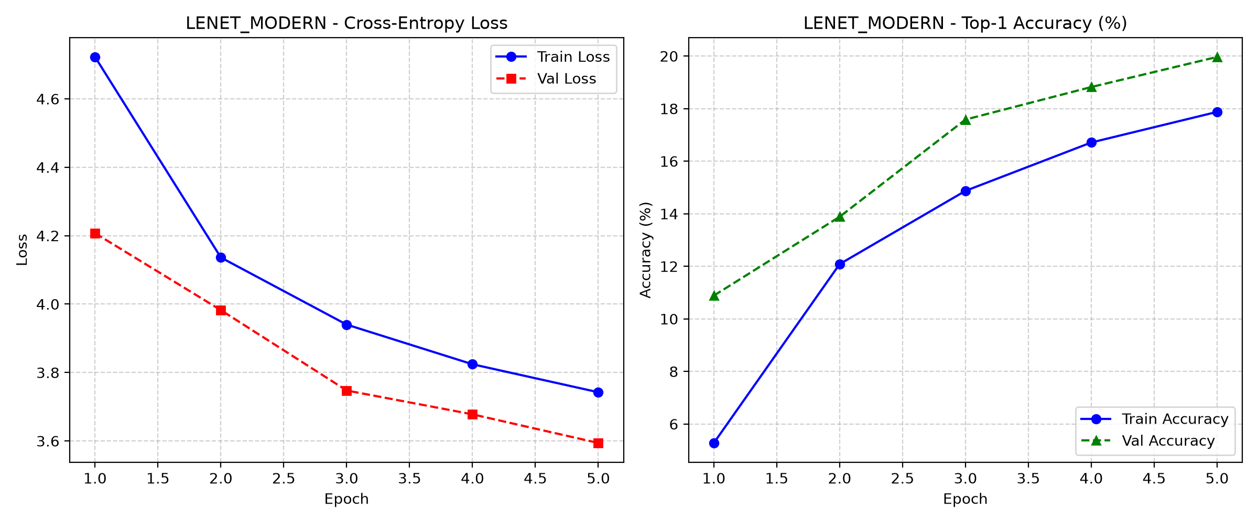
Figure 10: loss_lenet_modern_tiny.png

