University of Macau
Faculty of Science and Technology
Department of Computer and Information Science


CISC3014
Information Retrieval and Web Search
Movie Recommendation System
by
Group 5 - TTK
CHU KA SENG, DB926473
TAM HOI CHON, DB925542
CHE CHI HANG, DB926533
02/12/2021

Table of contents
1 Project description 3
2 Algorithm 4
2.1 Recommender system 4
2.1.1 Collaborative Filtering 5
2.2 Top Rank 250 6
2.2.1 Wilson Score 7
2.2.2 Bayesian average 8
3 Comparison 10
4 Discussion 12
4.1 Pros and Cons of the Collaborative Filtering 12
4.2 USER-USER vs ITEM-ITEM 12
4.3 Bayesian average problem 12
5 User Interface 13
5.1 Application 13
5.2 Web page 14
6 Conclusion 16
6.1 Difficulties and constraints 16
6.2 Future plan 16

Project description
During the COVID-19 outbreaks, most of us are having more time staying at home compare to the past, watching movies has become one of the popular ways to have leisure time at home. In this project, we are going to develop a system to recommend movies to the users, where the user can access the website of our system, log in to their accounts, and recommend them movies according to their ratings on each movie.

Dataset
To be started, we have found a dataset from IMDb, the dataset includes 668 users rating some of the movies from 10329 movies, the rating is from 0 to 5 score, in step 0.5. The dataset is an important data to recommend movies to the user, the recommendation algorithm would be explained in the following sections.

Outcome
The movies would be recommended in two ways, one is the “Today’s recommendation”, where all user’s ratings would be combined to recommend users’ movies, not recommend in a way that fits the user’s favor individually. While the second one is the “Movies recommended for you” which is specialized for each user, to recommend them movies according to their favor, users can also categorize the movies by genres to see the outcome.

Algorithm

Recommender system
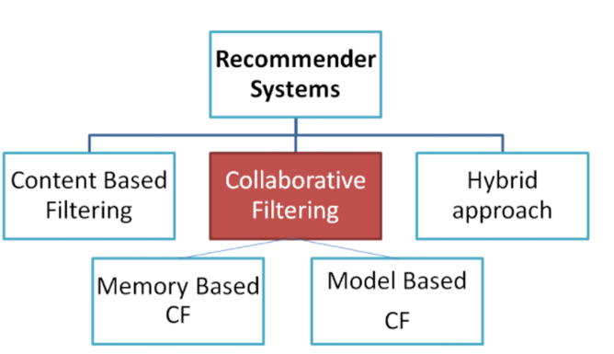
There are many methods to implement the Recommender System, which can be divided into 3 types, Content Based Filtering, Collaborative Filtering, and Hybrid approach.
Content-Based Filtering: Based on the content of items to find out the similarity to recommend to the users, for example in the movie recommender system, it will base on the crew of the movie, director, artist, genres to calculate the similarity.
Collaborative Filtering: Collecting the opinions of everyone, finding the most similar customers or finding the most related products, and then recommending the products. According to the analysis method, it is divided into two kinds, Memory Based CF and Model-Based CF.
Memory Based CF: Based on the history or previous record to predict the similarity item to recommend to the user, it needs a lot of data to implement it, when the dataset is small, this method is not recommended.
Model Based CF: Use various machine learning, deep learning (Deep Learning, RL), or reinforcement learning (Reinforcement learning, DL) algorithms to build a recommendation system, it can reduce the matrix calculation between the Memory Based CF, it means that can save more time.
Hybrid approach: This method is jointed Content-Based Filtering and Collaborative Filtering to build up the recommended system.

In our system, we would choose Collaborative Filtering, it is because our dataset is about user rating in each movie, it is not capable of using Content-Based Filtering. Moreover, we have over 100,000 records of data in our dataset, so we can choose the Memory Based CF to have a better prediction.

2.1.1 Collaborative Filtering
In Collaborative Filtering, it needs to gather everyone’s idea to recommend the items and it also has two different methods to implement, which are User-User and Item-Item CF.

User-User CF: Group the users into different similar customer groups (USER-USER Similarity Matrix), view the products they often buy, and recommend them to the new customers, such as based on the user interests, jobs, habits to find which is similar with him and recommend items with the similar user interests. However, in a large system, it may have a vast number of users (over 10 million), then the matrix is exponentially large, about 10 million multiply 10 million, and needs a very long time to calculate the similarity matrix. Therefore, we will choose another method which is Item-Item CF.
Item-Item CF: Find out the product group (ITEM-ITEM Similarity Matrix) that is the most similar to the product currently browsed, and recommend it to users. For instance, when a user buys lipstick and perfume, then the system may recommend the makeup product to him, this method is suitable for the system when there are a lot of users.

Therefore, we would choose the Item-Item CF in our system, it is because in a real movie recommender system the number of users must greater than movies 1000 times, so we choose this method to be more suitable in a real situation.

After we have built up the item-item matrix, we need to calculate the similarity matrix, there are 3 common methods, Jaccard similarity, Pearson similarity, and cosine similarity. We mainly focus on the cosine similarity; it is the most widely used method. We consider each column or column in the matrix as a vector and calculate their similarity value two by two. For Cosine Similarity, when cos θ =1, which means the angle=0°, then the two would be the most similar. Oppositely, when cos θ=-1, it means the angle=180°, then the two are the most different.

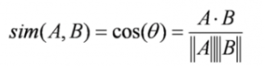

When we have calculated the similarity matrix, we can calculate the rating of the recommended movie. By using the similarity matrix to calculate the rating of the user’s unwatched movies, it will refer to the neighborhood items when the nearest neighborhood has more power to dominate the rating.
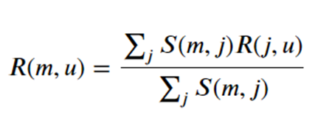
- In this formula, 𝑅 (m, u) is the rating for movie m by user u
- S (m, j) is the similarity between movie 𝑚 and movie j
- j∈ J where J is the set of the similar movies to movie 𝑚

Top Rank 250
When recommending movies to new users, there is a lack of historical records from the user. In this case, collaborative filtering will not be able to carry out effective movie recommendations. Therefore, new users will use the Top-ranking movies for a recommendation, by using the existing data from other users in the database to sort ranking through algorithms. This enables new users to quickly find high-quality movies, but it does not guarantee that the movies recommended from the Top-ranking movies suit his favor. Therefore, if the new users would like to have an individual recommended movie list, they should rate the movies to provide sufficient data for collaborative filtering to be used.

For old users, long-term use of the collaborative filtering system may narrow down the types of movies the system recommends, the system might overlook the movies that users may like. The Top-ranking provides a way for old users to explore other new genres or currently popular movies so that the user's data set can be continuously updated in diversity, which balances the side effect of collaborative filtering.

In this project, we have considered two sorting algorithms, which are Wilson interval and Bayesian average. We will compare these two algorithms and analyze their pros and cons.

Wilson Score
When ranking, the number of samples is especially important. If the number of samples is large enough, then the score would be more reliable, but if the number of samples is too small, even if the average score of that movie is high, the score would be unreliable due to the few reviews done to the movie. We need to use some algorithms to solve the unfairness caused by different sample sizes. Therefore, the Wilson Score will solve this problem.

Wilson Score is based on the binomial distribution. Since the normal interval is not reliable for small samples, the American mathematician Edwin Bidwell Wilson proposed a correction formula called "Wilson interval" in 1927, which solved the accuracy problem of small samples.

The Wilson interval method has the following presuppositions:
- The scoring of each user is an independent event.
- The user has only two choices, either vote like or vote dislike.
- If the total number of people is n and the likes are k, then the ratio p of likes is equal to k/n.

Based on this method, only binary input is accepted with like and dislike, so we need to consider how to convert the score into binary. The system uses the middle value of the user's maximum and minimum values for discrimination. If it is greater than or equal to the middle value, it means he likes the movie, otherwise, he does not like the movie. This method is based on a large number of movies that the user has watched, as the dataset of the old users is large enough to estimate, this method can distinguish whether the users like and dislike the movie.

Wilson Score formula:
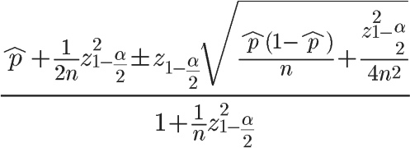
When the value of n is large enough, this lower limit will tend to $\hat{p}$. If n is extremely small (few voters), this lower limit will be much smaller than $\hat{p}$. In fact, this formula has the effect of reducing the "voting ratio" and lowering the score and ranking of the project.

To be simplified, it can get Wilson Score based on the following formula:
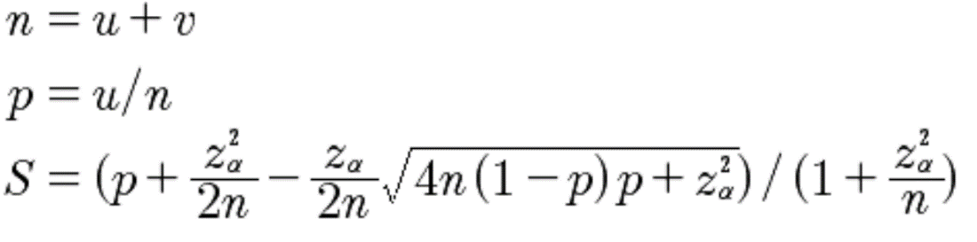
u: The number of positive, that means how many people like this movie
v: The number of positive, that means how many people dislike this movie
n: Total votes, that means how many people vote for this movie
p: Favorable(positive) rate
z: Confidence 95%, by checking the Normal distribution table, z is 1.96
S: Wilson score

However, the drawback of the Wilson Score algorithm is that it is not fair to unpopular movies, if the movies have only a few votes, Wilson Score will give a lower score.

Bayesian average
Therefore, we consider using another algorithm, which is the Bayesian average. Bayesian average is the method that IMDB used to do movie ranking. Bayesian averaging provides compensation values for unpopular movies to prevent unreliable ratings due to a small number of ratings by adding a certain amount of exposure to each movie. As the number of rating increases, the score will approach an actual value. Firstly, the result of the votes is unknown, so a value would be estimated, then constantly revise with new information to approach the final result.

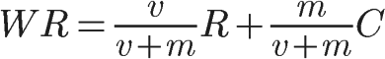

v: Represents the actual number of views of the movies.
m: Minimum number of votes for the movies.
R: Average score for this movie.
C: The average score of all movies.
WR: weighted rating

$\frac{m}{v+m}$ is a small value in the formula. When the number of voters continues to increase, the proportion of $\frac{v}{v+m}$ will become larger and larger, and the score will be closer to the real situation.

To be concluded, the Bayesian ranking is more reflective of the actual situation, a movie with more votes and higher scores will have a higher rank, and movies with lower scores would have a lower rank. Compare with the ranking method of only ranking them based on the mean votes of each movie, Bayesian ranking will get a more reliable result.

Comparison
Crawling IMDb
We need to verify which results from the two methods are relatively correct, so we use a web crawler method to crawl the content of the top250 movie page of IMDb and compare it with our results. Since our data set is not updated and incomplete, it is not possible to obtain similar results. Therefore, it is necessary to calculate the ranking deviation value of each movie, to estimate which method is more reasonable from the overall phase.
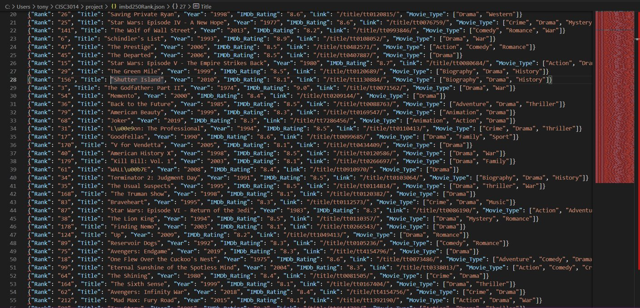

Wilson Score and Bayesian average
First, find out our result from the two methods used and the result from IMDb according to the ID of each movie, take the difference of ranking and then take the absolute value, we can get the ranking deviation value of movies. To facilitate the evaluation, we will sort the deviation values from low to high. So, we can get the following results on the graph below.

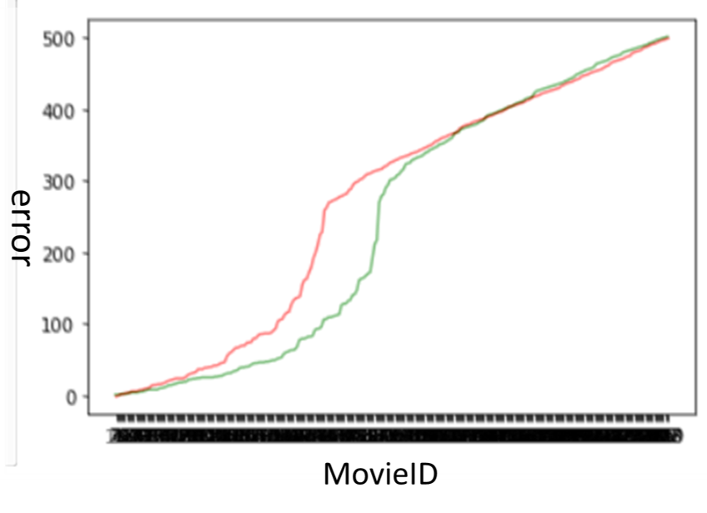
- Red: Wilson Score
- Green: Bayesian average

In the above figure, it can be found that the deviation of the Bayesian average in a certain interval (error = 10-400) is significantly lower than the Wilson Score, so it can be concluded that the Bayesian average is more accurate to be used for this data set.

Runtime
Wilson Score’s runtime is 1046.44 seconds (about 17 and a half minutes)
Bayesian average’s runtime is 256.45 seconds (about 4 and a half minutes)
By comparing the runtime, Wilson Score’s runtime is longer than the Bayesian average, since Wilson Score needs to convert the score into binary in each movie which takes a longer time.

Discussion

Pros and Cons of the Collaborative Filtering
Pros
- Work on any kind of data - It can run without the feature of items, so it can use in various items not only for the movie.
- More credible – It is because the system gathers all users' opinions and used their data to predict results, so the results are referenced to all users’ opinions.

Cons
- Cold Start - At the beginning of the system, there was no relevant historical data, or when the new product was first launched, there was no record of purchase or comment. Currently, there is no way to calculate it.
- Not always suitable to the user - It is because, in the system, it cannot recommend some unique items to the users, it always recommends the popular items to the user.
- Not instant - It is because the system needs a lot of time to recalculate the recommended item, when some new rating appeared it cannot instantly use it and put it in a recommender system.

USER-USER vs ITEM-ITEM
For user-user CF and item-item CF, besides the time consumption difference, also the recommend list also has some differences in recommending items.
USER-USER: it always recommends items used by the most users, so hot items are often recommended
ITEM-ITEM: Long-tail items are easier to be recommended (the number of views is not large, but people keep browsing it), which will have a benefit to the system's overall views.

Bayesian average problem
The scores obtained by the Bayesian average may give the same result for the different standard deviations of the voting data. For example, if there are 10 votes, 5 people vote one point, and 5 people vote ten points, this compares with another case that ten people vote 5 points, would bring the same result.

User Interface

Application
We have made an application with a PC to implement a recommendation system, the application UI of the system can be referred from CISC3014-UI.ipynb, it is using python library – Pyqt5 to implement it.
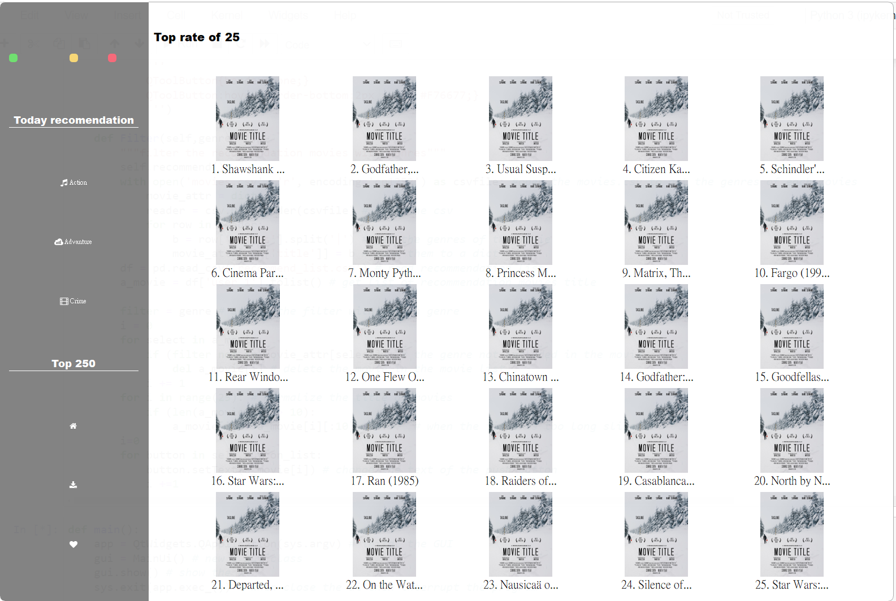
Figure 1 - Home page of the Application
The home page is for viewing the top 25 ranks of movies from the Top_250 rank.csv.
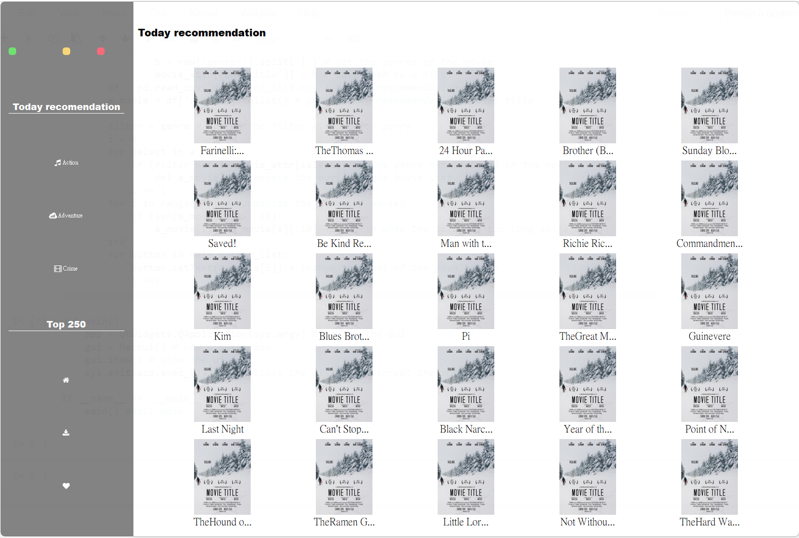
Figure 2 - Movies recommended for a particular user after login
For demonstration, we assume that we have logged in with user 1. In this page, it shows the 25 recommended movies by clicking the “Today recommendation” button on the left side of the screen. Users can also choose some specific genres under the “Today recommendation” button by clicking them, the 25 recommended movies with the clicked genre will be shown.

Web page
As the user of our system is everyone, we decided to make a web page to implement the recommendation system so that every user online can use our system, the web page UI of the system can be referred from the file “index.html” attached.
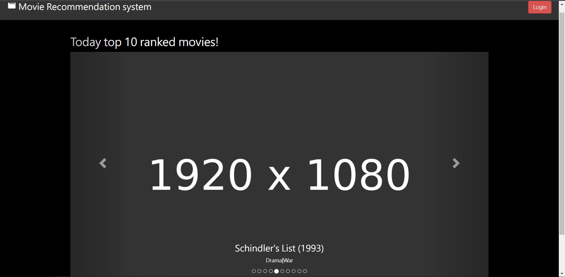
Figure 3 - Home page of the website
Like a normal website, we would like to show the user the “Today’s recommendation” at their first glance on the home page. Although we have generated the top 250 ranked movies, we would only show 10 of them in the carousel. An image placeholder is used instead of the movie picture as we did not get the right to use it on our web page. The movie’s name, published year with its genre would be shown at the bottom part of the carousel.
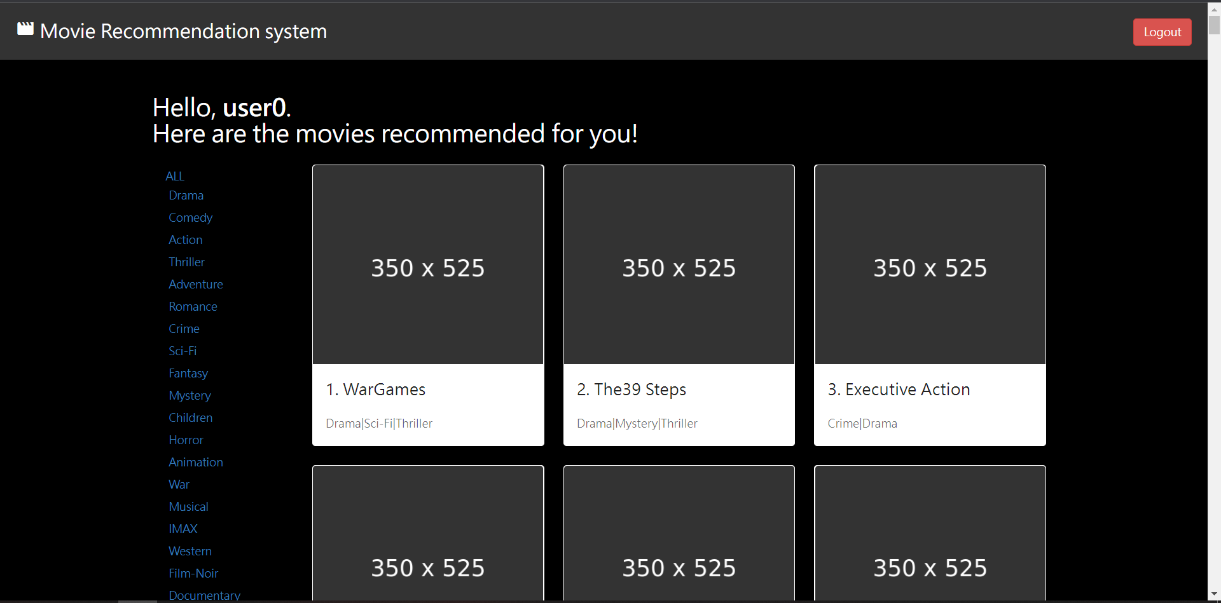
Figure 4 - Movies recommended for a particular user after login
The outcome of the recommended movies for a particular user would be shown after the user login to the system by clicking “Login” at the upper-right corner. For demonstration, only the username is needed to log in, and the username is in the format “user0”, “user1”, …, “user667”, representing the 668 users where we have collected from the IMDb. The recommended 250 movies of 668 users have been generated in advance and stored in the database, after fetching via the API, the outcome would be shown ordering in its recommending score.
The recommended movies are categorized, by clicking the corresponding genre on the left navigation bar, the user can select the recommended movies grouped by genres. By clicking “ALL” all the 250 recommended movies would be shown without being grouped by genres.

Conclusion

Difficulties and constraints
Weak server
To fulfill the need for an instant result showing to the user, a more powerful server is needed to fetch the movie recommended list database.
Small Dataset
At this stage we only got the data of 668 users, which is insufficient for an accurate prediction of new users, a large dataset is preferable for a more accurate result.
Time-consuming
It takes a long time to generate the results and verify the accuracy of the data, due to a lack of physical equipment of computing units to compute the result in a reasonable time.

Future plan
Due to the time limit, we have only made a demo for the system, at the current stage, it is only used for viewing the 668 users’ recommending movies. In order to have it become a real recommendation system, there are several functions we must accomplish:
- Register as a new user
A new user can create his account after the verification of his email, after that he can rate the movies by searching the movie name.
- Recommend new user movies
According to what the new user has rated on the movies, the system can return the 250 recommended movies to the user by running the python program in the backend, then uploading the result to the database and showing them on the web page.
- Put the system online
To get a domain name, upload the website into the server, and available online for any user in the world.

By implementing the above functions, we can collect the user’s reviews of the movie without relying on other sources, solving the constraints of information collecting. The system can also become a real online movie recommendation system, the recommendation would be more accurate too as the dataset gets larger and larger.

