Nama : Vincent Sirait

NIM : 191402081

Mata Kuliah : Enterprise Development Software

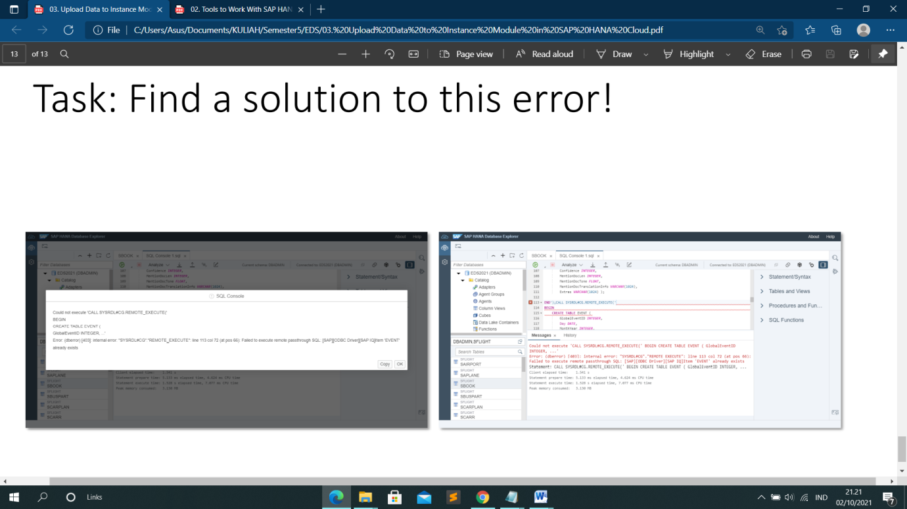**Laporan Tugas II**

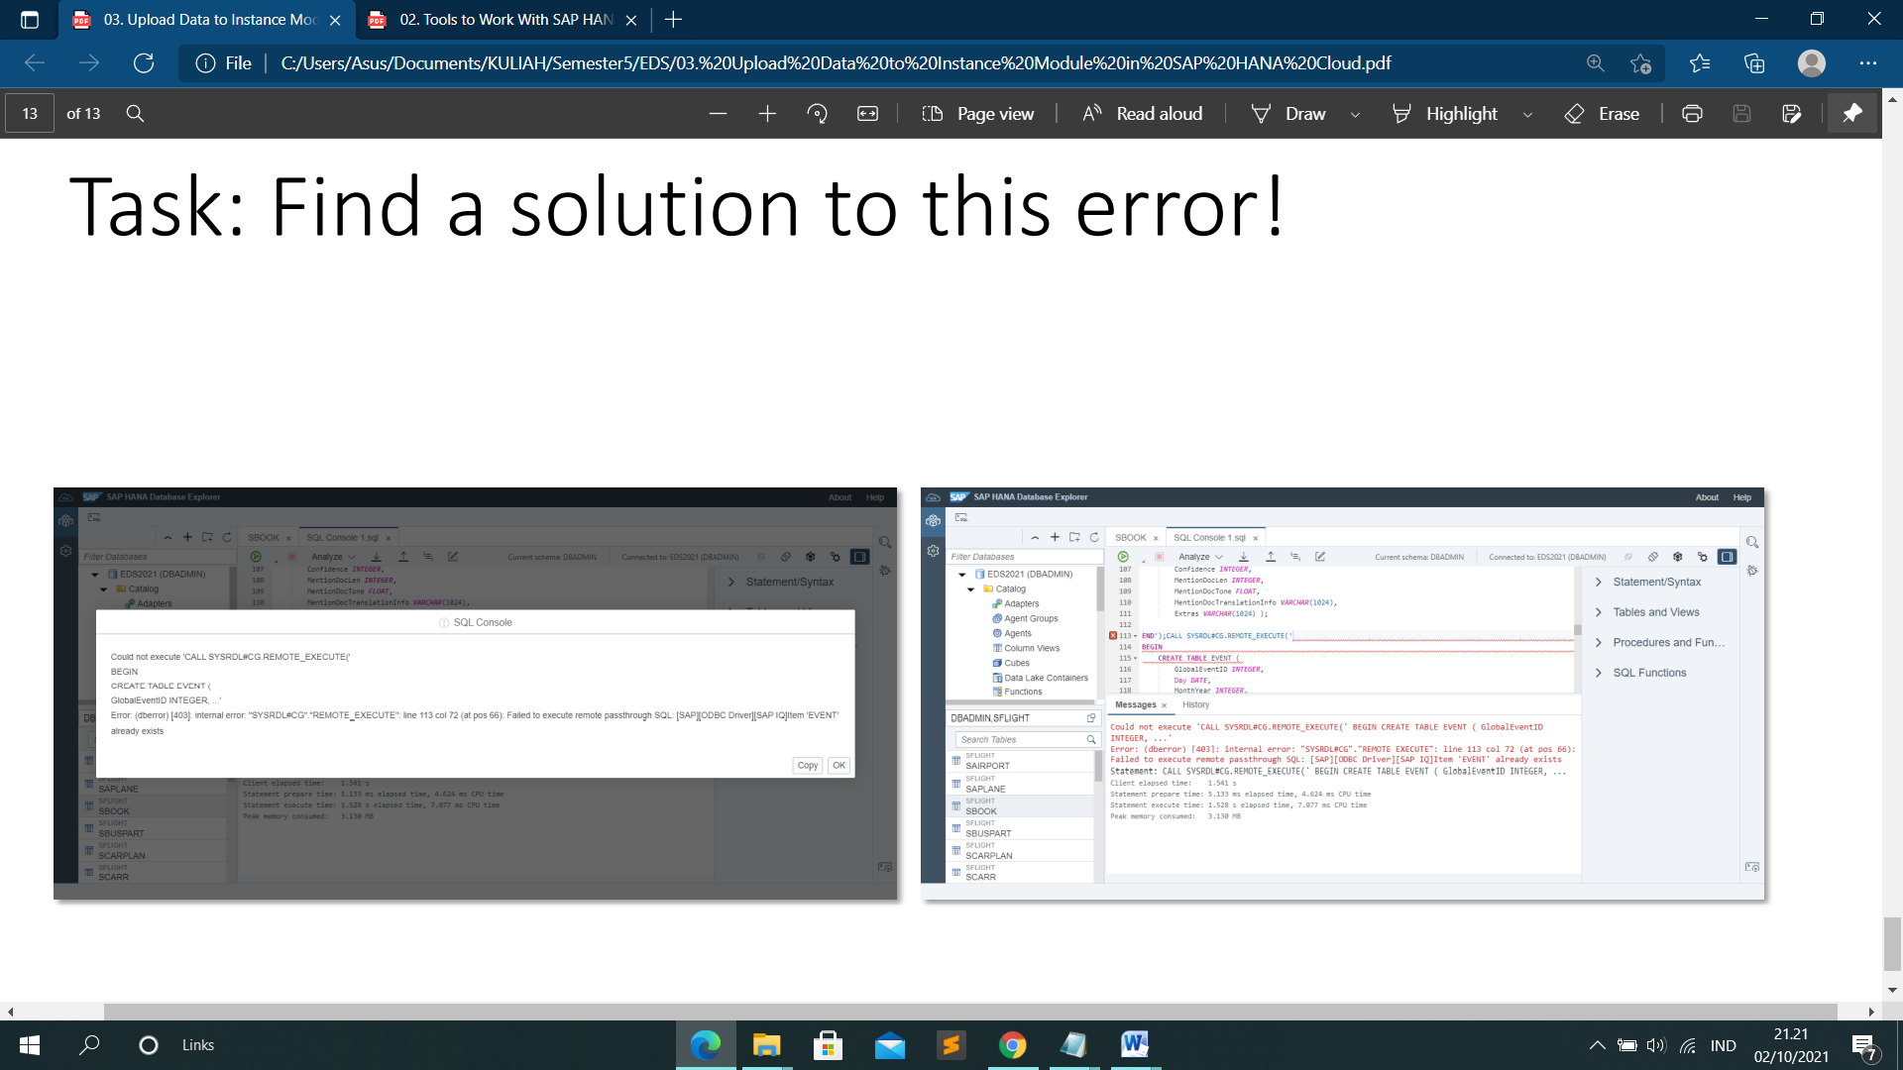

Solusi dalam menyelesaikan masalah tersebut adalah menggunak file sql berisi query sbb:

CALL SYSRDL#CG.REMOTE_EXECUTE('

BEGIN

CREATE TABLE EVENT (

GlobalEventID INTEGER,

Day DATE,

MonthYear INTEGER,

Year INTEGER,

FractionDate FLOAT,

Actor1Code VARCHAR(27),

Actor1Name VARCHAR(1024),

Actor1CountryCode VARCHAR(3),

Actor1KnownGroupCode VARCHAR(3),

Actor1EthnicCode VARCHAR(3),

Actor1Religion1Code VARCHAR(3),

Actor1Religion2Code VARCHAR(3),

Actor1Type1Code VARCHAR(3),

Actor1Type2Code VARCHAR(3),

Actor1Type3Code VARCHAR(3),

Actor2Code VARCHAR(27),

Actor2Name VARCHAR(1024),

Actor2CountryCode VARCHAR(3),

Actor2KnownGroupCode VARCHAR(3),

Actor2EthnicCode VARCHAR(3),

Actor2Religion1Code VARCHAR(3),

Actor2Religion2Code VARCHAR(3),

Actor2Type1Code VARCHAR(3),

Actor2Type2Code VARCHAR(3),

Actor2Type3Code VARCHAR(3),

IsRootEvent INTEGER,

EventCode VARCHAR(4),

EventBaseCode VARCHAR(4),

EventRootCode VARCHAR(4),

QuadClass INTEGER,

GoldsteinScale FLOAT,

NumMentions INTEGER,

NumSources INTEGER,

NumArticles INTEGER,

AvgTone FLOAT,

Actor1Geo_Type INTEGER,

Actor1Geo_FullName VARCHAR(120),

Actor1Geo_CountryCode VARCHAR(2),

Actor1Geo_ADM1Code VARCHAR(4),

Actor1Geo_ADM2Code VARCHAR(64),

Actor1Geo_Lat FLOAT,

Actor1Geo_Long FLOAT,

Actor1Geo_FeatureID VARCHAR(10),

Actor2Geo_Type INTEGER,

Actor2Geo_FullName VARCHAR(120),

Actor2Geo_CountryCode VARCHAR(2),

Actor2Geo_ADM1Code VARCHAR(4),

Actor2Geo_ADM2Code VARCHAR(64),

Actor2Geo_Lat FLOAT,

Actor2Geo_Long FLOAT,

Actor2Geo_FeatureID VARCHAR(10),

ActionGeo_Type INTEGER,

ActionGeo_FullName VARCHAR(120),

ActionGeo_CountryCode VARCHAR(2),

ActionGeo_ADM1Code VARCHAR(4),

ActionGeo_ADM2Code VARCHAR(64),

ActionGeo_Lat FLOAT,

ActionGeo_Long FLOAT,

ActionGeo_FeatureID VARCHAR(10),

DateAdded DATETIME,

SourceUrl VARCHAR(1024) );

CREATE TABLE GKG (

GKGRecordId VARCHAR(24),

DateAdded DATETIME,

SourceCollectionIdentifier INTEGER,

SourceCommonName VARCHAR(1024),

DocumentIdentifier VARCHAR(1024),

V1Counts TEXT,

V2Counts TEXT,

V1Themes TEXT,

V2EnhancedThemes TEXT,

V1Locations TEXT,

V2EnhancedLocations TEXT,

V1Persons TEXT,

V2EnhancedPersons TEXT,

V1Organizations TEXT,

V2EnhancedOrganizations TEXT,

V2Tone TEXT,

EnhancedDates TEXT,

GCAM TEXT,

SharingImage TEXT,

RelatedImages TEXT,

SocialImageEmbeds TEXT,

SocialVideoEmbeds TEXT,

Quotations TEXT,

AllNames TEXT,

Amounts TEXT,

TranslationInfo TEXT,

ExtrasXML TEXT );

CREATE TABLE MENTIONS (

GlobalEventID INTEGER,

EventTimeDate DATETIME,

MentionTimeDate DATETIME,

MentionType INTEGER,

MentionSourceName VARCHAR(1024),

MentionIdentifier VARCHAR(1024),

SentenceID INTEGER,

Actor1CharOffset INTEGER,

Actor2CharOffset INTEGER,

ActionCharOffset INTEGER,

InRawText INTEGER,

Confidence INTEGER,

MentionDocLen INTEGER,

MentionDocTone FLOAT,

MentionDocTranslationInfo VARCHAR(1024),

Extras VARCHAR(1024) );

Jika berhasil maka akan muncul tampilan sebagai berikut :

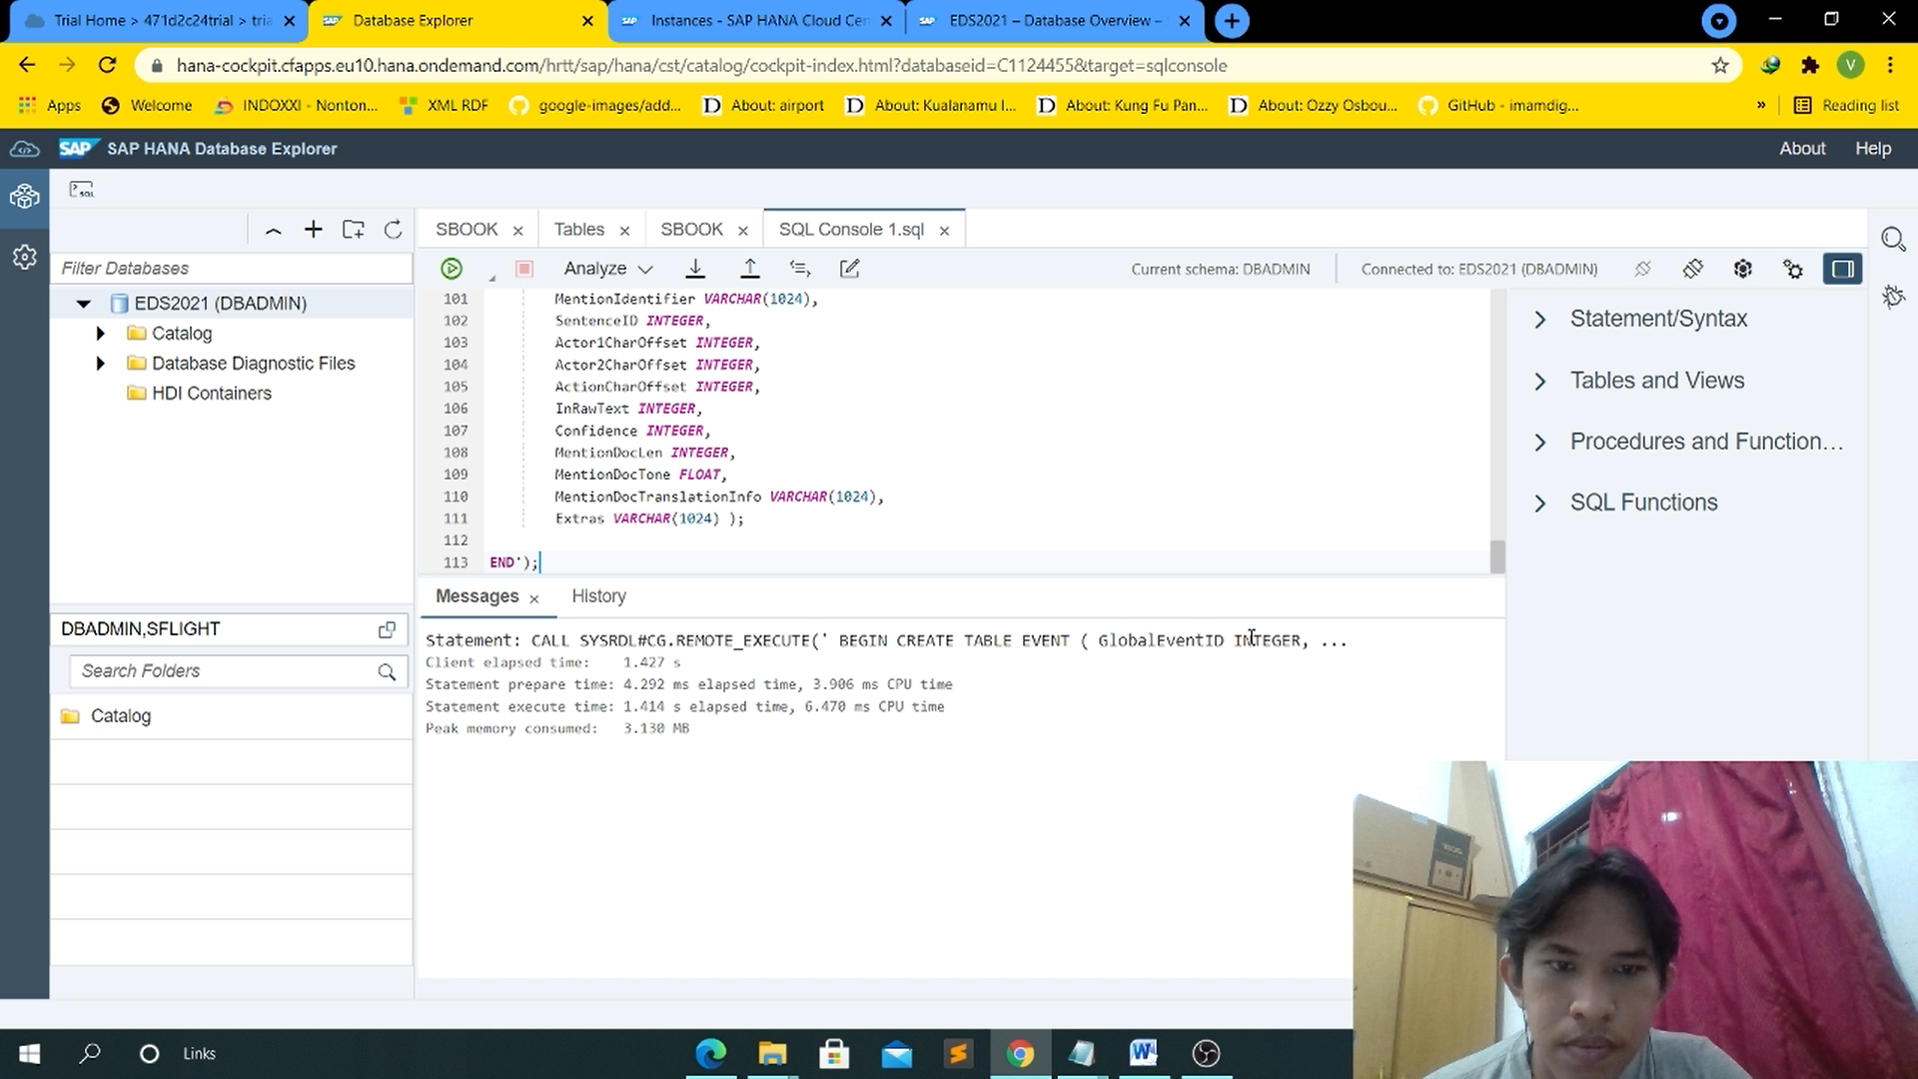

Penyebab query tersebut dapat gagal adalah karena memasukkan query tersebut dua kali ataupun berulang karena akan memunculkan error kalu query tersebut telah di gunakan seperti berikut :

