Puter Computer Vision HW2 Report
Student ID: B11901123
Name: 張甡源

Part 1. (10%)
• Plot confusion matrix of two settings. (i.e. Bag of sift and tiny image) (5%)
Ans:
Tiny image | 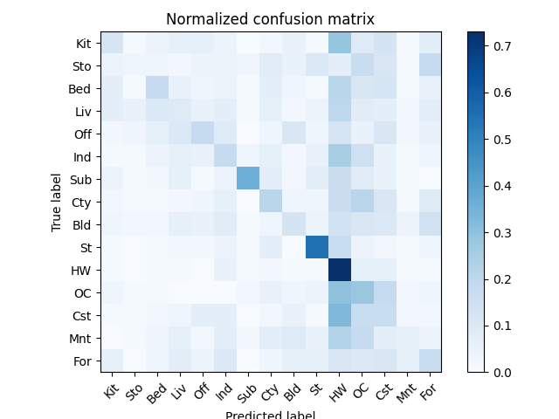
Bag of sift | 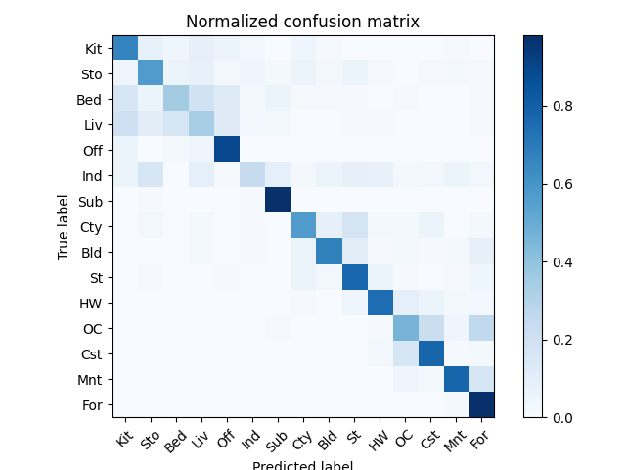

• Compare the results/accuracy of both settings and explain the result. (5%)
Ans:
Accuracy
Tiny image | 0.22
Bag of sift | 0.65

- Tiny Image:
  - Just resizes images to 16×16 and flattens them into a vector.
  - Ignores important spatial and local features.
  - Low accuracy because it captures very little semantic content.
- Bag of SIFT:
  - Extracts local keypoint descriptors (SIFT) that are invariant to scale and rotation.
  - Builds a visual vocabulary and represents images as histograms over that vocabulary (like word counts).
  - More robust to variations and captures distinctive patterns, improving classification.
Bag of SIFT significantly outperforms Tiny Image because it captures meaningful and local patterns in the image, while Tiny Image is too simplistic and loses vital information through aggressive downsampling.
Part 2. (25%)
• Report accuracy of both models on the validation set. (2%)
Ans:
 | ResNet18 | MyNet
Val accuracy | 0.90660 | 0.86260

• Print the network architecture & number of parameters of both models. What is the main difference between ResNet and other CNN architectures? (5%)
Ans:
1. ResNet18: a deeper, pretrained 18-layer architecture with skip connections, optimized for general image tasks, and adapted for CIFAR-10 with a modified first layer.
2. MyNet: a shallower, custom-built CNN with three residual blocks, designed specifically for CIFAR-10, with fewer parameters and simpler structure.

1. ResNet:
ResNet18(
(resnet): ResNet(
(conv1): Conv2d(3, 64, kernel_size=(3, 3), stride=(1, 1), padding=(1, 1), bias=False)
(bn1): BatchNorm2d(64, eps=1e-05, momentum=0.1, affine=True, track_running_stats=True)
(relu): ReLU(inplace=True)
(maxpool): Identity()
(layer1): Sequential(
(0): BasicBlock(
(conv1): Conv2d(64, 64, kernel_size=(3, 3), stride=(1, 1), padding=(1, 1), bias=False)
(bn1): BatchNorm2d(64, eps=1e-05, momentum=0.1, affine=True, track_running_stats=True)
(relu): ReLU(inplace=True)
(conv2): Conv2d(64, 64, kernel_size=(3, 3), stride=(1, 1), padding=(1, 1), bias=False)
(bn2): BatchNorm2d(64, eps=1e-05, momentum=0.1, affine=True, track_running_stats=True)
)
(1): BasicBlock(
(conv1): Conv2d(64, 64, kernel_size=(3, 3), stride=(1, 1), padding=(1, 1), bias=False)
(bn1): BatchNorm2d(64, eps=1e-05, momentum=0.1, affine=True, track_running_stats=True)
(relu): ReLU(inplace=True)
(conv2): Conv2d(64, 64, kernel_size=(3, 3), stride=(1, 1), padding=(1, 1), bias=False)
(bn2): BatchNorm2d(64, eps=1e-05, momentum=0.1, affine=True, track_running_stats=True)
)
)
(layer2): Sequential(
(0): BasicBlock(
(conv1): Conv2d(64, 128, kernel_size=(3, 3), stride=(2, 2), padding=(1, 1), bias=False)
(bn1): BatchNorm2d(128, eps=1e-05, momentum=0.1, affine=True, track_running_stats=True)
(relu): ReLU(inplace=True)
(conv2): Conv2d(128, 128, kernel_size=(3, 3), stride=(1, 1), padding=(1, 1), bias=False)
(bn2): BatchNorm2d(128, eps=1e-05, momentum=0.1, affine=True, track_running_stats=True)
(downsample): Sequential(
(0): Conv2d(64, 128, kernel_size=(1, 1), stride=(2, 2), bias=False)
(1): BatchNorm2d(128, eps=1e-05, momentum=0.1, affine=True, track_running_stats=True)
)
)
(1): BasicBlock(
(conv1): Conv2d(128, 128, kernel_size=(3, 3), stride=(1, 1), padding=(1, 1), bias=False)
(bn1): BatchNorm2d(128, eps=1e-05, momentum=0.1, affine=True, track_running_stats=True)
(relu): ReLU(inplace=True)
(conv2): Conv2d(128, 128, kernel_size=(3, 3), stride=(1, 1), padding=(1, 1), bias=False)
(bn2): BatchNorm2d(128, eps=1e-05, momentum=0.1, affine=True, track_running_stats=True)
)
)
(layer3): Sequential(
(0): BasicBlock(
(conv1): Conv2d(128, 256, kernel_size=(3, 3), stride=(2, 2), padding=(1, 1), bias=False)
(bn1): BatchNorm2d(256, eps=1e-05, momentum=0.1, affine=True, track_running_stats=True)
(relu): ReLU(inplace=True)
(conv2): Conv2d(256, 256, kernel_size=(3, 3), stride=(1, 1), padding=(1, 1), bias=False)
(bn2): BatchNorm2d(256, eps=1e-05, momentum=0.1, affine=True, track_running_stats=True)
(downsample): Sequential(
(0): Conv2d(128, 256, kernel_size=(1, 1), stride=(2, 2), bias=False)
(1): BatchNorm2d(256, eps=1e-05, momentum=0.1, affine=True, track_running_stats=True)
)
)
(1): BasicBlock(
(conv1): Conv2d(256, 256, kernel_size=(3, 3), stride=(1, 1), padding=(1, 1), bias=False)
(bn1): BatchNorm2d(256, eps=1e-05, momentum=0.1, affine=True, track_running_stats=True)
(relu): ReLU(inplace=True)
(conv2): Conv2d(256, 256, kernel_size=(3, 3), stride=(1, 1), padding=(1, 1), bias=False)
(bn2): BatchNorm2d(256, eps=1e-05, momentum=0.1, affine=True, track_running_stats=True)
)
)
(layer4): Sequential(
(0): BasicBlock(
(conv1): Conv2d(256, 512, kernel_size=(3, 3), stride=(2, 2), padding=(1, 1), bias=False)
(bn1): BatchNorm2d(512, eps=1e-05, momentum=0.1, affine=True, track_running_stats=True)
(relu): ReLU(inplace=True)
(conv2): Conv2d(512, 512, kernel_size=(3, 3), stride=(1, 1), padding=(1, 1), bias=False)
(bn2): BatchNorm2d(512, eps=1e-05, momentum=0.1, affine=True, track_running_stats=True)
(downsample): Sequential(
(0): Conv2d(256, 512, kernel_size=(1, 1), stride=(2, 2), bias=False)
(1): BatchNorm2d(512, eps=1e-05, momentum=0.1, affine=True, track_running_stats=True)
)
)
(1): BasicBlock(
(conv1): Conv2d(512, 512, kernel_size=(3, 3), stride=(1, 1), padding=(1, 1), bias=False)
(bn1): BatchNorm2d(512, eps=1e-05, momentum=0.1, affine=True, track_running_stats=True)
(relu): ReLU(inplace=True)
(conv2): Conv2d(512, 512, kernel_size=(3, 3), stride=(1, 1), padding=(1, 1), bias=False)
(bn2): BatchNorm2d(512, eps=1e-05, momentum=0.1, affine=True, track_running_stats=True)
)
)
(avgpool): AdaptiveAvgPool2d(output_size=(1, 1))
(fc): Linear(in_features=512, out_features=10, bias=True)
)
)

Total parameters: 11,173,962
Trainable parameters: 11,173,962
Non-trainable parameters: 0

2. Mynet:
MyNet(
(conv_block_1): Sequential(
(0): Conv2d(3, 64, kernel_size=(3, 3), stride=(1, 1), padding=(1, 1))
(1): BatchNorm2d(64, eps=1e-05, momentum=0.1, affine=True, track_running_stats=True)
(2): ReLU()
(3): Conv2d(64, 64, kernel_size=(3, 3), stride=(1, 1), padding=(1, 1))
(4): BatchNorm2d(64, eps=1e-05, momentum=0.1, affine=True, track_running_stats=True)
)
(downsample1): Conv2d(3, 64, kernel_size=(1, 1), stride=(1, 1))
(relu1): ReLU()
(pool1): MaxPool2d(kernel_size=2, stride=2, padding=0, dilation=1, ceil_mode=False)
(conv_block_2): Sequential(
(0): Conv2d(64, 128, kernel_size=(3, 3), stride=(1, 1), padding=(1, 1))
(1): BatchNorm2d(128, eps=1e-05, momentum=0.1, affine=True, track_running_stats=True)
(2): ReLU()
(3): Conv2d(128, 128, kernel_size=(3, 3), stride=(1, 1), padding=(1, 1))
(4): BatchNorm2d(128, eps=1e-05, momentum=0.1, affine=True, track_running_stats=True)
)
(downsample2): Conv2d(64, 128, kernel_size=(1, 1), stride=(1, 1))
(relu2): ReLU()
(pool2): MaxPool2d(kernel_size=2, stride=2, padding=0, dilation=1, ceil_mode=False)
(conv_block_3): Sequential(
(0): Conv2d(128, 256, kernel_size=(3, 3), stride=(1, 1), padding=(1, 1))
(1): BatchNorm2d(256, eps=1e-05, momentum=0.1, affine=True, track_running_stats=True)
(2): ReLU()
(3): Conv2d(256, 256, kernel_size=(3, 3), stride=(1, 1), padding=(1, 1))
(4): BatchNorm2d(256, eps=1e-05, momentum=0.1, affine=True, track_running_stats=True)
)
(downsample3): Conv2d(128, 256, kernel_size=(1, 1), stride=(1, 1))
(relu3): ReLU()
(pool3): MaxPool2d(kernel_size=2, stride=2, padding=0, dilation=1, ceil_mode=False)
(dropout): Dropout(p=0.3, inplace=False)
(classifier): Sequential(
(0): Linear(in_features=4096, out_features=512, bias=True)
(1): BatchNorm1d(512, eps=1e-05, momentum=0.1, affine=True, track_running_stats=True)
(2): ReLU()
(3): Dropout(p=0.5, inplace=False)
(4): Linear(in_features=512, out_features=10, bias=True)
)
)

Total parameters: 3,292,618
Trainable parameters: 3,292,618
Non-trainable parameters: 0

• Plot four learning curves (loss & accuracy) of the training process (train/validation) for both models. Total 8 plots. (8%)
Ans:
ResNet18
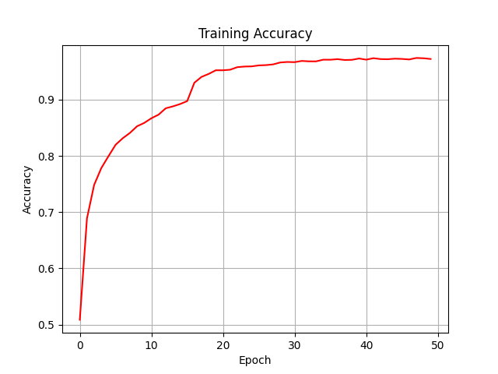 | 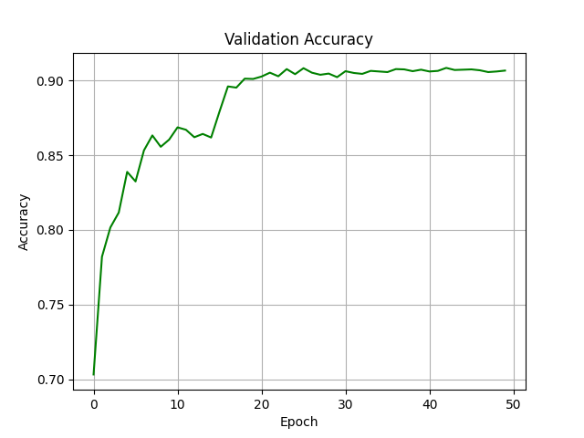
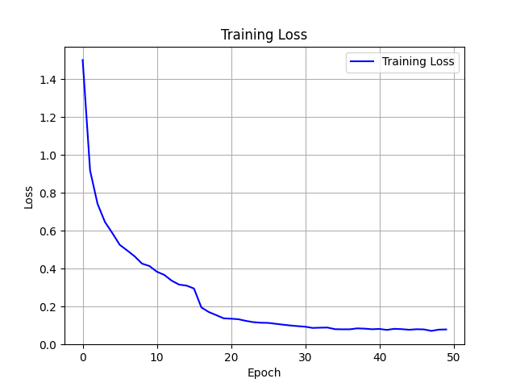 | 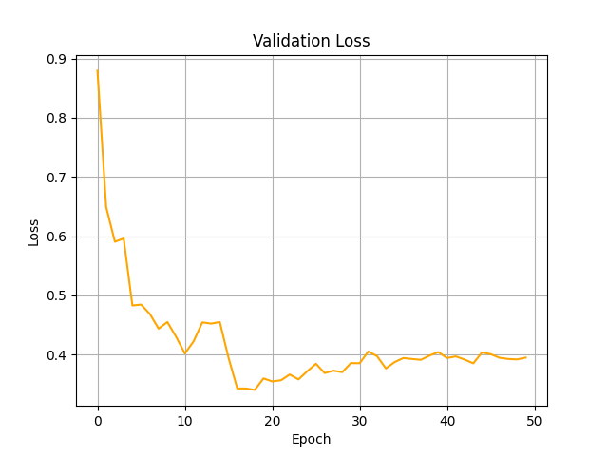

MyNet
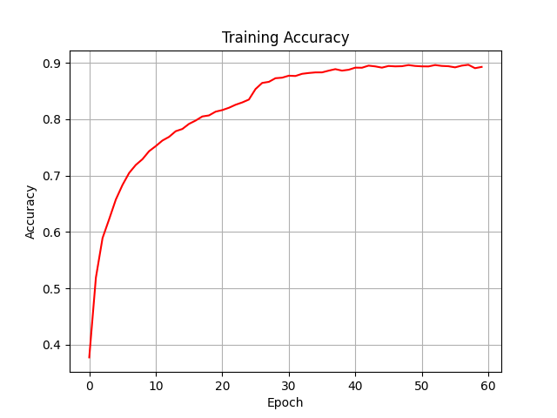 | 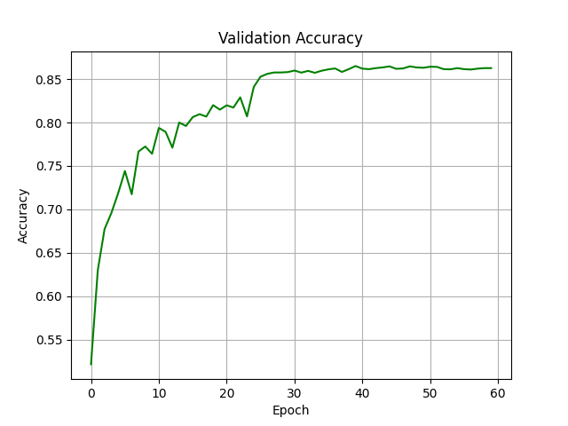
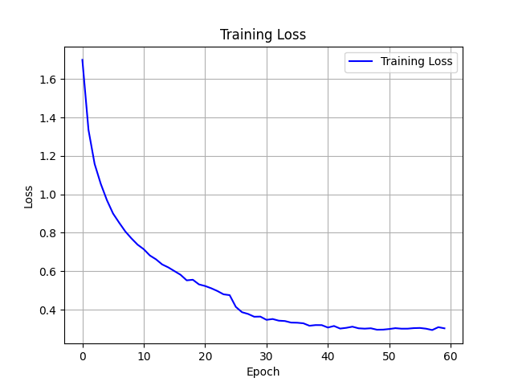 | 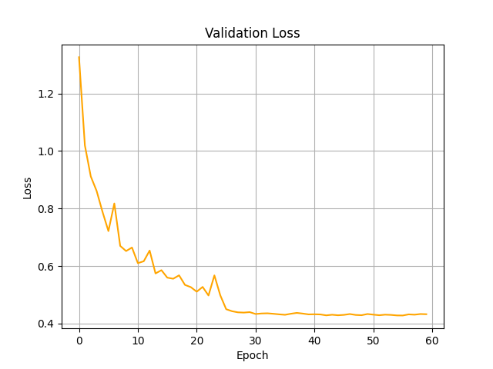

• Briefly describe what method do you apply on your best model? (e.g. data augmentation, model architecture, loss function, etc) (10%)
Ans:
For my best model (MyNet):
- Data Augmentation: Random horizontal flip, rotation (±15°), crop (4-pixel padding), color jitter, resize to 32x32, normalization.
- Model Architecture: Custom CNN with three residual blocks, batch normalization, ReLU, dropout (0.3/0.5), and a linear classifier.
- Loss Function: CrossEntropyLoss.
- Optimizer: Adam (lr=3e-4).
- Scheduler: MultiStepLR (milestones=[25,40,50], gamma=0.1).
- Training: 60 epochs, batch size=64.

