# Introduction

In today's world, where environmental consciousness is increasingly paramount, planning major events such as concert tours requires balancing operational efficiency with sustainability. The Eras Tour by Taylor Swift, covering various stadiums, stands as a prime example of this challenge. This paper presents an approach to optimize the tour route for efficiency and environmental sustainability, contributing to the evolving discourse on green logistics in event management.

The central objective of this study is twofold: firstly, to minimize the total distance traveled between concert venues. This is crucial not only for logistical efficiency but also for reducing costs and managing time effectively. Secondly, the study aims to reduce the carbon footprint of the tour. This aspect is vital in promoting environmental sustainability within the entertainment industry, a sector increasingly scrutinized for its environmental impact.

In addition to the primary objective of enhancing operational efficiency and environmental sustainability, this study explores two distinct optimization methods: the Miller-Tucker-Zemlin (MTZ) formulation which we will be using as our base and Fischetti and Toth’s Polyhedral Approach which will be a new method we are willing to explore. The MTZ formulation is renowned for its effectiveness in route optimization, particularly in scenarios involving multiple locations. Fischetti and Toth’s approach, tailored to the Asymmetric Traveling Salesman Problem (ATSP), offers a sophisticated solution for the more complex routing challenges often encountered in real-world scenarios. The comparison of these two methodologies will not only determine the most efficient routing strategy for the tour but also provide insights into the strengths and practical applications of each approach in large-scale event planning.

Taylor Swift's Eras Tour serves as an ideal case for this study. Her global popularity necessitates extensive touring, which, while connecting with fans worldwide, also entails a significant environmental footprint. By optimizing the tour route, this paper aims to demonstrate how strategic planning can achieve operational efficiencies while aligning with environmental stewardship. This approach is not just beneficial for the artist and the touring company in terms of cost and time efficiency, but it also sets a precedent in the industry for sustainable event management.

The study's findings and recommendations are geared towards stakeholders in the music and entertainment industry, particularly those involved in tour planning and logistics. The insights gained from this optimization study could serve as a model for future tours, not just for Taylor Swift but for other artists and events as well. By showcasing the potential for operational efficiency coupled with environmental responsibility, this paper adds a valuable perspective to the ongoing dialogue on sustainable practices in the entertainment sector.

# Problem description and formulation

The specific goal of this optimization is to strategically plan Taylor Swift's concert tour. The challenge lies in determining the most efficient route that covers all the selected stadiums, thereby minimizing travel distance without compromising the potential audience reach. This approach not only promises a maximized fan experience but also contributes to reducing the carbon footprint associated with extensive touring.

In the expansive arena of Taylor Swift's global popularity, her concert tours span across five continents, reaching fans in a multitude of countries. However, for this optimization study, we have consciously limited our scope to 20 major stadiums within the United States. This decision is rooted in several practical considerations. Firstly, managing tour schedules across continents involves complex logistical challenges, including international travel restrictions, diverse venue availabilities, and varied market dynamics. Focusing on the U.S. allows for a more controlled and manageable optimization environment. Secondly, the United States represents a significant portion of Taylor Swift's fan base and a key market for her music and tours. Optimizing her tour schedule within this region can yield substantial benefits in terms of audience reach and revenue generation. Last but not least, this study can be viewed as a pilot or initial phase, concentrating on a specific and significant market. The methodologies and insights gained here can later be adapted and expanded to include international venues in future optimizations.

By narrowing our focus to 20 stadiums in the U.S., we aim to create a practical optimization model that can deliver tangible benefits and insights, potentially serving as a blueprint for more extensive global tour planning in future.

The problem is defined as a single-objective optimization task within the framework of the Asymmetric Traveling Salesman Problem (ATSP). The asymmetry of the ATSP accommodates varying distances between venues depending on the travel direction, a realistic consideration in tour planning.

*Image 1 shows the original route taken by Taylor Swift for Eras Tour in the North American region.*

## MTZ Model:

The MTZ formulation is a classic approach in the realm of operational research, particularly for solving route optimization problems like the Traveling Salesman Problem (TSP). This model is especially relevant for scenarios where a series of locations, such as concert venues, need to be visited in the most efficient manner.

In the context of Taylor Swift's Eras Tour, the MTZ model can be efficiently applied to determine an optimal route that minimizes travel distance and time, thereby contributing to both operational efficiency and environmental sustainability. The model's formulation is grounded in a set of binary decision variables and continuous variables, which collectively define the tour's structure and sequence.

**Decision Variables:**

The MTZ model introduces two types of variables:

1. Binary variables indicating whether the tour moves directly from stadium to stadium .
2. Continuous variables representing the order in which each stadium is visited, helping to eliminate subtours.

**Objective Function:**

The primary objective is to minimize the total travel distance, expressed as the sum of distances associated with each chosen route segment:

**Constraints:**

1. **Visit Each Stadium Once:** Ensures each stadium is visited exactly once.
2. **Leave Each Stadium Once:** Guarantees each stadium is departed exactly once.
3. **Subtour Elimination:** Prevents the formation of subtours, ensuring that are consistent with

For our case, n is the number of cities which equates to 20 which means we have 400 variables, 19 variables which equates to 419 variables in total. This MTZ formulation is implemented using a linear programming Gurobi, which efficiently navigates through the solution space to identify the optimal tour route. The model's strength lies in its ability to systematically eliminate subtours, ensuring a single, continuous route that visits each stadium exactly once.

The MTZ model, with its clear and straightforward approach, serves as a robust tool for optimizing the Eras Tour route. Its application provides a baseline for comparing with the more complex Fischetti and Toth’s Polyhedral Approach, ultimately offering a comprehensive understanding of the most effective strategies for large-scale event route optimization.

Fischetti and Toth’s Polyhedral Approach to the Asymmetric Traveling Salesman Problem

Fischetti and Toth's model (Fischetti et al, 1997) for the Asymmetric Traveling Salesman Problem (ATSP) is a sophisticated approach that combines linear programming techniques with combinatorial optimization strategies. It specifically addresses the asymmetry in the TSP, where the cost (or distance) of traveling from point A to point B is not necessarily the same as traveling from B to A.

Central to this model is the development of a sophisticated branch-and-cut algorithm. This algorithm not only utilizes the assignment problem (AP) relaxation as a foundation but significantly extends it by dynamically incorporating ATSP-specific facet-defining cuts. These cuts are crucial in effectively tackling and solving hard instances of ATSP that prove challenging for AP-based methods. The model also introduces new separation algorithms for various classes of facet-defining cuts and a novel variable-pricing technique to address issues in highly degenerate primal linear programming problems. Through computational analysis, this approach has demonstrated its capability to outperform existing AP-based algorithms, particularly in solving complex, real-world instances of ATSP. As a result, this model is used to develop the open-ended asymmetric travelling salesman problem involving Taylor Swift’s Eras Tour in North America cities.

**Decision Variables:**

V is a set of stadiums (vertices), and A is the set of directed connections between stadiums (arcs)

**Objective Function:**

The objective is to minimize the total distance travelled, which is the sum of the distances travelled by the corresponding binary decision variables:

Where is the distance from node i to node j.

**Constraints:**

1. **Degree Constraints:**

Each node must be left once:

Each node must be entered once:

1. **Subtour Elimination Constraints (SECs):**

Dynamic constraints are added during the branch and cut process to eliminate subtours.

1. **Binary Constraints:** The following constraint is to ensure no tour includes the same stadium twice.
2. **LP Relaxation and Branch-and-Cut:**

Initially solve the problem as a linear program without integer constraints, then branch on fractional variables, and iteratively add SECs to cut off infeasible solutions.

This formulation lays the groundwork for solving the ATSP using Fischetti and Toth's approach, with a focus on eliminating subtours and efficiently navigating the solution space. The precise implementation details, including the exact nature of the cutting planes and branching strategies, would be based on the specific content and methodologies outlined in the paper.

**Justification to use this model:**

The Fischetti model's superiority in solving the ATSP is evident from its mathematical and algorithmic sophistication, as analyzed in the paper by Roberto Roberti and Paolo Toth. (Roberti, R et al, 2012). This model outperforms others primarily due to its efficient lower bound calculation. It rapidly computes tight lower bounds, which is crucial for efficiently pruning the solution space in the branch-and-cut algorithm. Unlike many other models, the Fischetti model implements an advanced mechanism for dynamically adding subtour elimination constraints during the solving process. This adaptability ensures that the model continuously refines its search space, eliminating infeasible solutions more effectively. Furthermore, by integrating cutting planes directly into the branching process, the model navigates through the solution space more effectively, enhancing both the speed and accuracy of finding the optimal solution. Finally, the Fischetti model is particularly tailored to address the challenges posed by the asymmetric nature of the problem, where the cost of traveling from point A to B is not necessarily the same as from B to A. This specificity makes it more adept at handling real-world instances of the ATSP, where asymmetry is a common feature.

# Numerical implementation and results

## Description of data for problem formulation

### Data Sources and Types

We first employed the Google Maps API and Bing API for accurate geolocation data of potential concert venues. The stadium data is essential for calculating the distance between concert venues. Two factors indeed influenced our decision to choose a stadium. The first is the historical venue’s popularity. After research, we gave higher weight to stadiums where Taylor Swift has previously performed successfully, which indicates a strong fan base in those cities. We also took stadium capacity and facilities into consideration. We weighed more on the stadium, which accommodates large audiences and provides the necessary amenities for a world-class singer like Taylor Swift. This dataset plays a crucial role in the optimization process, serving as a foundation for determining the most efficient travel routes between venues.

## Data Preparation and Transformation

The datasets were loaded into our analytical environment using the Python Data Analysis Library (pandas), which offers robust capabilities for handling and processing large datasets. For the optimization model to effectively process the data, we transformed the stadium coordinates into a list of tuples. Furthermore, the distance data was formatted into a 2D matrix, aligning with the requirements of our optimization algorithms. This transformation ensures that the data is in a suitable format for subsequent analysis and optimization modelling. The distance matrix, derived from the datasets, is pivotal in calculating the exact distances between each pair of stadiums. This matrix forms the core of our optimization model, enabling us to determine the most efficient touring route. The data prepared, including the geolocation of stadiums and the distance matrix, will be directly fed into Gurobi to formulate the optimization problem. This integration is crucial for ensuring that the real-world constraints and objectives of Taylor Swift's tour scheduling are accurately represented in the optimization model.

The data preparation stage sets a solid foundation for the forthcoming modelling and optimization phases. By collecting and transforming relevant data, we have established a robust basis for optimizing Taylor Swift's tour schedule. The subsequent sections of this report will delve into the problem formulation and the solutions derived from this well-prepared dataset, aiming to achieve an efficient and fan-centric tour schedule.

## Problem Formulation

We have approached the open-ended asymmetric travelling salesman problem involving Taylor Swift's Eras Tour in North America cities by exploring and implementing two optimization models:

### Miller-Tucker-Zemlin (MTZ) formulation

The formulation of MTZ approach to the Asymmetric Traveling Salesman Problem has been implements using the modeling language Python and its optimization solver library, Gurobi. The mathematical formulation has been translated into the code as follows:

#### Decision Variables

In the code, we've introduced two sets of decision variables:

1. Binary variables indicates whether the tour moves directly from stadium to stadium , and
2. Continuous variables represents the order in which each stadium is visited, to help eliminate subtours.

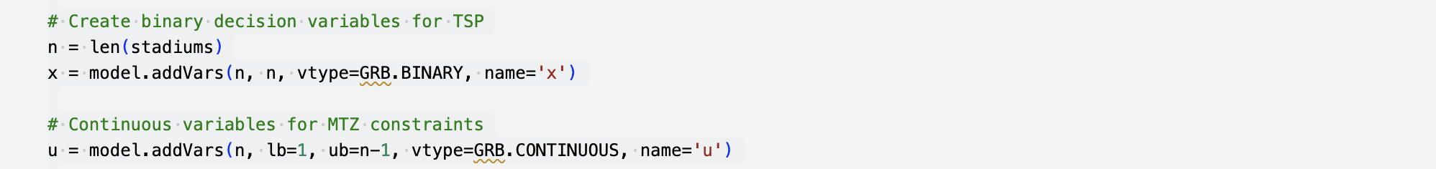

#### Objective function

The objective of minimizing the total travel distance is translated into the code by summing up the product of distances and binary variables . We've used Google Maps API to determine the distances between pairs of stadiums. The API calculates distances based on the latitude and longitude coordinates of the stadiums. For each stadium pair, a request is made to the Googles Maps API to obtain driving distances. The resulting distances are then stored in the distance matrix and saved on a file. The same thing was done with Bing maps as a reference. To facilitate further computations, the distance matrix is converted into a NumPy array, denoted as .



#### Constraints

Out-Degree: We've added this constraint to the Gurobi model to ensure each stadium is visited exactly once. The line of code specifies that the sum of outgoing arcs from each stadium () is equal to 1.

In-Degree: We've added this constraint to the Gurobi model to ensure each stadium is left exactly once. The line of code specifies that the sum of outgoing arcs from each stadium () is equal to 1.  
  
We include the condition in both the above constraints to prevent self-loops, ensuring that a stadium is not counted as both visited and left at the same time.

Subtour Elimination: We've added this constraint to the Gurobi model to prevent the formation of subtours.

*Note: A subtour is a subset of the overall tour that does not cover all the vertices, meaning that it does not represent a complete and valid solution to the transportation problem.*

In the code, for each pair of stadiums () where is not equal to , we add a constraint involving continuous variable and binary decision variable . This constraint helps eliminate subtours, ensuring that the optimization focuses on complete and valid tour sequences for an improved solution.

### Fischetti and Toth’s Polyhedral Approach to the Asymmetric Traveling Salesman Problem

The formulation of Fischetti and Toth’s Polyhedral Approach to the Asymmetric Traveling Salesman Problem has been implemented using the Gurobi modeling language in Python. The mathematical formulation has been translated into code as follows:

#### Decision Variables

In the code, the decision variables are represented by the binary variables , where and represent the indices of stadiums in the set of vertices . These variables are defined using Gurobi's function with the variable type set to .

The binary variable is used to indicate whether the arc from stadium to stadium is selected in the optimal solution.

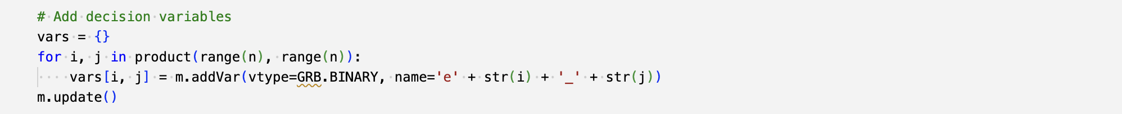

#### Objective function

The objective of minimizing the total distance travelled is translated into the code by summing up the product of the distance matrix elements and the binary variables . The summation is performed over all possible arcs in the graph using a nested loop. In the code, the objective function is set up using in the function.



#### Constraints

No Self-Loops: We've added this constraint to the Gurobi model () to prevent a stadium from being connected to itself in the tour. This is achieved by ensuring that the decision variables are equal to 0 for all stadiums ().

Out-Degree: We've added this constraint into the model to ensure each stadium is visited exactly once in my tour. The line of code specifies that the sum of outgoing arcs from each stadium () is equal to 1.

In-Degree: We've added this constraint into the model to ensure each stadium is entered exactly once in the tour. The line of code specifies that the sum of incoming arcs to each stadium () is equal to 1.



Subtour Elimination constraints (SECs):

In order to ensure that the optimal solution does not contain subtours, we've created two functions and .

The function is designed to find a subtour, which is a subset of the solution in an optimization problem that doesn't cover all the nodes. The function starts by creating a list of edges (arc connections) from the solution where the variable values are greater than 0.5. It then explores the nodes, forming a cycle by visiting connected nodes until all nodes are visited. The function returns the indices of the nodes forming the identified subtour.

The function is a callback function that gets invoked during the optimization process, specifically when a new solution is found (). The function aims to identify and eliminate subtours dynamically by adding constraints to the model. It utilizes the subtour function to find subtours in the current solution. If a subtour is identified (), the function adds a subtour elimination constraint to the model (). It ensures that the sum of decision variables associated with arcs within the identified subtour is constrained to be less than the length of the subtour minus 1. This constraint prevents the optimizer from considering similar subtours in subsequent iterations.

We assign to ensure the callback function retrieves information about the ongoing solution. Next, we enable the incorporation of lazy constraints in the model to handle subtours iteratively. These constraints are not initially present but are dynamically introduced during the optimization process, triggered by specific conditions outlined in the callback function (). Finally, we ensure each time a new feasible solution is discovered during optimization, the callback function is invoked.

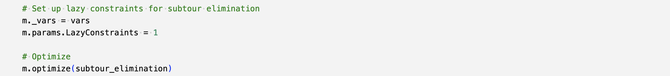

## Solution and Interpretation

Both the MTZ and Fischetti's approaches to optimize Taylor Swift's Eras tour in North America result in a total distance of 9692.4 miles (~15,600 kms). This outcome remains consistent, regardless of the initial stadium (i.e., starting point).

If we initiate the journey from State Farm Stadium, the optimal solution takes a route from Allegiant Stadium to Sofi Stadium, proceeding to Levi's Stadium, Lumen Field, Empower Field at Mile High, GEHA Field at Arrowhead Stadium, U.S. Bank Stadium, Soldier Field, Ford Field, Gillette Stadium, MetLife Stadium, Lincoln Financial Field, Acrisure Stadium, Paycor Stadium, Nissan Stadium, Mercedes-Benz Stadium, Raymond James Stadium, NRG Stadium, AT&T Stadium, ultimately returning to State Farm Stadium.

*Image 2 shows the optimal route for Taylor Swift's Eras Tour in the North American region based on Miller-Tucker-Zemlin (MTZ) and Fischetti and Toth’s Polyhedral Approach to the Asymmetric Traveling Salesman Problem*

In practice, Taylor Swift's Eras tour deviated from an optimal route, commencing at State Farm Stadium and proceeding through Allegiant Stadium, AT&T Stadium, Raymond James Stadium, NRG Stadium, Mercedes-Benz Stadium, Nissan Stadium, Lincoln Financial Field, Gillette Stadium, MetLife Stadium, Soldier Field, Ford Field, Acrisure Stadium, U.S. Bank Stadium, Paycor Stadium, GEHA Field at Arrowhead Stadium, Empower Field at Mile High, Lumen Field, Levi's Stadium, Sofi Stadium, and finally returning to State Farm Stadium. This actual route covered a total of approximately 12,574 miles (~20,236km).

As a result, our optimal solution(s) could potentially reduce travel costs by around ~23%, because of following reasons:

1. While actual tour started from State Farm Stadium and progressed to the right, the optimal tour progressed to the left, to save on the travelling cost.
2. The actual tour involved inefficient distance coverage, involving travel of 1124 miles from AT&T Stadium to Raymond James Stadium, followed by 990 miles back to NRG Stadium and 802 miles to Mercedes-Benz Stadium. In contrast, the optimal solution traveled from Mercedes-Benz Stadium to Raymond James Stadium to NRG Stadium to AT&T Stadium, covering a total distance of 460 + 990 + 265 = 1,715 miles.
3. The actual tour included a suboptimal tour of 302 miles from Lincoln Financial Field to Gillette Stadium and 207 miles to MetLife Stadium (total 509 miles). The optimal solution streamlined this by traveling 207 miles from Gillette Stadium to MetLife Stadium and an additional 96.4 miles to Lincoln Financial Field (total 303.4).
4. Another significant detour in the actual tour covered 209 miles from Gillette Stadium to MetLife Stadium, 783 miles to Soldier Field, 282 miles to Ford Field, 285 miles to Acrisure Stadium, 867 miles to U.S. Bank Stadium, and 703 miles to Paycor Stadium (total 3129 miles). In contrast, the optimal solution strategically avoided detours, aiming for a unidirectional travel pattern. It covered 704 miles from Paycor Stadium to U.S. Bank Stadium, 411 miles to Soldier Field, 282 miles to Ford Field, 704 miles to Gillette Stadium, and 207 miles to MetLife Stadium (total 2308 miles).

## Assessment of solution compatibility with our original problem

The fundamental objection of our optimization was to minimize the travel distance, under the assumption that shorter routes lead to reduced travel costs and a lower carbon footprint. By comparing the mileage of our optimized solutions with the actual route, we see a clear opportunity not only to cut travel expenses but also to significantly reduce the carbon emissions associated with the tour. Assuming travel costs and carbon emissions are directly proportional to the distance traveled, our solutions could potentially save on both fronts.

For example, by shortening the tour from ~12,574 miles to 9692.4 miles, we estimate that our optimized routes can result in a considerable reduction in carbon footprint for the fleet of 50 semi-trucks. On average, a semi-truck emits approximately 6-8 metric tons of carbon dioxide per 10,000 miles traveled. Considering the reduction in distance, our optimized routes could potentially save 100 - 140 metric tons of carbon dioxide emissions for the entire fleet throughout the tour.

# Problem extensions

The existing concert tour has exhibited instances of suboptimal routing, characterized by backtracking and inefficient distance coverage. For example, in the provided graph, the tour initially commenced at Soldier Field in Chicago, then proceeded eastwards to Ford Field in Detroit, and further east to Pennsylvania before ultimately retracing its path and skipping several preceding stadiums to reach Minneapolis.

In contrast to our established Traveling Salesman Problem (TSP) model, such behavioral patterns appear to be illogical and counterproductive. A more optimized route, focusing on minimizing distance, would have entailed connecting Pennsylvania to the New England corridor and establishing a continuous westward trajectory encompassing Detroit, Chicago, and Minneapolis, thereby eliminating any backtracking.

At this stage, it is imperative for the present study to transcend simplistic distance-based optimization and incorporate an additional critical factor: time. Specifically, our attention should be directed towards the Traveling Salesman Problem with Time Windows (TSPWT). This variant accounts for the temporal availability constraints associated with stadium venues, which are frequently subject to prior bookings by other tours during the peak summer season. Moreover, certain outdoor stadiums may solely permit events prior to the arrival of winter, while others experience restricted availability owing to the commencement of the NFL season in early August.

According to López-Ibáñez et al. (2018), the travelling salesman problem with time windows (TSPTW) is a variant of the classic travelling salesman problem (TSP) that incorporates temporal constraints on the service times of the customers. In the TSPWT framework, each stadium is characterized by a fixed parameter denoting the time required to travel to other stadiums by road. Additionally, stadiums possess predefined time windows, specified by intervals denoted as (e, l), which represent the earliest and latest permissible periods for hosting a concert. The decision variables within this model correspond to the temporal durations required between successive concerts, encompassing both travel time and possible waiting periods denoted as . For instance, consider the scenario of traveling from stadium number 1 to stadium number 2. If stadium 2 is currently available and the travel time is estimated at 1 day, the temporal duration required would be 1 day. Conversely, if stadium 2 is inaccessible until a week later, the inter-concert duration would be extended to 1 day + 1 week = 8 days. The objective function of this optimization model aims to minimize the aggregate time required to complete the entire tour, as expressed by (López-Ibáñez et al., 2018). Consequently, there may be instances where it is advantageous to temporarily bypass a stadium when it is unavailable and subsequently revisit it at a later point to circumvent potential delays.

Within the confines of the present study, the TSPWT model has not been selected for two principal reasons. Firstly, the primary objective of this model is to curtail travel distance and, by extension, mitigate the carbon emissions associated with transportation. Secondly, the comprehensive acquisition of stadium availability data for all 20 venues proves challenging, considering the multifaceted factors that influence their scheduling, such as event bookings, sporting events, weather conditions, and other pertinent considerations.

Nevertheless, it is noteworthy that this model can still be regarded as a valid approach, particularly when the aim is to minimize the financial costs associated with hosting the concert tour. A reduced tour duration would yield lower wage expenditures for the production team, in addition to diminished outlays for accommodations, sustenance, and other associated resources.

# Recommendations and Conclusions

As a consultant, we would recommend taking our project as a foundational starting point for enhancing the optimization of Taylor Swift's Eras tour or any other tours. We would incorporate a broader range of cost factors including lodging and local transportation would provide a more holistic view of the tour's financial aspects. Incorporating environmental sustainability and stakeholder engagement would enhance practicality and alignment with industry standards.

In our project, we explored optimizing travel distances for Taylor Swift's Eras tour in North America using the MTZ formulation and Fischetti and Toth’s Polyhedral Approach for the Asymmetric Traveling Salesman Problem (ATSP). The Fischetti model demonstrated superiority in handling complex instances.

While the optimized routes suggested a ~23% reduction in travel distance, we acknowledge the oversimplification of associating shorter routes with reduced travel costs, considering the dynamic nature of Taylor Swift's touring schedule. Further, It is challenging to acquire stadium availability data for all venues due to various factors including weather conditions, etc. Despite this, our models effectively minimize tour-related financial costs, potentially saving on production team wages and resource outlays.

Considering Taylor Swift's use of her private jet, the model's emphasis on minimizing travel distance has a significant impact on carbon emissions. Real-world application should consider the evolving nature of her tour itinerary, emphasizing continuous refinement for efficient and flexible tour planning. We recommend a balance between distance reduction and broader tour objectives, adapting optimization models to dynamic constraints and objectives in the ever-changing landscape of global concert tours.

Reflecting on our project, we've realized that the complexity of distance planning involves various factors and uncertainties. If given the opportunity to redo the project, we would aim to further refine our approach by categorizing travel into airway and road segments. This would involve estimating the total travel required not just for Taylor Swift but also for her crew, providing a more detailed and nuanced perspective on tour logistics.

# 

# Appendix

1. Fischetti M, Toth P, 1997. A polyhedral approach to the asymmetric traveling salesman problem.
2. 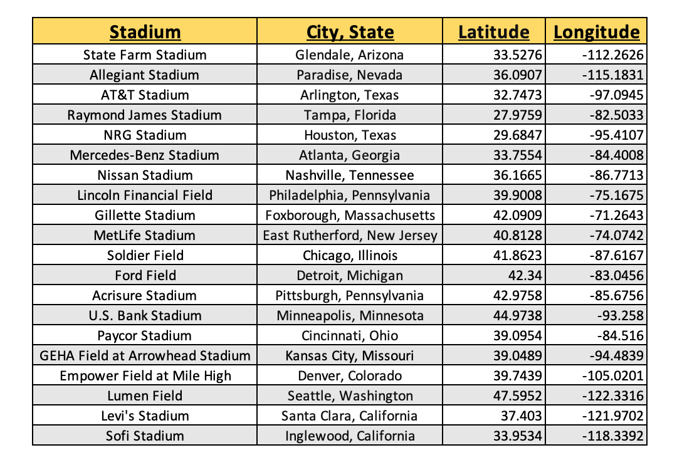Roberti, R. and Toth, P., 2012. Models and algorithms for the Asymmetric Traveling Salesman Problem: an experimental comparison.
3. Masley, Ed. (2023, March 23). Taylor Swift 'Eras' tour 2023 locations. AZ Central. <https://www.azcentral.com/story/entertainment/music/2023/03/23/taylor-swift-eras-tour-2023-locations/70031117007/>
4. López-Ibáñez, M., Blum, C., Ohlmann, J. W., & Thomas, B. W. (2018). The travelling salesman problem with time windows: Adapting algorithms from travel-time to makespan optimization. European Journal of Operational Research, 271(2), 369-385. <https://doi.org/10.1016/j.ejor.2018.05.023>