**Maths/LA/Tutorial 7**

**Q1: Find Orthogonal basis of A from the 3 vectors below in ex2.**





**Q2: Form matrix A with the 3 column vectors x1,x2, x3 in Q1. Find its QR factorization.**





**Q3: Lay/Ch6.5/pg364/Ex4**

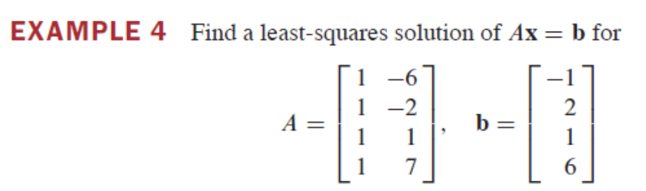

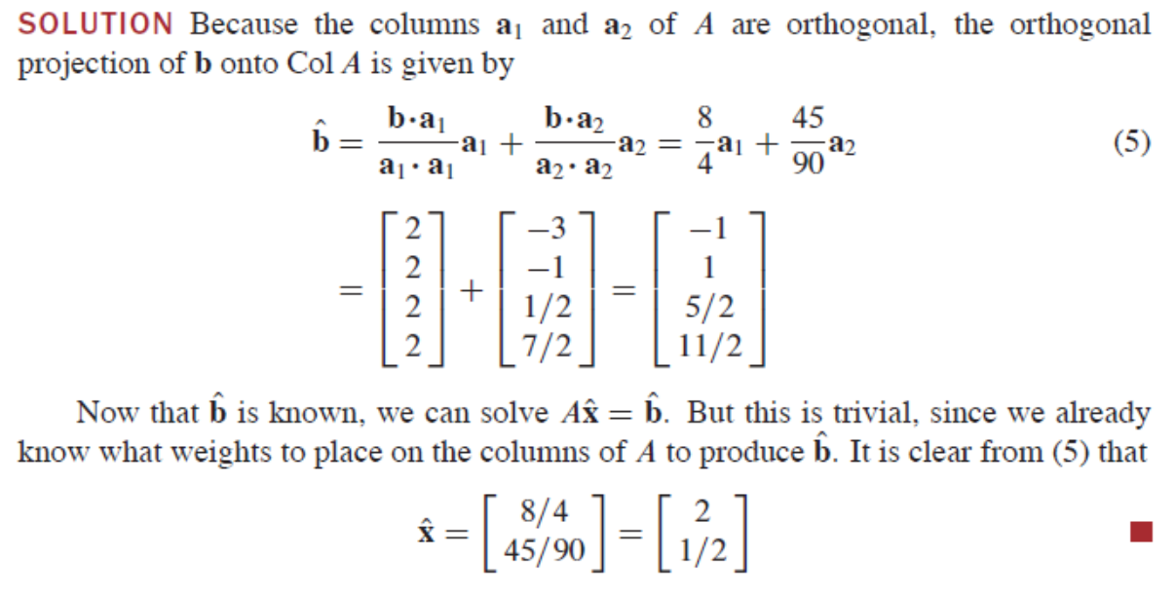

**Q4) Lay/ch6.5/pg 366/Q14/**

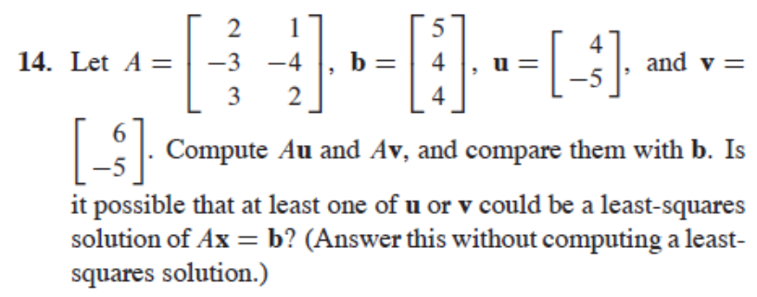

Ans: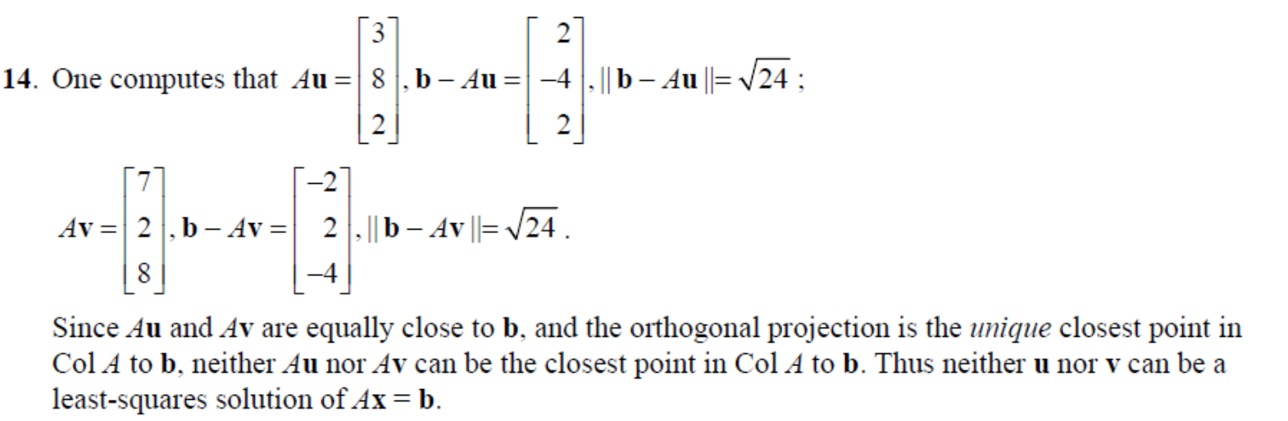

**Q5: Lay/ch6.5/pg366/Q17+18**

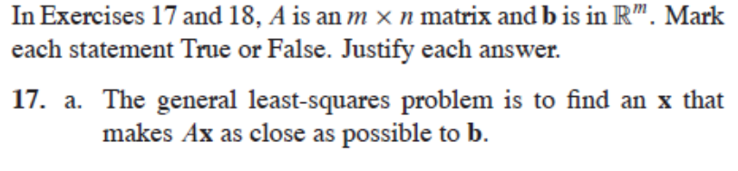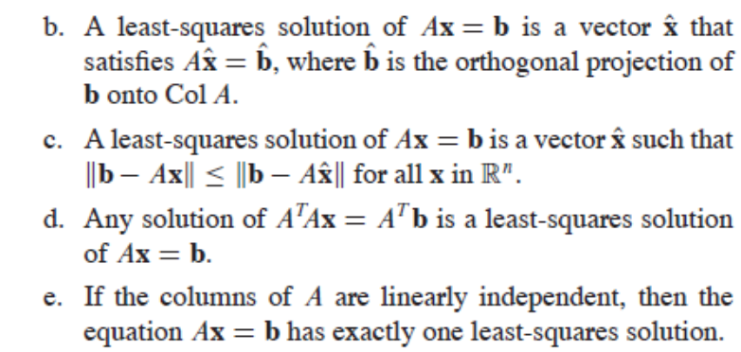

**Answer:**

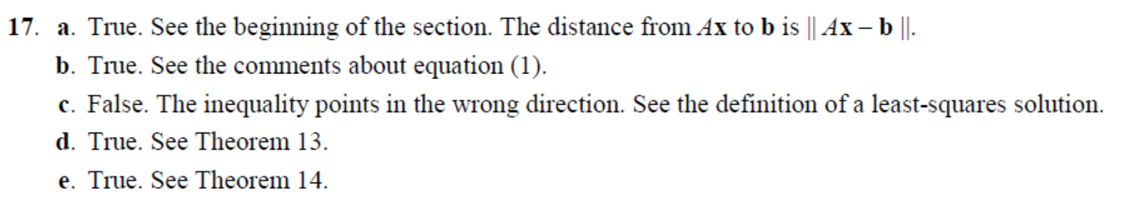

**Q6:**

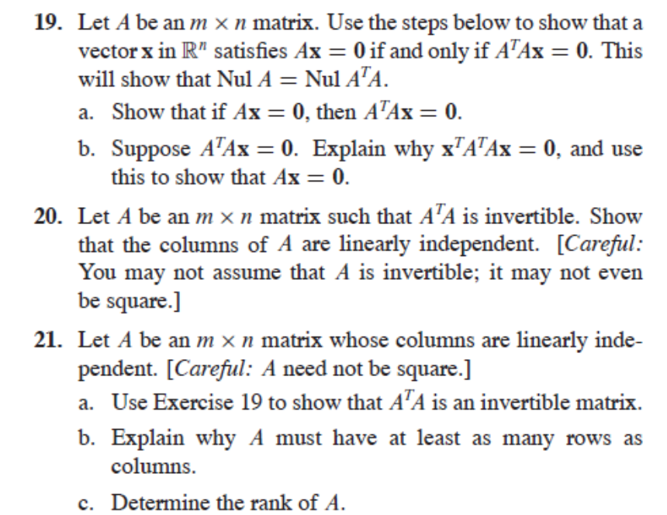

**Answer**

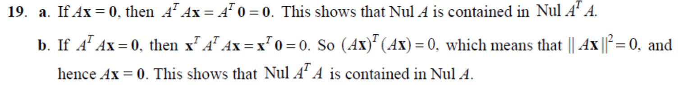

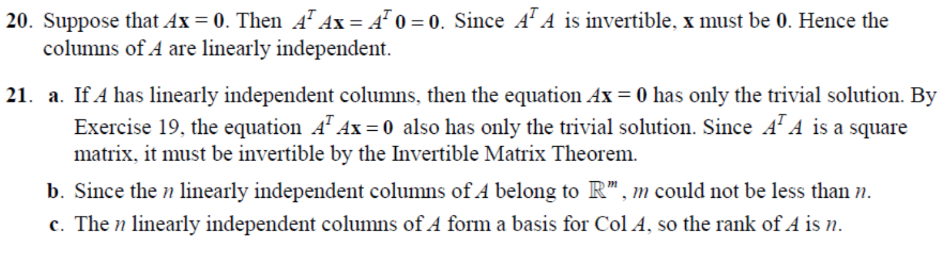

Q7:



Answer to 1: (let student compute): y = 0.9 + 0.4x

Full Answer to Q2: y = -0.6 + 0.7x (full answer below)

