Nanyang Business School

**BU8201 Business Finance**

**Tutorial 5: Risk and Rates of Return**

**(Common Questions)**

1) **CAPM and required return.** Bradford Manufacturing Company has a beta of 1.2, while Farley Industries has a beta of 0.7. The required return on an index fund that holds the entire stock market is 11.0%. The risk-free rate of interest is 4%. By how much does Bradford’s required return exceed Farley’s required return?

Ans: 3.5%

2) Evaluate the following statements to determine whether they are TRUE or FALSE. Explain your answers.

a) When diversifiable risk has been diversified away, the inherent risk that remains is market risk, which is constant for all stocks in the market.

Ans: False

b) Portfolio diversification reduces the variability of returns on an individual stock.

Ans: False

c) If all the investors in the market are risk averse and hold only one stock, we can conclude that the required rate of return on a stock whose standard deviation is 0.21 will be greater than the required return on a stock whose standard deviation is 0.10. However, if stocks are held in portfolios, it is possible that the required return could be higher on the stock with the lower standard deviation.

Ans: True

d) An investor who holds just one stock will generally be exposed to more risk than an investor who holds a diversified portfolio of stocks, assuming the stocks are all equally risky. Since the holder of the 1-stock portfolio is exposed to more risk, he or she can expect to earn a higher rate of return to compensate for the greater risk.

Ans: 3.5%

e) Market risk refers to the tendency of a stock to move with the general stock market. A stock with above-average market risk will tend to be more volatile than an average stock, and its beta will be greater than 1.0.

Ans: False

3) **Security Market Line**. Based on the following security market line (SML), answer the following questions.

a) What is the equation for the Security Market Line (SML)?

Ans: 3.5%

b) Is Company A correctly valued? If not, what should be the expected return of Company A when it is in equilibrium?

Ans: 3.5%

c) Suppose you invest 40% of your money in the market portfolio and 60% of your money in Company A, what is the beta of the resulting portfolio? What is the expected return on your portfolio?

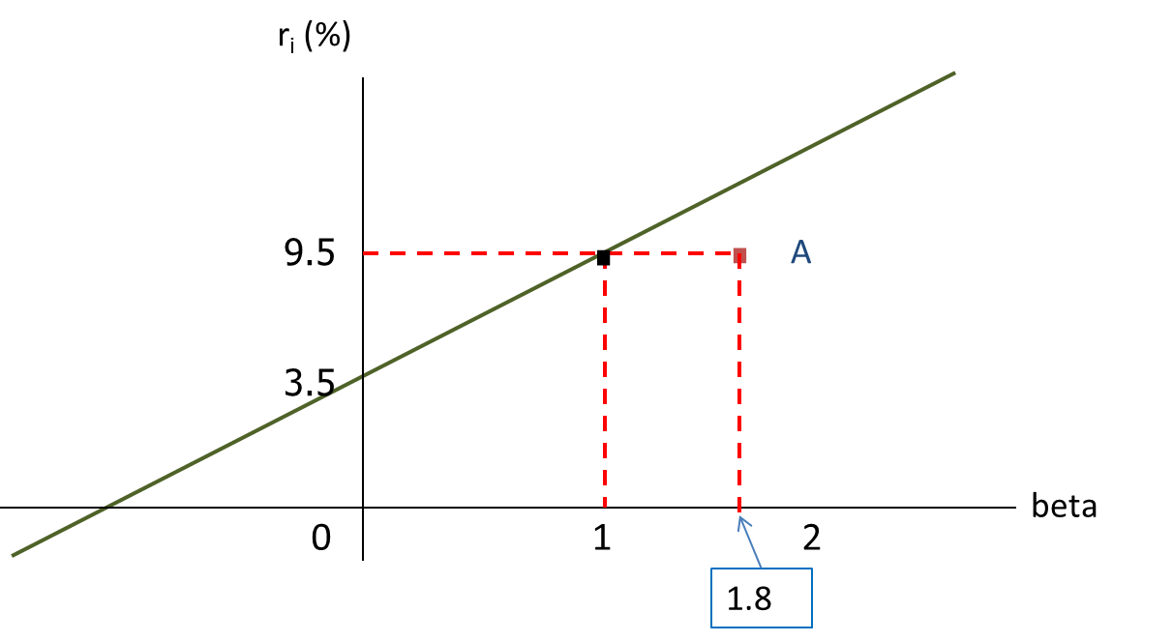

Expected return of Company A

Ans: 3.5%

4) **Evaluating risk and return**. Stock X has an expected return of 9.5 percent, a beta coefficient of 0.9, and a 30 percent standard deviation of expected returns. Stock Y has a 13 percent expected return, a beta coefficient of 1.3, and a 20 percent standard deviation. The risk-free rate is 5 percent, and the market risk premium is 5.5 percent.

a) Calculate the coefficient of variation of each stock.

Ans: 3.5%

b) Which stock is riskier for diversified investors? Which stock is riskier for undiversified investors?

Ans: 3.5%

c) Use the CAPM model to calculate each stock’s required rate of return.

Ans: 3.5%

d) On the basis of the two stocks’ expected and required returns, which stock would be more attractive to a diversified investor?

Ans: 3.5%

e) Calculate the required return of a portfolio that has $7,000 invested in Stock X and $3,000 invested in Stock Y.

Ans: 3.5%

f) If the market risk premium increased to 6.5 percent, which of the two stocks would have the larger increase in its required return? Why would the market risk premium increase?

Ans: 3.5%

**Self-practice question**

You are managing a portfolio of 5 stocks, stocks M, N, O, P, and Q, which are held in equal amounts. The current beta of the portfolio is 1.8, and the beta of stock M is 2.2. If stock M is sold, what would the beta of the replacement stock have to be to produce a new portfolio beta of 1.6?

**Answers to self-practice question**

Step1: Find beta of portfolio of N, O, P, and Q. Let beta of this portfolio be X.

4/5X+1/5(2.2) = 1.8 🡺 X = 1.7

Step 2: Find beta of replacement stock. Let it be Y.

4/5(1.7) + 1/5Y = 1.6 🡺 Y = 1.2