**Assembly Homework 2 #Procedure**

**Department:** CSIE 2-B

**Student Number:** 110502567

**Name:** 蔡淵丞Vincent

**DATA SECTION:**

**ChStrs:** the pattern ‘7’ in 8x8 grid

**BitStrs:** the 1X8 line we want to print to the console each time



**THOUGHT:**

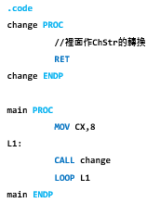 Given the recommended structure of the code, it is easy to

see that we treat ‘change PROC’ as a function which we want to

call 8 time, for each we print a 1X8 line of our 8X8 pattern to the

screen. Therefore, we just have to consider what we are going to

perform to each line of the pattern.

**MAIN PROC:**

***Esi:***  to store the current index of ChrStrs

***Ecx:*** loop count

***L1:*** call ‘change’ 8 times

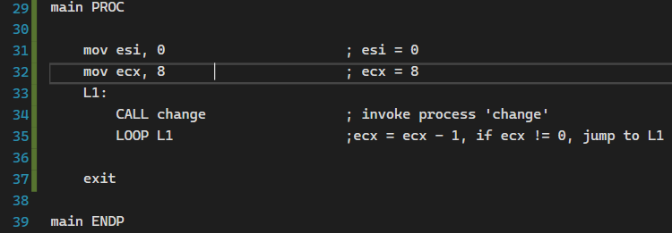

**CHANGE PROC:**

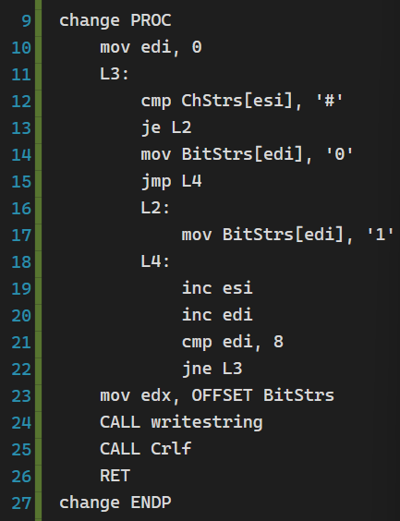

**Line 10:**

I use ***edi*** as loop count of L3 and the current index of BitStrs.



**Line 12-17:**

Compare character in ChStrs. If it is ‘#’ then store ‘1’ in BitStrs, else store’0’.

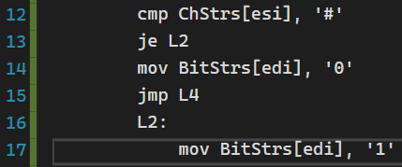

**Line 19-22:**

Increase ***esi, edi***. If ***edi*** equals 8, the line is complete, finish the loop.

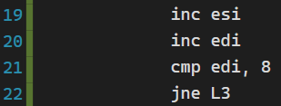

**Line 23-26:**

Write the line (BitStrs) to the console and return.

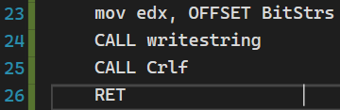

Before returning out of ‘change’ we will have printed a 1X8 line of our pattern to the console.

**RESULT:**

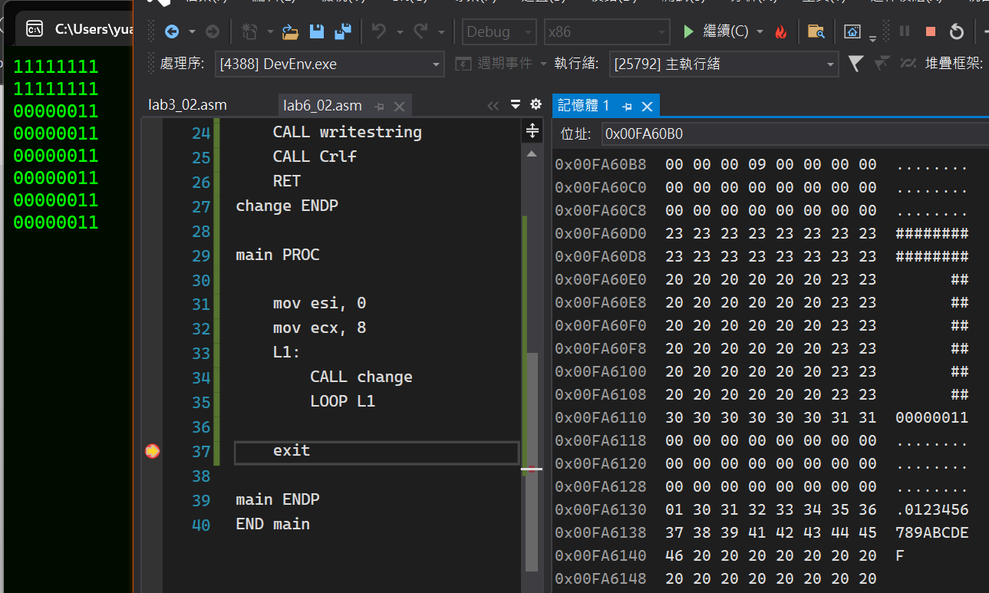

**REVIEW:**

I encountered a bug during my homework. The loop L1 doesn’t finish when the ***cx*** counts down to 0, and then my friend told me to make sure the entire ***ecx*** is 0, not until which I realized that I didn’t move 0 to the entire register ***ecx***. 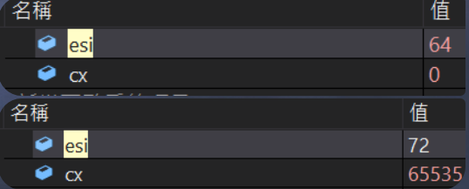

the code beside is misleading 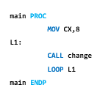

**FULL CODE:**

