Assembly Language and System Programming Lab10

Group: 2

Names: 林柏廷(Brian)、蔡淵丞(Vincent)

Student ID: 110502531、110502567

**Objective:**

Copy the first group member’s ID to the end of the second group member’s ID, and print the result.

**Data:**

Initialize the IDs.

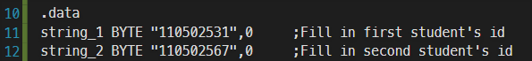

**main PROC:**

Invoke the procedure with three arguments ( OFFSET string_1, OFFSET string_2+9, (SIZEOF string_2)-1 ), and then call the printing methods.

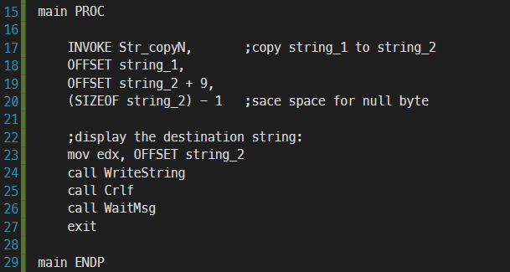

**Str_copyN:**

Copy a string from source to target, limiting the number of characters to copy by maxChars. The value in maxChars does not include the null byte.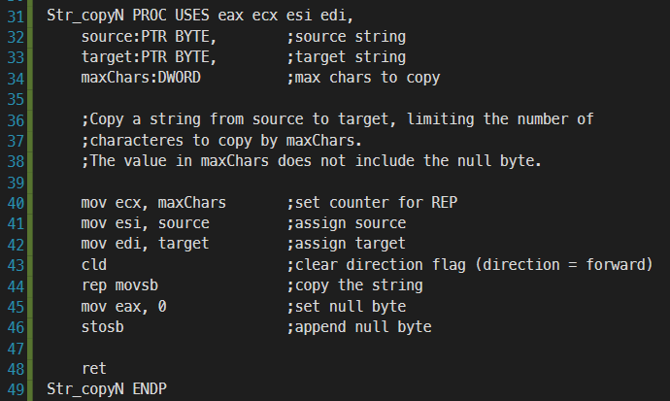

**Line 32-34:**

Define three input parameters: source, target, and maxChars

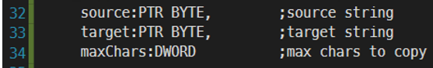

**Line 40-42:**

Set counter for REP, and assign source and target.

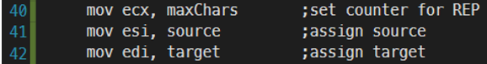

**Line 43:**

Clear the direction flag. This set the direction to forward.



**Line 44:**

The instruction ‘rep movsb’ will copy ***[esi]*** to ***edi*** and increase ***esi*** and ***edi*** by 1.



**Line 45-46:**

Append a null byte to the end of the string.



**Result:**

As we expected, the source string is append to the end of the target string.

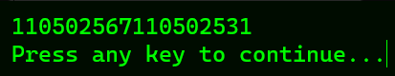

**Review:**

In this lab and lecture, we’ve learned how to use movsb instruction, which copies data from the memory location pointed to by esi to which pointed to by edi. This instruction combined with the instruction rep, which can be inserted before movsb, movsw, or movsd. This can be really useful when manipulating strings.

**Full code:**

