Assembly Language and System Programming Lab11

Group: 2

Names: 林柏廷(Brian)、蔡淵丞(Vincent)

Student ID: 110502531、110502567

**Objective:**

Print a rectangle in the console.

**Data:**

**Line 7-9:**

Characters for printing the box.

**Line 11-14:**

Arguments for ‘WriteConsoleOutputAttribute’ and ‘WriteConsoleOutputCharacter’.

**Line 16-19:**

Attributes for the characters.

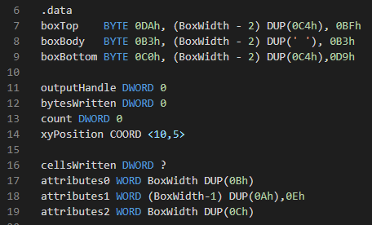

**main PROC:**

Invoke the procedure with three arguments ( OFFSET string_1, OFFSET string_2+9, (SIZEOF string_2)-1 ), and then call the printing methods.

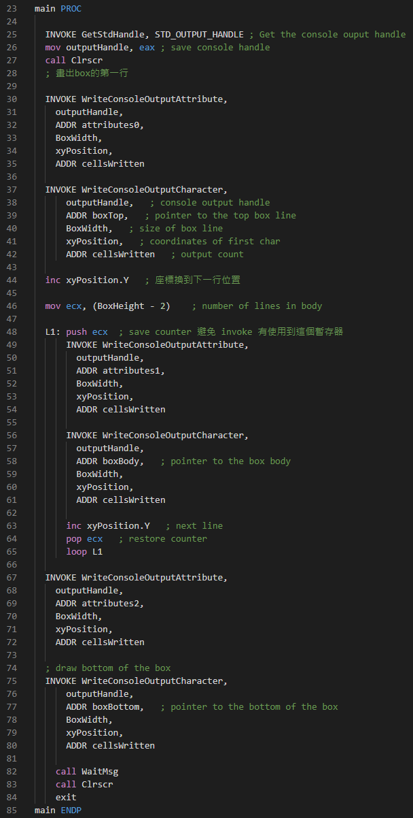

**Line 25-27:**

Get and store the console output handle.



**Line 30-42:**

Draw the top line of the box.

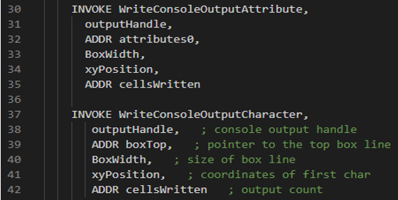

**Line 44:**

Increase the y position to make it print at the next line.



**Line 46-65:**

Draw the body of the box by repeating calling the printing function.

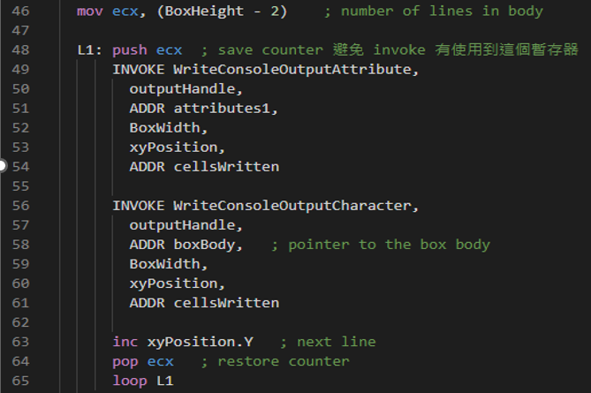

**Line 67-80:**

Draw the bottom of the box.

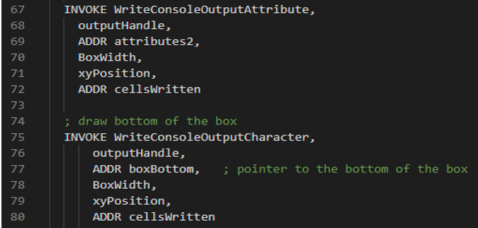

**Line 82-84:**

Wait for the user message and clear the screen.

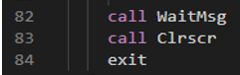

**Result:**

As we expected, we have drawn the colorized box. But because of the configuration of my terminal, the box is not close to a square.

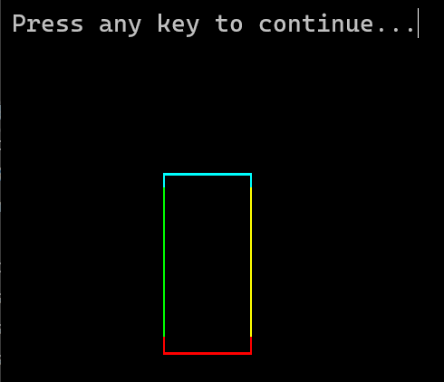

**Review:**

In this lab and lecture, we’ve learned how to get the handle of the console and use it to manipulate the console in our program.

**Full code:**

