Assembly Language and System Programming Lab13

Group: 2

Names: 林柏廷(Brian)、蔡淵丞(Vincent)

Student ID: 110502531、110502567

**Objective:**

Get the keyboard event and move the cursor in the console

**Data:**

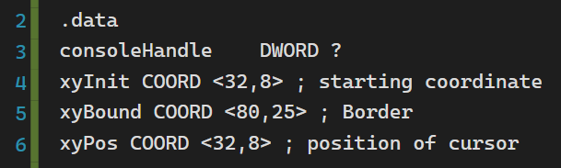

**Line 2:**

**main PROC:**

Invoke the procedure with three arguments ( OFFSET string_1, OFFSET string_2+9, (SIZEOF string_2)-1 ), and then call the printing methods.

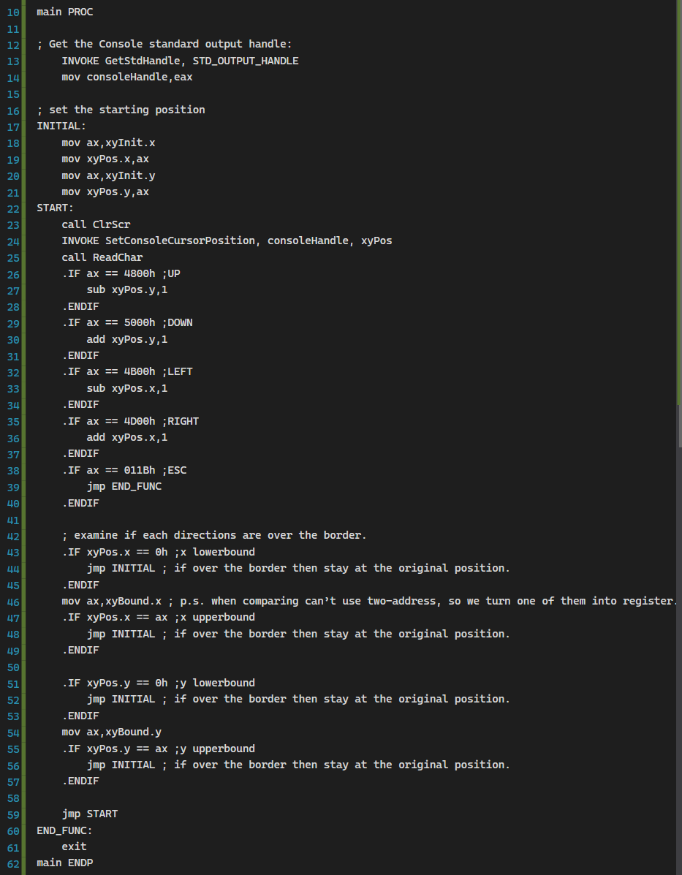

**Line 13-14:**

Get and store the console output handle.



**Line 18-21:**

Draw the top line of the box.

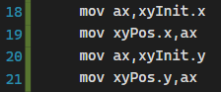

**Line 23-40:**

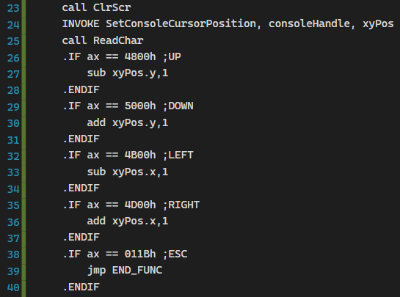

**Line 42-59:**

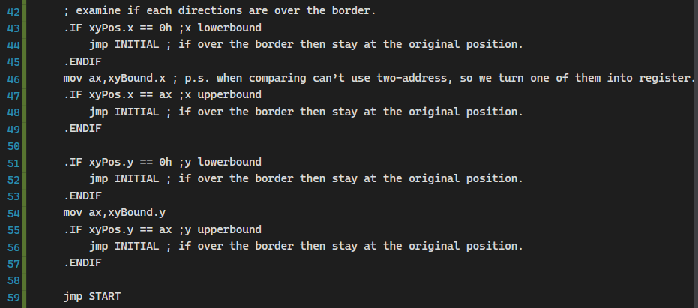

**END_FUNC:**

Exit the program



**Result:**

As we expected, we have drawn the colorized box. But because of the configuration of my terminal, the box is not close to a square.

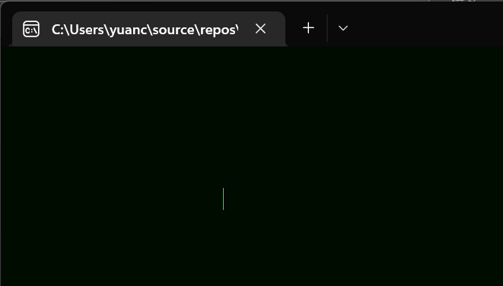

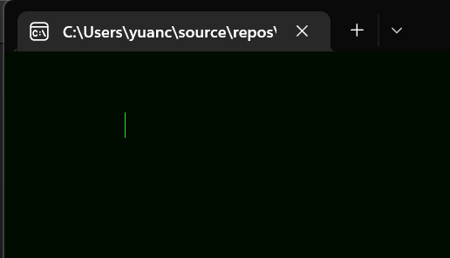

**Review:**

In this lab and lecture, we’ve learned

**Full code:**

