Assembly Language and System Programming Lab1 Report

Group: 2

Names: 林柏廷(Brian)、蔡淵丞(Vincent)

Student ID: 110502531、110502567

**Source code:**

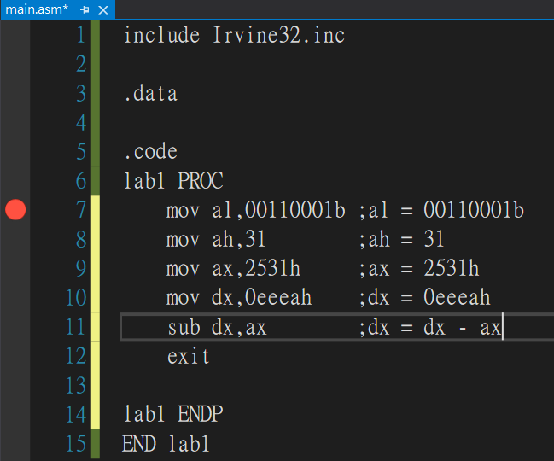

**Registers before line 7:**

The registers were full of garbage before assigning values to them.

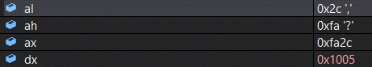



**After line 7 :**

The *al* was assigned 00110001(binary), thus the value of *al* was changed to 31(hexadecimal). Notice that the value of *ax* was also changed since *al* is the lower part of *ax*.



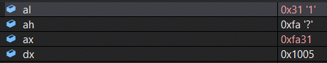



**After line 8:**

The value of *ah* changed to 1f(hexadecimal) since we assigned 31 to *ah*. Notice that the value of *ax* was also changed since *ah* is the higher part of *ax*.



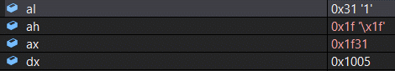



**After line 9:**

The value of *ax* changed to 2531(hexadecimal) since we assigned 2531h to *ax*. Notice that this will also affect the value of *ah* and that of *al*.



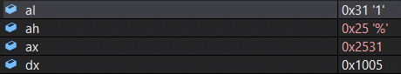



**After line 10:**

We simply stored the value eeea(hexadecimal) in *dx*.



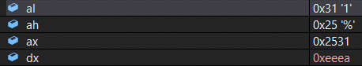



**After line 11:**

We subtracted the value of *ax* from that of *dx*, and then stored the result in *dx*.



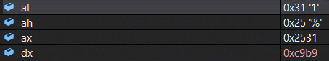



eeea - 2531 = c9b9 (hexadecimal)

**Review:** Monitoring the changes of the value stored in the registers provides us a better understanding of the execution of the program.