Assembly Language and System Programming Lab2 Report

Group: 2

Names: 林柏廷(Brian)、蔡淵丞(Vincent)

Student ID: 110502531、110502567

**Objective:** Calculate -(Val3 – 14 * (Val1 + Val2)).

**Source code:**

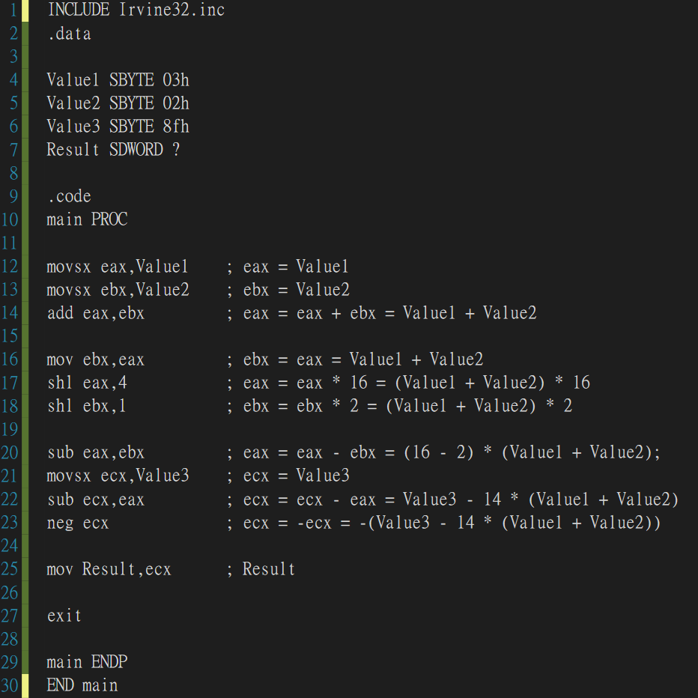

**Registers before line 12:**

The registers were full of garbage before assigning values to them.

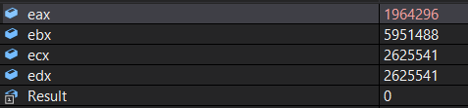



**After line 12 :**

Store Value1 which is 3(decimal) in the register *eax*.



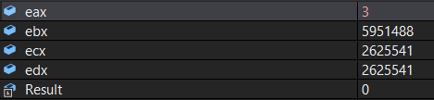

**After line 16:**

Store Value2 which is 2(decimal) in the register *ebx*.



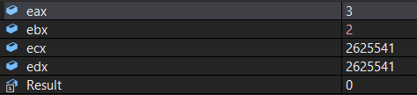

**After line 14:**

Add the value of *ebx* to that of *eax* and store it in *eax*. (3 + 2 = 5)

The value of *eax* now is Value1 + Value2 or 5.



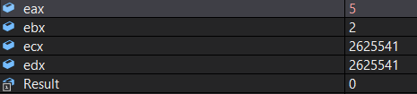

**After line 16:**

Store the value of *eax* in *ebx* since we’ll need to use it later on.



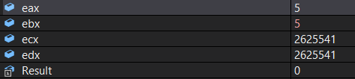

**After line 17:**

Shift *eax* to the left by 4, also multiply the value of *eax* by 16(2^4).

The value of eax now is 16 * (Value1 + Value2) or 80.  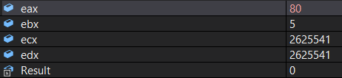

**After line 18:**

Shift *ebx* to the left by 2, also multiply the value of *eax* by 2(2^1).

The value of ebx now is 2 * (Value1 + Value2) or 10.



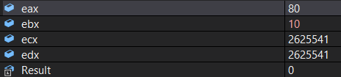

**After line 20:**

Subtract *ebx* from *eax*.

The value of *eax* now is 14 * (Value1 + Value2) or 70.



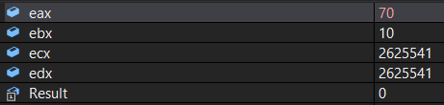

**After line 21:**

Store Value3 which is –113(decimal) in *ecx*.



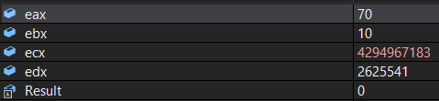

**After line 22:**

Subtract *eax* from *ecx*.

The value of *ecx* now is Value3 – 14 * (Value1 + Value2) or –183.



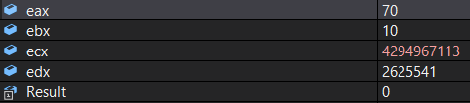

**After line 23:**

Negate the value of *ecx*. -(-183) = 183.

Now the value of *ecx* is exactly what we want, which is -(Val3 – 14 * (Val1 + Val2)).



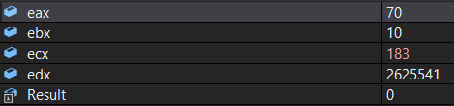

**After line 25:**

Assign the value of *ecx* to *Result*.



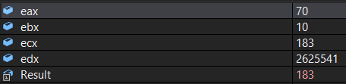

**Check the memory:**

The memory of Result shows b7(hexadecimal) which is the hexadecimal value of 183(decimal), proving that our work is correct.

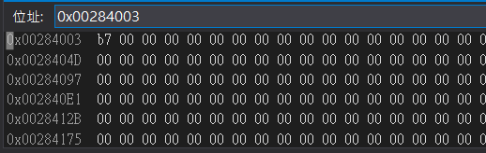

**Review:**

In this lab we learned a way to monitor the value stored in any address of the memory. We also get more used to the arithmetic operation of assembly language.