Assembly Language and System Programming Lab3 Report

Group: 2

Names: 林柏廷(Brian)、蔡淵丞(Vincent)

Student ID: 110502531、110502567

**Objective:** Use loop to calculate multiplication table from 9*1 to 9*9.

**Source code:**

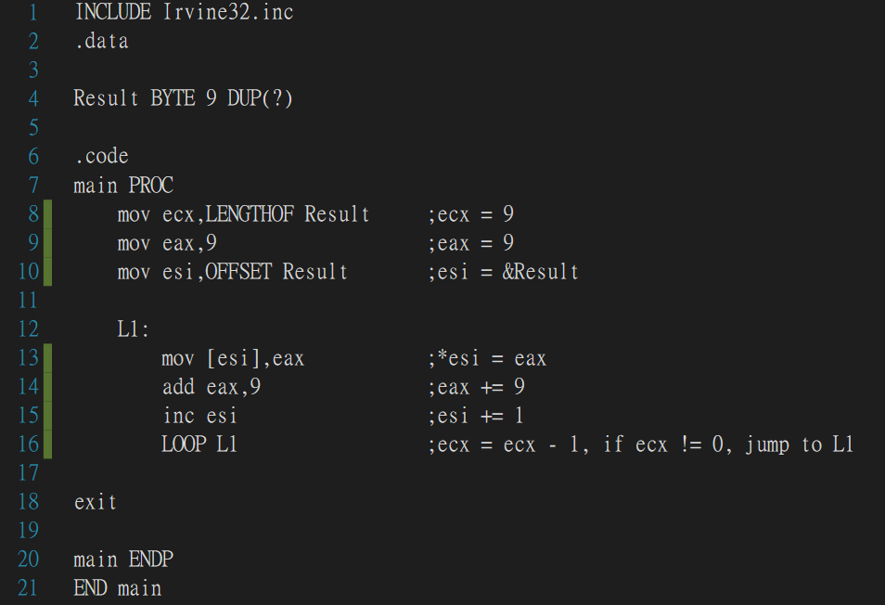

**Registers before entering L1:**

We store the length of ***Result*** to ***ecx*** because we want to iterate 9 times, and for each time we store the multiples of 9 in ascending order.We then store the first multiple of 9 in ***eax***, and the first memory address of the array in ***esi.***

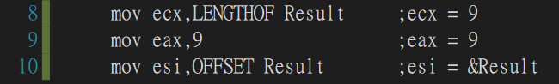

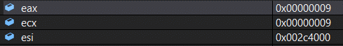

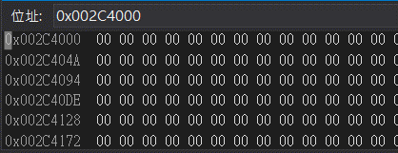

**LOOP:**

1. Store the value of ***eax*** in the memory address represented by ***esi***.
2. Increase ***eax*** by 9.
3. Increase ***esi*** by 1, which makes it point to the next position of the array.
4. Subtract ***ecx*** by 1, meaning that we have iterated once. If ***ecx*** is not equal to 0 then jump to L1, and if not, then continue the program.

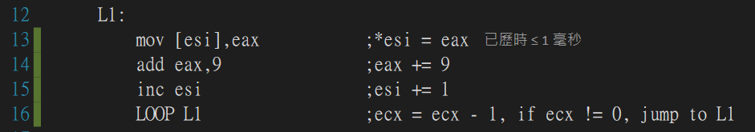

**After first iteration:**

***eax += 9, ecx -= 1, esi += 1.***

The first multiple of 9 is stored in ***&Result***.

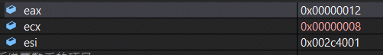

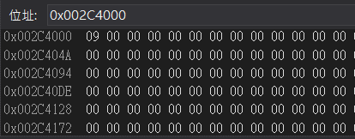

**After 9 iterations:**

***eax = 5a(9*10), ecx = 0(9-9), esi = 0x002c4009.***

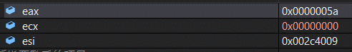

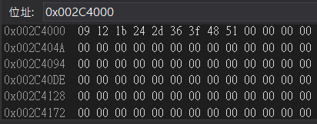

The array ***Result*** has been filled with the multiples of nine.

**Review:**

We have learned how to use loop and how to access memory through indirect operand.