Assembly Language and System Programming Lab7 Report

Group: 2

Names: 林柏廷(Brian)、蔡淵丞(Vincent)

Student ID: 110502531、110502567

**Objective:**

Add a MACRO named divide to the program. After the program calls divide, four parameters are passed in. Perform a division operation and return the quotient and remainder remaining.

**main PROC:**

Line 30-32, 36-38, 40-42 is printing process, whereas line 34 is the usage of macro ‘divide’.

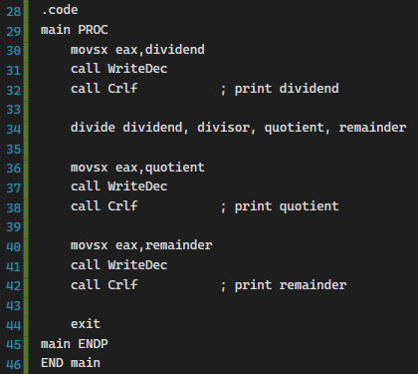

**MACRO:**

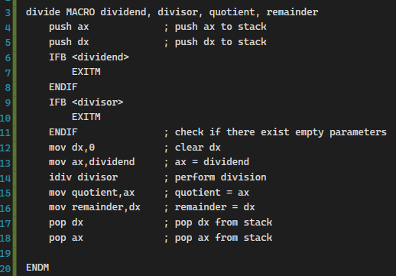

**Line 4-5, 17-18:**

We use the stack to store the original value of the registers, in case of the loss of data.





**Line 6-11:**

Check if the arguments are blank.

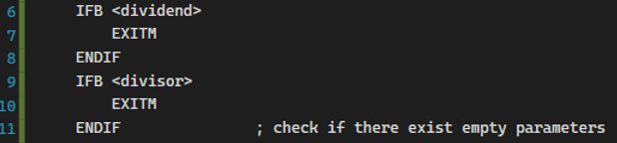

**Line 12-14:**

Firstly, we clear dx in which the remainder is stored. Then we move dividend to ***ax***. Lastly, we perform the division, which will divide ***ax*** by its operand, in this case, divisor. And then it will store the quotient in ***ax***, the remainder in ***dx***.

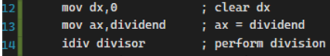

**Line 15-16:**

Store the result in memory.



**Result:**

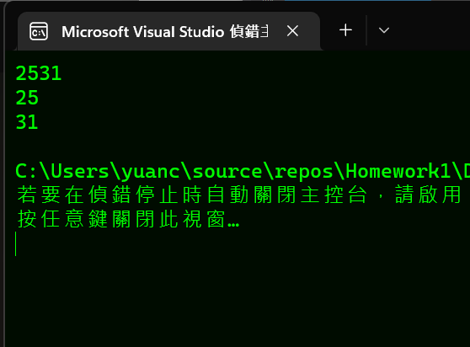

**Review:**

**Full code:**

