Assembly Language and System Programming Lab9 Report 1

Group: 2

Names: 林柏廷(Brian)、蔡淵丞(Vincent)

Student ID: 110502531、110502567

**Objective:**

Find out if v1, v2 and v3 these three inputs are all different. If they are all different set register ***eax*** to 1, otherwise set it to zero.

**main PROC:**

Invoke the procedure five times with five different inputs and call WaitMsg, then invoke ExitProcess.

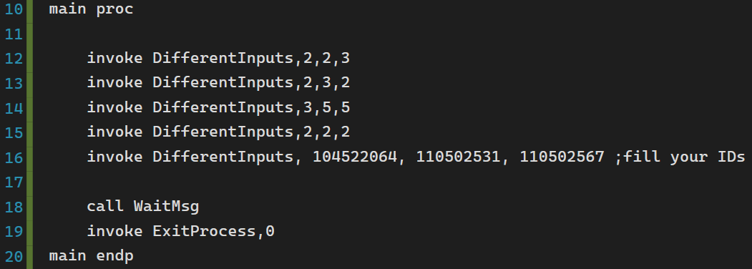

**DifferentInputs:**

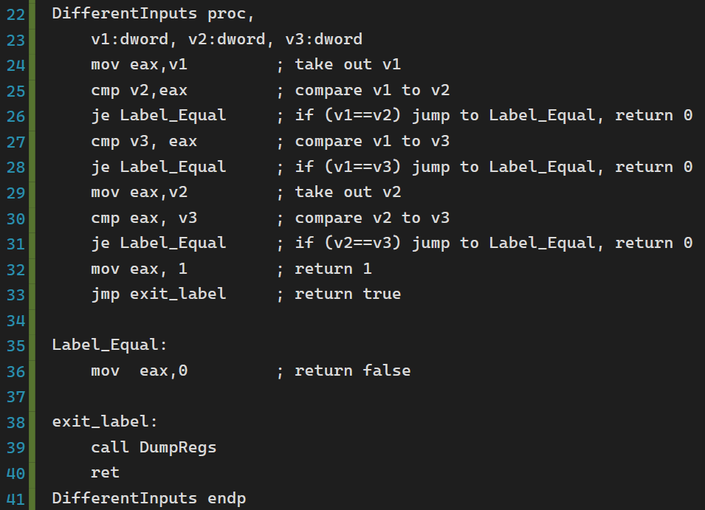

**Line 23:**

Define three input arguments v1, v2 and v3.



**Line 24-31:**

Compare each input by the others. If any of them are equal, jump to Label_Equal, in which will move 0 to ***eax*** and return.

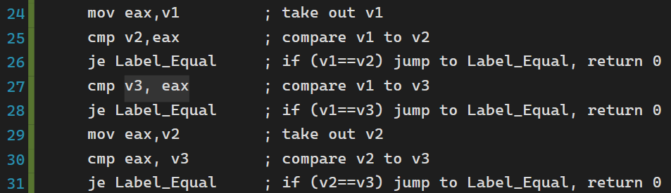

**Line 32-33:**

If these lines are executed, three inputs are all different. We move 1 to ***eax***, and then jump to exit_label.



**Label_Equal:**

If any of the two inputs are equal, we move 0 to ***eax.***

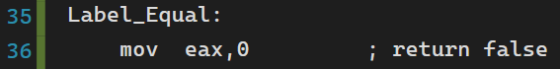

**exit_label:**

Print out all registers and return.

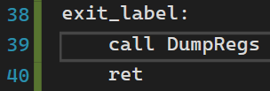

**Result:**

As we expected, only the fifth invoke have three different inputs, so only in the fifth call DumpRegs ***eax*** is 1.

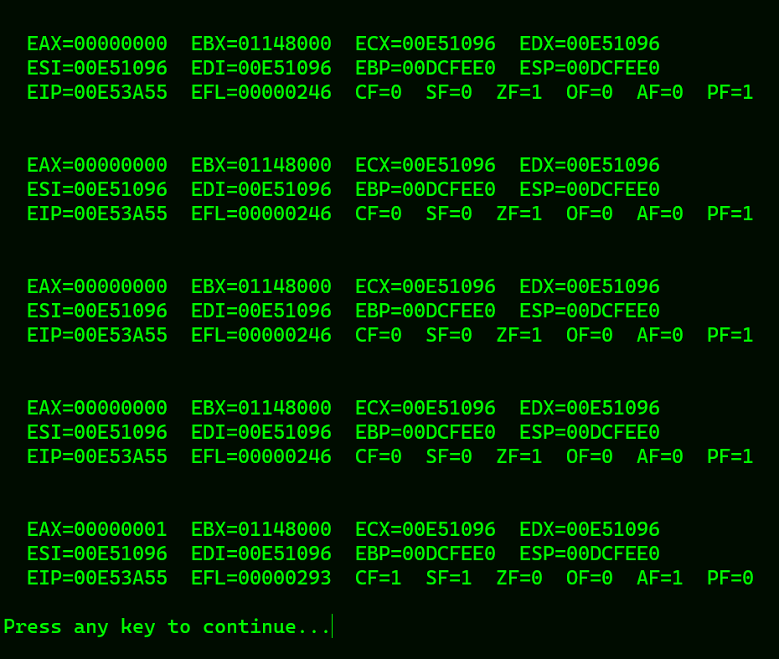

**Review:**

Nothing new from the previous lab, except for ‘DumpRegs’ that seems to be useful when it comes to monitoring registers.

**Full code:**

