**數位系統導論期末範例2**

**迴圈演算法離散事件建模和電路合成**

**陳慶瀚**

**2022-06-08**

**一. 演算法離散事件建模**

**for (i=Start_Value;i<=EndValue;i++)**

**{**

**task ;**

**}**

**迴圈的GRAFCET建模**

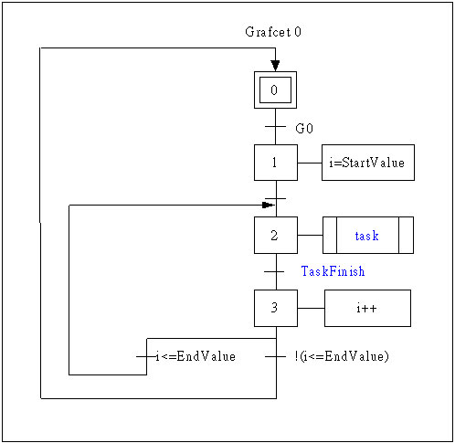

**架構合成**



**二. 設計實例─迴圈累加演算法**

**for(i=0;i<10;i++)sum=sum+i;**

**GRAFCET建模**



**控制器電路合成**

grafcet :PROCESS(CLK,RST)

BEGIN

IF RST='1' THEN

X0<='1';X1<='0';X2<='0';

ELSIF CLK'EVENT AND CLK='1' THEN

IF X0='1' THEN X0<='0'; X1<='1';

ELSIF X1='1' THEN X1<='0'; X2<='1';

ELSIF X2='1' AND I<10 THEN X2<='0';X1<='1';

ELSIF X2='1' AND I=10 THEN X2<='0';X0<='1';

END IF;

END IF;

END PROCESS grafcet;

**Datapath電路合成**

datapath :PROCESS(CLK,RST)

BEGIN

IF CLK'EVENT AND CLK='1' THEN

IF X0='1' THEN TMP<=0; I<=0;

ELSIF X1='1' THEN TMP<=TMP+I;

ELSIF X2='1' THEN I<=I+1;

END IF;

END IF;

END PROCESS datapath;

**系統合成**

ENTITY SUM is

PORT (

CLK, RST : IN STD_LOGIC;

S : OUT INTEGER RANGE 0 TO 128

);

END SUM;

architecture arch of SUM is

SIGNAL X0,X1,X2:STD_LOGIC;

SIGNAL I: INTEGER RANGE 0 TO 15;

SIGNAL TMP: INTEGER RANGE 0 TO 128;

BEGIN

grafet : process(CLK,RST)……

datapath : process(CLK,RST)……

S<=TMP;

END arch;

**波形模擬**

