Wether report Solutions

testWether V1

Document Authors:

Vincent Yang
Solution Architect, Inside Sales - Online Commerce

Version: 1.0

Date: 8/16/2015

Purpose of Document:

The document has been produced to provide the high level technical external design for the ENI-GIL WSE-W application. It is required in order to complete the feasibility analysis and gain sign off to the project definition document (PDD) and agreement to progress forward with planning, development, testing and deployment activities.

Table of Content

1. Document History 4
1.1 Revision history 4
1.2 WSE-W Solution Team Contact Information 4
1.3 WSE-W Client e-Solution Contact Information: 4
1.4 Approvals: 4
2. Introduction 5
2.1 Project Purpose 5
2.2 Project Approach 5
2.3 Assumptions 5
2.4 Scope 6
2.5 Out of Scope 6
2.6 Dependencies 6
2.7 Constraints 6
2.8 Feasibility or Pre-Planning Information 6
3. References 7
3.1 Referenced Documents or Notes 7
4. Business Scope 8
5. Business Processes 9
6. Risks 10
7. Function Requirements 11
7.1 User Profiles 11
7.2 System Context 14
7.3 Business Requirements 14
7.4 Functional Requirements 16
7.5 Use Case Diagram 21
7.6 Workflows 22
7.7 Separation of User Roles (Duties) 23
8. Functional Component Design (Outline) 26
9. Non-Functional Requirements 27
9.1 Performance Guidelines 27
9.2 Security and Privacy Requirements 28
9.3 Infrastructure Requirements 28
9.4 Architecture Requirements 30
9.5 Maintainability 30
9.6 Business Constraints 30
9.7 Technical Standards 30
9.8 Technical Constraints 30
9.9 Corporate rules compliance 30
10. Architecture Model 31
10.1 Architecture Decisions 31
11. User Interface Architecture 32
12. Data Requirement 33
12.1 Logical Data Model 33
12.2 Business Objects 33
12.3 State Diagram 33
12.4 E-Solution Capacity Profile 33
13. Master Test Plan & Test Cases 34

Document History

Revision history

This must be updated as and when changes are made to the document. A new version number should be allocated if substantial changes have occurred.

Version | Date | Summary of Changes
V1.0 | 8.16.15 | Initial Document Creation

Solution Team Contact Information

Contact Name | Role | Email
 | Project Manager
 | Business Analyst
Vincent Yang | Solution Architect | 270495803@qq.com
Vincent Yang | Application Developer | 270495803@qq.com
 | Application Tester | 270495803@qq.com

Client e-Solution Contact Information:

Contact Name | Role | Email

Approvals:

This document requires the following signed approvals:

Name | Job Title

Introduction

Project Purpose

testWether is a project that can be generate a weather report. We need to build a web application to display current weather for 3 Australian cities: Sydney,Melbourne and Wollongong. There should be a dropdown list on web page for city selection,when city is changed corresponding real-time weather information should be displayeddynamically like below
City | Melbonrne
Updated time | Thursday 11:00 AM
Weather | Mostly Cloudy
Temperature | 9℃
Wind | 32km/h

Project Approach

This project will adhere to the IBM Worldwide Project Management Method (WWPMM) methodology (http://w3-03.ibm.com/transform/project/pmmethod-v2/#publish.mgmt.wwpmm_website.base-ibm_int/guidances/supportingmaterials/welcome_wwpmm_7AD73959.html) as applicable to requirements .

Design Phases

The software will be designed and constructed in a phased approach.

Phase | Description of Work
Phase 1 | - To create an Online tool within the J2EE environment. Coding will incorporate the core elements to allow the application to be used .  - The tool will provide the manual ability within the User to get weather information report.  - We need to support 3 Australian cities .Sydney, Melbourne and Wollongong
Pahse 2 | - We need add more cities in our project  - We need more beautiful shows in view page as some picture  - We need imply a backup server for get weather information

Assumptions

The following assumptions are applicable for this project and should be considered as constraints for all project development activities.
A1 | Project should be build on Github for source control and management
A2 | The Delivery must be complied and tested successfully using Maven
A3 | We use baidu API for get weather infomation
A4 | We use google API for backup provide server.

Scope

This specification establishes the Solution requirements for Pactera . Please see Section 7. Functional Requirements.

- This is a simple project
- Coding will incorporate the core elements to allow the application to be used by open users.
- The initial version of the tool will provide the manual ability to get weather report for 3 cities.

Out of Scope

- Merge this project to other projects.

Dependencies

- The requirements from email which raise by Jiang Hua(7672924@qq.com)
.

Constraints

- The application must build by JAVA
- The application must be delivery by Github
- The application should build and test by Maven
- The application should be delivery in 1 day.

Feasibility or Pre-Planning Information

References

Referenced Documents or Notes

Document Number / Location / URL | Reference Description/Name

Business Scope

Business Processes

Risks

Risks to consider: Technical Risks
The following risks have been identified with respect to the testWeather project.

- Maven is a new tools for application team.

Function Requirements

User Profiles

User Profiles | Description | Activities
Open user | User can select one city form Sydney Melbourne and Wollongong, and can see the weather report. | - Select one city in man  - See weather report for the selected city  - See error announce if the weather report can not be show

System Context

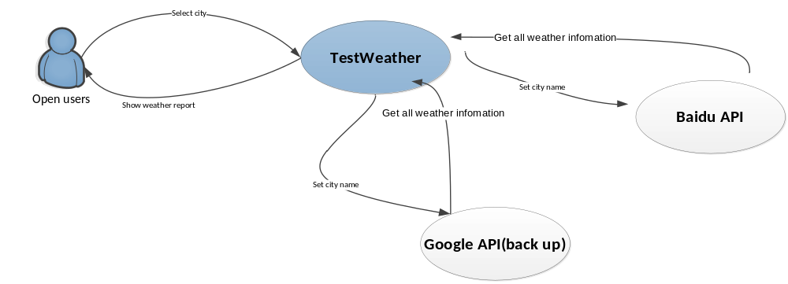

Note: missing CustomerProjectMgr role; it only participates in the UseridRequest flow.
Titile | Role | Actions
Open user select city | user | User can select city form map
Get weather report for the selected city | testWeather | Shows some weather information to user
Get all weather information | testWeather | Send city name to API server
Send back weather information | Baidu server | Send back weather information
Get all weather information | testWeather | Send city name to API server(Only when baidu server is not available)
Send back weather information | Google server | Send back weather information

Business Requirements

Req no. | Name | Description
BR001 | User can select city to get weather | We need to build a web application to display current weather for 3 Australian cities: Sydney,Melbourne and Wollongong.
BR002 | Weather report | 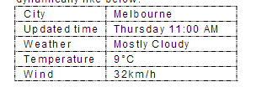
BR003 | Gitbut as manage system | Project should build on Github for source control and management. Your check -inand check-out history should be there
BR004 | Maven | The Delivery must be compiled and tested successfully using Maven.  a.There must be Maven build script.  b.There must be Unit test and related test class
BR005 | Any API for get weather | You can use any online Weather API to get source data.
BR006 | User some open framework | You would use some open source framework like SpringMVC and any JavaScriptlibrary to implement the Web application for backend and frontend implementation
BR007 | Github delivery | Github URL with your buildable project.

Functional Requirements

The following function requirements have been identified to be included in this project.

Req | Functional area | Requirement | BR link
FR001 |  | Get weather report | BR001  BR002

Use Case Diagram

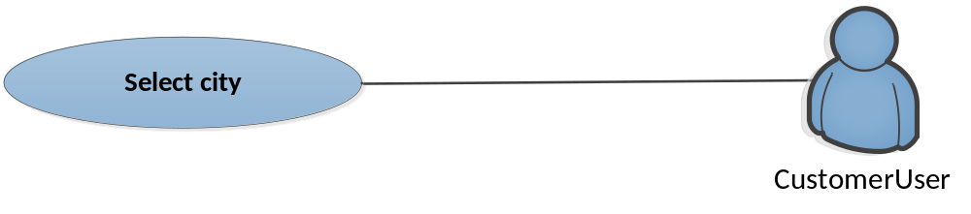
Use Case | Description | Success | Error
UserCase01 | User can select city from map | Get weather report | Get error infomation

Functional Component Design (Outline)

Non-Functional Requirements

ID | Name | Description | Requirement No.
NFR001 | Github | Use Github as a code manage systen | BR003
NFR002 | Maven | Use Maven as developing tool | BR004
NFR003 | Github delivery | Use Github as delivery communit | BR006
NFR004

The Non-Functional Requirements for a business system address aspects of the system that, not directly affecting the functionality of the system as seen by the users, it can have a profound effect on how that business system is accepted by both the users and the people responsible for supporting that solution.

Functional requirements drive the analysis, Non-Functional Requirements and usability requirements drive the architecture.

Architecture Requirements

All requirements have been split into functional and non-functional requests. Functional requirements can be viewed in 7.4 and non-functional section 9. Business requirements have been highlighted in section 7.3 but are also listed in the main non-functional section.

Maintainability

This paragraph specifies the maintainability requirements of the system.
- Use HTML and javascript in view side.
- Use Struts2 in control side.
- Use Java as server side language
- One JavaBean as server API communication.
- One JavaBean as server API communication(connect backup API).

Business Constraints

This paragraph specifies the business constraints that the system must satisfy.
- none

Technical Standards

This paragraph specifies the technical standards to which the system must conform.
- Comply with the Web2.0 standard.
- Comply with google geoChart API functions and components.

Technical Constraints

This paragraph specifies the technical constraints that the system must satisfy.

Architecture Model

No need to deploy in production environment.

Architecture Decisions

Name | Description of Reason
AD-001 | Use Baidu API weather as webService API.
AD-002 | Use Google API as backup WebService API
AD-003 | User google geoChart API as JS package to draw

Architectural Decision AD-001

Subject Area | Baidu API | Topic | webService
Architectural Decision | Use BaiduAPI as webService API to provide our wether Information | ID | AD - 001
Issue or Problem Statement | Open source API for all users. But maybe some times it will be shut down.
Assumptions | Each customer is online & baidu API is running.
Motivation | .
Alternatives | Option 1 – Baidu API  Option 2 – Some other API provider.  Option 3 - Google API
Decision | Use option 1
Justification | It is provided by Baidu, more stable then other providers, compare with google API it will be more quickly, and google API is not allowed in China
Implications | None.
Derived requirements | None
Related Decisions | None

Architectural Decision AD-002

Subject Area | User Google API as backup webservice provider | Topic | webService
Architectural Decision | In case , the primary webservice provider down, we need another webService provider as backup server. | ID | AD - 002
Issue or Problem Statement | More slowly and not allowed in China
Assumptions | The primary provider is down. And the customer is location not in China
Motivation | It is extend for the project
Alternatives | Option 1 - Google API as server provider
Decision | Use option 1
Justification | This is backup provider in case some situation we can not
Implications | The knowledge of front-end malicious code and JS is required.
Derived requirements | None
Related Decisions | None

Architectural Decision AD-003

Subject Area | Google geoChart | Topic | UI customization and integration
Architectural Decision | Google geoChart is free API, It is more easy to use . | ID | AD - 003
Issue or Problem Statement | Google API is more slow to load, when user load page, if there is some internet issue
Assumptions | The internet environment works fine.
Motivation | geoChart fashion facilitates customer's business process.
Alternatives | Option 1 –google geoChart.  Option 2 – D3.
Decision | Use Option 1
Justification | geoChart is more easy to use, and D3 will be draw chart by user’s experise.
Implications
Derived requirements | None

User Interface Architecture

Please see Section 7.1 which contains the User Profiles and the Activities for each role. Please also refer to section 7.6 for a detailed workflow diagram or the PriceBook Online quote process. This clearly shows the User Interface Architecture.

Data Requirement

Logical Data Model

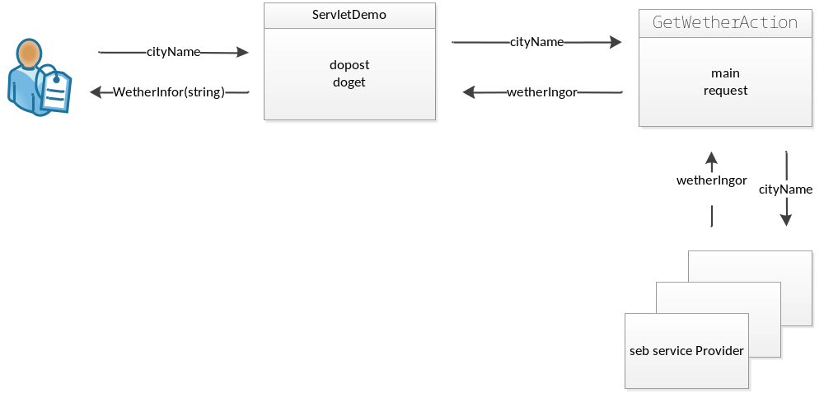

Business Objects

No need

Master Test Plan & Test Cases

This section contains the Master Test Plan for the e-solution being developed.

Its purpose is to answer such questions as “what will be tested, how will it be tested and who will do it and when”. It documents testing scope and objectives, test levels, test team roles and responsibilities as well as the test plan and schedule.
Test plans to be added post Feasibility check.

