Login 2
WSE leave and late policy 4
Your Manual 5
IMT_Requester Operation Manual 5
IMT_LeaveAdmin Operation Manual 5
IMT_PL Operation Manual 5
IMT_PM Operation Manual 5
IMT_Admin Operation Manual 5
IMT_DBAdmin ( to be continued) 5
Requester 6
Apply for holiday leave: 6
Regular 6
Contractor 8
Note: 11
Check your leave details 12
IMT_PL 13
Apply for holiday leave 13
Check your leave details 13
Check your team members' leave details 14
Apply for OT request for your team member 15
Check your team members' OT request details 15
IMT_LeaveAdmin 16
Apply for temporal leave for team member 16
Send notification 17
New urgency 18
New training 18
New absence 19
Check all team members' leave details & Search and export all leave requests 20
Data management 21
IMT_Admin 22
User management 22
Team management 24
Application setting 25
IMT_PM 26
Deal with all team members' holiday leave and OT requests 26
Check all team members' leave details 28
Apply for urgent holiday leave for team member 29

Weather project download
https://github.com/Vincent1984/testWether

DownLoad War file
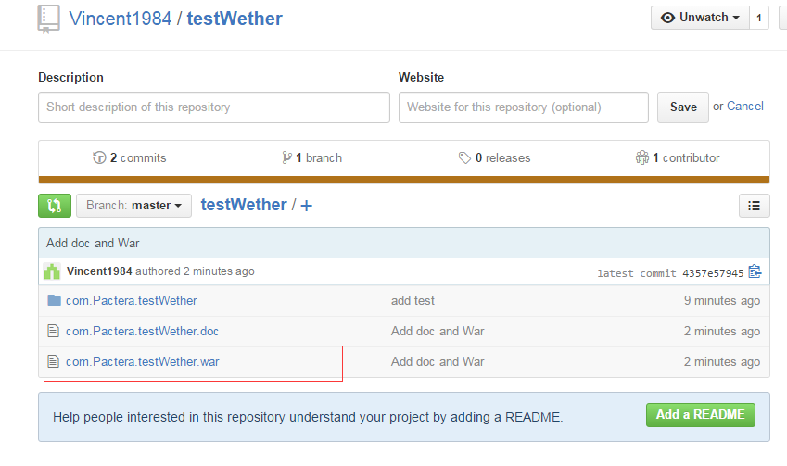

Put this file under tomcat server. Then customer can view this project

http://localhost:8080/com.Pactera.testWether/index.jsp

Then customer can see the following picture
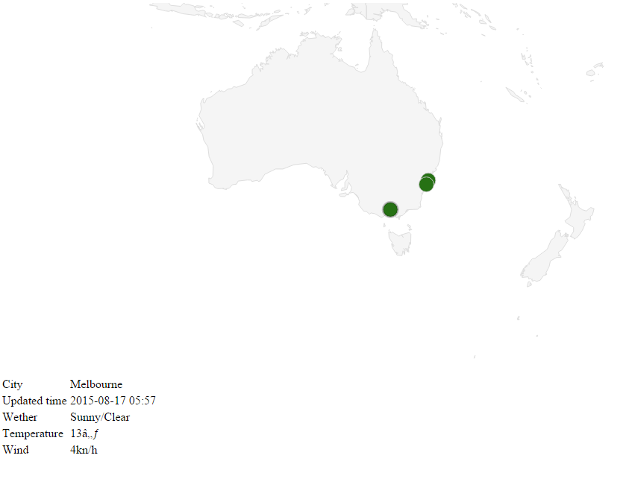

Cstomers can click the city in the map ,then the weather report will shows below the map

Demo:
You can also view this project by using my demo link which build in Sina Cloud :

http://testwether.sinaapp.com/

WeChar:
You can follow WeChat public number with interest by screen the following :


Then you can type city Name and send . as Sydney

