How to play Clanker

Introduction
Clanker is a shooting game where the player uses an AR-style fake gun to shoot robots.
The game is played through a scope, where enemies can be located and eliminated.
The main objective is to achieve the highest number of kills possible by aiming and shooting enemies that appear in the environment.

Starting the Game
To start the game, follow these steps:
- Turn on the device using the power switch located on the right side of the gun.
- Hold the gun in a stable position, similar to how a real firearm is held.
- Wait a few seconds for the system to initialize.
- When the white grid appears inside the scope, the game has successfully started.
- Once the grid is visible, the player can begin moving and shooting.

Power Switch
The power switch is marked in the diagram (orange circle).
This switch is used to turn the system on or off.

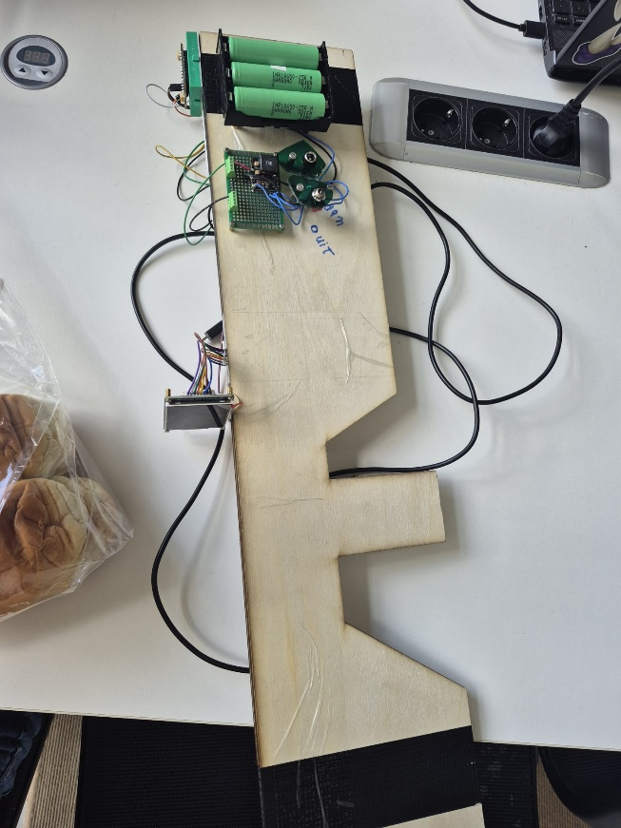
Right side of the Clanker shooter.

Scope and IMU
The scope is located at the top of the gun. It is the main visual interface of the game, where enemies and the environment are displayed.
Inside the top section of the gun, the IMU (Inertial Measurement Unit) is installed.
This sensor is responsible for tracking orientation and movement of the gun.
Important:
For correct calibration, the gun must be held straight during startup so that the IMU can properly initialize.
- Orange circle: Scope display area
- Green area: IMU location

On the top of the gun is the scope where you can see your enemies and is the IMU located which should be on a straight line from your body for start up as said above.

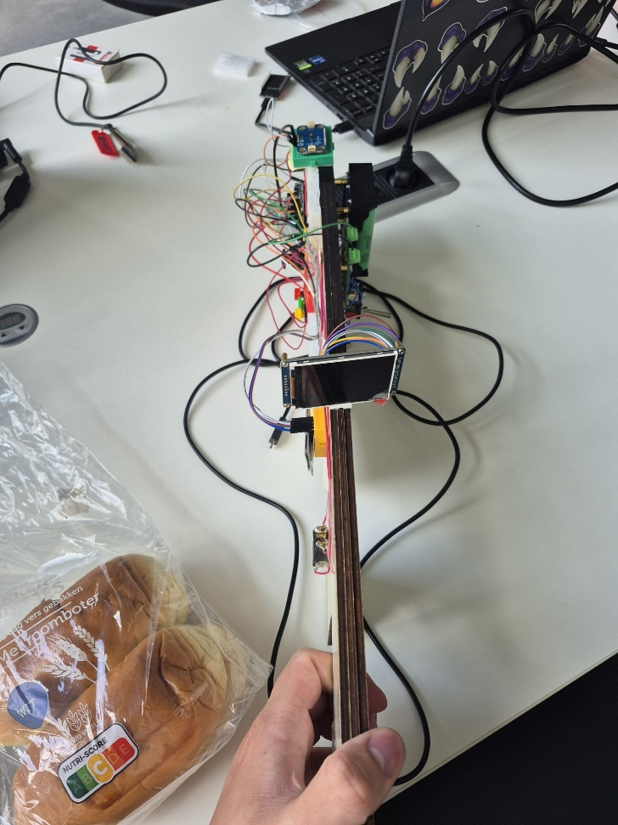
Top view of the Clanker shooter.

Controls and Gameplay Functions
During gameplay, the player has access to several controls:
- Joystick (blue circle):
Used for moving forward and backward.
- Trigger (green circle):
Used to shoot enemies.
- Side buttons (purple circle):
Used for pause, IMU reset, and game reset after death.
- HUD display (orange circle):
Shows remaining ammo and current kill count.

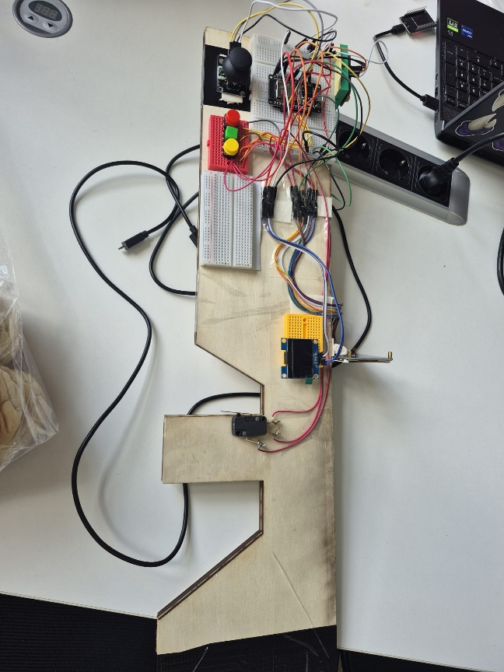
Left side of the Clanker shooter.

Objective
The main objective of Clanker is:
- Locate enemies through the scope
- Aim accurately using the gun’s orientation
- Shoot enemies to eliminate them
- Achieve the highest possible kill count

Device Overview
The left side of the device contains most of the functional controls and feedback systems.
This includes:
- Movement joystick
- Action buttons (pause, reset, restart)
- Trigger system
- Display for ammunition and kill tracking
The system is designed to simulate realistic aiming and movement using sensor-based tracking.

