Summary Clanker Shooter

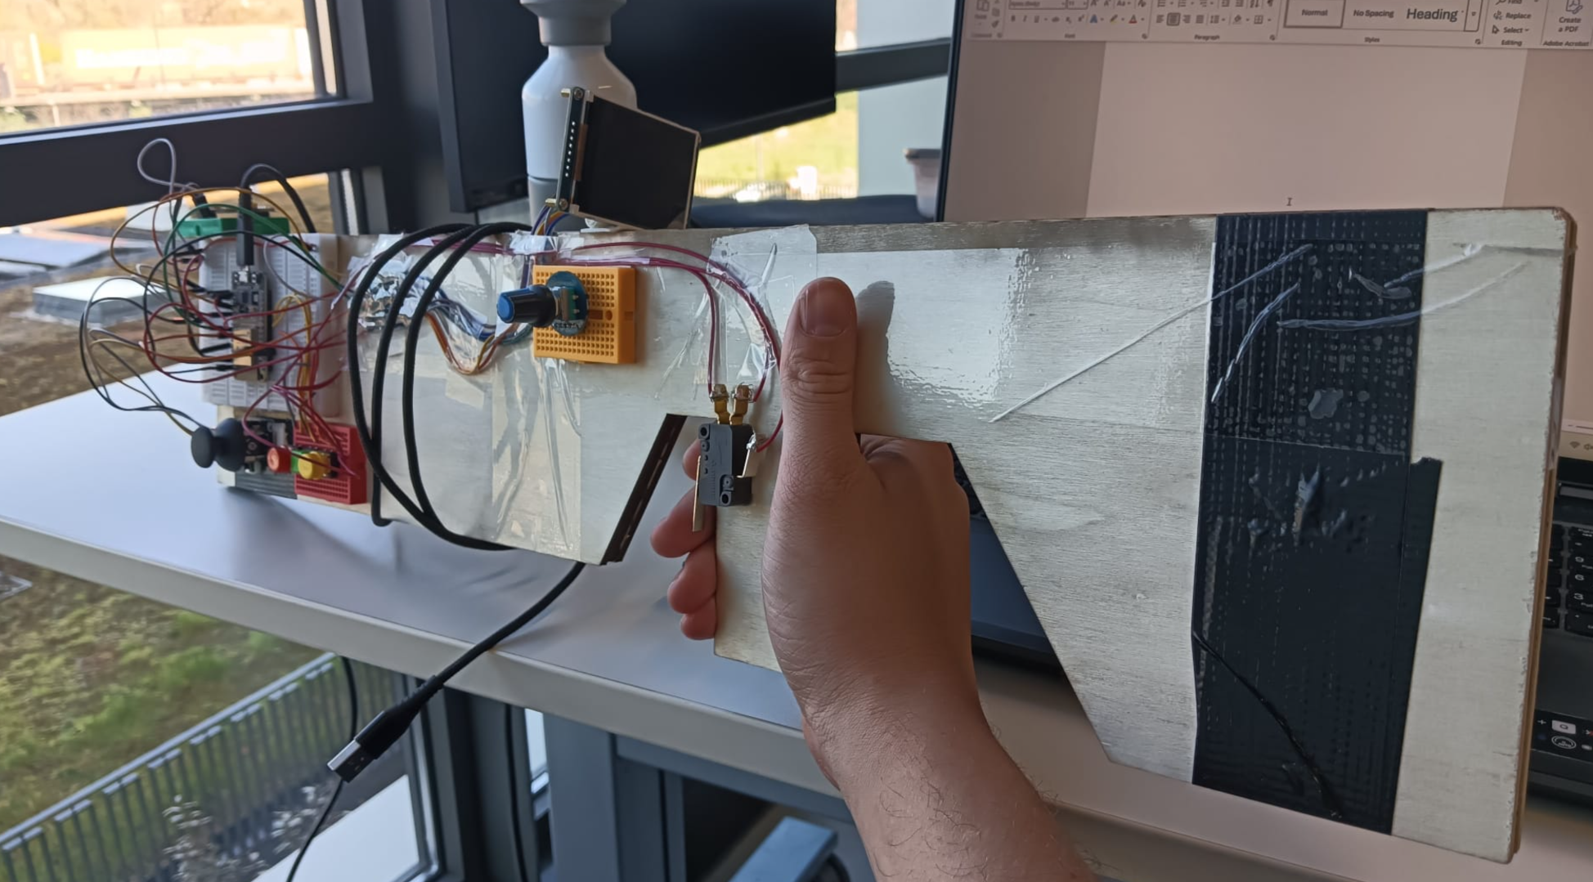

Contents
Introduction 3
Research questions 3
Sub question 1 4
Sub question 2 5
Sub question 3 6
Conclusion main question 7
Additional research and documentation 8
Ssh key 8
Project plan 8
Research 8
Acceptance test 8
User manual 8
IMU documentation 8
Additional work 9
Brainstorms 9
Flowchart 9
UML 9
Pinout 9
Schematic drawing 9
Pipeline 9
Planning and Moscow 10
Planning 10
Moscow 11
Personal review of my personal project 12
Tips for the future 12

Introduction
This document presents the results of the research and development process for the Clanker Shooter project. It contains the answers to the main research question and its three sub-questions, along with explanations of design choices, technical trade-offs, and implementation decisions made during the project.

The project focuses on developing a low-latency handheld AR shooting device, combining hardware and software to create a responsive and immersive gameplay experience.

The document also includes supporting materials such as planning documents, diagrams, technical documentation, and additional research outcomes. These sections provide further insight into the design process, hardware choices, and system architecture used in the project.

Overall, this report reflects both the research and practical development of the Clanker Shooter system, showing how the final design was achieved through performance, simplicity, and real-time responsiveness.

Research questions
I have one main question and 3 sub-questions. Some questions are answered more briefly than others because my research went agile to different topics. But the question are:

Main: How can a low-latency, immersive AR-gun prop be developed using a processor and real-time sensor fusion to create a responsive 360-degree shooting experience?

1 Sub: How can a handheld AR-gun prop be designed to facilitate "walking around" in a 2x2 meter virtual space, and what are the trade-offs between physical movement (IMU-based pedometric) and virtual movement (Joystick/Button input) for player immersion?

2 Sub: What are the technical trade-offs between a Microcontroller (ESP32) and a Single Board Computer (Raspberry Pi, Jetson) regarding power consumption, boot time, and graphical processing for a handheld AR device?

3 Sub: What are the performance implications and visual trade-offs of using a 2D "billboarding" sprite engine compared to a 3D perspective projection when rendering entities on a small display?

Sub question 1
The first sub-question I worked on at the begin looking at what would be a good way to make the movement for my game.

The question:
How can a handheld AR-gun prop be designed to facilitate "walking around" in a 2x2 meter virtual space, and what are the trade-offs between physical movement (IMU-based pedometric) and virtual movement (Joystick/Button input) for player immersion?

In short the answer I came on is For this project, the LSM6DSOX IMU will be used for orientation, combined with joystick-based movement for navigation. This hybrid system effectively balances immersion, accuracy, and feasibility within a small 2×2 meter physical space. Prototyping confirmed that 360-degree aiming feels natural with the IMU, while joystick movement is not working ideally yet, but is expected to be the best solution for the Clanker Shooter.
If you want to go more in depth about this question, you can find it in the document “Research.docx”

Sub question 2
The second sub-question I didn’t answer in the research document because I came very quickly on my answer.
The question:
What are the technical trade-offs between a Microcontroller (ESP32) and a Single Board Computer (Raspberry Pi, Jetson) regarding power consumption, boot time, and graphical processing for a handheld AR device?

For the handheld AR device in this project, the ESP32 microcontroller was selected over a single-board computer (SBC) such as a Raspberry Pi or NVIDIA Jetson.

The ESP32 has a very low power consumption, making it well suited for a battery-powered handheld device. It can also boot almost instantly, allowing the game to start immediately when the device is turned on. This creates a more responsive user experience and improves the overall gameplay feeling.

In contrast, Raspberry Pi and Jetson boards offer significantly more graphical processing power and are capable of rendering more complex 3D environments. However, they require higher power consumption and have longer boot times because they run a full operating system. Waiting several seconds before the game starts would reduce the feeling of an instant, portable gaming device.

The device also uses an Inertial Measurement Unit (IMU) to track the player's gun movement and update the displayed image in real time. This requires the system to maintain a high and stable refresh rate with very low latency. If the hardware cannot process the IMU data and render the next frame quickly enough, the result is dropped frames, stuttering, or delayed updates, which negatively affect the gameplay experience and immersion.

Although a Raspberry Pi or Jetson could produce more advanced graphics, the simple Doom-like game developed for this project does not require that level of graphical performance. The ESP32 provides sufficient processing power while ensuring fast response times, low power consumption, and smooth IMU-based motion tracking, making it the most suitable choice for this handheld AR device.

In theory, if you want low latency and nice graphics, you could also use an ESP32 for the hardware handling, which then talks to a Raspberry Pi or Jetson for vision display. But this costs an extra board and way more complexity and coding.

Sub question 3
The third and last sub-question I didn’t answer in the research document because it depends directly on the hardware choice made in the previous section.

The question is:
What are the performance implications and visual trade-offs of using a 2D "billboarding" sprite engine compared to a 3D perspective projection when rendering entities on a small display?

Because the system uses an ESP32 microcontroller instead of a Raspberry Pi or NVIDIA Jetson, the rendering approach is strongly constrained by available computational power and memory bandwidth. The ESP32 does not include a dedicated GPU for real-time 3D rendering, which makes traditional 3D perspective projection significantly heavier in terms of CPU load.

A 2D billboarding sprite engine, on the other hand, simplifies rendering by using pre-rendered sprites that always face the camera. This removes the need for complex 3D geometry calculations. As a result, it is much more efficient in terms of processing time and allows the system to maintain a stable frame rate, which is essential for smooth IMU-based tracking.

If you want both worlds, 3D rendering and fast IMU and other hardware handling, then both boards are the better option.

Conclusion main question
Now all the sub-questions are answered, the main question can be answered.
The main research question was:
How can a low-latency, immersive AR-gun prop be developed using a processor and real-time sensor fusion to create a responsive 360-degree shooting experience?

Based on the research and implemented prototype, the solution is achieved by using an ESP32 microcontroller combined with a joystick-based input system for walking.

The ESP32 was chosen because it provides very low latency, low power consumption, low cost, and fast boot time, which are all essential for a handheld and battery-powered device. In addition, the ESP32 allows for faster development and simpler software implementation using two boards, which is important within a limited project timeframe.

Instead of relying on more complex hardware such as a Raspberry Pi or NVIDIA Jetson, the design prioritizes responsiveness over graphical performance. While SBCs offer significantly better graphics capabilities, they also introduce higher cost, longer boot times, and increased system complexity.

Overall, the system achieves its goal by prioritizing low latency, simplicity, gameplay feeling, and fast development time over graphical fidelity and system complexity. This makes the ESP32 ideal for a real-time AR shooting experience.
I suggest looking at the demo and playing the demo, as it is a fun game .

Additional research and documentation
Next to this, I also made other documents and research. Below I will explain each and why.

Ssh key
Before I could start with my project, I was stuck with an SSH key problem on git. After I solved it, I made a small document that shows how to solve it quickly. To make sure I don’t use as much time as last time. You can find it in “HowToFixingMySshKey.docx”.

Project plan
After I did some brainstorming and the SSH key worked I made my project plan. Where I planned the whole project in more depth, and in which tasks should be handled for this project. For more In depth of my project plan, you should look at “Projectplan.docx”. Lower in this document, I will also write about Moscow and the planning of the project.

Research
There is one research file where sub-question one is answered. The plan was to answer all the sub-questions in this document. But because the focus of the project changed to a more building course and making the diagrams and IMU. And the other two sub-questions were very fast answered it only consists of the questions and research of the first sub-question. You can find it in “Research.docx”.

Acceptance test
When I got halfway, I found out that I had finished most of the must-haves and was working on the should-haves. I talked with Martin and said an acceptance test would be useful. This shows the acceptable state of the parts. You can find it in “acceptanceTest.docx”.

User manual
As I was adding more and more features and I let other people try my game, I found out I needed to explain some parts. I made a user manual to let people play even if I am not present to explain which parts of the gun handle which. This can be found in “HowToPlayClanker.docx”.

IMU documentation
In later sprints, Martin was curious about my IMU and how I use it. On which I made a small explanation documentation about my IMU and why I use this IMU instead of others and a bit more about IMU’s its in “DocumentationIMU.docx”.

Additional work
I also did some work which are not research and documentation. Such as a pipeline and diagrams.

Brainstorms
Before making this project, I did a few brainstorms on what I wanted to make for my personal project. The Clanker shoorter came out of it. But it was then a bit more brainstormed for a clearer project definition for the project plan later.

Flowchart
I also made a flowchart to show how the game handles it self when played. This was made around the middle of my project when I started with my code.

UML
Also, a UML of my classes and a few pictures of my classes code.

Pinout
If you want to remake the gun or add or change it. It is important to understand where wires and parts are connected to each other. As the components are a bit far away from each other.

Schematic drawing
Next to the pinout there is a general schematic drawing which shows the components and the general place on the gun.

Pipeline
As last there is also a pipeline for git. Which if you try to push your code, it builds it and its is successful, it may be pushed. So the code in git always is clean and should work.

Planning and Moscow
At the start of my project in my project plan, I made a planning and a Moscow. Now, to look back, I followed it, and it indeed went as expected.

Planning
I followed my planning very well. Except in total, I had 17 days, which I underestimated in how short it was. Because of that, the research part was a lot shorter than normal. But all the technical parts went as planned. Below you can see my global planning from the project plan.

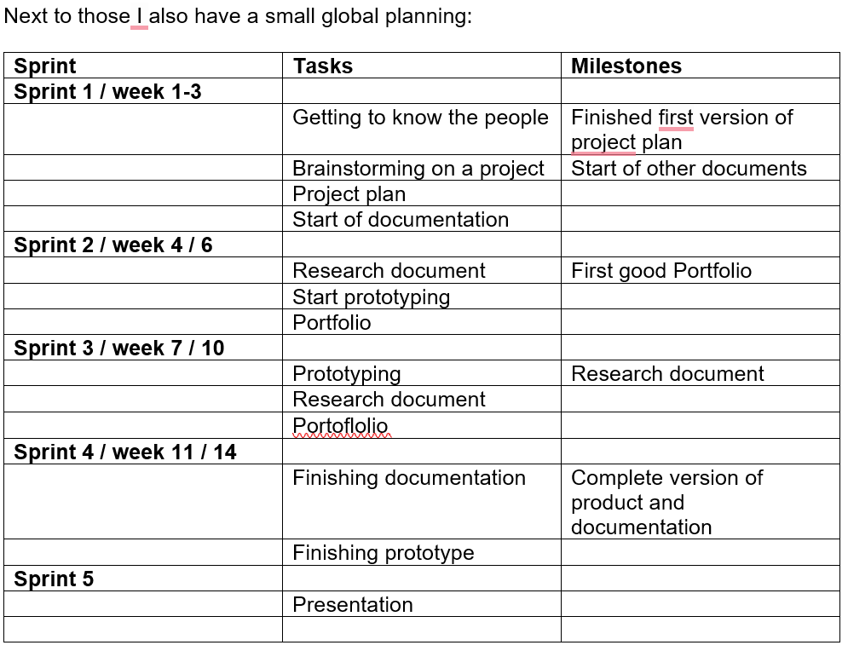

Moscow
As for Moscow, I worked very well within the planning. First, I made the must-haves. Then I talked with stakeholders and some people who played my game and asked what would you like to see to make it more engaging for them. For example I made a pause button, reset game button, reset IMU button, extra display showing bullets and kills, and joystick movement.

Green is done, Red is not done. Below is the Moscow:
Must have | Should have | Could have | Wont have
One person plane | 360 degrees, two planes | Box 360 degrees x 360 degrees | Full VR room scale movement
Circles you aim and shoot and disrepair | Circles that come to you | Clankers that come to you
Trigger and reload buttons | Zoom (pot meter) | Vibration feedback
 | Fire mode switch  (one bullet, semi, auto)W | HDMI output for spectators
 |  | Grenade launcher module
 |  | USB extension module

Personal review of my personal project
Personally, I really liked working on this project. Because I could plan it myself and make it the way I wanted and expected it to go. Especially since I have a physical AR play gun. As a review, looking back, I should maybe have done more research and documentation. But I don’t regret my choices, as coding and making the game work better, working in iterations and letting people play and work on those features again, was very fun.

Tips for the future
For future development, there are several aspects that I would address if the project is extended further.
One important improvement would be to design and solder a custom PCB. At the moment, the prototype uses loose wiring, which can become unreliable during movement. When the device is shaken too much, it can occasionally shut down or crash due to unstable connections. A soldered PCB would significantly improve durability and overall system stability.
Another improvement would be to expand the control system by adding vertical movement input, and using tilt detection. This would make the experience more immersive and complete.
At the same time, the current idea of walking within a 2×2 meter area could be removed. A more practical and stable setup would be a seated experience, where the player sits in a rotating chair or stands. This would allow full 360-degree movement by turning physically, while still enabling vertical aiming and tilt. This setup would still feel very immersive and make the game less complex for future extensions. And easier to play the game.
Finally, once the core system is stable, additional gameplay features could be added to enhance the overall experience and make the project more game like engaging.

