Project plan

Clanker Shooter

AV-HIT
Eindhoven

Date : 27-02-2025
Version : 1
Status : In progress
Author : Vincent van Laarhoven

Version

Version | Date | Amendments | Status
1 | 27-02-2025 | Start of the project plan | completed

Table of contents
Contents
1. Project Assignment 4
1.1 Context 4
1.2 Goal of the project 4
1.3 The assignment 5
1.4 Scope 6
2. Approach and Planning 7
2.1 Approach 7
3. Project Organization 9
3.1 Team members 9
3.2 Communication 9
4. Planning 10
4.1 Breakdown of the project 10
4.2 Time plan 11
5. Finance and Risks 12
5.1 Cost budget 12
5.2 Risks and fall-back activities 13
6. Other 14
5.1 Sources 14

Project Assignment

Context
The gaming industry is mostly on the PC. But in the old days, you held a physical controller and experienced. For example, a Wii tennis racket, a steering wheel, or a SpongeBob head. While VR offers immersion, it is also more expensive and not yet a big on the market. My project offers a bridge between these worlds.

Goal of the project
This project aims to bridge the gap of cheaper old handheld games and VR expansive immersion. It aims to do this by creating a standalone AR-gun prop that allows users to engage in a 360-degree shooter game against Clankers (robots) using physical movement and an integrated scope display.

Design and develop a handheld AR weapon system. The player must be able to look through a physical scope to see a digital world where robots attack from all directions.

Core Hardware Requirements:
- Brain: ESP32 (due to built-in Bluetooth/Wi-Fi and low power) or Raspberry Pi / Jetson (if high-end graphics are needed).
- Visuals: A display integrated into the scope.
- Tracking: Gyroscope/Accelerometer/Magnetometer
- Tactile Input: Physical buttons for Trigger, Reload, Reset, and a Potentiometer for variable Zoom.

The assignment
This MoSCoW analysis is based on the project goal and may be subject to change as I gain more insights into the needs of the project.

Below you can see the table that uses the Moscow strategy.
Must have | Should have | Could have | Wont have
One person plane | 360 degrees, two planes | Box 360 degrees x 360 degrees | Full VR room scale movement
Circles you aim and shoot and disrepair | Circles that come to you | Clankers that come to you
Trigger and reload buttons | Zoom (pot meter) | Vibration feedback
 | Fire mode switch  (one bullet, semi, auto) | HDMI output for spectators
 |  | Grenade launcher module
 |  | USB extension module

Scope
This chapter concerns the scope of the internship. The scope details the boundaries during our process, what will and what won’t be done. And the requirements detail a list of the desires of the product owner.

The project includes: | The project does not include:
A prototype module of the must-have | Full VR room scale movement
A plank that depicts the gun prop | .

Approach and Planning

Approach
For this project, the Agile Scrum software development methodology will be used. It enables us to respond quickly to changes and deliver working solutions efficiently.
A key aspect of Agile is the Scrum framework, which organizes work into time-boxed iterations called sprints.

The project is divided into 5 sprints, each of which takes 3 weeks. allowing enough time to move from a hardware concept to a functional C++ feature. To manage my tasks and maintain a clear overview of the Backlog, I will use a GitHub Issue Board. Each subsystem/model will get its own issue. For example, sensors and documents will all get a task/issue to work on.
Research questions
Main: How can a low-latency, immersive AR-gun prop be developed using a processor and real-time sensor fusion to create a responsive 360-degree shooting experience?

1 Sub: What are the technical trade-offs between a Microcontroller (ESP32) and a Single Board Computer (Raspberry Pi, Jetson) regarding power consumption, boot time, and graphical processing for a handheld AR device?

2 Sub: What are the performance implications and visual trade-offs of using a 2D "billboarding" sprite engine compared to a 3D perspective projection when rendering entities on a small display?

3 Sub: How can a handheld AR-gun prop be designed to facilitate "walking around" in a 2x2 meter virtual space, and what are the trade-offs between physical movement (IMU-based pedometry) and virtual movement (Joystick/Button input) for player immersion?

Project Organization

Team members
There are multiple stakeholders in this project. Below there is a table of people and where to find them.
Name + Phone + e-mail | Abbr. | Role/tasks | Availability
Martin Roa Villescas + m.roavillescas@fontys | Assessor 1 | Assessor 1 | At TQ, Teams, and mail
Jan obbelsteen + 31885071694 + j.dobbelsteen@fontys.nl | Assessor 2 | Assessor 2 | At TQ, Teams, and mail
Belle,Joeri J. van + +31885082297 + j.vanbelle@fontys.nl | Coordinator | Coordinator | At TQ, Teams, and mail
Vincent van Laarhoven + 06 81037862 + v.vanlaarhoven@student.fontys.nl | Developer | Developer | At TQ the whole week. Of Via email, teams of telephone.
Edwin van den Oetelaar + e.vandenoetelaar@fontys.nl + 31885070034 | Expert | Expert | At TQ, Teams, and mail

Communication
Most communication is going through face to face. if can't find a person or want to schedule a meeting, then use mail or teams.

Planning

4.1 Breakdown of the project
Below you can see a breakdown of the project in a global planning.

Git: https://github.com/Vincent23431/ClankerShooterSem7

Git isseu board: https://github.com/users/Vincent23431/projects/2/views/1?system_template=kanban

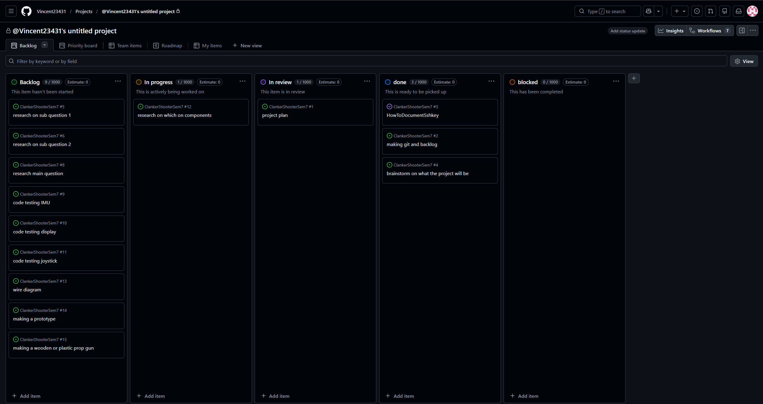
Image of the issue board

Next to those I also have a small global planning:

Sprint | Tasks | Milestones
Sprint 1 / week 1-3
 | Getting to know the people | Finished first version of project plan
 | Brainstorming on a project | Start of other documents
 | Project plan
 | Start of documentation
Sprint 2 / week 4 / 6
 | Research document | First good Portfolio
 | Start prototyping
 | Portfolio
Sprint 3 / week 7 / 10
 | Prototyping | Research document
 | Research document
 | Portoflolio
Sprint 4 / week 11 / 14
 | Finishing documentation | Complete version of product and documentation
 | Finishing prototype
Sprint 5
 | Presentation

4.2 Time plan
To divide my project plan into phases, There will be 5 phases to the project. Each
phase takes as long as each sprint to make it easier to plan and keep track. As the
project will work with Agile, some of the planning parts and phases may take more or
less time. Or be decided on a different course. As the project is not working in
Waterfall, the planning is not set in stone. The effort planning on giving for the project
will be 100% so that every part should be in a good state. You should always try to do
your best in every part of the project. And do not neglect an important part.

Phasing | Effort | Start | Ready
1 Orientation phase | 100% | Week 1 | Week 3
2 Problem analysis phase | 100% | Week 4 | Week 7
3 Development | 100% | Week 7 | Week 10
4 Completion phase | 100% | Week 11 | Week 14
5 Evaluation phase | 100% | Week 15 | Week 17

Finance and Risks

Cost budget
As for the costs, there are multiple parts that could be needed. Such as: development board, Gyro, display, and prototyping materials (wires, bread bords, etc).
But as a student from Fontys ICT you can borrow materials from the ISSD for testing. So that only the final product needs to be bought. This can all depend on which indicators are bought and which board is chosen. At such there is not enough information to know it yet. And the developer Vincent (me) has some parts at home which will be worked on first. I plan to try make it from my own materials or buy some from Tiny Tronics. But testing with ISSD
Software tools are also needed, such as PlatformIO, Python, and C/C++ platforms. Luckily most of these are free.

Risks and fall-back activities
There are also multiple risks in this project. It is impossible to know all the risks beforehand. But the ones with high probability there will be a small prevention and fall back plan for. So there are not all risks written on such as the building will be on fire.
Below in the table, you can see the risks and solutions.
Risk | Prevention activities included in the plan | Fall-back Activities
1. Absence of Company Supervisor | Have a second assignment I can work on. | Consult with a other supervisor.
2. I have a illness which disrupts the planning | Have buffer week at the end of the planning. | Ask for an extension
3. Technical parts break down | Have some backup materials | Order with next day delivery a new part. Or borrow from the ISSD department a temporary replacement.
4. Stakeholder Misalignment | Engage stakeholders early and make contact. Ask for contact information of the stakeholders. | Increase communication efforts to address concerns. Adjust project deliverables based on stakeholders feedback.
5. Resource constraints | Have a raspberry on stand by if testing on Linux is needed. | Ask stakeholders for more components. Discuss a schedule or time with the SDC team when I can use resources.
6. unclear communication channels | Establish clear communication protocols, such as mail and teams. Have regular stand-ups. | Ask for a team-building activity.
7. Failure to meet project deadlines | Make a realistic sprint planning. Monitor progress regularly. | Reassess project priorities and adjust schedules. Communication with stakeholders about potential impacts and delays or changes.

Other

5.1 Sources

Hbo-I. (z.d.). ICT Research Methods — Methods Pack for Research in ICT. ICT Research Methods. https://ictresearchmethods.nl/dot-framework/

Slawek-Polczynska, A. (2020, 26 november). Is Agile always the best solution for software development projects? SolDevelo. https://soldevelo.com/blog/is-agile-always-the-best-solution-for-software-development-projects/

