How To making a new ssh key
I followed the “Gitlab SSH access steps v26-9-2024.pdf” tutorial.
My ssh key was expired and needed a new one.
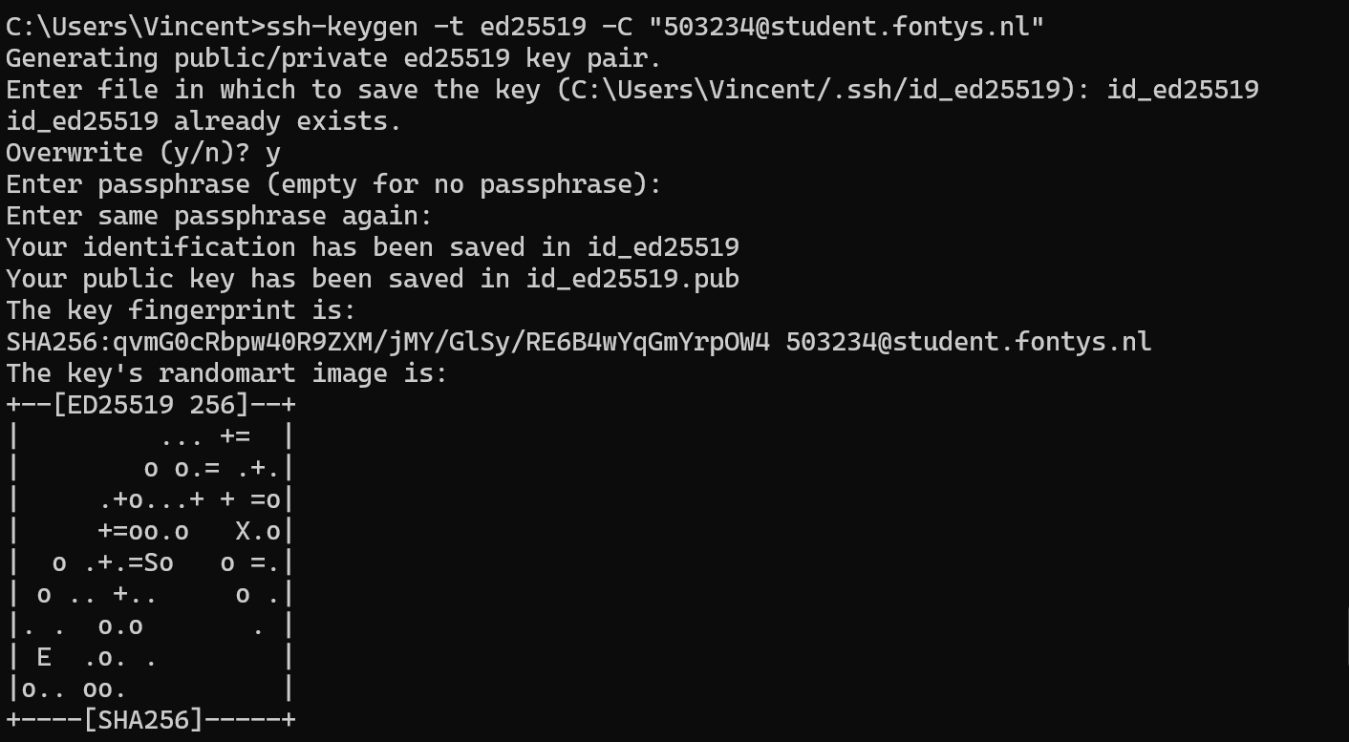
fastest way to find it is with “windows key” and “R key” then look for the file it is saved in.
Take the .pub file and open with notepad and you have the key.
Don’t forget to delete the first ones else there will be a overlap and the new key wont be accepted.
