# Feature Roadmap and LLM Agent Briefing
This entire document is written in markdown formatting for agent ease of reading, but make sure to read copy paste images inside this document
First, write out a plan on how to achieve the road map, so another agent can pick up when you run out of tokens in a tag team fashion. Then, return this updated roadmap to github and strike through every completed task
# Intro screen
See image – boot screen dice needs to be bigger and have a small console log which records the roll. A nice way to test the physics engine
Right now, the
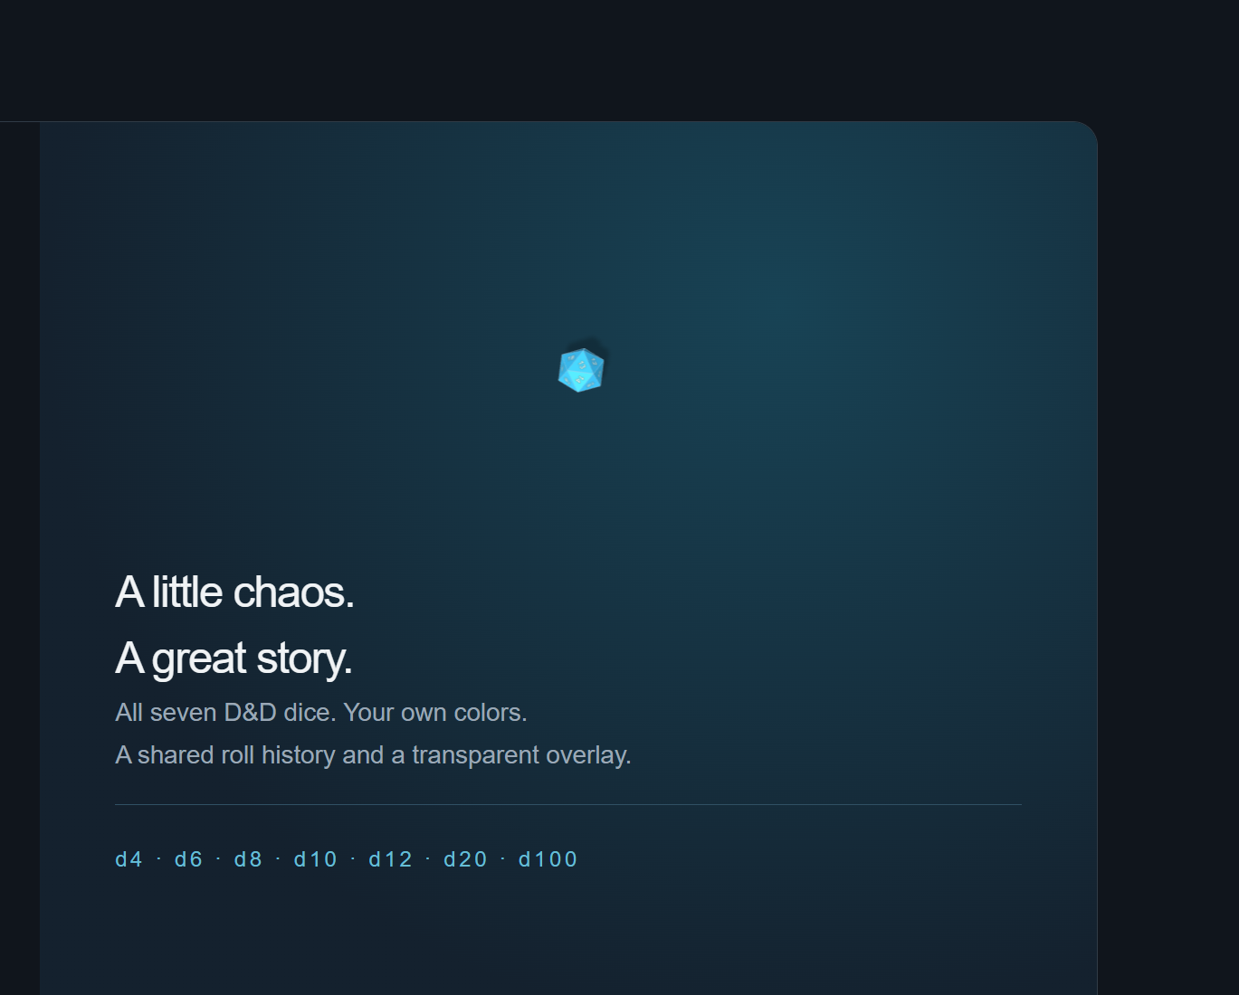
Right now, the dice seem to be unable to roll outside of the area marked blue – I would like the physical table and roll area to always extend to the full area of the container

Change the text here
Title: DnD Sundays 2026: Dungeons of Drakkenheim
subtext: It’s just another day, just another job... in the DUNGEONS OF DRAKKENHEIM!
the dice accent line must be: SIX – SIX – SIX – THE STAR GODS HUNGER – SIX – SIX -SIX

# Main roll table
Current
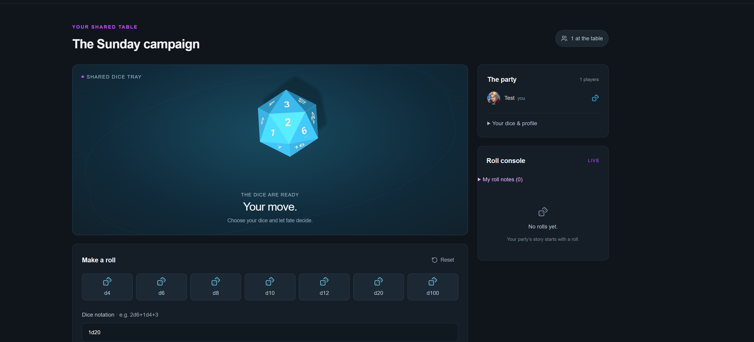
fixes: The dice are too big. See below mockup for a good dice size to container ratio
The dice cannot roll across the entire container – make the full container (marked green here) party of the physical table
Change SHARED DICE TRAY to : Last Roll: [PlayerName] in their accent color
