1. Supervised Experiment

2. Unsupervised Learning Experiment

3. Part 1: VGG16 From Scratch

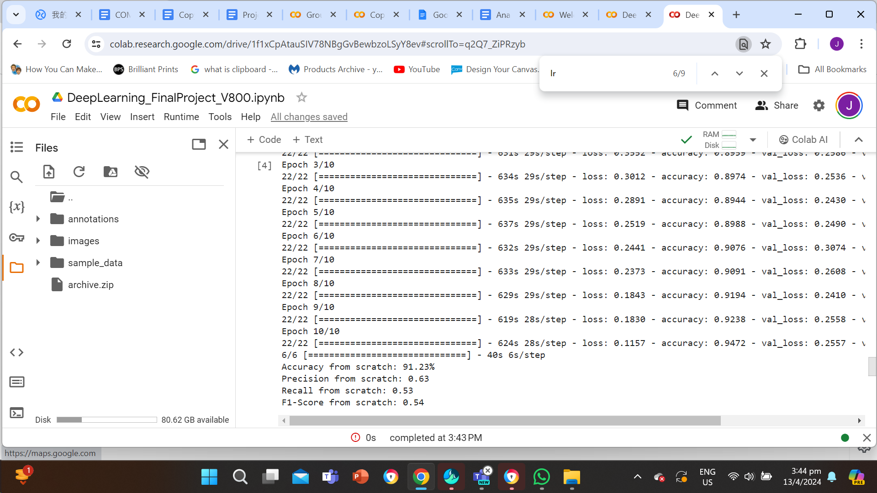

Accuracy from scratch: 91.23%

Precision from scratch: 0.63

Recall from scratch: 0.53

F1-Score from scratch: 0.54

Part 2, VGG16 with Transfer Learning

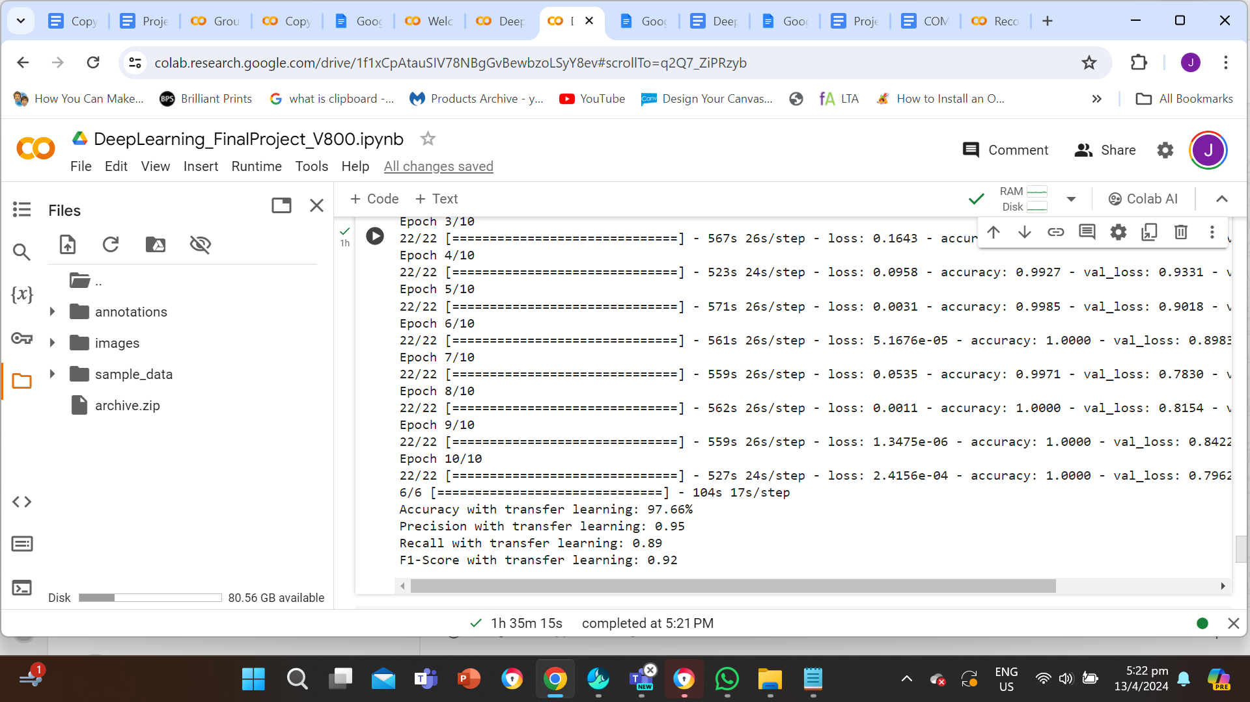

Accuracy with transfer learning: 97.66%

Precision with transfer learning: 0.95

Recall with transfer learning: 0.89

F1-Score with transfer learning: 0.92