Jauntlet

Final Project

Report

I.E.S. San Vicente
San Vicente del Raspeig (Alicante)
2015/2016

Teacher:
José Ignacio Cabanes

Student:
Vicente Cuenca Reyes

1. Introduction
Project name
Jaulent

Made by
Vicente Cuenca Reyes

Short description of the project
This is an adventure game in which you can choose from four characters to get out of the dungeon .

2. Functionality of the project
When you start the game appear a brief history . When finished, the player must choose between the four playable characters and start your adventure.

During the game is to find keys , secret doors and defeat the enemies before they kill him.
The game will feature five levels and a boss to which we will have to kill to get beat the game and score in the ranking.

3. Screen prototype
The game screen will look like this:

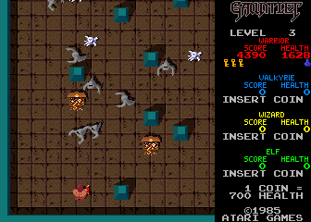

4.Analysis

4a. Requisites
Requisite | Date achieved
Make shots and correct collisions. | 23/05
Add life that comes down over time as heroes | 23/05
And add life to the enemies . | 24/05
Add doors and keys. | 26/05
Correct the scroll to work properly | 23/05
Add food to increase health and break if it receives an attack | 26/05
Add punctuation to kill enemies | 23/05
Make enemies persecute the character and when you remove life collide
Make monsters generators | 31/05
Add to warrior
Add to mage
Add to and archer
Add sound to the game.
Add potions that can be used harming monsters
Homescreen with history
Screen credits and Ratings cooperative play
Make lava levels and hidden rooms ...
cooperative play
Make the final boss ( dragon ) This will be depending on the complexity of one or more days .

4b. Basic pseudocode

//TODO

4c. Classes diagram

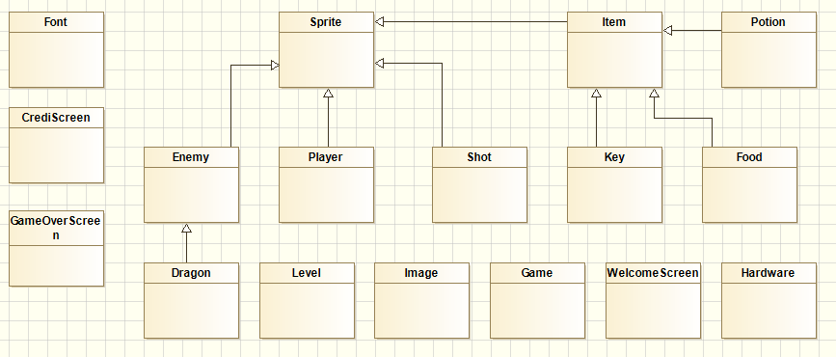

Add class Door : Sprite.
Now Dragon : Sprite.
Add class Generator : Enemy

And Delete class Item because is empty

5. Initial planning and expected deliveries

5a. Expected deliveries

v.1: Make shots and correct collisions.
v.2: Add life that comes down over time as heroes
v.3: And add life to the enemies .
v.4: Add doors and keys.
v.5: Correct the scroll to work properly
v.6: Add food to increase health and break if it receives an attack
v.7: Add punctuation to kill enemies
v.8: Make enemies persecute the character and when you remove life collide
v.9: Make monsters generators
v.10: Add to warrior
v.11: Add to mage
v.12: Add to and archer
v.13: Add sound to the game.
v.14: Add potions that can be used harming monsters
v.15: Homescreen with history
v.16: Screen credits and Ratings cooperative play
v.17: Make lava levels and hidden rooms ...
v.18: cooperative play
v.19: Make the final boss ( dragon ) This will be depending on the complexity of one or more days .

5b. Real deliveries

20/05/2016: Make shots and correct collisions.
Correct the scroll to work properly
23/05/2016: Add life that comes down over time as heroes.
And add life to the enemies .
Add punctuation to kill enemies

24/05/2016 Convert Arrays in List
Generate Instances in fuction the level
Add Class Door
Make metod for Open Door.(not proved)

25/05/2016 Correct errors wich x and Y order altered.
Funcional door.

27/05/2016 Basic Instruction.
Clear door complety.
Funcional Food.

31/05/2016 Fix door horizontal
Destroi food whicht shot
Add Class generator

02/06/2016 Create generator enemies
Logic move enemies to player
Found errors which movement enemies.

6. File formats

6a. Plain files format

The score format:
File. score.txt
--NAME-- --SCORE--
-VINCENT ----10000
-VINCENT ----10000
-VINCENT ----10000
-VINCENT ----10000
-VINCENT ----10000
-VINCENT ----10000
-VINCENT ----10000
-VINCENT ----10000
-VINCENT ----10000

7. Problems found and solutions

8. Improvements or restrictions to the starting design

9. Screenshots of the final project

10. Source code of the final project

