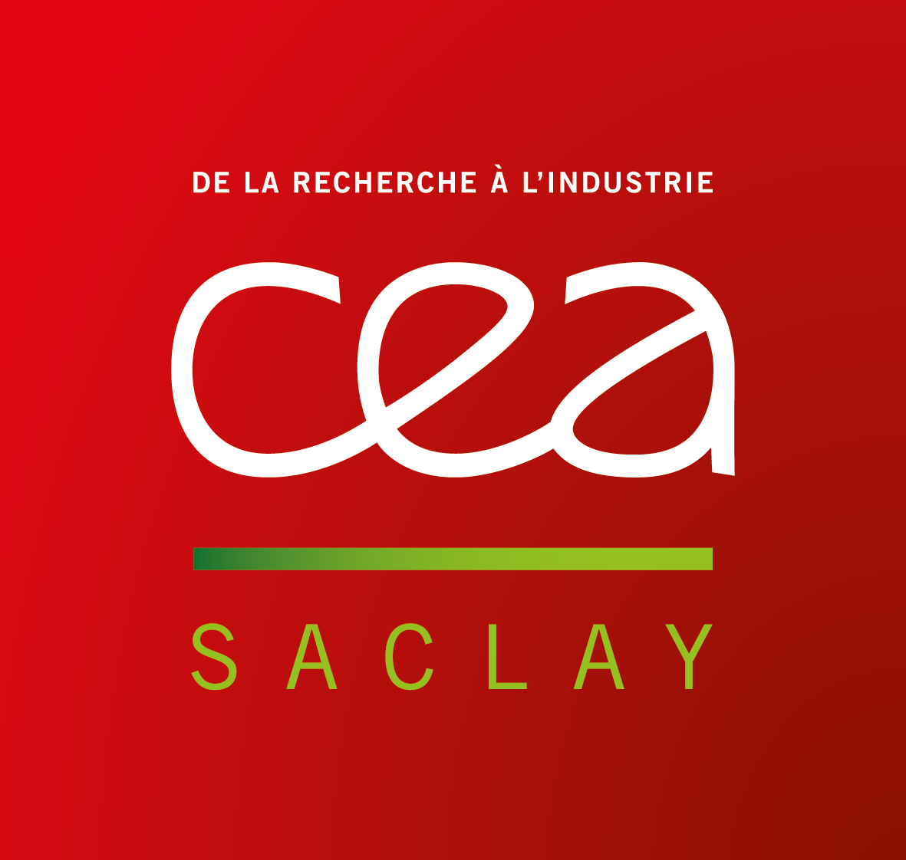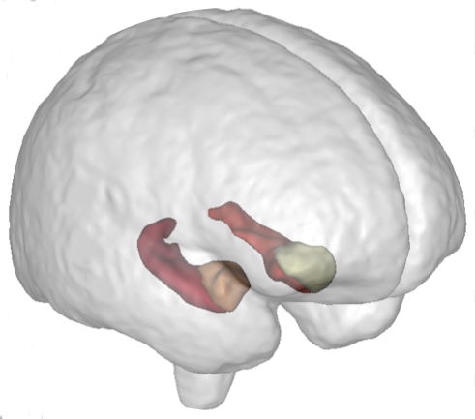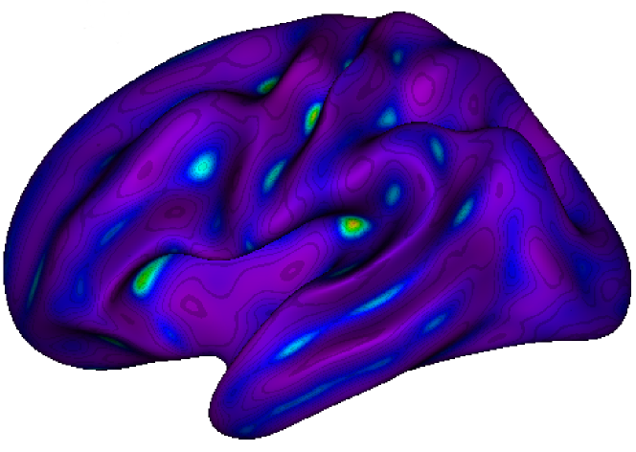

**NeuroSpin** is an outstanding research center on the **Human brain**. Part of the CEA (Atomic Energy Commission) and Paris-Saclay University, the NeuroSpin teams are leaders in very high field MRI carry out studies in **fundamental and clinical neurosciences**. The **BrainOmics** team works in **imaging-genetics**, at the crossroad where **neuroinformatics, bioinformatics** and **machine learning** meet and in collaboration with Gustave Roussy, ICM-La Pitié-Salpétrière, Mondor Biomedical Research Institute.

**Machine learning and radiogenomics in Neuro-Oncology**

In the **BrainOmics** team at Neurospin, the post-doc researcher will work on the conception of **machine learning** models incorporating multi-modal MRI radiomic and multi-omic data. Moreover, he/she will take part to the analysis of patients cohorts in imaging-genetics, about **neuro-oncology pathologies**.

Post-doc Activities

* Data quality control and inspection for each modality separately.
* Train **machine learning** prediction models for each modality.
* **Radiogenomic data integration (imaging and genomics)**.
* **Applications in neuro-oncology**: Primary CNS Lymphoma, pediatric High Grade Glioma**.**

Searched profile

PhD in one of the following fields : Data Science, Machine Learning, Applied Statistics, Radiomics, Radiogenomics, Neuro-Imaging, Genomics. Fluent in english.

Job-related skills

* **Very good skills in statistics and applied mathematics**
* Programming : **Python**, R, Matlab
* **Curiosity, taste for multi-disciplinary environment and for innovation.**
* **Good communication skills, good personal relationship skills.**
* Knowledge in biomedical image analysis and/or genetics and/or oncology is an asset.

Behavioral skills

Good team player, strong motivation, rigor, autonomy and resourcefulness.

Duration**: 2 years**, starting in june 2019.

Location : NeuroSpin-CEA, Plateau de Saclay, Gif-sur-Yvette.

Please email your CV + cover letter **by April 30th, 2019** to [cathy.philippe@cea.fr](mailto:cathy.philippe@cea.fr) and [vincent.frouin@cea.fr](mailto:vincent.frouin@cea.fr)

Aerts *et al.* (2014). Decoding tumour phenotype by noninvasive imaging using a quantitative radiomics approach. *Nature Communications.*

Kickingereder *et al.* (2016). Radiogenomics of Glioblastoma: Machine Learning–based Classification of Molecular Characteristics by Using Multiparametric and Multiregional MR Imaging Features. *Radiology.*