# AndPad

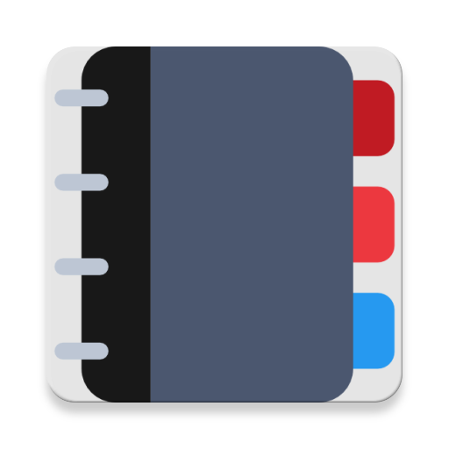

16129125 - UNG CECILE

16129093 - GUIDON VINCENT

16129101 - SELARIES JULIEN

GitHub: <https://github.com/VincentGuidon/AndPad>

This document presents the application “AndPad”, a notepad application for Android realized as a school project at Beijing Jiaotong University.

We are hereby introducing the features and design choices of the application.

We will first review the List View that displays the list of stored notes, then focus on the Note View and lastly talk about other noticeable features.

Brief summary of the features:

- Optimization and Personalization of the ListView;

- Optimized design;

- Media storage (background image);

- Font color change;

- Color picker;

- Sharing option;

- Note deletion;

- Note edition;

- Note saving;

- Splash screen;

- Data storage in files

# I. The List View

## A. Design Overview

*This picture shows the main view of the application: the list of notes.*

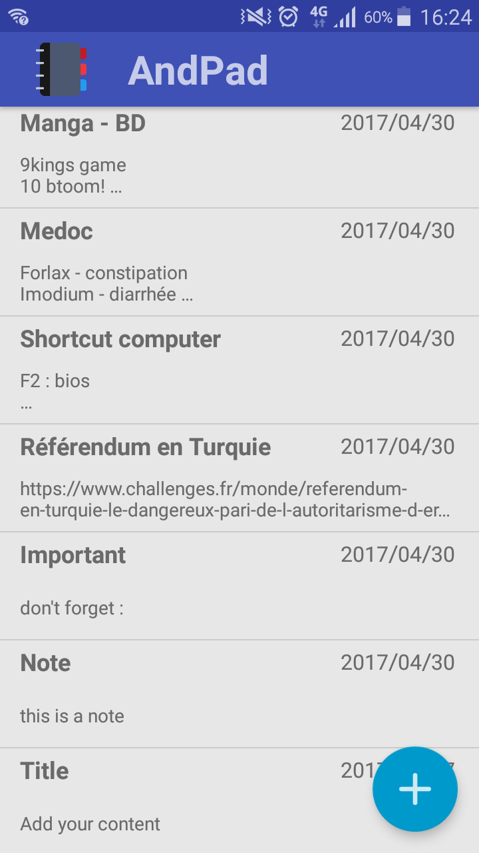

Title – big and bold to highlight it!

Date

Customized toolbar with our logo and app name

Two-line preview of the content

FloatingActionButton to create a new note

## B. Optimization and Personalization

A classic ListView always creates the item and destroys it then when a new item needs to be displayed. A significant number of items causes a problem though, while scrolling, the display speed with slow down and lose significant Frames.

This is how we are recycling the view and reusing it just by editing the text:

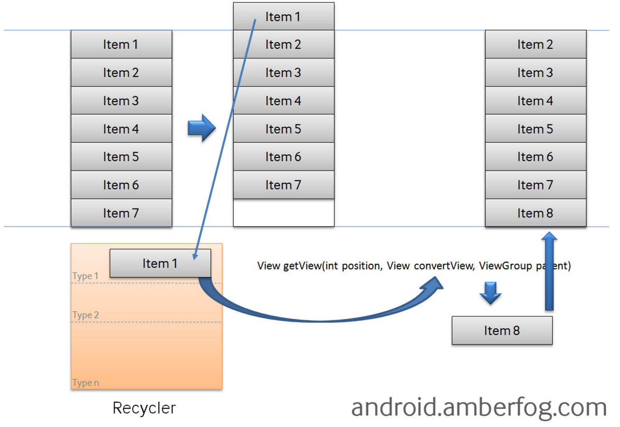

# II – Note View

## A. Note View overview

Note Deletion

Return

Note title

Save

Menu – Menu once displayed

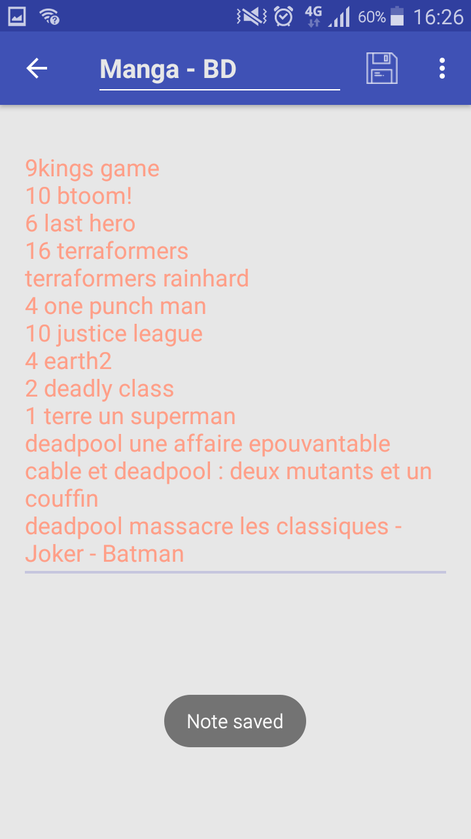

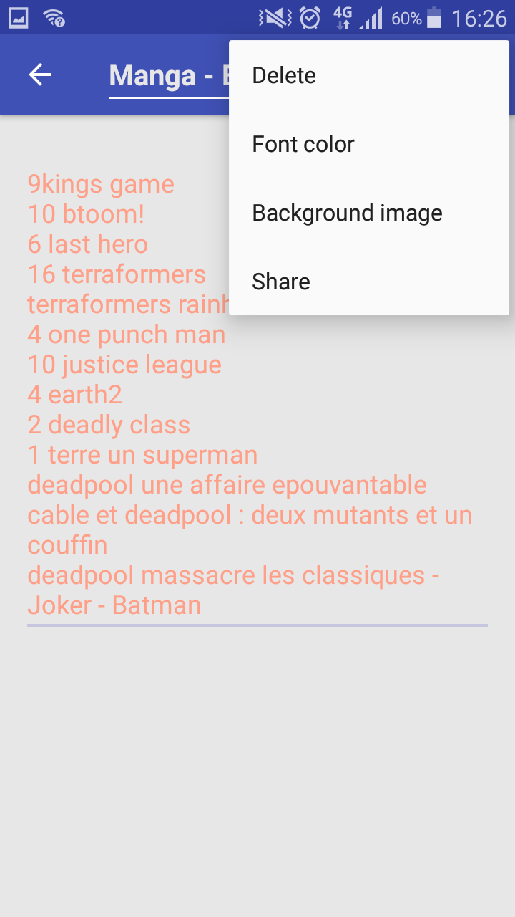

Edit the content of the note

Confirmation message

See part B-2

See part B-3

See part B-1

## B. Further detailing of the features

### 1. Background image

The user can choose an image to put in the background of their note for more customization.

### 2. Font color

Since you can add a background image and the image is saved, we have added the option of changing the text color, so you can always able to see your text!

A color picker will appear on the screen upon selection on the menu.

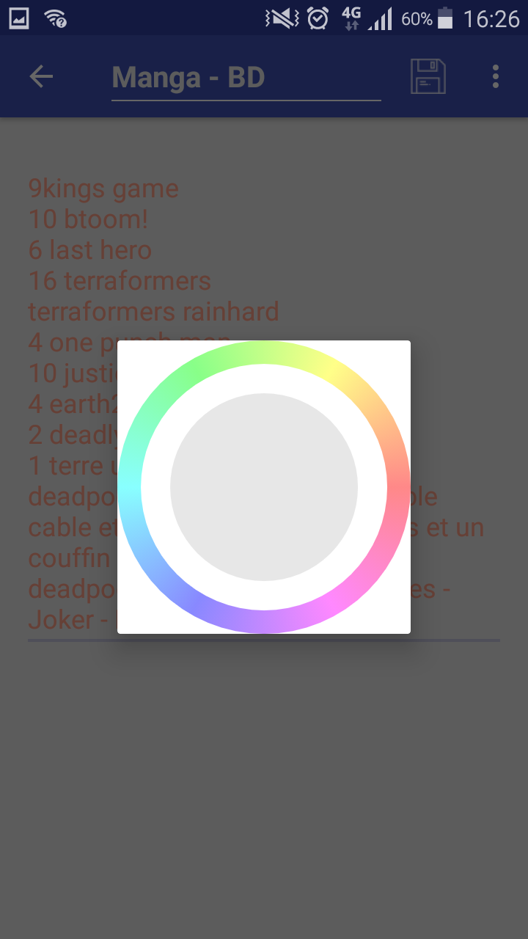

### 3. Sharing option

The user can share notes and use them with other applications or the clipboard by choosing the “Share” option in the note menu. Their applications will then be displayed so that the user can select where to send / use the note data.

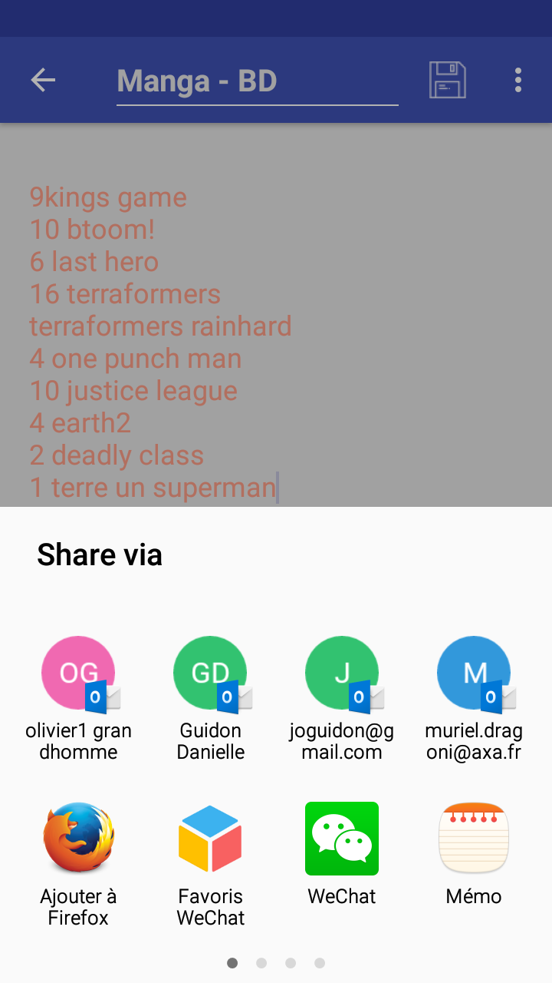

### 4. Storage

The images are saved in the directory of the application.

The Notepad is saved in a file, a JSon feature. We didn’t want to use a database manager because it would have been heavier and less optimized for the few variables we want to save.

# III – Other noticeable features

### 1. Splash screen

Just like a firm, we are using a splash screen in order to display our beautiful logo.

### 2. Optimized Design

The global design of the application has been created so it is easy to understand, just like most applications nowadays.